**Contents | Ngā Ihirangi**

Executive summary | He kupu whakarāpopoto 2

Context | Te horopaki 3

Connecting care project overview | He tirohanga whānui 4

Background 4

Collaborative approach 6

Methods 8

Measures 12

Results 14

Status as at project close | Te mana o te kaupapa 17

Transition to DHBs 17

Outstanding actions | Ngā mahi e toe ana 18

Summary of lessons learned | He kupu whakarāpopoto mō ngā hua 18

Learning for the MHA quality improvement programme 20

Case studies | Ngā take rangahau 21

Conclusion | He kupu whakakapi 27

[Appendix 1: Programme information for the project teams |  
Āpitihanga 1: He mōhiohio mō te hōtaka mā ngā rōpū mahi 29](#_Toc114210964)

[Appendix 2: Project self-assessment scale |  
Āpitihanga 2: He tauine aromatawai ā-whaiaro 30](#_Toc114210965)

Appendix 3: Seven-day follow-up– acute inpatient post-discharge community care | Āpitihanga 3: He arowhai rā-whitu – te tauwhiro tūroro ki te hapori 31

# Executive summary | He kupu whakarāpopoto

[Te tūhono i ngā manaakitanga, te whakapai ake i ngā whakawhitinga ratonga | Connecting care: Improving service transitions](https://www.hqsc.govt.nz/our-work/mental-health-and-addiction-quality-improvement/projects/connecting-care-improving-service-transitions/) was a priority area within the seven-year mental health and addiction (MHA) quality improvement programme co-ordinated by the Health Quality & Safety Commission (the Commission) that began in July 2017.

The purpose of the Connecting care quality improvement project was to look at ways to improve the processes around transitions of care between MHA services to ensure consumers, families and whānau receive continuous quality care as they move between health providers.

Beginning in August 2018, multidisciplinary project teams were established in each former district health board (DHB),[1] focusing on one of three transition areas.[2] All project teams completed a six-month co-design phase and a nine-month quality improvement phase to test and implement evidence-based interventions designed to improve their chosen service transition. This work was supported by monthly videoconference coaching sessions.

The proxy measure used at the national level across 15 DHBs with adult inpatient units[3] showed an improvement in transitions outcome data. During the testing period, the proportion of consumers discharged from acute mental health inpatient services who were followed up in the community within seven days of their discharge showed a statistically significant rise above the previous median. This equates to an increase of between five and six consumers followed up in a given month.

In October 2020, supported by the MHA quality improvement programme team, the project began to transition to DHBs. Outcomes from the project include:

* improved quality and experience of transitions of care in many DHBs
* increased co-design and quality improvement methodology capability in project teams.

Resources created as a result of the project include:

* a [video illustrating the lived experience of a consumer](http://www.hqsc.govt.nz/resources/resource-library/pono-consumer-story-kolini-baker) during a service transition to community care
* top [tips and examples from provider project teams](https://www.hqsc.govt.nz/resources/resource-library/connecting-care-improving-service-transitions-top-tips-te-tuhono-i-nga-manaakitanga-te-whakapai-ake-i-nga-whakawhitinga-ratonga/) capturing the most important learning from project activities
* a case study per transition area.

The Connecting care project has now been successfully transitioned to DHBs and, as agreed by the MHA quality improvement programme team, this project is now closed. Te Whatu Ora – Health New Zealand entities will manage ongoing oversight of this important area of activity through the reporting and monitoring of their seven-day follow-up data.

# Context | Te horopaki

The national mental health and addiction (MHA) quality improvement programme is a Health Quality & Safety Commission (Commission) initiative, funded and supported by district health boards (DHBs). It is a seven-year programme that began in July 2017 and will run to June 2024. It uses an evidence-based approach, which includes identifying and testing different ways of improving health services, to enable people to receive high-quality, safe and equitable care and support.

The MHA quality improvement programme aims to:

* improve the experiences consumers and their families and whānau have with MHA services, resulting in better health
* reduce variability in the access to, and quality of, MHA services so that consumers receive the same high-quality care, no matter who or where they are
* build skills and a culture of quality improvement leadership in the MHA sector workforce, and strengthen leadership
* share learning across service providers and encourage quality improvement and safety
* measure the impact and effectiveness of quality improvement initiatives.

The work of the programme is spread across five priorities:

* Aukatia te noho punanga: E whai ana ki te whakakore i te noho punanga i mua o te 2020 | Zero seclusion: Towards eliminating seclusion by 2020
* Te tūhono i ngā manaakitanga, te whakapai ake i ngā whakawhitinga ratonga | Connecting care: Improving service transitions
* Te ako mai i ngā pāmamaetanga me te wheako tāngata whaiora me te whānau | Learning from adverse events and consumer, family and whānau experience
* Te whakanui ake i te hauora ā-tinana | Maximising physical health
* Te whakapai ake i te whakahaere rongoā, i te tūtohu rongoā hoki | Improving medication management and prescribing.

Te Tiriti o Waitangi overarches the programme. This means an integral part of the programme is to form strong partnerships with Māori, upholding the articles and principles of Te Tiriti. These two elements – articles and principles – are contained in the Treaty of Waitangi Health Equity Framework[4] developed under the guidance of the MHA quality improvement programme’s Māori Advisory Group.

The framework initiates the bicultural service approach, accurate collection and analysis of inequity data, co-designed care decisions, including consumers, families and whānau, and the science of the [Institute for Healthcare Improvement’s](http://www.ihi.org/) quality improvement methodology to test intervention effectiveness and deliver safe, effective health outcomes.

For further information, see the MHA quality improvement programme overview on the Commission’s website: <https://www.hqsc.govt.nz/our-work/mental-health-and-addiction-quality-improvement/>.

# Connecting care project overview | He tirohanga whānui

[Te tūhono i ngā manaakitanga, te whakapai ake i ngā whakawhitinga ratonga | Connecting care: Improving service transitions](https://www.hqsc.govt.nz/our-work/mental-health-and-addiction-quality-improvement/projects/connecting-care-improving-service-transitions/) is one of the five priority areas of the MHA quality improvement programme.

The purpose of the Connecting care quality improvement project is to look at ways to improve the processes around transitions of care between MHA services to ensure consumers, families and whānau receive continuous quality care as they move between health providers.

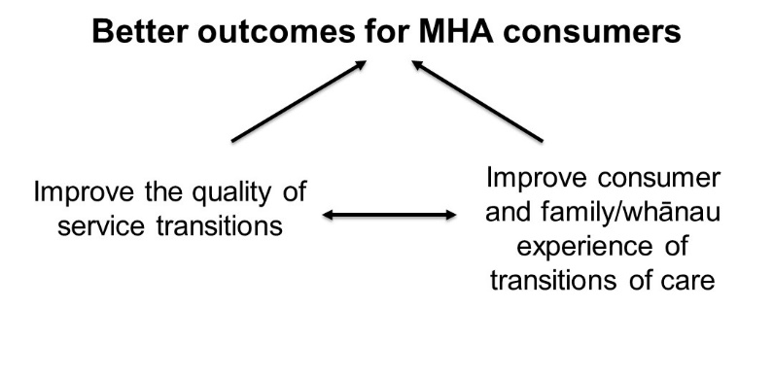The two factors directly related to service transitions to enable better outcomes are: quality of service transitions; and consumer, family and whānau experience.

To achieve the aim, the project objectives were to:

* improve the capability and capacity within the MHA sector to undertake quality improvement work
* improve the experience of care for MHA consumers, families and whānau when transitioning between, and from, services
* reduce unwarranted variation and achieve more equitable outcomes across the MHA sector.

## Background

International evidence shows that good planning before a person transitions between or discharged from services is critical in providing effective support for people with mental health problems. When done well, transition/discharge planning brings together a person’s health and broader social needs and enables those needs to be met. However, if the system fails to support these people effectively, there are huge implications for them, their families and whānau, and the health and other sectors. ‘Getting it right is an investment with significant payback.’[5]

MHA problems are highly prevalent in Aotearoa New Zealand. About 40 percent of people experience a mental illness during their lifetime[6] and psychiatric conditions are now the leading cause of health loss here.3

The demand for MHA services is also increasing. The number of people accessing specialist mental health services increased from 143,000 in 2011 to 162,222 in 2015 (accounting for 3.5 percent of the population).[7] [8] Drivers of demand for services include a growing population, increasing inequalities, changes in environments and cultures, increased globalisation, social media, and work type changes.5

Growing public dissatisfaction with services influenced the decision to conduct a national inquiry into mental health services. The report *He Ara Oranga*,[9] released in November 2018, outlined a vision for a new system with:

Mental health and wellbeing for all at its heart: where a good level of mental wellbeing is attainable for everyone, outcomes are equitable across the whole of society, and people who experience mental illness and distress have the resilience, tools and support they need to regain their wellbeing.7

Poor transitions of care in the MHA setting, across the system of care providers, are linked to negative experiences of care for consumers, families and whānau. Māori are more likely to be affected by poverty than non-Māori and may be sent to services that do not provide adequate food, warmth, safety and shelter or may stay longer in inpatient units because of the lack of community supports and services.7

Gaps in the continuity of information, care planning and timely access to appropriate services were outlined as significant issues in the report of the Office of the Auditor*-*General.3 As the Mental Health and Wellbeing Commission’srecent report notes, improvements are needed to ensure consumers have access to health and social services that are well connected.[10]

## Collaborative approach

DHB-led project teams chose to focus on one of the following transition areas for their Connecting care quality improvement work.

|  |  |
| --- | --- |
| **Transition** | **Number of DHBs working on this transition area** |
| From DHB adult inpatient specialist services to DHB adult community services | 5 |
| From DHB community services to primary care | 9 |
| From DHB youth community services to DHB adult community services | 6 |

Each project team chose its transition area based on regional discussions, the work completed by the first cohort of participants on the MHA quality improvement facilitator course, an evidence review undertaken for the Commission, and the report of the Office of the Auditor-General. It was expected that whichever transition area a project team chose to focus on, many of the successful ideas for change would apply to the other two transition areas as well.

Non-governmental organisation (NGO) care providers were engaged in this improvement work.

Beginning in August 2018, multidisciplinary project teams were established in each DHB, focusing on one of the three transition areas listed above. All project teams completed a six-month co-design phase followed by a nine-month quality improvement phase to test and implement evidence-based interventions designed to improve their chosen service transition, supported by monthly videoconference coaching sessions via Zoom (see Figure 1 project timeline).

As part of the learning session and collaborative model used in this project, teams received information to help with the start-up of their project, including establishing their project team (see Appendix 1). They also received tools to support their co-design and quality improvement phases.

After project teams gave feedback about progress on their projects using a project self-assessment scale (see Appendix 2), two more supra-regional learning sessions took place   
in 2020.

Connecting care project timeline**Figure 1: Connecting care project timeline**

## Methods

### Co-design

Co-design is an important part of a process to identify a challenge or opportunity to engage consumers, families, whānau, staff and other stakeholders in order to:

* capture their experiences and ideas
* organise the learning they bring to create new understanding and insight from their perspective of the care journey and their emotional journey
* continue together in partnership to review learning and ideas
* plan and implement improvements
* review what difference that change has made.

### Plan-do-study-act cycleThe Model for Improvement

The Model for Improvement (MFI) provides a framework to structure improvement efforts.[11] The model is based on three key questions, known as the thinking components.

* What are we trying to accomplish?
* How will we know that a change is an improvement?
* What change can we make that will result in improvement?

These questions are then used in conjunction with small-scale testing of ideas for change. The ‘doing’ component is known as the plan–do–study–act (PDSA) cycle.

### Driver diagram

A driverdiagram is a way of describing a team’s ideas and theories about what needs to be in place to achieve an improvement aim. The driver diagram is a living document that is updated throughout an improvement project to reflect the new knowledge gained through the improvement process.[12]

Primary drivers are high-level concepts or levers that, if implemented, will achieve the improvement aim. The best way of implementing primary drivers is to identify a series of actions (otherwise known as secondary drivers) that will contribute to achieving the primary drivers and, in turn, the aim.

Change concepts represent abstract forms that underlie change ideas, while change ideas identify the actions that have been shown to make improvements in a system.

The Connecting care driver diagrams below outline the key recommended elements to include in a project aimed at improving the experience of transitions for consumers. Figure 2 focuses on the transition from acute to community-supported care, while Figure 3 has an equity focus that can apply to any transition type.

DHB-led project teams developed their own driver diagrams relevant to their chosen transition area and setting and populated it with change ideas generated through their co-design process.

**Figure 2: Connecting care driver diagram**

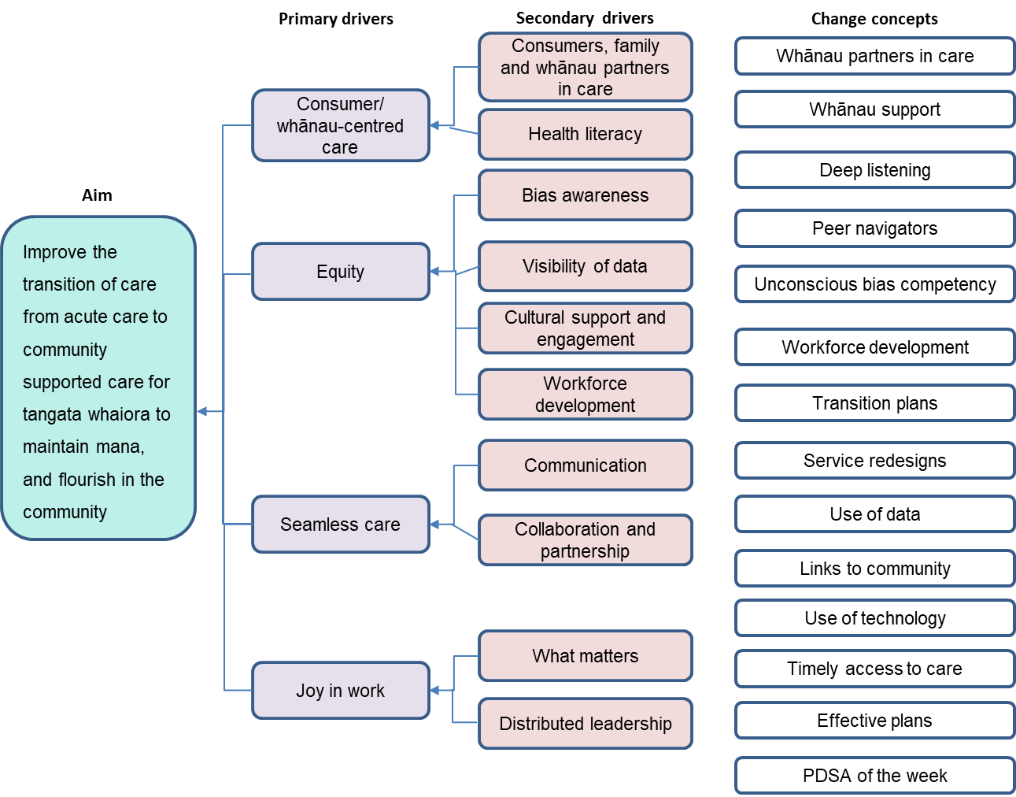

**Figure 3: Connecting care equity example driver diagram**

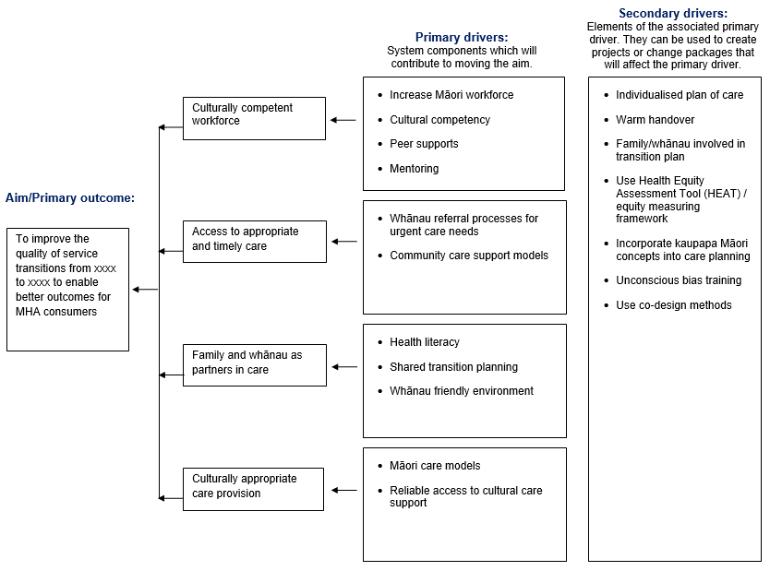

## Measures

The best nationally available data relevant to the Connecting care project is for the adult inpatient to community transition. Since October 2020, monitoring of adult inpatient-to-community has focused on data from reports that DHBs are required to make to the Ministry of Health on community follow‐up within the first seven days of mental health inpatient discharge.[13] See Appendix 3 for a technical description of the DHB inpatient to community seven-day follow-up (KPI 19) indicator.

Since March 2021, the Commission has had access to the ‘7-day follow-up’ data through the [Mental Health & Addiction Key Performance Indicator (KPI) Programme](https://www.mhakpi.health.nz/) dashboard, hosted on the Mental Health & Addiction KPI Programme website.

### The challenge with Connecting care outcome measures

Establishing consistent, feasible, timely and meaningful measures for complex change programmes is a challenge experienced across the health sector, not just for this programme. This challenge applies particularly to projects that cross multiple services, and where evidence of the impact of changes only emerges some time after the process change occurs.[14]

For the Connecting care project, outcomes were not clearly defined and proved difficult to measure. Transitions are complex, available data does not capture all transition detail, and the deterioration of consumer health after discharge may not be related to the earlier transition. The challenges in identifying data to meaningfully measure outcomes were different for each of the transitions.

For the transition from DHB adult inpatient specialist services to DHB adult community services, one existing measure used in other parts of the sector is a readmission rate within 28 days. However, not all readmissions are a sign of a failed or suboptimal transition. Connecting care teams told the MHA quality improvement programme team that quite often consumers have brief admissions to successfully manage times of crisis and in such cases their use of treatment is a sign of good engagement.

For this reason, the programme team looked for an indirect measure for the Connecting care project to approximate failings in the transition process – whether those failings occurred because of incomplete or ineffective discharge planning or due to inadequate follow-up care.

It was not possible for the project to have oversight of data at a national level for transitions either from DHB community services to primary care, or from DHB youth community services to DHB adult community services. This limitation applied for two reasons: either relevant data is not collected in the PRIMHD[15] national collection and there is no requirement to report this data; or some of this data may be held in primary care data sets for which no national data set is currently available. Given the complexity with the youth to adult transition data, some DHBs developed additional local measures.

After considering all these issues and in consultation with Connecting care project teams, the programme team chose the DHB inpatient to community seven-day follow-up as a ‘proxy’ measure of good transitions or failings in the transition process for all three of the Connecting care transitions.[16]

A proxy indirectly measures what we are aiming to improve with Connecting care. The direct outcome is improving the quality of service transitions, but the proxy measure is seven-day follow-up of DHB inpatients after their transition to the community. Because direct measures are not possible with the available data, we are using this proxy measure, which we expect to be correlated with the outcome we are trying to achieve – that is, the outcome of better transitions generally, including for the three transition types that DHB project teams focused on. The source of this measure is data from the MHA KPI Programme, which we accessed through PRIMHD.

DHB project teams also developed their own outcome, process and balancing measures and tracked these at a local level.

* **Outcome** measures are what the project is aiming to achieve – what is the system performance?
* **Process** measures assess steps in a process that lead to the expected outcomes of a project.
* **Balancing** measures monitor unintended consequences – are changes to improve one part of the system adversely affecting other parts of the system?

The following are examples of each of these types of measures that Connecting care project teams chose locally (which we share here with their permission).

Examples of **outcome measures** are the:

* percentage of consumers with a transition plan
* percentage of discharged consumers referred back to MHA services from police within 28 days of discharge
* percentage of discharged consumers where referral ended due to lack of consumer engagement or failing in relationship within 28 days of discharge
* percentage of discharged consumers who had an MHA-related emergency department presentation within 28 days of discharge.

Examples of **process measures** are the:

* percentage of consumers who received a copy of their transition plan
* percentage of consumers that had a transition plan recorded in *xxx* system using the template
* percentage of consumers that had a transition plan review within one month prior to discharge.

Examples of **balancing measures** are:

* the number of consumers discharged each month from the relevant MHA service team(s)
* feedback from team meetings and individual consumers on the quality of transition.

## Results

The proxy measure at the national level across 15 DHBs with adult inpatient units[17] shows an improvement in transitions outcome data. During the testing period, we saw a statistically significant rise above the previous median for the proportion of consumers discharged from acute mental health inpatient services who were followed up in the community within seven days of their discharge. This equates to an increase of between five and six consumers followed up in a given month (Figure 4).

The increase in the median for all ethnicities was 0.8 percent. This compares with a 0.4 percent increase for Māori (Figure 5), 1.4 percent increase for Pacific peoples (Figure 6) and 1.0 percent for non-Māori, non-Pacific peoples. Māori, however, still have the lowest median follow-up rate of 79.8 percent, and are the only prioritised ethnicity group with a follow-up rate below 80 percent.

Figure 4: Percentage of consumers with a seven-day follow-up after discharge for all ethnicities (national data)

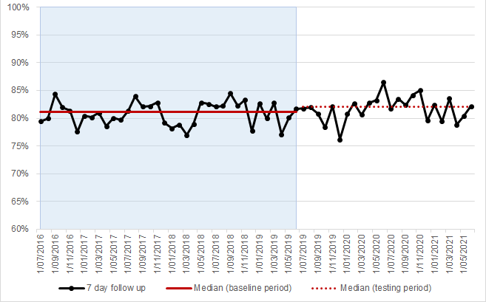

Figure 5: Percentage of Māori consumers with a seven-day follow-up after discharge (national data)

Figure 6: Percentage of Pacific consumers with a seven-day follow-up after discharge (national data)

The Mental Health & Addiction KPI Programme has reported the seven-day follow-up data for DHB inpatient to community transitions in bar charts on a quarterly basis on its dashboard. This format presented data challenges and limited the ability for project teams to learn how their tests of change were impacting on the desired outcome. To address this issue, the MHA quality improvement programme team provided run charts[18] to the DHB project teams to support their improvement project and monitoring of change in their outcomes (Figure 7). This data was used as a proxy across the three transition areas though it may not have been the particular transition focus of the DHB.

We know that Māori face inequities in transition processes and outcomes. For this reason, the run charts provided to DHB project teams in December 2021 included a view by ethnicity (Māori and non-Māori). Teams were encouraged to look at their ethnicity outcome data as well as to examine their process measure data by ethnicity.

Figure 7: Example of run chart for DHB project teams

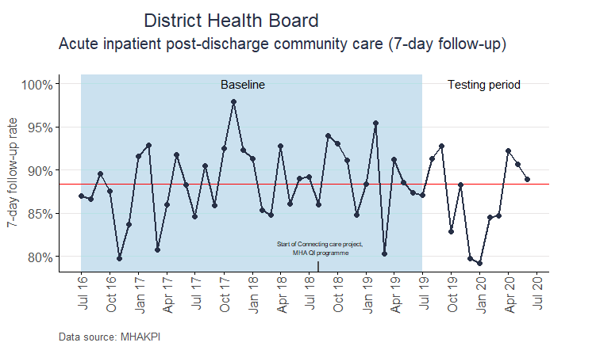

# Status as at project close | Te mana o te kaupapa

## Transition to DHBs

Since October 2020, the Connecting care project has been transitioning to DHBs. Ongoing support from the MHA quality improvement programme team during this period has included:

* tracking follow-up within first seven days of mental health inpatient discharge data hosted on the KPI Programme dashboard. Note that the Ministry of Health also has oversight of this data with mandatory reporting from October 2020 from an assurance perspective

A couple of women sitting at a table. On the right is Kolini Baker.


* producing run charts for project teams to monitor their data over time to detect trends or shifts

Kolini Baker (right) – watch her journey with mental ill health and addiction and transition to community care at: [www.hqsc.govt.nz/resources/resource-library/pono-consumer-story-kolini-baker](http://www.hqsc.govt.nz/resources/resource-library/pono-consumer-story-kolini-baker) [6.3 minutes]

* developing a video illustrating the lived experience of a consumer during service transitions
* facilitating quarterly online sessions to network and share successes and challenges, through to the final session on Wednesday 27 October 2021
* capturing the most important learning from the project, see [‘Top tips and examples from provider project teams’](https://www.hqsc.govt.nz/resources/resource-library/connecting-care-improving-service-transitions-top-tips-te-tuhono-i-nga-manaakitanga-te-whakapai-ake-i-nga-whakawhitinga-ratonga/) and ‘Summary of lessons learned’ below
* continuing to profile Connecting care project work and achievements, including a case study from each transition area (see case studies on pages 21-27).

# Outstanding actions | Ngā mahi e toe ana

The majority of teams have completed their Connecting care project and moved project team resource elsewhere.

A few teams continue to work on some aspects of their project in order to reach their aim and integrate activities into business as usual or into the operating model of the service as an ongoing area of continuous improvement. Examples of this work include:

* making consumers, family and whānau voice/goals visible to all
* providing acute teams with a discharge summary template, pre-discharge checklist and decision-making matrix for determining actions for people lost to follow-up
* continuing to have transitions as an agenda item at governance and team meetings
* incorporating the transition checklist into multidisciplinary team meetings
* implementing a generic discharge pathway for business as usual.

# Summary of lessons learned | He kupu whakarāpopoto mō ngā hua

Below are some top learning tips and examples that DHB project teams have offered from their Connecting care project activities (August 2018 to October 2020). The examples are a summary of what the teams shared.

**TIP: Have a clear aim – measurable and specific**

**TIP: Involve the consumer, family and whānau**

Auckland DHB: Family and whānau now have a clearer role in care.

Canterbury DHB: A new transition pathway has been established that promotes consistent process while allowing for flexibility and adaptability based on individual consumer need and circumstances.

Counties Manukau Health: Feedback gathered on the experience for people discharged through improved transition of care pathway, and staff experiences using the pathway.

Northland DHB: Improvement in a transition pathway process must include the consumer, family and whānau in a co-design approach if the work is hoping to be effective in meeting their needs.

West Coast DHB:

* More consumer, family and whānau feedback captured through Mārama Real-Time Feedback survey.
* Independent consumer advisor surveying discharged consumers, focusing on improving the journey.
* Consumer and family/whānau voice and goals are visible to all and in everything the DHB does.

**TIP: Include non-governmental organisations (NGOs) as part of the care team**

Auckland DHB: NGOs now part of the care team.

Northland DHB: It is vital to put time into key stakeholder engagement and developing working relationships early on in the project process.

Waitematā DHB: NGO members engaged in consumer discharge planning and support in achieving consumers’ recovery goals.

Whanganui DHB: Refer to kaupapa Māori services as a first option. This is working well for some consumers and their family and whānau on discharge from inpatient services who, when offered, have chosen kaupapa services and then do not need to be referred to them via the community mental health and addiction service. From an equity perspective this offers direct choice to the most appropriate service for consumers, family and whānau.

**TIP: Involve staff at every level, including senior clinicians**

**TIP: Have only one consolidated transition plan**

Bay of Plenty DHB:

* Median of 14 percent (March 2019) has shifted to median of 40 percent (August 2020) of people transitioning from the service with a copy of their wellness/transition plan.
* One wellness/transition plan instead of multiple forms being used.

Waitematā DHB:

* Community alcohol and drug service: all teams agreed to use only one discharge letter for client and other health professionals.
* More collaborative transition planning.
* Less paperwork for clinicians.

MidCentral DHB: Standardisation of protocols and practices.

**TIP: Automate your processes**

Mental Health, Addictions and Intellectual Disability Service (MHAIDS):

* Increased use of telehealth (Zoom) facilities. Draft Zoom guidelines developed.
* Internal transfer of care procedure established; person is digitally tracked and monitored from the initiating to the receiving team.
* Increase in family and whānau engagement and communication at Hutt South Community Mental Health.
* Automated digital client notes, including service exit plans, are electronically sent to GPs when submitted.
* The GP liaison service and automated digital client notes have improved communication between primary and secondary services.

**TIP: Include transition planning as a standard agenda item + TIP: Use a discharge checklist**

Northland DHB: A checklist approach for standardising transitions can help staff with both a best practice guide along with providing a sense of quality expectations. But keep it easy to use – clear, simple language, not too many words and a simple format. If the checklist can be developed as a form in an application, then it can also be useful for reporting.

Waitematā DHB: Use of checklist prompts clinicians about what needs to be done to support discharge of consumers from the service.

**TIP: Inter-DHB transfer communication envelope**

West Coast DHB: Inter-DHB transfer communication envelope developed to ensure the correct information is provided in a standardised manner and provide a safe way to transfer hard copy information.

**TIP: Practise co-design**

Whanganui DHB: Consumer ideas and feedback are shared at a monthly ‘Conversation Café’,[19] a joint effort by the Mental Health & Addiction Service, Balance, Te Oranganui Trust and Mental Health & Wellbeing Support, to ‘hear the voices of the community and people with lived experience of mental health and addiction services (consumers) and their whānau’ in line with He Ara Oranga.

**TIP: Establish ongoing measurement plans**

MidCentral DHB: Gather good baseline data on the number of transitions and alternative destinations.

Northland DHB: Creating a measurement framework beyond project close as the work moves into business as usual is important to see the ongoing results of the work and can help to maintain relationships with partners in the transition pathway.

Waikato DHB:

* Huge learning about data, how information is collected, what the organisation records, and how to use Excel, designing audit tools, stakeholder collaboration and communication.
* Updating demographic data is important – the DHB now has a proactive process for keeping this information current, which has had a positive flow-on effect.

Whanganui DHB: For 7-day post-discharge follow-up data, ensure that all activity codes are entered correctly and promptly as, if not, it may appear that some consumers were not being seen when it is documented in the clinical notes that they were.

## Learning for the MHA quality improvement programme

Some learning from this project is relevant to the wider MHA quality improvement programme. In particular, it is worthwhile spending more time in the project set-up phase to clearly define the measurement strategy. This work includes assessing whether the proposed measures are available and it is feasible to sustainably collect the required data, as the MHA quality improvement programme’s mid-programme evaluation report acknowledges.12 A risk in persisting with the use of a national data set is that measures that are applicable to all projects may not be sensitive enough to evidence improvements. This could be because the measures are too clustered and/or too distanced from improvements.

In addition, clear timelines are needed to establish the point at which the MHA quality improvement programme team will reduce or complete its support and the programme team should proactively work with project teams to establish their independent project plans beyond the life of the programme. The goal should be for organisations to commit to continuing to work on these project areas beyond the life of the programme, until the desired level of improvement has been sustained and can be considered part of ‘business as usual’, or it is built into the operating model of the service as an ongoing area of continuous improvement.11

# Case studies | Ngā take rangahau

**Case study one: From DHB adult inpatient specialist services to DHB adult community services**

[***Project inspires quality improvement across West Coast mental health services***](https://www.hqsc.govt.nz/news/project-inspires-quality-improvement-across-west-coast-mental-health-services/)

Undertaking one quality improvement project relating to seclusion soon highlighted to West Coast District Health Board (DHB)’s mental health and addiction services the need for improved processes relating to the coordinated transfer of care of tangata whaiora (consumers) so they and whānau receive continued support.

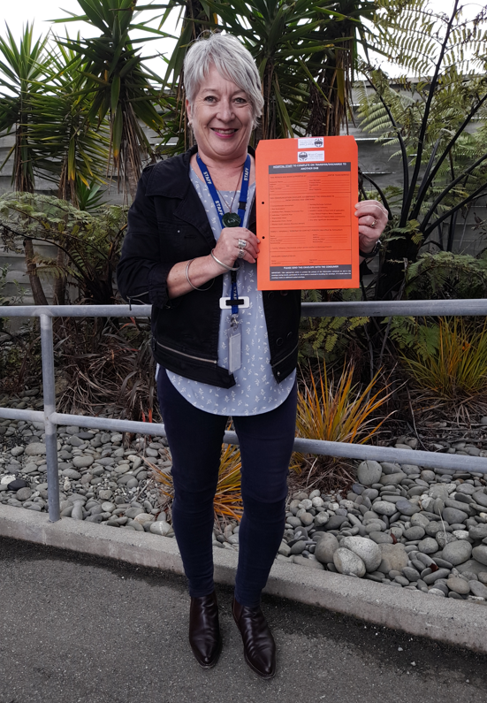

This work by the DHB is part of [Te tūhono i ngā manaakitanga, te whakapai ake i ngā whakawhitinga ratonga | Connecting care: Improving service transitions](https://www.hqsc.govt.nz/our-work/mental-health-and-addiction-quality-improvement/projects/connecting-care-improving-service-transitions/), one of five priority areas for the Health Quality & Safety Commission’s (the Commission’s) national seven-year [mental health and addiction (MHA) quality improvement programme](https://www.hqsc.govt.nz/our-work/mental-health-and-addiction-quality-improvement).

West Coast DHB nurse manager, central mental health services, Paula Mason, had recently taken up her new role when the DHB began working on the programme’s first priority area, [Aukatia te noho punanga: Noho haumanu, tū rangatira mō te tokomaha | Zero seclusion: Safety and dignity for all](https://www.hqsc.govt.nz/our-work/mental-health-and-addiction-quality-improvement/projects/zero-seclusion-safety-and-dignity-for-all/), and it wasn’t long until the need for further quality improvement was identified in a related area – service transitions.

Paula Mason, nurse manager, central MHS, with the new envelope

Paula explains: ‘Once we started the Zero seclusion project work, we realised there was so much opportunity for quality improvement across the service, we didn’t know where to start.

‘In the preceding eight months there had been some horrific events on the ward, including a death, assaults and property damage. The quality and standard of care had to change.

‘It became clear from our Zero seclusion project that entry into the service and exit out of it were just as important. Essentially, we combined the two projects and called it “Connecting care to Zero seclusion”, because all care needs to be connected.’

The project team included the DHB’s quality manager and mental health services quality facilitator, members of the DHB’s consumer council and whānau and consumer advisers.

The quality facilitator completed the Commission’s MHA quality improvement facilitator training course delivered through Ko Awatea, Counties Manukau Health.

‘This was really valuable and, along with the support from the Commission, helped us frame up the work we needed to do and make decisions on what to focus on to achieve change,’ says Paula.

‘I also found the regular get-togethers with other DHB MHA quality improvement project teams facilitated by the Commission programme enormously valuable. We picked up so much from hearing what others were doing and thinking about how we could apply what had worked for them to our situation.

‘We put a lot of energy into capturing more feedback through Mārama Real-Time Feedback, a consumer satisfaction survey of tangata whaiora and family/whānau experience of the services they receive in the MHA sector.

‘Our consumer advisor also met with every tangata whaiora a month or so after they’d been discharged to ask what they thought could be improved. That feedback helped us change some things, including in the inpatient unit.

‘We developed checklists for admissions and discharges and for inter-DHB transfers to make sure the information was correct, standardised, going to the right people, and that the right people had been consulted.’

A new key tool for the inter-DHB transfers is a double-sided envelope to provide a safe way to transfer hard-copy clinical information when staff are escorting consumers between DHBs. Each DHB completes the relevant checklist printed on each side of the envelope.

‘The idea for the envelope came from one used by aged residential care for residents coming into and leaving general hospital care, so we knew the concept already worked and was very popular.’

Paula says quality improvement principles and training are now business-as-usual for the service and are being applied in other areas.

‘At least 70 percent of our policies and procedures were years out of date, so we’ve been updating those, as well as guidelines for staff, so they’re better resourced. We also have much more robust processes for discharge.

‘In terms of reducing readmission rates, we also looked at improvements we could make to prevent tangata whaiora being discharged too early in their journey and ensure continued care in the community after discharge.

‘Transfers of tangata whaiora from the inpatient unit to other DHBs have been static at around six per year. We’ve received positive feedback from receiving DHBs about the transfer envelope and it has helped to standardise relevant information when we receive tangata whaiora back into our care.

‘The Coast is pretty hot on better integration of primary and secondary health services and being more inclusive. We’re now looking at the continuum of care and education around the fact that when someone comes into mental health care they’ve come from general practice, so they’re already under care. It’s not an “us and them” situation.’

More information about Connecting care: Improving service transitions, including top tips from provider project teams, can be found [here](https://www.hqsc.govt.nz/our-work/mental-health-and-addiction-quality-improvement/projects/connecting-care-improving-service-transitions/).

**Case study two: DHB community services to primary care**

[***Northland quality improvement project brings better support for tangata whaiora and whānau***](https://www.hqsc.govt.nz/news/northland-quality-improvement-project-brings-better-support-for-tangata-whaiora-and-whanau/)

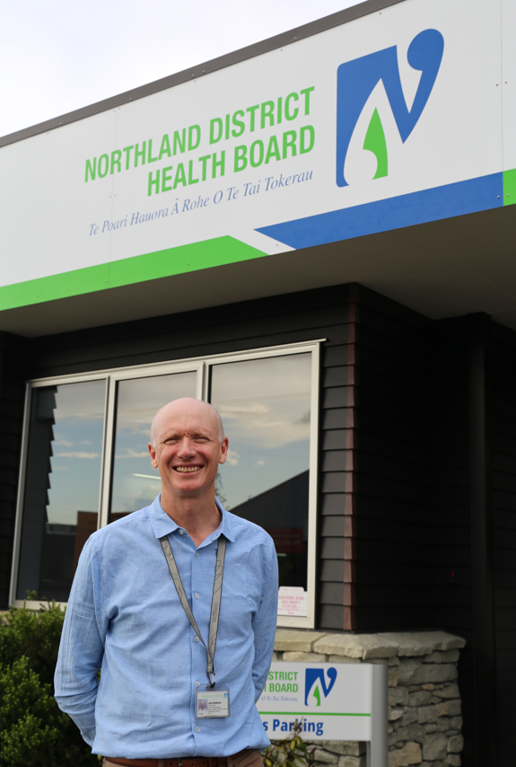

A Northland District Health Board (DHB) project to improve the transition between services for mental health and addiction (MHA) tangata whaiora (consumers) is improving support for tangata whaiora and whānau, as well as providing a forum for secondary services, non-governmental organisation (NGO) services, tangata whaiora and general practice to work together on quality improvement projects.

The Northland project is part of [Te tūhono i ngā manaakitanga, te whakapai ake i ngā whakawhitinga ratonga/Connecting care: Improving services transitions](https://www.hqsc.govt.nz/our-work/mental-health-and-addiction-quality-improvement/projects/connecting-care-improving-service-transitions/), one of five priority areas for the Health Quality & Safety Commission’s (the Commission’s) national seven-year [mental health and addiction (MHA) quality improvement programme](https://www.hqsc.govt.nz/our-work/mental-health-and-addiction-quality-improvement).

The project looked at ways to improve processes relating to the coordinated transfer of care between MHA services so tangata whaiora and whānau receive continued support. It used a co-design approach involving MHA service staff, tangata whaiora, NGOs and GPs. It focused specifically on standardising discharge processes, improving discharge documentation and socialising transition pathways relating to transitions from DHB MHA community teams back to general practice.

Northland DHB’s service development project lead, mental health and addiction services, Joe Crowley

The project lead is Northland DHB’s service development project lead, mental health and addiction services, Joe Crowley (pictured right). He says the project process really benefited from the team putting time put into key stakeholder engagement and developing working relationships early on.

‘This was vital for the success of the project and it means we now have a unique representative forum we can use for future MHA quality improvement projects.’

Joe says the project solutions turned out to be surprisingly straightforward, although it took some time for the team to discuss potential improvements and build a development and testing plan.

‘Pre-COVID-19, we were able to meet face to face,’ says Joe. ‘We worked with our consumer and family leader team to identify a number of tangata whaiora with recent experience of transition between Northland DHB and general practice. We invited an interested group to share some kai and had a good discussion about what was working well for them, what wasn’t and what could be improved.

‘Through the GP liaison on our project team we approached general practices with a survey and also took the opportunity to sit down with GPs and discuss issues they face with the discharge process from MHA secondary services.

‘We also presented to staff at the community general adult team based in Kamo, who handle the bulk of the non-acute MHA case load in Whangārei.’

Joe says a number of inconsistencies were identified, including the quality and timeliness of discharge information provided to GPs.

‘The issues for tangata whaiora were around understanding what was happening to them and having good information. GPs also had issues with the information delivery mechanism, but it was the information itself that was crucial. And, if we improved information flow for GPs, it improved the transition experience for tangata whaiora as well.’

He says the first step was defining a good discharge from all perspectives. ‘The main tool was tightening up the documentation and getting that into the Northland DHB’s patient management system to help improve the flow of information across and between MHA care settings, including allied health and NGOs.

‘That gave us a protocol in the form of a discharge summary checklist, which provided staff with a best-practice guide as well as a sense of quality expectations. We kept the checklist easy to use, with clear language, not too many words and a simple format.

‘We’re measuring improvement through recovery plan completion rates, qualitative feedback from tangata whaiora, GPs and NGOs, and tracking 90-day fast-track readmissions back into secondary care. The fast-track means tangata whaiora can go straight back to their existing care team within 90 days of discharge, without going through the full intake assessment process.’

However, Joe says tangata whaiora going back into secondary services within 90 days is not necessarily an indicator of a low-quality discharge.

‘For instance, it might mean there’s been a change and the tangata whaiora is now willing to engage with the service to better support their mental health so they can stay well for longer out in the community.’

The DHB is now looking at improving the issues identified by GPs relating to paper-based delivery of information as a separate piece of work.

Joe completed the Commission’s MHA quality improvement facilitator training course delivered through Ko Awatea, Counties Manukau Health, and says he found the skills he gained and the ongoing support from the Commission’s MHA quality improvement programme team invaluable.

‘It’s good to be able to talk to like-minded people about issues. Descriptions of things like “transitions” can be a little vague, so to try and turn a discussion about transitions into a piece of work you can deliver takes a bit of talking through. It’s easy to go off in other directions.’

More information about Connecting care: Improving service transitions, including top tips from provider project teams, can be found [here](https://www.hqsc.govt.nz/our-work/mental-health-and-addiction-quality-improvement/projects/connecting-care-improving-service-transitions).

**Case study three: DHB youth community services to DHB adult community services**

[***Repairing the broken bridge between youth and adult mental health services in Canterbury***](https://www.hqsc.govt.nz/news/repairing-the-broken-bridge-between-youth-and-adult-mental-health-services-in-canterbury/)

With all the pressures of becoming an adult, turning 18 can be an anxious time for young people. For those who need ongoing support from mental health services beyond the age of 18, the prospect of transitioning from specialist youth to general adult mental health services can add to this anxiety and increase the risk of disengagement at a time where support should be at its most robust.

With this in mind, Canterbury District Health Board, Te Poari Hauora ō Waitaha (CDHB) chose to focus on the youth to adult mental health services transition as part of the Health Quality & Safety Commission’s (the Commission’s) Connecting care: Improving service transitions – Te tūhono i ngā manaakitanga, te whakapai ake i ngā whakawhitinga ratonga project.

With the support of the Commission and a focus on co-design (an approach to designing services that actively involves all stakeholders), CDHB developed and implemented a new process aiming to promote safety and continuity of care by making this transition less risky, more collaborative and generally less stressful for young people and their whānau.

#### Preventing young people from falling through the cracks

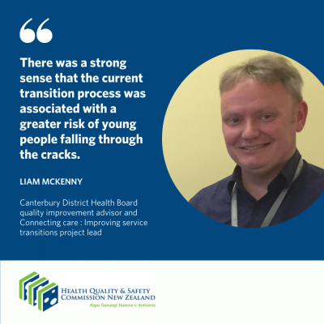

The project group was made up of clinicians, leaders, consumer advisors and whānau advisors from both youth and adult speciality services. They applied a ‘repairing a broken bridge’ analogy to the project, quality improvement advisor and project lead Liam McKenny said.

‘There was a strong sense that the current transition process was associated with a greater risk of young people unnecessarily falling through the cracks. A young person’s care and treatment should not be negatively impacted by service-imposed demarcations, particularly at such an uncertain point in their lives when they may already be encountering other transitions, such as leaving home, leaving school or entering tertiary education or the workforce,’ he said.

#### Planets aligning through Connecting care

CDHB’s specialist mental health service team felt strongly about this issue and jumped at the opportunity to address it through the Connecting care project.

‘The planets all aligned,’ said Liam. ‘I happened to be undertaking the Commission’s quality improvement facilitator (QIF) training programme [sponsored by the Commission] at the same time as the Connecting care project was launched. QIF programme participants were expected to undertake a project that aimed to improve transitions of care. For mental health care settings, three possible focus areas were identified: DHB adult inpatient specialist services to DHB adult community services, DHB services to primary care and DHB youth community services to DHB adult community services.

‘In reality we could have focused on any one of these areas as they all present challenges and opportunities for improvement. However, the youth to adult services transition was one that stakeholders felt most strongly about. We ultimately chose to focus on this transition because we know the consequences and emerging risks associated with poor transition processes are significant and far-reaching. Poor transitions can, for example, lead to vulnerable consumers completely disengaging from services or presenting an increased risk of self-harm or suicide.’

#### Using co-design

To keep the emphasis on co-design, the project group collected feedback from young people, whānau and clinicians about their experiences of transitioning to adult services. Those who had a negative experience used words like ‘anxious’, ‘overwhelmed’, ‘unwanted’, ‘abandoned’, ‘fear’, ‘disorientated’, ‘no-control’ and ‘confused’. Conversely, those who described positive experiences used words like ‘respected’, ‘listened to’, ‘believed’ and ‘informed.’

‘Analysing this feedback helped us understand what good looks like,’ Liam said. ‘We also drew on case studies of previous transitions as well as complaints and incident reviews to increase our understanding.’

#### Transfer of care checklist for case managers

Mapping the transition process helped the project group appreciate and better understand the complexity and variation of the transition. They quickly learned there could not be a ‘one size fits all’. Creating a transfer of care checklist slowly emerged as a way of combining several of the ideas for improvement the group had identified during their exploration into a single, elegant solution.

‘The co-design process helped us identify what the “core” elements of “good” transitions are. Adopting a checklist format allowed us to capture these essential elements in the same place,’ Liam said. ‘The challenge with the checklist approach was balancing a methodical approach with the need for some flexibility so the transition process can be tailored to the unique needs of the young person.

‘It’s a tool to help clinicians to support the young person and their whānau through a successful transition; it also promotes a safer, more positive experience while fostering an increasingly collaborative process between services.’

#### Youth-friendly information

Another theme described by young people and their whānau about the transition was a fear of the unknown. This led to an idea to develop a youth-friendly information package to help young people and their whānau think ahead about the transition, formulate questions and address common concerns.

The content of the package was created in direct response to issues raised during the co-design process. The final iteration of the package contains lots of essential information written in clear, concise language, for example, how the adult service will be different from the youth service and what will be the same. It also outlines what will happen during the transition and what a young person can expect from their first appointment with the adult team.

#### Evaluation

‘The relatively small number of direct youth to adult mental health services transitions that occur at CDHB makes evaluation of these changes challenging in the short-term. However, those transitions that have occurred since the new tools were introduced have had positive outcomes. Particularly when looking at whether young people remained engaged with adult services after the transition,’ Liam said.

Feedback from clinicians has also been positive. ‘Some youth case managers had never overseen a transition from youth to adult services before and, for those who had, it wasn’t unusual to just “wing it”,’ Liam said. ‘Clinicians who have worked with the new process seem to really value the structure and clarity it provides.

‘I am hopeful that meaningful benefits to young people and whānau will be revealed over time through a reduction in complaints or serious events occurring where the quality of the transition is a contributing factor,’ Liam said.

#### Tools now available for use

The project is now complete and the tools are available for use. The message about them is also getting out to clinicians and teams.

The CDHB quality team will continue to monitor progress to ensure improvements are embedded and sustained.

‘Transitions in health care are complex and this was a challenging piece of work. I am so pleased we saw it through to the end and remained focused on the goal.’ Liam said.

# Conclusion | He kupu whakakapi

In these high-quality projects, the project teams became increasingly familiar and comfortable with co-design and quality improvement methodology. At the same time, the quality and experience of transitions of care improved in many DHBs.

An example of one DHB’s local-level data shows that since the change ideas were tested, the percentage of consumers transitioning from the MHA service with a copy of their wellness/transition plan has significantly increased.

The run chart in Figure 8 clearly demonstrates the effect of the change idea on this improvement. From the original median of 14 percent (at 4 March 2019), the percentage rose by 10 data points at the upward shift. After that, the median was recalculated and showed a sustained new level of performance at 28 percent. This reflects a 100 percent increase in consumers who received a copy of their transition plan (data shared with permission).

**Figure 8: Percentage of consumers who received a copy of their transition plan at one DHB**

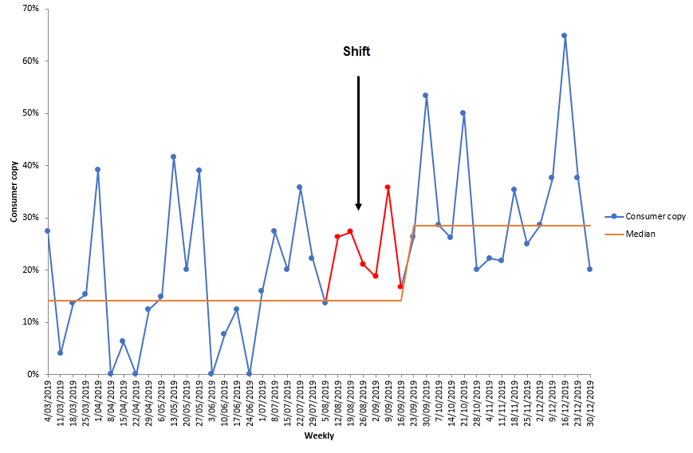

Feedback from consumers included:

Great transition – the process started a long time ago with my doctor and therapist. Transition happened the way it was meant to be, I’m the chief of my own waka and the service is just paddling.

The phase of transitioning the Connecting care project back to DHBs is complete and, as agreed by the MHA quality improvement programme team, this project will now close. This transition process has been under way since October 2020, which the MHA quality improvement programme team has supported in various ways as highlighted in this report. DHBs will manage ongoing oversight of this important area of activity through the reporting and monitoring of their seven-day follow-up (KPI 19) data.

The MHA quality improvement programme is a seven-year programme of work (July 2017 – June 2024). It has two remaining priority areas[20] for the team to turn its focus to, within its finite resource, with the aim of improving the experiences of consumers and their families and whānau with MHA services, resulting in better health.

# 

# Appendix 1: Programme information for the project teams | Āpitihanga 1: He mōhiohio mō te hōtaka mā ngā rōpū mahi

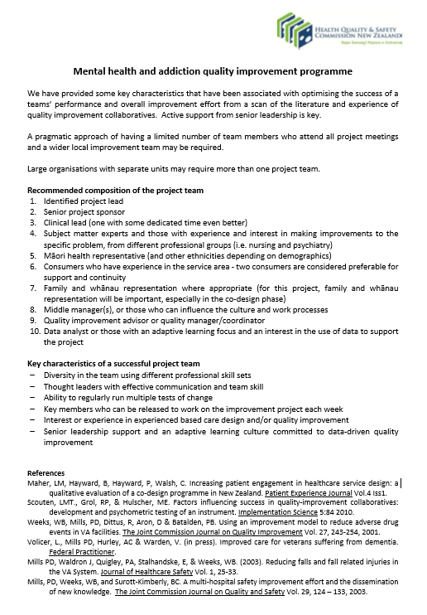

# Appendix 2: Project self-assessment scale | Āpitihanga 2: He tauine aromatawai ā-whaiaro

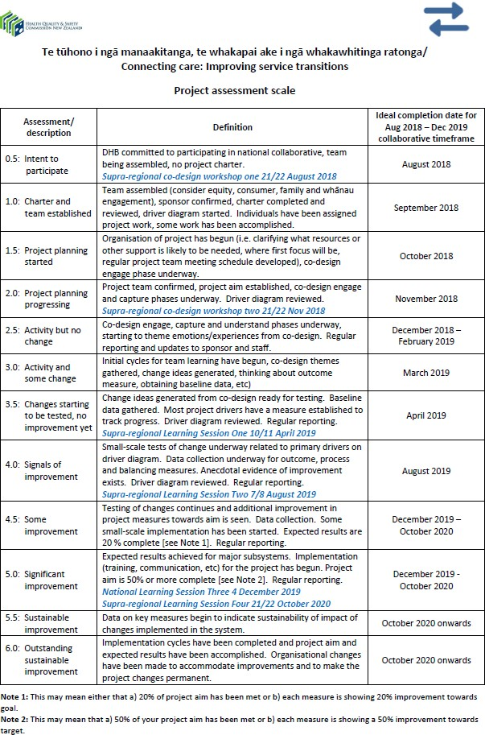

# Appendix 3: Seven-day follow-up[21] – acute inpatient post-discharge community care | Āpitihanga 3: He arowhai rā-whitu – te tauwhiro tūroro ki te hapori

Acute inpatient post-discharge community care, more commonly referred to as seven-day follow-up or KPI 19, measures the percentage of acute inpatient discharges that are followed up in the community within the seven days immediately following discharge. A responsive community support system for people who have experienced an acute psychiatric episode requiring hospitalisation is essential to maintain clinical and functional stability and to minimise the need for hospital readmission. Service users leaving hospital after a psychiatric admission with a formal discharge plan, involving links with community services and supports, are less likely to need early readmission. Research indicates that service users are more vulnerable immediately following discharge, including by being at a higher risk for suicide.

### Data source

PRIMHD

### Description

Percentage of overnight discharges from the mental health and addiction service organisation’s inpatient unit(s) where a community service contact was recorded in the seven days immediately following that discharge.

**This key performance indicator (KPI) calculates an overall follow-up rate, which is the percentage of all acute inpatient discharges that were followed up, regardless of where that follow-up occurred (DHB, NGO or both).**

### Indicator rationale

A responsive community support system for people who have experienced an acute psychiatric episode requiring hospitalisation is essential to maintain clinical and functional stability and to minimise the need for hospital readmission.

Service users leaving hospital after a psychiatric admission with a formal discharge plan, involving links with community services and supports, are less likely to need early readmission. Research indicates that service users are more vulnerable immediately following discharge, including by being at a higher risk for suicide.

### Denominator

Count of **acute inpatient discharges**

### Numerator

Count of **acute inpatient discharges** where a follow-up community contact (for the same person) exists and where:

Community follow-up activity start date is between one and seven days after acute inpatient discharge date:

* ActivityStartDate >= dateadd(1, day, InpatientDischargeDate)
* ActivityStartDate < dateadd(8, day, InpatientDischargeDate).

Note: As of November 2020 terminology has changed from ReferralClosureDate to InpatientDischargeDate to eliminate confusion.

### Technical notes

This denominator is shared with the other members of the acute inpatient KPI suite: 28-day readmission, length of stay, and pre-admission community contact.

### General terminology

An **acute inpatient discharge** is any referral record where:

1. ReferralEndDate is not null — ended referral
2. TeamType is Inpatient — into an inpatient team
3. ReferralEndCode is DR, DW or DT — ended in a way where we expect follow-up
4. ReferralTo is not PI, AE or NP — was not moving on to another hospital setting
5. Exists at least one activity where — there was at least one acute inpatient bednight
   1. ActivityTypeCode is T02 or T03 — acute inpatient bednight codes
   2. ActivityUnitCount > 0 — for more than 0 days

An **inpatient discharge date** is calculated as the:

1. Maximum ActivityEndDate for a referral record where: — end of last activity
   1. ActivityType is T02, T03, T04 or T37 — inpatient activity only

A **community contact** is any activity record where:

1. TeamType is not Inpatient — not inpatient follow up
2. ActivityUnitType is contact — not a bednight, seclusion or leave
3. ActivitySetting is not WR, OM or SM — includes service user participation
4. ActivityType is not T08, T35 or T32 — includes service user participation

Published July 2022 by the Health Quality & Safety Commission New Zealand. Available online at [www.hqsc.govt.nz](http://www.hqsc.govt.nz) | Enquiries to: [info@hqsc.govt.nz](mailto:info@hqsc.govt.nz)

This work is licensed under the Creative Commons Attribution 4.0   
International License. To view a copy, visit:   
<https://creativecommons.org/licenses/by-nc-sa/4.0/>

1. This project was undertaken and the report primarily written before the Pae Ora (Healthy Futures) Act 2022 came into force. As such, we refer to DHBs throughout for ease and consistency of reporting.
2. From DHB adult inpatient specialist services to DHB adult community services; from DHB community services to primary care; from DHB youth community services to DHB adult community services.
3. This excludes Wairarapa DHB, which does not have a mental health inpatient service, as well as Hawke’s Bay, Taranaki, MidCentral and Nelson Marlborough DHBs, all of which have ‘mixed’ units.
4. The MHA quality improvement programme’s Māori Advisory Group developed the Treaty of Waitangi Equity Framework in 2019. It supports project teams’ use of the bicultural approach integrating holistic Māori and Western expertise and technologies and quality improvement methodology in co-designing service improvements for all consumers, families and whānau.
5. Office of the Auditor-General. 2017. *Mental Health: Effectiveness of the planning to discharge people from hospital*. Wellington: Office of the Auditor-General. P 3. URL: [www.oag.govt.nz/2017/mental-health/docs/mental-health.pdf](http://www.oag.govt.nz/2017/mental-health/docs/mental-health.pdf) (accessed 15 February 2022).
6. This is the percentage of the population that had met the diagnostic criteria for a mental disorder at some time in their life, in 2005.
7. Ministry of Health. 2016. *Office of the Director of Mental Health Annual Report 2015*. Wellington: Ministry of Health.
8. It is not clear whether the reason for the increase in access is an increase in the prevalence of mental illness. Rather, it is likely due to a range of factors including better data capture, increased awareness of mental illness and greater willingness to seek help and support, and improved visibility of and access to available services.
9. New Zealand Government. 2018. *He Ara Oranga: Report of the Government Inquiry into Mental Health and Addiction.* Wellington: New Zealand Government. URL: <https://mentalhealth.inquiry.govt.nz/inquiry-report/he-ara-oranga>.
10. New Zealand Mental Health and Wellbeing Commission. 2022. *Te Huringa: Change and Transformation. Mental Health Service and Addiction Service Monitoring Report 2022.* P 11. Wellington: Mental Health and Wellbeing Commission. URL: [www.mhwc.govt.nz/assets/Te-Huringa/FINAL-MHWC-Te-Huringa-Service-Monitoring-Report.pdf](http://www.mhwc.govt.nz/assets/Te-Huringa/FINAL-MHWC-Te-Huringa-Service-Monitoring-Report.pdf).
11. Langley GJ, Moen RD, Nolan KM, et al. 2009. *The Improvement Guide: A Practical Approach to Enhancing Organizational Performance* (2nd ed). San Francisco: Jossey-Bass. (Chapter 5: Using the model for improvement, pp 89–108).
12. Provost L, Bennett B. 2015. What’s your theory? Driver diagram serves as tool for building and testing theories for improvement*. Quality Progress* July: 36–43.
13. Acute inpatient post-discharge community care, more commonly referred to as seven-day follow-up or KPI 19, measures the percentage of acute inpatient discharges that are followed up in the community within the seven days immediately following discharge. A responsive community support system for people who have experienced an acute psychiatric episode requiring hospitalisation is essential to maintain clinical and functional stability and to minimise the need for hospital readmission. Service users leaving hospital after a psychiatric admission with a formal discharge plan, involving links with community services and supports, are less likely to need early readmission. Research indicates that service users are more vulnerable immediately following discharge, including by being at a higher risk for suicide (KPI Programme: <https://www.mhakpi.health.nz/indicators/>).
14. Health Quality & Safety Commission. 2020. *Summary Report for the Mid-programme Evaluation of   
    the Mental Health and Addiction Quality Improvement Programme*. Wellington: Francis Health &   
    Kahui Consulting.
15. The Programme for the Integration of Mental Health Data (PRIMHD) database is a single collection of national mental health and addiction services information, administered by the Ministry of Health, and includes service activity and outcomes data. [www.health.govt.nz/nz-health-statistics/national-collections-and-surveys/collections/primhd-mental-health-data](http://www.health.govt.nz/nz-health-statistics/national-collections-and-surveys/collections/primhd-mental-health-data).
16. The transitions are: 1. from DHB adult inpatient specialist services to DHB adult community services;  
    2. from DHB community services to primary care; and 3. from DHB youth community services to DHB adult community services.
17. This excludes Wairarapa DHB, which does not have a mental health inpatient service, as well as Hawke’s Bay, Taranaki, MidCentral and Nelson Marlborough DHBs, all of which have ‘mixed’ units.
18. A run chart is a graphic representation of data over time, also known as a ‘time series graph’ or ‘line graph’. This type of data display is particularly well suited to process improvement activities.
19. Read the full news story about He Hohonga Kōrero | the Conversation Café at [www.hqsc.govt.nz/news/he-hohonga-korero-the-conversation-cafe/](http://www.hqsc.govt.nz/news/he-hohonga-korero-the-conversation-cafe/)
20. Te whakanui ake i te hauora ā-tinana | Maximising physical health and Te whakapai ake i te whakahaere rongoā, i te tūtohu rongoā hoki | Improving medication management and prescribing.
21. This appendix is adapted from the KPI Programme’s website: [www.mhakpi.health.nz/indicators](http://www.mhakpi.health.nz/indicators)