Model for Improvement
The Model for Improvement is a simple yet powerful tool for accelerating improvement, which has two parts:
three fundamental questions, which can be addressed in any order
the plan–do–study–act (PDSA) cycle to test and implement changes. The PDSA cycle guides the test of a change to determine if the change is an improvement.
Setting an aim: To achieve improvement, project teams first need to set an aim. The aim should be time-specific and measurable. It should also define the specific population of tāngata whaiora that will be affected.
Establishing measures: Project teams use quantitative measures to determine if a specific change leads to an improvement.
Choosing changes: All improvement requires making changes, but not all changes result in improvement. For this reason, organisations must identify the changes that are most likely to result in improvement.
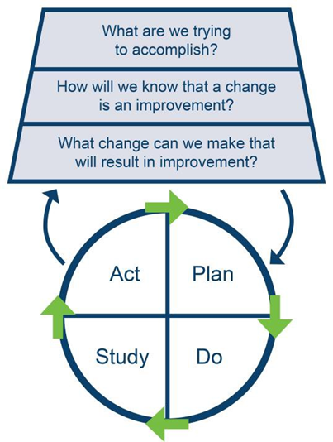
Testing changes: The PDSA cycle is shorthand for testing a change in the real work setting – by planning it, trying it, observing the results and acting on what you learn. This is the scientific method used for action-oriented learning.

Developed by Associates in Process Improvement based in the USA (www.apiweb.org).

