Zoom procedures and etiquette for online learning sessions

The Health Quality & Safety Commission’s mental health and addiction (MHA) quality improvement programme uses Zoom to deliver online learning sessions. This document provides useful information for session participants about how to use the platform, and the features which will be used during the session.

Key points
- Familiarise yourself with the Zoom web-based video conferencing tool prior to the meeting.
- Test your video and audio settings prior to the meeting.
- Join the meeting on time and be ready to begin.
- Keep your microphone muted when you are not speaking.
- Edit your display name to show your name and organisation as you join.

Registering and attending a learning event on Zoom
- You will receive an email with a link inviting you to register for the MHA quality improvement programme event on Lil Regie, our event registration website.
- Click the link and fill in the form to register. You will automatically be sent a confirmation email containing the event link and password.
- For certain events, you may see multiple links for different regions. Please check that you are joining the right event.
- If there is someone else you think should attend who has not been invited, please email mentalhealthaddiction@hqsc.govt.nz.

Joining the learning event
- Click the link you received in the confirmation email and enter the password if prompted.
- You can join the event earlier if you want to check your connection, audio and video. The event host will arrive at least 10 minutes ahead of the scheduled start time.
- If you haven’t joined a Zoom meeting before, you will be prompted to run the software; follow the instructions on screen. Once the software is ready, you will be able to access the meeting and see the event host who will have their camera and microphone on.
- Your microphone and video will be turned off automatically when you join.
- You can control your camera and microphone throughout, but we ask you to keep your microphone muted unless you are speaking, to reduce noise and interruptions during presentations.
- Display your name and organisation by renaming yourself in Zoom. Click ‘participants’ on the menu bar at the bottom of the screen, hover over your name and click ‘rename’.

Controlling your screen and who you can see
- The various screen layouts in Zoom take some getting used to, but they are flexible and will allow you to view the speaker and the presentation at the same time.
- Click here for Zoom’s guide to screen layout options.

Chat function
- The ‘chat’ function will be available throughout the event.
- Click on ‘chat’ at the bottom of the screen to open the chat window.
- Using the drop-down arrow, select who you want to chat with. You can choose ‘everyone’ or a specific person.
- Type in your comment or question.
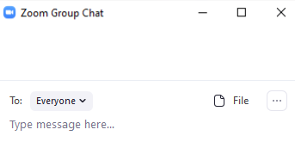
Choose recipient(s) here.

Asking a written question
- You can ask a question at any time during the event.
- The event administrator will gather all questions during the session and give them to the presenter to answer at the end of the session.
- To ask a question, open chat, write ‘QUESTION’ followed by your question.
- If you don’t add ‘QUESTION’ first, it might get lost among the other chat and not get answered.

Asking an oral question
- At the end of each presentation, the presenter or event host will invite questions from the audience.
- Indicate you want to ask a question by ‘raising your (virtual) hand’. Click on the ‘participants’ button, then click ‘raise hand’.

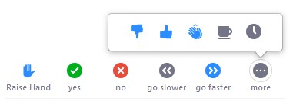
- The host and presenter can now see your raised hand. The host/presenter will call on you (not necessarily immediately) to unmute your microphone and ask your question.
- To avoid interruptions, presenters will not take questions while they are speaking.

Breakout rooms
- We may use breakout rooms during the event for smaller group discussion.
- You will be assigned to a breakout group/room by the host when required.
- An option to join your breakout room will appear on screen. Click ‘join’. You will be transferred to the breakout room, which feels like a smaller Zoom meeting.
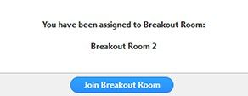

- The host can move between rooms, so they may visit during your discussion. You can also call the host to your room by clicking the question mark in the meeting controls at the bottom of the screen.
- When the time is up, the host will call you back to the main event room. A message will pop up asking you to return (you will be automatically returned after 60 seconds if you do not click to re-join).
- You can leave the breakout room and return to the main meeting at any time.

Polling
- Polling may be used to get feedback during the event.
- The host will announce pre-arranged polls; when polling starts, a window will appear on your screen; click the answer you wish to give.
- Other polls will be taken as needed. Respond to these using the ‘yes’ and ‘no’ buttons in the ‘participants’ panel.

Leaving the event
- You can leave the event at any time by clicking the red ‘leave meeting’ button at the bottom right of your screen.
- If you need to step away from the meeting for a short time, you can remain connected and leave your computer, then come back when you are ready.

Rejoining the event
- You can re-join the event at any time by clicking the link in your email invitation.

Recordings and photos
- The event will not be recorded.
- Photographs may be taken. If you do not wish to have your photograph taken please let the event administrator know.

Help during the meeting
- Please familiarise yourself with Zoom before the event and to try to solve any problems yourself.
- If you need help, use the chat function and type HELP before your query.
- If there are lots of people asking questions, it may take a little while for us to get to you.
- If you cannot join the event at all, email us at mentalhealthaddiction@hqsc.govt.nz.

