National Mortality Review Committee
data access policy and application guide | Kaupapa here tiki raraunga o te
Komiti Arotake Matenga ā-Motu
me te aratohu mamahi

Accessing National Mortality Review Committee data or information for research purposes | Te tiki atu i te rauranga o te Komiti Arotake Matenga ā-Motu hei take rangahau

February 2024 | Huitanguru 2024

Contents
Foreword | Kōrero takamua 2
Definitions of terms used 4
Introduction | He kupu whakataki 5
Policy scope 5
Background to policy 5
Section 1: Legislation | Wāhanga 1: Te ture 7
Powers 7
Responsibilities 7
Governance of Māori data 8
Section 2: Access to and analysis and publication of NMRC data and information | Wāhanga 2: Te tiki atu, te tātari rauranga hoki me te mōhiohio a te NMRC 11
Demonstrate a safe process 11
Application procedure 13
Agents of the NMRC 15
Timing of access 16
Using the data and information 16
Disseminating results 17
Destroying the data and information 17
The importance of supervision and support | He mea nui te arataki me te tautoko 18

Published in February 2024 by Te Tāhū Hauora Health Quality & Safety Commission, PO Box 25496, Te Whanganui-a-Tara Wellington, 6146.
ISBN 978-1-991122-04-9 (online)
Available online at www.hqsc.govt.nz
Enquiries to: info@hqsc.govt.nz
This work is licensed under the Creative Commons AttributionNonCommercial-ShareAlike 4.0 International
(CC BY-NC-SA 4.0). To view a copy of this licence, visit creativecommons.org/licenses/by-nc-sa/4.0

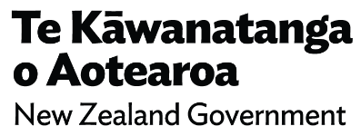

Foreword | Kōrero takamua
Any information – data, stories, the tears shed by whānau – about the lives of people who have died prematurely is about knowing that these people have passed too soon. Their lives, their potential and the generations that may have borne their whakapapa have been foreshortened. In mortality review, we are charged with looking back to understand what was going on for those who died. Guiding this work is the hope that we – the communities and systems that support people’s lives – can be at our most helpful and supportive and that we do better in the future.
Mortality review must start with a love and respect for the dignity and humanity of all people. This will mean illuminating the way that current systems continue to provide benefit for some and unfairly disadvantage others, contributing to the entrenched inequities we see across preventable mortality.,,
This policy document sets the kaitiaki role of Te Tāhū Hauora Health Quality & Safety Commission (Te Tāhū Hauora) for mortality data and information as collected for the purposes of mortality review.
The document describes the processes for accessing data held by Te Tāhū Hauora on behalf of the National Mortality Review Committee (NMRC) for the purposes of research. The scope of work defined under the term ‘research’ is that which requires access to personally identifiable data and information collected for the purposes of mortality review. External researchers are those who are external to the national mortality review function or those who are undertaking work that extends beyond the scope of their current agent status (see Section 2).
Where stakeholders are seeking access to NMRC data or information solely for the purpose of audit or monitoring, we suggest they contact the source agency to obtain information. For example, a count (or case-identifying information) of SUV roll-over fatalities can be obtained from the Manatū Hauora Ministry of Health collection of mortality data. Usual resident area for specific types of fatalities can be obtained from the Department of Internal Affairs.
It is important to read this document alongside Te Pou – Māori responsiveness rubric and guidelines and He Puna Whakatau, the NMRC’s decision-making tool (see Figure 1). These documents provide the context within which the NMRC collects, analyses and reports on data, and the parameters under which topic areas are considered of interest.

Definitions of terms used
Agent: All people who interact with Schedule 5 of the Act (personally identifiable information) in the context of mortality review must be appointed agents of the NMRC. Agent status is assigned for a specific purpose and for a defined time period.
Data: Detail captured about an individual. Note that most data captured by the national mortality review function is collated through interaction with government agencies and may include the product of data-sharing agreements between agencies. As such, their level of accuracy depends on the robustness of the data-collection processes of those agencies. Users should be aware that such data may not have been collected for the purposes for which they are now being used (ie, data collected for the purposes of service delivery now being used for the purposes of research or mortality review).
Information: Knowledge communicated concerning some particular fact, subject or event.
Strengths-based analysis: Strengths-based approaches support the generation of research findings that are focused on strengths to reward and reinforce positive change, without altering statistical rigour.
National Mortality Review Committee (NMRC): Appointed under Section 82 of the Pae Ora (Healthy Futures) Act 2022 (the Act), the NMRC is the statutory committee appointed by Te Tāhū Hauora to review and report to Te Tāhū Hauora on specified classes of deaths in Aotearoa New Zealand. The NMRC advises Te Tāhū Hauora on matters related to mortality and morbidity, quality assurance and ongoing quality improvement programmes.
Under Schedule 5 of the Act, a mortality review committee has statutory power to require that information is provided to it. Te Tāhū Hauora provides or arranges the provision of the architecture that supports the holding, management of and access to the various data sets that relate to the work of the NMRC.
National mortality review function: The national mortality review function is a collaborative environment supported through Te Tāhū Hauora. The function is composed of the national mortality review function management group, the NMRC, subject matter experts, local review groups and local and national agents of the NMRC.
National mortality review function management group: The primary purpose of the national mortality review function management group is to deliver the NMRC’s strategic vision and values. The management group is the ‘engine room’ of the national mortality review function. Staff within the management group coordinate and support local review groups, oversee data collection and audit data quality, provide policy advice, follow up on recommendations and develop national mortality review function products.

Introduction | He kupu whakataki
This document outlines the legislative context within which data is collected by the national mortality review function (the function) on behalf of the National Mortality Review Committee (NMRC) and provides guidance for researchers seeking access to that data. Researchers should carefully review this document when considering research on premature mortality or serious morbidity for the purposes of prevention, intervention, policy directives or local quality improvement activity.
As part of its process, the NMRC collects information related to deaths from a variety of sources in accordance with the Pae Ora (Healthy Futures) Act 2022 (the Act). This information is stored on databases funded by Te Tāhū Hauora Health Quality & Safety Commission (Te Tāhū Hauora). The NMRC encourages the use of and provides access to mortality data for research that meets the criteria outlined within this policy. Data access applications should be limited to data considered most useful for the purposes of answering a well-specified research question. Access applications should also consider Te Tiriti o Waitangi, Māori health advancement and Māori data governance and equity imperatives, as set out in the ‘Governance of Māori data’ section.
To determine whether information held by the NMRC will be suitable for the proposed research, first please contact the national mortality review function management group at: nmrmg@hqsc.govt.nz. Researchers should initiate this contact early in the process to determine the most appropriate data sets and fields to request.

Policy scope
- Section 1 provides the context of the NMRC and the legislation under which it operates.
- Section 2 explains the process for seeking access to information and data held by Te Tāhū Hauora on behalf of the NMRC.

Background to policy
In 2011, Te Tāhū Hauora assumed responsibility for four statutory mortality review committees under Section 59E of the amended New Zealand Public Health and Disability Act 2000. The mortality review committees reviewed and reported to Te Tāhū Hauora on particular types of deaths, with a view to reducing the number of deaths.
Following a review of the committee structure and the introduction of the Pae Ora Act, one national mortality review committee was established in July 2023 to advise on:
- strategic oversight of mortality review and system-level impact
- Te Tiriti compliance across all aspects of mortality review
- areas of focus for potential in-depth reviews, analysis or surveillance
- data governance, including Māori data governance
- additional expertise required for mortality review working groups (subject matter experts)
- making recommendations clear, coordinated and impactful.
These functions are supported by the national mortality review function management group (the management group) and are expected to be undertaken within the resources allocated by Te Tāhū Hauora. As a result, there will be areas of mortality review that are not addressed within the work undertaken by the function. Therefore, the NMRC welcomes expressions of interest for research to be undertaken using the data and information made available through the NMRC legislation (see Section 1).
With the introduction of the NMRC, He Puna Whakatau (Figure 1) was developed to support decision-making about resource allocation and the assessment of focus areas for the function’s work. Within the Prioritisation section of the application form, the headings and questions relate to the descriptions provided in He Puna Whakatau. Researchers are encouraged to use this to support applications to access NMRC data and information.

Section 1: Legislation | Wāhanga 1: Te ture

Powers
Accessing NMRC data and information for research purposes requires an understanding of the legislative framework within which the NMRC operates.
Section 82 of the Act gives Te Tāhū Hauora (referred to as HQSC in the Act) the authority to:
(1) appoint 1 or more committees to perform any of the following functions that HQSC specifies by notice to the committee:
- to review and report to HQSC on specified classes of deaths of persons, or deaths of persons of specified classes, with a view to reducing the numbers of deaths of those classes or persons, and to continuous quality improvement through the promotion of ongoing quality assurance programmes
- to advise on any other matters related to mortality that HQSC specifies in the notice.
Under the provisions that apply to mortality review committees (Schedule 5 of the Act), the committees have unique legislative powers that enable them to obtain personally identifiable information to provide Te Tāhū Hauora with the best possible advice. These legislative powers remove barriers to collecting and using identifiable, private or confidential information in mortality review and ensures the ongoing protection and privacy of the information stored. The committee can appoint ‘agents’ who then are also bound by this legislation.
Schedule 5 prevails over the principles in the Privacy Act 2020. The Official Information Act 1982 cannot be used to access the NMRC data collections.

Responsibilities
Schedule 5 of the Act provides the committee(s) and appointed agents with specific powers and responsibilities for the information gathered, and these responsibilities are reinforced and strengthened by penalties under Section 82(6). Every researcher applying to use NMRC data must be aware that there are established policies and processes around the appointment of committee agents that are carefully observed and followed.
Schedule 5 of the Act also provides clear rules that govern how information is requested, produced, disclosed and recorded.
The guiding powers and responsibilities that apply to members of the NMRC and their agents are as follows:
- NMRC members, executive officers and agents have a personal obligation to maintain the security of any information that became known to that person only because of the NMRC's functions being carried out. Under Section 82(6), any person that discloses information contrary to Schedule 5 commits an offence and is liable for a fine of up to $10,000; and
- if they are a member of a registered occupational profession, they are liable to disciplinary proceedings of that profession.

Governance of Māori data
Governance and sovereignty of Māori data and information are central to the use and analysis of NMRC data and information because of persistent and significant inequities that remain in the health status between Māori and other Aotearoa New Zealand populations and in mortality outcomes. These inequities are the consequence of colonisation, unequal access to services and differences in the quality of care Māori receive compared with other groups., These health inequities are a breach of Te Tiriti o Waitangi and are avoidable, unethical and unjust.
Māori data sovereignty recognises that Māori data and information should be subject to Māori governance. Decisions about governance and access to data and information for secondary purposes should be consistent with the Māori data governance pou, developed by Te Kāhui Raraunga. While these principles were developed for Māori data, their application to all health data is also recommended and reflects good practice.
Māori data refers broadly to digital or digitisable data, information or knowledge (including mātauranga Māori) that is about, from or connected to Māori. It includes data about population, place, culture and environment.
Māori data sovereignty: The inherent rights and interests that Māori have in relation to the collection, ownership and application of Māori data.
Māori data governance: The principles, structures, accountability mechanisms, legal instruments and policies through which Māori exercise control over Māori data.
As outlined in the Health Sector Principles (applicable to the Minister of Health, Manatū Hauora and all health entities, including Te Tāhū Hauora), the NMRC is committed to working with data and information in a way that supports Māori to achieve Māori aspirations. The function uses two key documents to guide this work:
- Te Pou
- Te Kāhui Raraunga Māori Data Governance Model
Ngā Pou Arawhenua (the Māori Caucus of the previous five mortality review committees) produced Te Pou. Te Pou provides the NMRC, the management group and agents thereof with a tool to assist with the interpretation and reporting of Māori mortality data and information and to strengthen Māori perspectives in mortality review committee reporting.
The function further draws on the guidance of Te Mana Raraunga when describing Māori data and information, Māori data sovereignty and Māori data governance. In doing so, the function recognises Māori rights and interests in data to be protected and for the potential for stigmatising and discriminatory reporting through the use of the data and information. The use of Te Pou allows the function to actively manage this potential.
All research in Aotearoa New Zealand is of interest to Māori: all research may produce benefits for Māori and has the potential to support Māori to achieve their aspirations but may also present risks of harm. Therefore, all researchers in Aotearoa New Zealand must consider the degree to which they can contribute to improving Māori health outcomes.

Figure 1: He Puna Whakatau
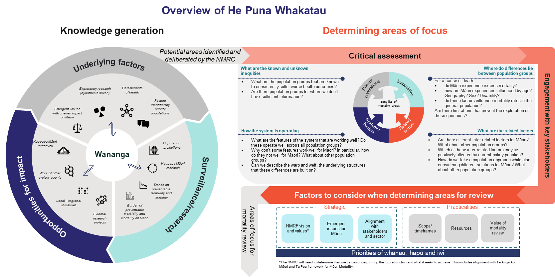

Section 2: Access to and analysis and publication of NMRC data and information | Wāhanga 2: Te tiki atu, te tātari rauranga hoki me te mōhiohio a te NMRC
Data and information may only be released to researchers for the purposes of the NMRC’s functions, as briefly described in Section 1. Further, research results that include that data cannot be published without the consent of the committee, who will check that any release is consistent with its purpose. He Puna Whakatau supports decision-making about resource allocation for the mortality review work programme within a defined budget. To access NMRC data and information, researchers should describe how their proposed project aligns with the parameters described within He Puna Whakatau (see Figure 1).

Demonstrate a safe process
The following procedures describe the minimum standards expected to be able to work with NMRC data and information. These procedures are closely aligned with the Stats NZ ‘Five Safes’ framework: safe people, safe projects, safe settings, safe data and safe output.

Safe and responsible people
Individual research teams (or individuals) must have the skills required to analyse the data requested as determined by the management group. Research teams must identify at least one member who has these skills.
Research teams must also include experience in the area of interest and an understanding of reporting for equity (see, for example, Dyck et al 2018). If these skills are divided among research team members, the contribution of each member must be clearly specified.
Researchers may only seek access to data and information that is directly relevant to the study for which they have approval. All researchers must become agents of the NMRC (see the section ‘Agents of the NMRC’).

Safe projects
Any research proposal must be aligned with the functions of the NMRC. Researchers must clearly describe how the proposed research fits within He Puna Whakatau.
The NMRC advises Te Tāhū Hauora on how to reduce premature mortality and morbidity, the development of quality improvement programmes and matters related to mortality that Te Tāhū Hauora specifies. The NMRC must also develop plans and methodologies to reduce mortality and morbidity. Access to any of the NMRC data and information will be considered on the basis of whether the specified research project aligns with the committee's functions as defined by the Act and the NMRC’s terms of reference.
The management group will not consider projects whose primary purpose is to stigmatise or discriminate against a population group.

Safe settings
Researchers must provide details of the physical and electronic environments in which they will be working, to ensure they will comply with the stringent legal requirements set out in the Act and the proposed research agreement.
Any data or information acquired from the NMRC must be stored in a safe, secure location, and detail about this must be provided in the application form. The researcher and the management group will agree on the safe storage requirements during the project.
There should be no physical copies of the data or information provided by the NMRC, only electronic copies. NMRC data must be analysed in a safe and secure room where the screen cannot be viewed by a non-agent. Electronic files must be securely stored in a password-protected folder on an organisation’s server, not on a laptop. All computers must be password protected.
Upon completion of the research project, data and information provided by the NMRC must be destroyed. In the event that analysis is required to be re-run in the future, the management group can reproduce the data request.

Safe data
The amount of personally identifiable data or information provided will be the minimum amount possible to undertake the research project. Where possible, unique identifiers will be used in preference to personal identifiers (such as name).
Only the fields that are required to undertake the investigation will be supplied. Please carefully consider the data and information required for the investigation and discuss this with management group staff. Exploratory analysis (fishing) is not permitted. Investigators are encouraged to have well-defined research questions to guide data requests.

Safe outputs
To maintain the security of the information provided, all outputs must be approved by the management group before they are presented outside the research team of approved agents or published by any external parties (non-agents). This includes abstracts for conference presentations, presentations themselves and any draft documents before being peer reviewed, submitted for publication or reviewed by any non-agent. Any changes requested by the NMRC or management group to reduce the identifiability of people in the data set must be made and approved before release.
Results and conclusions from research must be framed in a way that is ethically sound, is strengths-based and provides a culturally safe and appropriate interpretation. Researchers are encouraged to refer to Te Pou to ensure that presentation of the information will do no further harm.
The approval process for release of results/findings will be limited to ensuring the confidentiality of the information being made available for external release, statements of fact and alignment with Te Pou. All cells where the value is less than 5 must be suppressed. Researchers are referred to Statistics New Zealand’s Microdata output guide for guidance on suppressing low cell values. Researchers are responsible for ensuring the accuracy of facts.
Each year, upon renewal of agent status, researchers must update the management group to ensure the work stays within the agreed parameters of the proposed project and will receive the NMRC’s approval for publication.

Application procedure
Accessing data or information for research purposes entails several steps (see Figure 2 for a summary). When planning their study, researchers need to be aware that the process from first making a data application to receiving approval may take several months.
Figure 2: Summary of application process
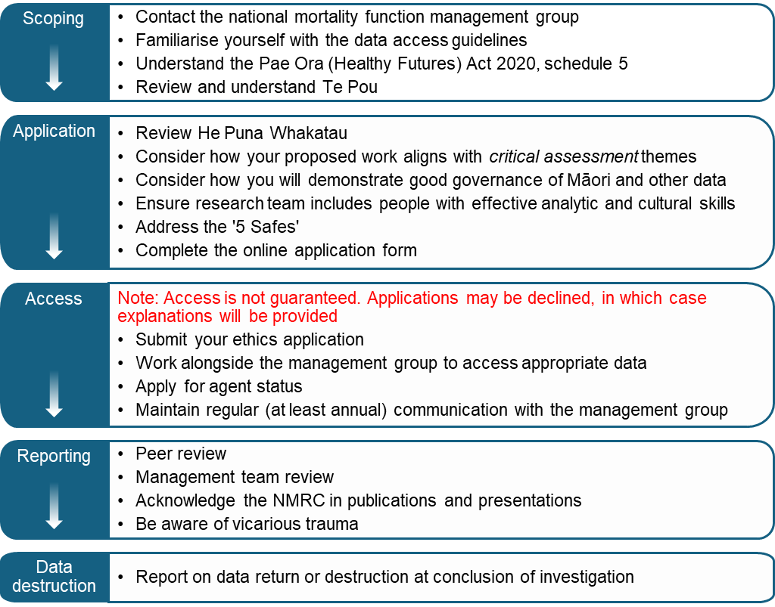
To seek approval to access NMRC data and information, the researcher must complete the associated data access application form.
The management group will:
- consider the research application in accordance with this policy
- review how the application aligns with the safe processes described in the section ‘Demonstrate a safe process’, He Puna Whakatau and Te Pou
- give fair and impartial consideration to all applications and consider the advice of independent referees as nominated by the research team
- make enquiries, when necessary, to help avoid duplication of the work of other researchers in the same field
- consider the scientific interest and public health importance of the proposed study, its methodology and the likelihood of beneficial outcomes and risk of exacerbating existing inequities
- consider how the proposed study, methodology and likely beneficial outcomes support Te Tiriti o Waitangi, Māori health advancement and equitable outcomes for all populations
- carefully evaluate the proposal to ensure that studies conducted using NMRC data and information are well designed
- ascertain the degree to which the proposal adheres to the Māori data governance pou (please see ‘Governance of Māori data’)
- request further information if necessary
- make a recommendation to the NMRC, who hold the authority to approve or deny access to NMRC data and information.
If the application is approved, the management group will work with the researchers to identify the parameters of the dataset, including relevant fields, years of interest and filters on the data. A clear specification of the data set parameters will allow the data set to be reproduced in future, if required.
Researchers should then seek the appropriate ethics approval. Once this is obtained, the NMRC data and information will be released. Applications will be declined if there are concerns over ethics, confidentiality or cultural (or other) safety.
At this second step, the management group will send a letter of agreement to the research team. This letter will include the:
- specific data/fields required
- date of data provision
- means of data transmission
- expiry date of data availability and agent status.
The NMRC chair and lead researcher will co-sign the letter of agreement, which will be held by the management group and, where relevant, the New Zealand Mortality Review Data Group.
Data and information released by the NMRC to a researcher remains under the guardianship of the NMRC, and researchers must comply with all conditions specified by the NMRC.
Any publications arising from the data or information provided must be approved by the management group before being presented or submitted and include acknowledgement of the NMRC and Te Tāhū Hauora.

Costs and funding
- The research must be cost neutral to the NMRC. Any costs related to data extraction and required advice must be met by the researcher.
- If external funding is supporting the research, the limits of use of the data and information must be made clear to funders.

Conflicts of interest
- Any conflicts of interest must be actively managed.
  - Researchers should consider and notify the mortality review committee of any actual or potential conflict of interest that arises following access to the data and information or the conduct of the research.
  - Researcher should advise how any conflict of interest (actual or perceived) will be managed, and this must be approved by the management group.

Agents of the NMRC
Data and information may become identifiable when sufficient detail is disclosed that the researcher could determine the identity of the deceased and/or associated family or whānau. To ensure a safe process, researchers requesting both personally identifiable and non-identifiable data and information must become agents of the NMRC.
Once the NMRC approves the research application, each member of the research team will be sent a link to the online Mortality Review Agent Management System (MRAMS), through which they must apply to be an agent of the NMRC. MRAMS is managed by the New Zealand Mortality Review Data Group at Te Whare Wānanga o Otāgo | University of Otago. It outlines agents’ obligations and requires the researcher to fully understand and accept responsibility for the personal liability they will carry as an agent.
Researchers must comply with the responsibilities that the Act imposes on agents of the NMRC. All agents carry individual liability for a penalty of up to $10,000 for any dissemination of data or information contrary to Schedule 5 of the Act.
A list of NMRC agents is publicly recorded on MRAMS.
Ownership and responsibility for the policies and procedures regarding agent status, level of data access and the guardianship of the data and information itself rests with the function.
Researchers may not, under any circumstances, request additional information on behalf of the NMRC.

Validity of agent status
Researchers will only be granted agent status for the period of the project for which the data and information requested is used, to a maximum of 1 year.
If the researchers have not completed their research within this time or continue to use the outputs of the research for presentation or publication, they will need to apply for an extension to their agent status and submit a progress report.
Failure to extend agent status would place the research team in breach of Section 82(5) of the Act, at which point they would be committing an offence and would each individually be liable for a penalty of up to $10,000.

Timing of access
Data and information will be provided only for the time period agreed to between the researcher and the NMRC.

Extensions
Any request for an extension of the timeframe must be made before the completion of the initial time period. Please refer to the ‘Validity of agent status’ section for the penalties for failure to extend.
The researcher is responsible for ensuring that funding and organisational arrangements are adequate for the completion of the research.

Using the data and information
The manner in which the data or information is shared between the management group and the researcher will be agreed by the researcher and the management group before the data or information is released.
Data and information is provided solely for, and must only be used for, the purposes outlined in the data access application and must not be used for any other purpose.
The data or information is not to be copied or forwarded. Significant penalties for misuse of the data and information are clearly outlined in Section 82 of the Act.
Researchers must not release the NMRC data and information to other parties, including to journals who require a minimum data set to be submitted with papers. Where journal articles require a statement regarding access to data and information on which findings are based, researchers should direct inquiries to the management group.
We note that third-party data is considered an acceptable data access restriction, as is ‘data that the authors cannot legally distribute’, which would be the case for NMRC data. Where relevant, it is possible to submit a statement that describes the data set and the third-party source, verification of permission to use the data set and all necessary contact information that others would need to apply to gain access to the data. Authors should use management group contact information in this situation. For examples of data availability statements, see the author guidelines for PLOS journals, Taylor & Francis Group journals or the specific journal submission.

Disseminating results
Research teams are responsible for the reliability and validity of the research resulting from their analysis.

Peer review
Researchers must obtain consent from the management group before sharing or publishing any outputs. The management group will review the outputs to ensure no identifiable information is inadvertently released. If the management group does identify any concerns, the researcher will be required to further summarise or de-identify the output. The management group retains the right to refuse publication if other criteria are not met (eg, safety, ethics).
The management group encourages researchers to build in sufficient time to allow a representative of the NMRC to peer review publications. This review will check that interpretation of results follows the guidelines set out in Te Pou and will give the committee an opportunity to engage with the findings and potentially promote them when they are released.

Published data and information
Researchers are asked to confirm that they will acknowledge the assistance of the NMRC in manuscripts submitted for publication. However, the NMRC does not exercise any control over where researchers publish their results or require inclusion in author lists.
The NMRC requires a copy of published articles, abstracts presented at meetings and information about any other relevant presentations, publications or media interviews. This information is maintained only for record-keeping purposes, so may occur after the fact but should be before agent status ceases. For time-sensitive outputs such as media interviews, the management group appreciates being alerted that an interview is taking place in case Te Tāhū Hauora is approached for comment. For other outputs, a copy should be sent to Te Tāhū Hauora within a month of publication.

Destroying the data and information
On completion of the project, all data files, including backups, must be destroyed. Researchers must notify the management group in writing when and how this was done.

The importance of supervision and support | He mea nui te arataki me te tautoko
As highlighted in the foreword to this document, the data collated on behalf of the NMRC is about the lives of people who have died too soon. Reading these stories can have a substantial impact on those involved with mortality review.

Vicarious trauma
Saakvitne et al define vicarious trauma as the cumulative transformative effect, both positive and negative, on those working with survivors of traumatic life events. Recognising vicarious trauma allows an understanding that working with trauma survivors greatly affects helpers and that responses are required for both helpers and clients. Vicarious trauma is unavoidable and is the natural consequence of being human and connecting to and caring about people as we see the effects of trauma on their lives. According to Saakvitne et al, the single most important factor in the success or failure of trauma work relates to the attention paid to the experience and the needs of the helper.
It is inevitable that people involved with reviewing traumatic life events will develop an increased awareness of the reality and occurrence of traumatic events, and this makes those involved more aware of their vulnerability. Safety and security are threatened when people become aware of the frequency of traumas, often leading to feelings of loss of control and helplessness. Vicarious trauma can affect how people exposed to trauma relate to their families, friends and partners. They may also experience changes in esteem for themselves and for others.
Signs and symptoms of vicarious trauma
- Emotional numbing
- Social withdrawal
- Work-related nightmares
- Feelings of despair and hopelessness
- Loss of sense of spirituality
- More negative view of the world
- Reduced sense of respect for your clients
- Loss of enjoyment of sexual activity
- No time or energy for yourself
- Feeling that you can't discuss work with family or friends
- Finding that you talk about work all the time (can't escape)
- Sense of disconnection from your loved ones
- Increased sense of danger (reduced sense of safety)
- Increased fear for safety of children or loved ones
- Sense of cynicism or pessimism
- Increased illness or fatigue
- Increased absenteeism
- Greater problems with boundaries
- Difficulties making decisions
- Reduced productivity
- Reduced motivation for your work
- Loss of sense of control over your work and your life
- Lowered self-esteem and/or sense of competence in your work
- Difficulties trusting others
- Lessened interest in spending time alone
- Less time spent reflecting on your experiences.

Within Te Tāhū Hauora, professional supervision and peer support is required for those involved with mortality review. While it is not possible to establish this as a requirement for the release of mortality data to external researchers, we strongly advise that consideration is given to making professional supervision available.

Ngā Pou Arawhenua, Child and Youth Mortality Review Committee, Suicide Mortality Review Committee. 2020. Te Mauri The Life Force I Rangatahi suicide report I Te pūrongo mō te mate whakamomori o te rangatahi. Wellington: Health Quality & Safety Commission. URL: www.hqsc.govt.nz/resources/resource-library/te-mauri-the-life-force-i-rangatahi-suicide-report-i-te-purongo-mo-te-mate-whakamomori-o-te-rangatahi.
Cormack D, Paine SJ. 2020. Dear Epidemiology: a letter from two Māori researchers. The Pantograph Punch. URL: pantograph-punch.com/posts/dear-epidemiology.
Te Tāhū Hauora Health Quality & Safety Commission. 2023. Terms of reference for the National Mortality Review Committee. Wellington: Te Tāhū Hauora. URL: www.hqsc.govt.nz/our-work/mortality-review-committees/national-mortality-review-committee/terms-of-reference.
Te Tāhū Hauora Health Quality & Safety Commission. 2023. National Mortality Review Committee. Wellington: Te Tāhū Hauora. URL: www.hqsc.govt.nz/our-work/mortality-review-committees/national-mortality-review-committee.
Te Tāhū Hauora Health Quality & Safety Commission. 2023. About the national mortality review function. Wellington: Te Tāhū Hauora. URL: www.hqsc.govt.nz/our-work/mortality-review-committees/about-the-national-mortality-review-function.
Health Quality & Safety Commission. 2019. Te Pou – Māori responsive rubric and guidelines. Wellington: Health Quality & Safety Commission. URL: www.hqsc.govt.nz/resources/resource-library/te-pou-maori-responsive-rubric-and-guidelines.
Thurber KA, Thandrayen J, Banks E, et al. 2020. Strengths-based approaches for quantitative data analysis: A case study using the Australian Longitudinal Study of Indigenous Children. Population Health 12:100637. DOI: 10.1016/j.ssmph.2020.100637.
At the time, the committees were: child and youth, perinatal and maternal, family violence and perioperative. In 2017, the Suicide Mortality Review Committee was established under a separate contract with Manatū Hauora.
Te Tāhū Hauora Health Quality & Safety Commission. 2023. Final Report: Review of the National Mortality Review Function. Wellington: Te Tāhū Hauora. URL: www.hqsc.govt.nz/assets/Our-work/Mortality-review-committee/Publications-resources/NMRF_Final-Report-March-2022.pdf.
Parliamentary Counsel Office | Te Tari Tohotohu Pāremata. Pae Ora (Healthy Futures) Act 2022. URL: www.legislation.govt.nz/act/public/2022/0030/latest/LMS575405.html.
Te Tāhū Hauora Health Quality & Safety Commission 2023, op. cit.
Section 82, Pae Ora (Healthy Futures) Act 2022.
Schedule 3(2), Pae Ora (Healthy Futures) Act 2022.
Schedule 5(4)-(6), Pae Ora (Healthy Futures) Act 2022.
Section 82(5)-(7), Pae Ora (Healthy Futures) Act 2022.
National Ethics Advisory Committee | Kāhui Matatika o te Motu. 2019. National Ethical Standards for Health and Disability Research and Quality Improvement. Wellington: National Ethics Advisory Committee. URL: neac.health.govt.nz/publications-and-resources/neac-publications/national-ethical-standards-for-health-and-disability-research-and-quality-improvement.
Crengle S, Davie G, Whitehead J, et al. 2022. Mortality outcomes and inequities experienced by rural Māori in Aotearoa New Zealand. The Lancet 28: 100570. DOI: 10.1016/j.lanwpc.2022.100570.
Reid P, Robson B. Understanding Health Inequities. In: Robson B, Harris R, editors. Hauora: Māori standards of health IV A study of the years 2000–2005. Wellington: Te Rōpū Rangahau Hauora a Eru Pōmare; 2007.
Curtis, E., Jones, R., Willing, E. et al. Indigenous adaptation of a model for understanding the determinants of ethnic health inequities. Discov Soc Sci Health 3, 10 (2023). https://doi.org/10.1007/s44155-023-00040-6
Kukutai T, Campbell-Kamariera K, Mead A, et al. 2023. Māori data governance model. Wellington: Te Kāhui Raraunga. URL: www.kahuiraraunga.io/_files/ugd/b8e45c_803c03ffe532414183afcd8b9ced10dc.pdf
National Ethics Advisory Committee | Kāhui Matatika o te Motu 2019, op. cit.
Kukutai 2023, op. cit. (page xi).
Section 7, Pae Ora (Healthy Futures) Act 2022.
Health Quality & Safety Commission 2019, op. cit.
Kukutai et al 2023, op. cit.
Te Tāhū Hauora Health Quality & Safety Commission. nd. Ngā Pou Arawhenua. Wellington: Te Tāhū Hauora. URL: www.hqsc.govt.nz/our-work/mortality-review-committees/subject-matter-experts/nga-pou-arawhenua.
Kukutai T. 2018. Informed decision-making through the ethical use of data. Presentation given at Data Summit ’18. URL: www.data.govt.nz/assets/Uploads/Presentation-Tahu-Kukutai.pdf.
National Ethics Advisory Committee | Kāhui Matatika o te Motu 2019, op. cit.
A copy of this diagram is available here: www.hqsc.govt.nz/our-work/mortality-review-committees/access-to-national-mortality-review-committee-data
Stats NZ. 2019. The five safes framework. Wellington: Stats NZ. URL: www.stats.govt.nz/integrated-data/how-we-keep-integrated-data-safe/#five.
Dyck LA, Snelling S, Morrison V, et al. 2018. Equity reporting: a framework for putting knowledge mobilization and health equity at the core of population health status reporting. Health Promotion and Chronic Disease Prevention in Canada 38(3): 116–24. DOI: 10.24095/hpcdp.38.3.02.
It is not necessary for research projects to be aligned with the work currently being undertaken by the NMRC. However, researchers should use He Puna Whakatau to establish how their proposed project addresses an area of mortality that should be considered an area of interest for Aotearoa New Zealand.
Section 82(1), Pae Ora (Healthy Futures) Act 2022.
Te Tāhū Hauora Health Quality & Safety Commission 2023, op. cit.
Health Quality & Safety Commission 2019, op. cit.
Stats NZ. 2020. Microdata output guide. Wellington: Stats NZ. URL: www.stats.govt.nz/assets/Methods/Microdata-Output-Guide-2020-v5-Sept22update.pdf.
The Office of the Auditor General has published a guide to understanding and managing conflicts of interest for the public sector. URL: oag.parliament.nz/2020/conflicts
Mortality Review Agent Management System (mrams). URL: secure-www.otago.ac.nz/nzmrdg/mrams
PLOS ONE. 2019. Data availability. URL: journals.plos.org/plosone/s/data-availability
Taylor & Francis. Writing a data availability statement. URL: authorservices.taylorandfrancis.com/data-sharing/share-your-data/data-availability-statements
Saakvitne K, Gamble S, Pearlman S, et al. 2000. Risking connection: A training curriculum for working with survivors of childhood abuse. Baltimore: Sidran Institute.
Ibid.

