

Monitoring Sudden Unexpected Death in Infancy
Ko te Mana o te Pēpi

January 2026
Sudden Unexpected Death in Infancy (SUDI) continues to be a major contributor to infant mortality in New Zealand.
We acknowledge the pain still keenly felt by the more than 1000 families who have lost an infant to SUDI in the last two decades.
This report is a change to how we monitor SUDI making updates more timely and more accessible. It contributes to the significant efforts being made to reduce these preventable deaths, including the refreshed SUDI safe sleep messages developed by Hāpai Te Hauora, and the work Health New Zealand | Te Whatu Ora and service providers are doing to reduce SUDI.

What the monitoring information shows
The current national SUDI rate is 0.8 per 1000 live births.
The goal set by government to reduce SUDI rates to 0.1 deaths per 1,000 live births by 2025 is very unlikely to be met.
SUDI rates are highest in areas of greater social and economic deprivation.
Northland, Counties Manukau, Tairāwhiti, Whanganui, Hawke’s Bay and South Canterbury have SUDI rates above the national average.
The highest SUDI risk period is in the first four months of life.
There is an increased risk of SUDI for premature babies.
The SUDI rate is higher for Māori and Pacific infants.

National SUDI mortality rate
The rate of SUDI in New Zealand is not reducing (Figure 1). A goal set in 2017 under the National SUDI Prevention Programme was to reduce the rate of SUDI from 0.7 per 1,000 live births to 0.1 per 1,000 live births by 2025.
This report uses confirmed and estimated data to estimate the current mortality rate. The rate for the 2019 to 2023 period was 0.8 deaths per 1,000 live births. There was a substantial decrease in the rate of SUDI from 2007 to 2012. However, the decrease has since stalled.

Data used to monitor recent SUDI rates
To enhance reporting timeliness, the data presented here considers preliminary and confirmed cases to estimate SUDI rates. In addition:
rates are calculated based on the birth cohort rather than the year of death to account for variations in the birth rate
population rates are based on both total and prioritised ethnicity data.
Until now, we have relied on and published data that is often 3 to 4 years old. This allows time for the data to reflect a coroner’s consideration of the cause of death.
When there is a time lag between a death and monitoring reports, the information is less meaningful for the health sector as staff, programmes or even health care structures may have changed.
In this report we use data on suspected SUDI deaths (referred to as preliminary data) as well as data on deaths that have been confirmed by coroners. In recent years, 85 percent of suspected SUDI deaths were confirmed when coroners’ findings became available. This percentage is used to estimate the number of deaths, until the confirmed number becomes available. As coroners' findings become available, we will update estimated numbers with confirmed numbers in future reports.
Note this is a population level report. At the individual level, an infant’s death is confirmed as SUDI by a coroner, having investigated the causes and circumstances of the death.
The approach of using both confirmed and preliminary data will help the health sector respond in a timely manner, while awaiting final confirmation on the cause of death from the coroner.
Figure 1: Confirmed plus estimated SUDI rates, 2007 to 2023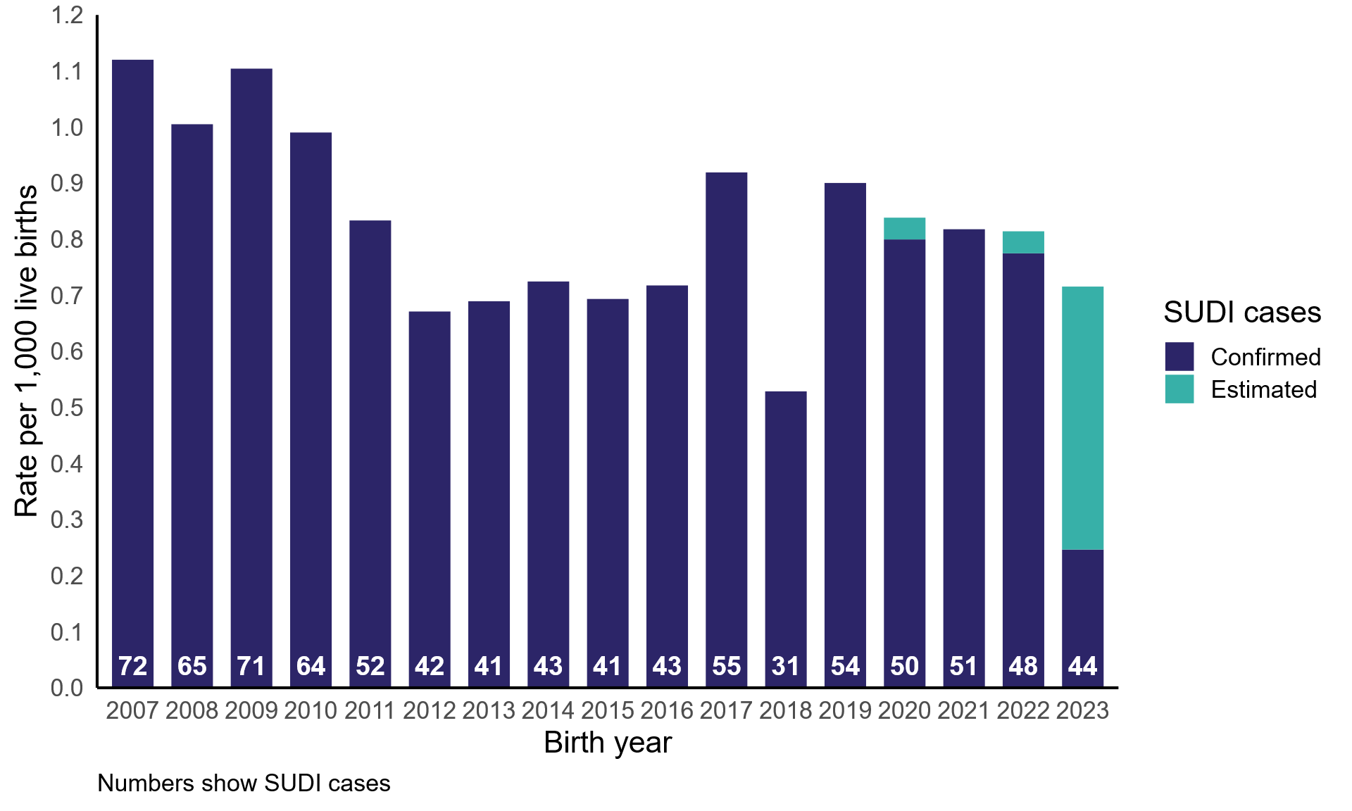
The estimated rate is based on the observation that 85 percent of suspected SUDI cases are later confirmed.
Figure 2: Preliminary plus confirmed SUDI cases, 2020 to 2024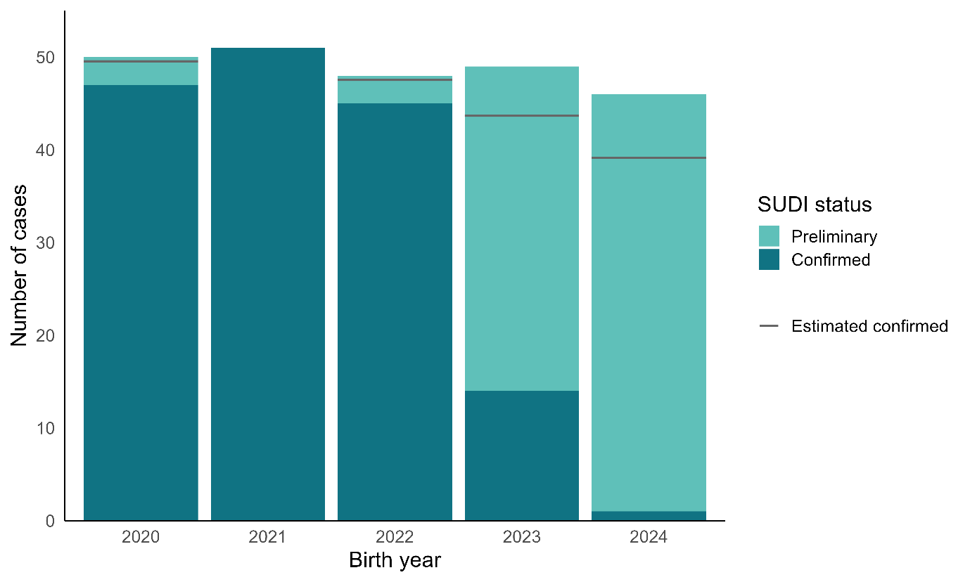
Notes:
Notifications of suspected SUDI cases can be a measure of SUDI numbers. These make up the preliminary data. Eighty-five percent of these were later confirmed, while 15 percent were not. By applying the historical confirmation rate for these cases, we estimated how many suspected cases are likely to be confirmed as SUDI. Noting there is a small number of cases (3–6 per year) which are later confirmed but were not in the list of suspected cases.
This confirmation rate provides the basis for estimating SUDI numbers from the preliminary data.
Case numbers below the ‘estimate confirmed’ line are likely to be SUDI; those above the line are unlikely to be SUDI.

SUDI rates are higher in deprived areas
The New Zealand Deprivation Index (NZDep) assigns scores to small geographic areas based on nine census-derived indicators of socioeconomic wealth and disadvantage. Indicators look at things like access to the internet and transport, work opportunities, income, education, housing and living conditions.
NZDep is not just a measure of deprivation but a map of opportunities showing where communities may benefit from extra support and investment.
Figure 3 shows over half (57 percent) of SUDI cases were concentrated in the most deprived areas in the years from 2019 to 2023.
Figure 3: SUDI rates among infants born alive, 2019 to 2023, by NZ deprivation quintile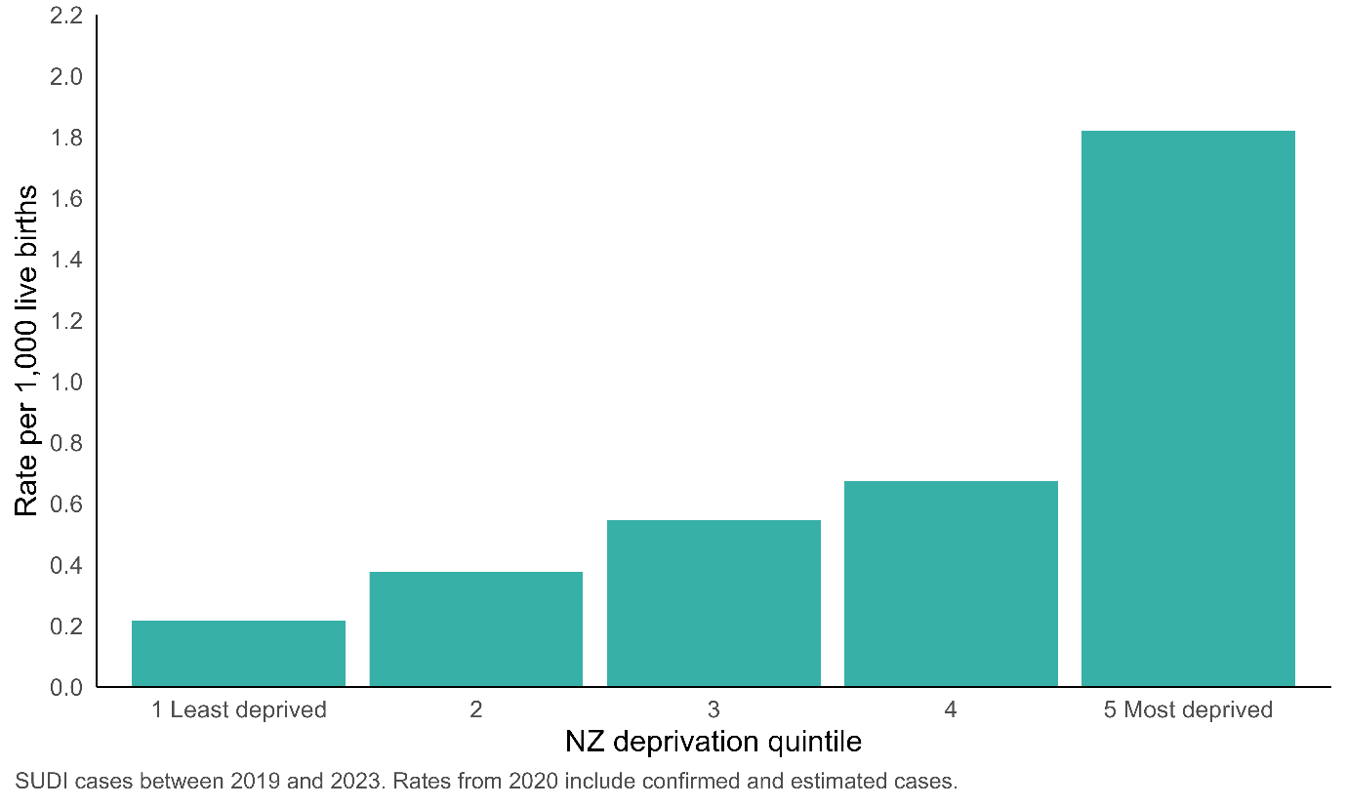
Note: Socioeconomic Deprivation Indexes: NZDep and NZiDep, Department of Public Health, Wellington – otago.ac.nz
The SUDI rate (Table 1) differed from a low of 0.22 deaths per 1,000 live births in the least deprived areas, to 1.82 deaths per 1,000 live births in the most deprived areas. The rate in the least deprived areas is close to the goal of 0.1 deaths per 1,000 live births. The rate in the most deprived areas is 18 times greater than the goal.
Table 1: SUDI rates among infants born alive, 2019 to 2023, by NZ deprivation quintile
Quintile | SUDI cases | Live births | Rate per 1000 live births | 95% CI
1 (Least deprived) | 10 (4%) | 45,368 | 0.22 | 0.12–0.40
2 | 19 (8%) | 51,478 | 0.38 | 0.24–0.59
3 | 30 (12%) | 54,448 | 0.55 | 0.38–0.78
4 | 45 (18%) | 67,350 | 0.67 | 0.50-0.90
5 (Most deprived) | 140 (57%) | 77,100 | 1.82 | 1.54-2.15
Notes: Unknown for one individual. From 2020 SUDI cases include confirmed plus 85 percent of preliminary cases. Rounding of these estimated cases impacts on SUDI case counts.

High SUDI rates in some health service districts
There is uneven district distribution of SUDI.
Northland, Counties Manukau, Tairāwhiti, Whanganui, Hawke’s Bay and South Canterbury rates are above the national average.
The lowest rates are seen in Nelson Malborough, Taranaki, and Southern Districts during this time period.
Figure 4: SUDI rates among infants born alive, 2019 to 2023, by district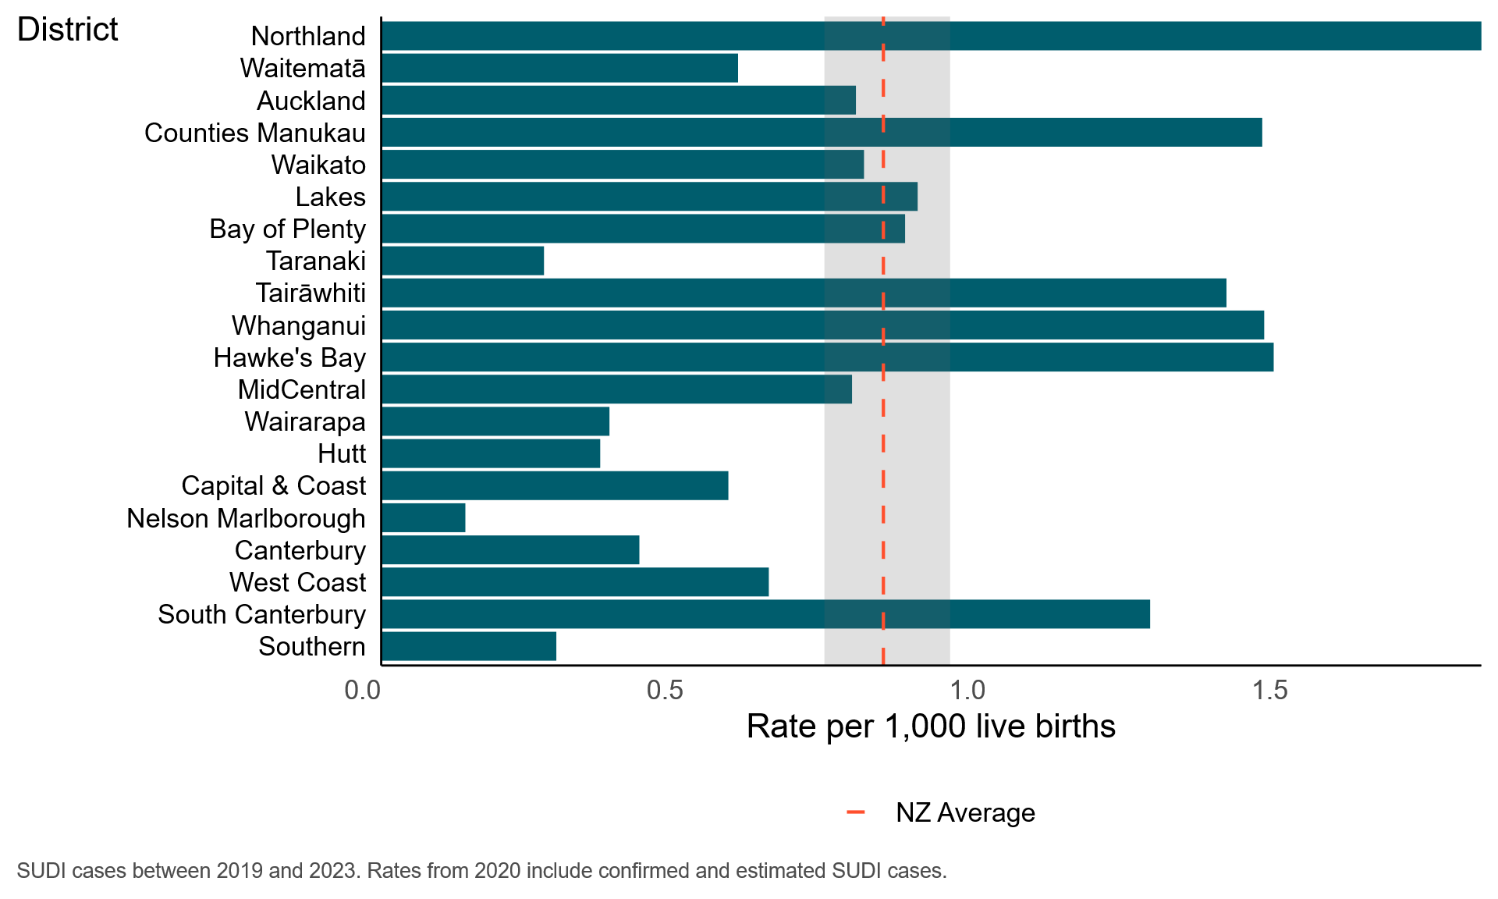
Note: The dotted red line shows the national average rate of SUDI cases, and the grey shading shows the confidence interval for the national average.

High SUDI in pre-term infants
Pre-term infants are over-represented among SUDI cases.
One in five SUDI cases (19%) are pre-term infants. Preterm infants make up 7.9 percent of live births so this is double what is expected.
Table 2: SUDI cases among infants born alive, between 2007 and 2023, by gestational age
Gestational group | Percent of all live births 2007-2023* | Number of SUDI cases | SUDI cases (%)
Pre-term  < 37 weeks | 7.9 | 167 | 19.3
Term and beyond  37 weeks plus | 92.0 | 666 | 77.0
Unknown | 0.1 | 32 | 3.7
Notes: From 2020 SUDI cases include confirmed plus 85 percent of preliminary cases. Rounding of these estimated cases impacts on SUDI case counts.
*Report on Maternity web tool – tewhatuora.govt.nz

High SUDI in the first four months of life
For all infants, the greatest risk period for SUDI cases is in the first four months of life.
Figure 5: Proportion of SUDI cases by age at death, 2007 to 2023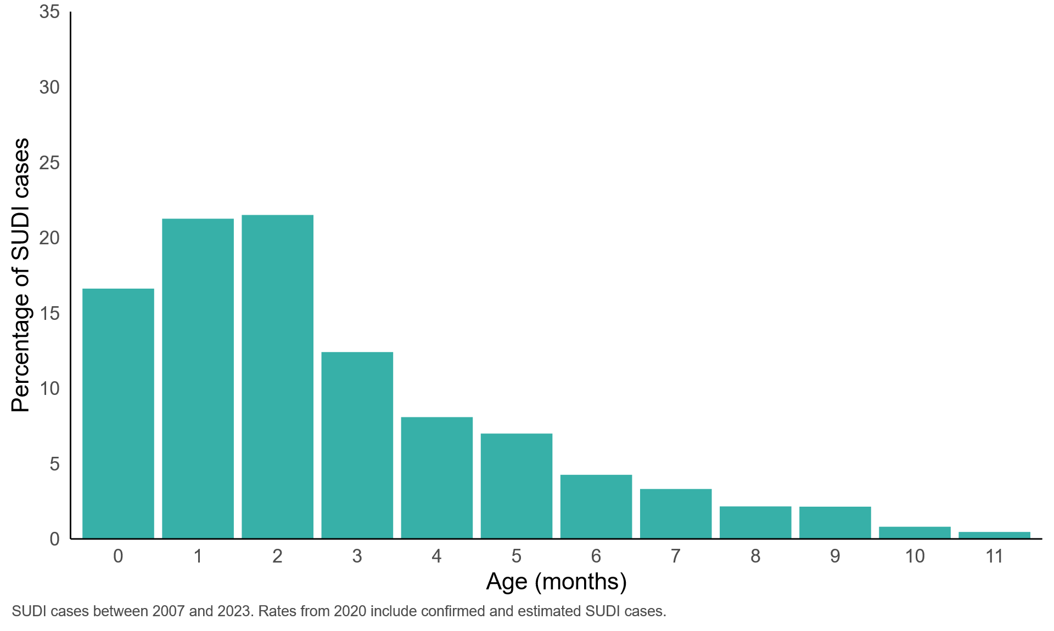
Table 3: Percent of SUDI cases by age at death between 2007 and 2023
Age (months) | SUDI cases | Percent | 95% CI
Under 4 months | 621 | 71.8 | 68.69–74.68
Four months and over | 244 | 28.2 | 25.32–31.31

SUDI rates and ethnicity
Figures 6 to 10 shows the relationship between ethnicity and SUDI rates. We describe ethnicity two ways in this report: prioritised ethnicity and total response ethnicity. Both these methods have strengths and limitations.
Prioritised ethnicity is a system that assigns a single ethnic group to individuals with multiple ethnic affiliations, based on a predetermined order of priority. The prioritisation places Māori first followed by Pacific peoples, Asian and then European/Other. It plays an important role in identifying people with Māori ethnicity in the population.
A limitation of prioritised ethnicity is the loss of nuanced information about individuals with multiple ethnic affiliations.
Total ethnicity addresses this limitation of prioritised ethnicity by acknowledging all ethnic groups an individual identifies with. It represents all ethnic groups in a population and prevents undercounting of ethnic groups lower down in the priority.
Using total ethnicity also has drawbacks. It lacks the advantage of prioritised ethnicity – its categories are not mutually exclusive, which hinders statistical analysis. Importantly, the total ethnicity can also inaccurately describe the size of individual groups due to overlap and can lose sight of the multi-ethnic identity of many New Zealanders, potentially leading to a misrepresentation of population dynamics.
The mortality rate for any given year needs to be interpreted with caution. The numbers of SUDI cases in each ethnic group are small and there is considerable year-to-year natural variation.
For Māori, rates remain the same using either total or prioritised ethnicity.
There was a significant decrease in SUDI rates between 2011 and 2013, which has not been sustained.
Figure 6: SUDI rates for Māori vs all New Zealand using prioritised ethnicity, 2007 to 2023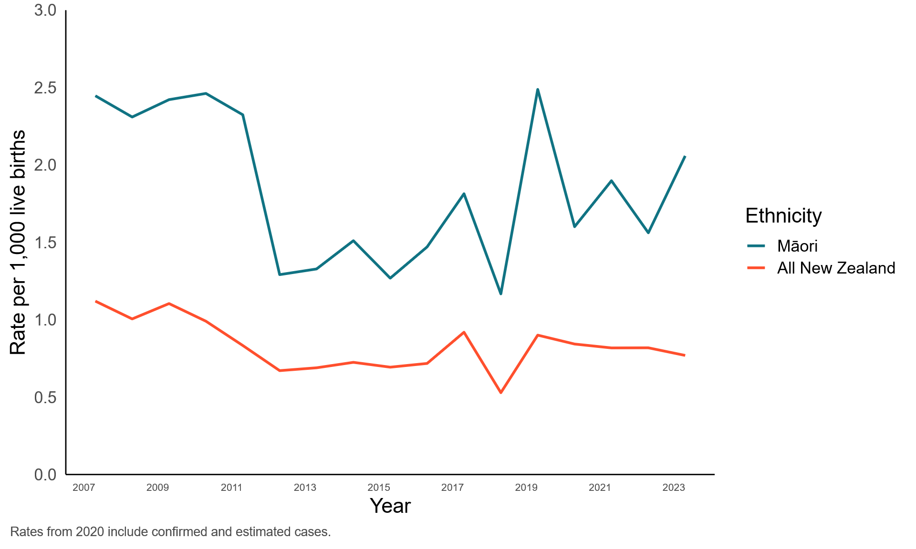
Using total ethnicity makes a significant difference for Pacific peoples.
SUDI rates for Pacific infants remain high. When Figure 7 (total ethnicity) is compared to Figure 8 (prioritised ethnicity) it shows SUDI rates for Pacific peoples are more visible when using total ethnicity.
Note there is more year-to-year variation in SUDI rates among Pacific peoples as the populations are smaller than for Māori and all New Zealand.
Figure 7: SUDI rates for Pacific peoples vs all New Zealand using total ethnicity, 2007 to 2023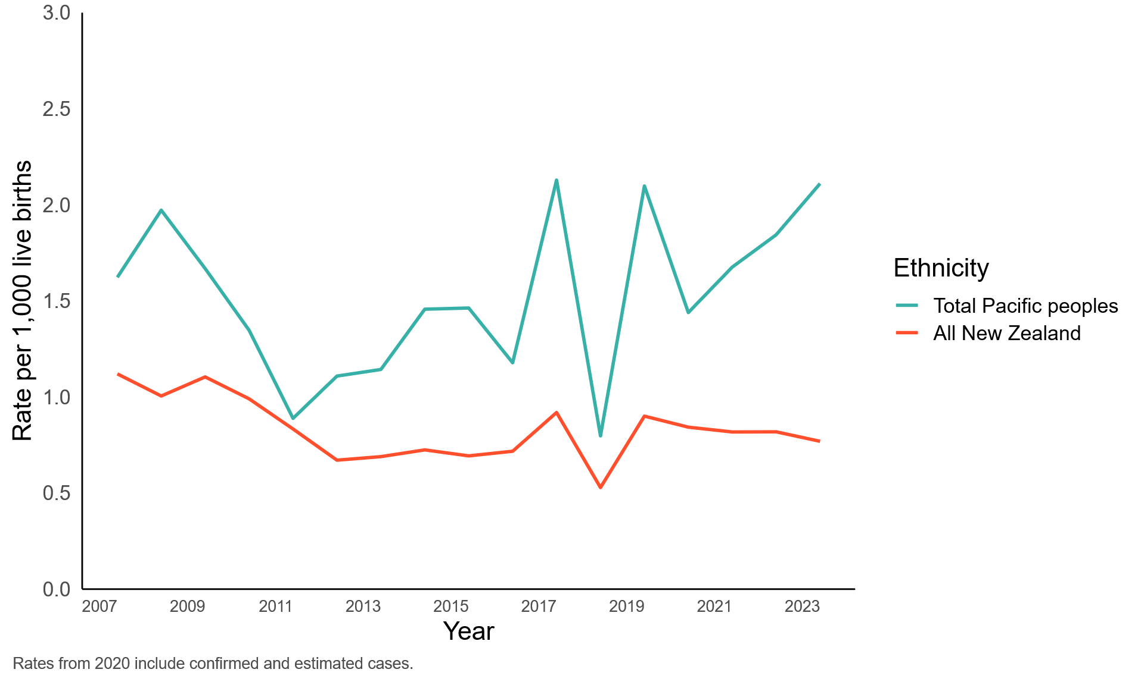
Figure 8: SUDI rates for Pacific peoples vs all New Zealand using prioritised ethnicity, 2007 to 2023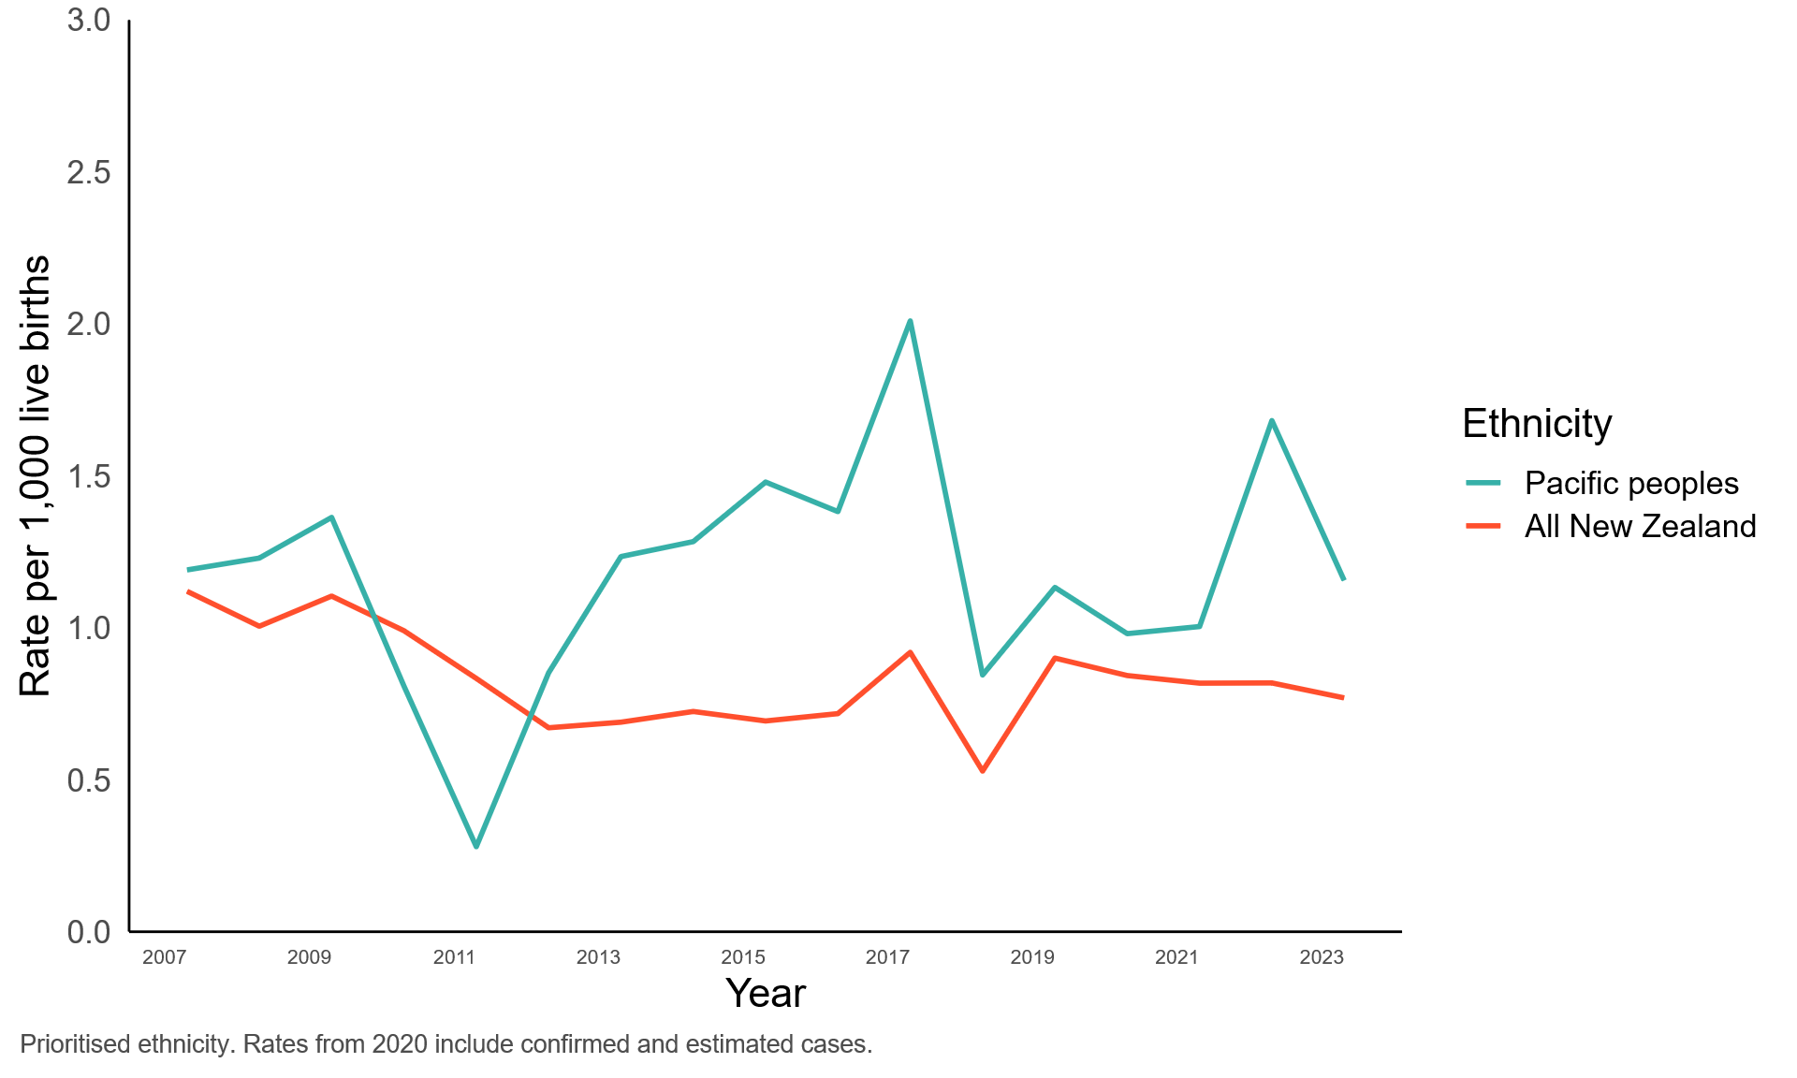
Figures 9 and 10 uses total ethnicity to describe the rate for European/Other and for Asian ethnic groups. For both these groups the rate is lower than the national average rate.
Note: for Asian ethnic groups 45 percent also identified as Māori or Pacific peoples.
Sixty-one percent of European/Other also identified as another ethnicity, Asian, Pacific peoples or Māori.
Figure 9: SUDI rates for European/Other vs all New Zealand using total ethnicity, 2007 to 2023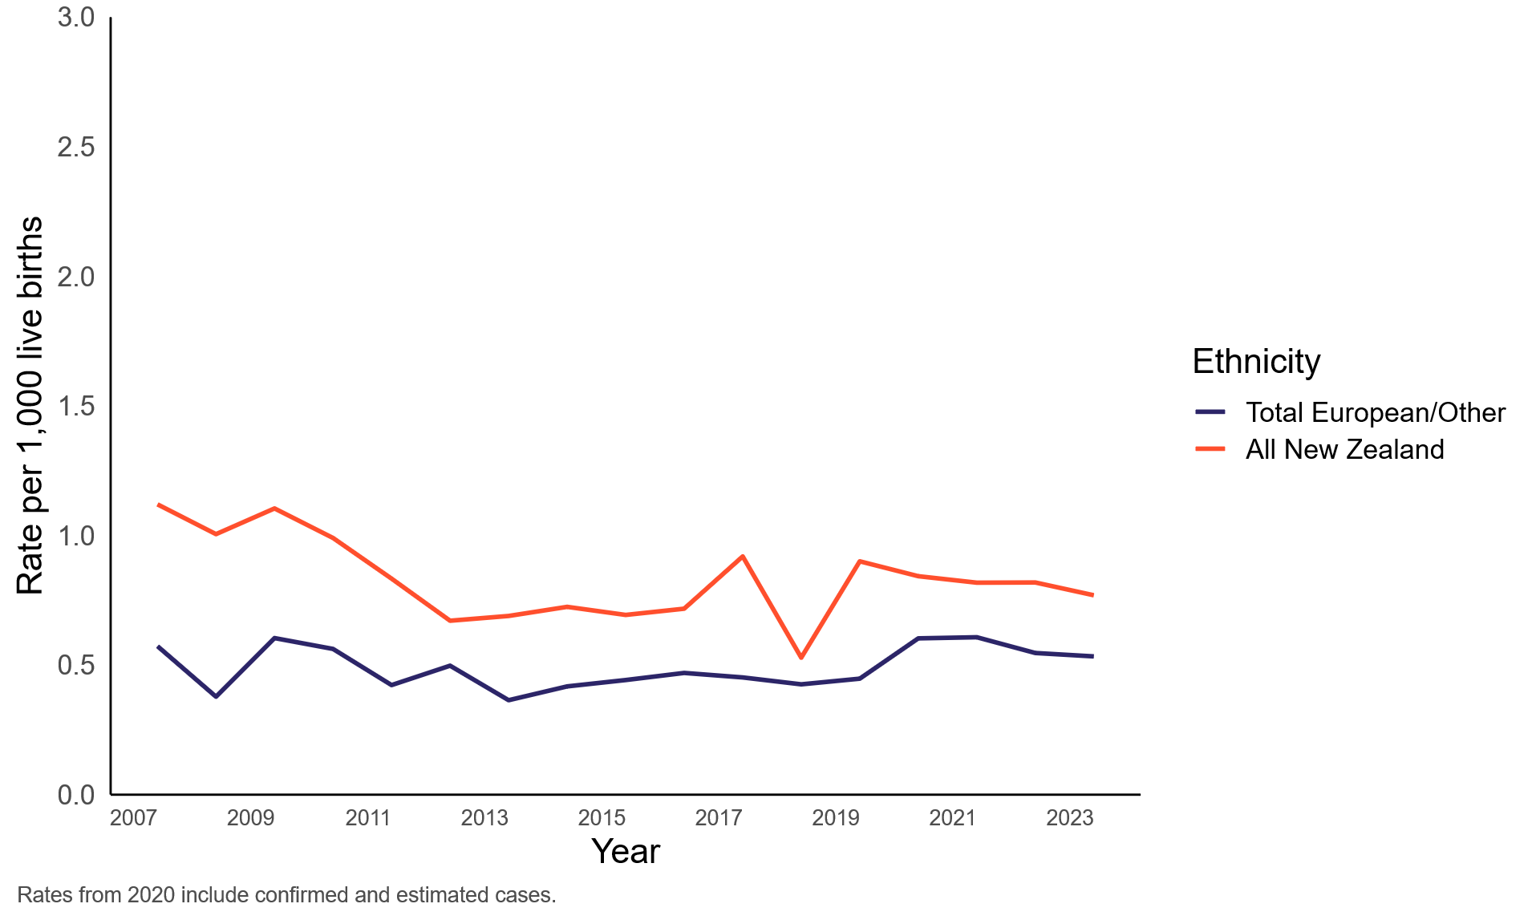
New Zealand European/Other, excluding Māori and Pacific, are reported together.
Figure 10: SUDI rates for Asian vs all New Zealand using total ethnicity, 2007 to 2023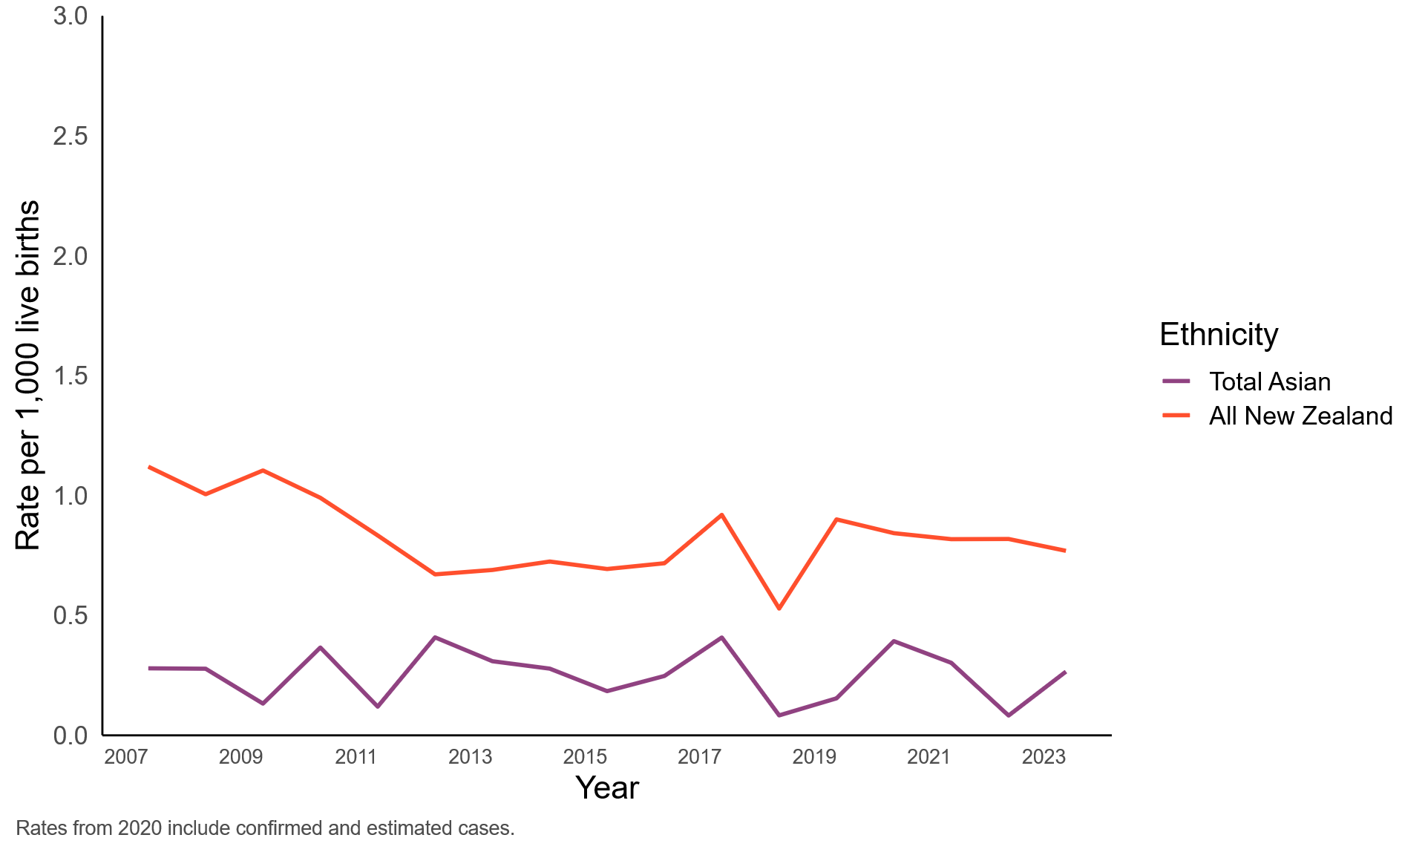
Note: Asian ethnicity includes Asian, Southeast Asian, Chinese, Indian.

This data supports important sector developments
Monitoring SUDI data over time identifies where and when greater support is required and supports the health sector to engage impacted communities and families. Important activities in the sector include:
Health New Zealand | Te Whatu Ora resetting the National SUDI Prevention Programme with national leadership, now under Hauora Māori Services and governance through the Kahu Taurima Steering Group, to strengthen coordination of the health sector response.
Hāpai Te Hauora publishing refreshed messaging on safe sleep in December 2025.
The SUDI prevention programme combines the work of agencies, including health, housing, social services and income support providers, to provide effective services that support hapū (pregnant) whānau and those with young infants to be and remain well, including having a safe place for pēpi to sleep. Engagement with those at risk, alongside culturally appropriate support and respectful ways that build trust is critical to achieving a reduction in these preventable deaths.

Contact us
This is the beginning of regular monitoring of SUDI by the Commission. Please contact us if you have any questions or additional data analysis you would like to see. Email: info@hqsc.govt.nz
Published in January 2026 by Health Quality & Safety Commission Te Tāhū Hauora, PO Box 25496, Wellington, 6146. Available online at www.hqsc.govt.nz. Enquiries to: info@hqsc.govt.nz


