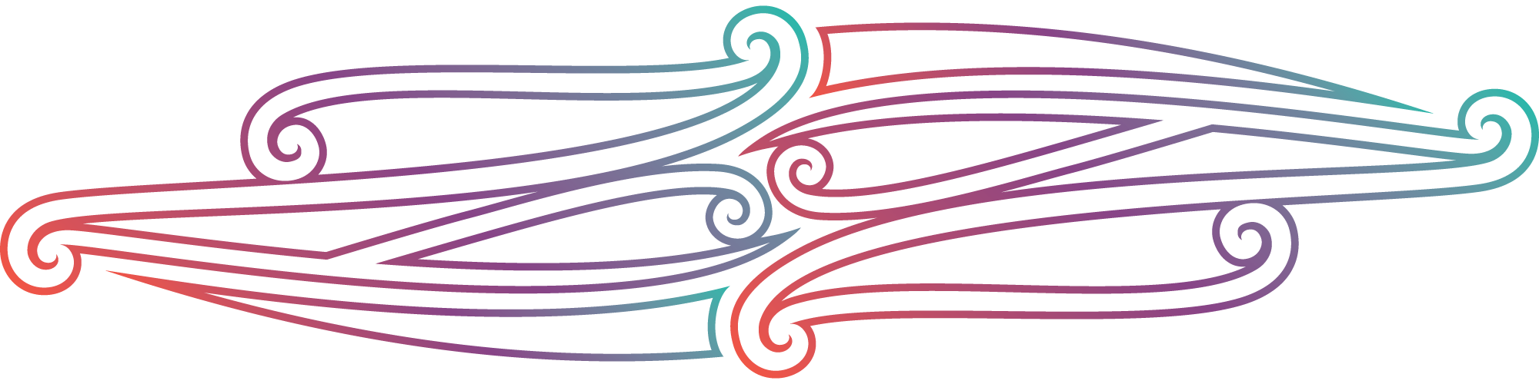
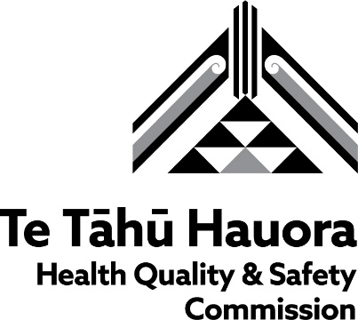

Strengthening connections – the new landscape for reducing preventable deaths

Te Tāhū Hauora Health Quality & Safety Commission report on the mortality review workshop, 17 October 2023

Overview
On 17 October 2023, a workshop was held for perinatal and maternal mortality review and child and youth mortality review local coordinators and chairs and Te Aka Whai Ora and Te Whatu Ora leaders. The workshop was held at Novotel Auckland Airport in Tāmaki Makaurau Auckland and was hosted by the National Mortality Review Committee, as part of Te Tāhū Hauora Health Quality & Safety Commission (Te Tāhū Hauora). The title of the workshop was ‘Strengthening connections – the new landscape for reducing preventable deaths’.

Purpose
This was the first time local coordinators and chairs from the two mortality review groups have come together in a shared workshop to hear the vision of the National Mortality Review Committee. The purpose of the workshop was to:
strengthen relationships and connect coordinators and chairs with colleagues working in mortality review in different parts of Aotearoa New Zealand
offer support and education to local coordinators in their roles, which are sometimes isolated within their organisations
provide an opportunity for Te Whatu Ora, Te Aka Whai Ora and other health organisations to increase their understanding of local mortality review and share ideas about how lessons learned can be best used and shared in future.

Programme
Atelaite Mapa and Jonathan Malifa from the Te Tāhū Hauora equity unit facilitated the day. Attendees included 28 perinatal and maternal mortality review and 11 child and youth mortality review local coordinators and seven child and youth mortality review local chairs.
The mihi whakatau was led by kaumātua Muru Maipi, Turongo Paki, Matua Roberts and mana whenua. They provided cultural awhi and mātaurangi Māori guidance and shared wisdom and care throughout the day. Dr Liza Edmonds (chair of the National Mortality Review Committee), Dr Nick Baker (Te Whatu Ora) and Dr Don Matheson (director of the National Mortality Review Function Management Group) provided introductions and overviews. Dr Edmonds led the kōrero on the new National Mortality Review Committee and its mandate. She welcomed participants’ contributions to shaping a more effective response to preventable mortality.
The morning session included understanding the current climate through falanoa, ‘modern tapa cloth-making’ (restorative practice) and feedback from small groups. A panel of eight senior leaders from Te Aka Whai Ora and Te Whatu Ora heard, commented on and responded to feedback from attendees. Over lunch, the panel continued to discuss how to work together to increase the visibility of local mortality review.
Alongside the workshop, representatives from Te Aka Whai Ora and Te Whatu Ora met with Liza Edmonds and Don Matheson and expressed both their appreciation and their admiration for the work being done in local mortality review. They saw many opportunities for system improvement, including greater alignment of national and local review activities and alignment with iwi–Māori partnership boards and health districts. The new mortality review function offers opportunities to shorten the time between data being gathered and action being taken and to take a broader view of being a subject matter expert, particularly as applied to te ao Māori. They also considered multiple ways to promote the visibility of current local mortality review activities, including closer collaboration between organisations to address preventable mortality and better use each organisation’s strengths, data and knowledge sources.
The two groups (perinatal and maternal mortality review and child and youth mortality review) ran separate concurrent sessions in the afternoon, including data classification and time to share with and listen to other local coordinators and chairs about challenges and local outcomes. At the end of the day, the groups gathered again to listen to a bereaved māmā sharing her story on video and a presentation on the Christchurch notification pathway for sudden unexplained death in infancy. Dr Matheson provided closing remarks and thanks, and kaumātua then officially closed the day.

Feedback
A crowd social wall ran throughout the day; participants were able to scan a QR code and submit anonymous feedback via Mentimeter.
An evaluation form was sent to all attendees via SurveyMonkey.
Written feedback was recorded throughout the day. The following quotes capture the depth of discussions.
‘Equality before equity’ – kaumatua
‘We've thoroughly deliberated the cases that we've reviewed, and then we've presented the findings and where they need to go as a gift, it's a koha really, and nothing happens, nothing changes and that's demoralising.’ – local coordinator
‘The first superpower of mortality review is rooted [in] the power of the legislation for data collection; the second superpower is the power of stories and the richness of the stories; and then the third superpower, which is the one I think we will need to work on, is influence and connections. To use the power of these stories, I think, somehow, we need to move to a time when mortality review is fully mixed into the system, if you like baked into the centre. Mortality review gives you the power to change, and therefore it needs to be baked in.’ – panel member

Summary and outcomes
The agenda for the day was ambitious, and we acknowledge that it was a big ask to cover everything in one day, but it was a great start.
Many participants acknowledged the coordinators’ strong commitment to their mahi, that local mortality review is challenging and takes a toll and the burden placed on whānau and those carrying out this important mahi. They expressed frustration about working within the current system and the many additional challenges during the change to the new mortality review function. A desire for lessons learned, input and feedback to be shared and for meaningful outcomes was highlighted many times. Matua Roberts reminded participants that ‘everyone who needs to be around the table should be around the table’, emphasising that local mortality review needs to think more broadly than just the health organisations involved in mortality review.
Feedback on the workshop indicated the value of having time and opportunity to connect and share with others carrying out similar work. Many participants would have liked more time, more specific discussions and more certainty for the future of local mortality review.
All enjoyed the efforts of the excellent facilitators, who kept everyone on time and on track. The engagement with and commitment to the work, both from those directly engaged in local mortality review and from those in senior positions bodes well for our ability to address the challenges ahead. Those involved clearly share a passion for making sure lessons are learned and corrective action is taken based on the stories of lives lost from preventable causes.

Kia ora rawa atu.

The national mortality review function management team
Don Matheson, Sue Peacock, Anna-Marie Frost, Jo Sorasio and Debbie Davies

