Head Injury

This newsletter is produced to inform staff about activities…..

Moderate to severe patient discharge information booklet

“To catch the reader’s attention, place an interesting sentence or quote from the story here.”

Caption describing picture or graphic.
Contents
ihirangi

- What is a Trauma Brian Injury / Post Traumatic Amnesia. About the brain
- Common symptoms
- Inpatient team, their role, possible assessments and treatments
- Recovery (reassurance / positive recovery)
- Management
- Fatigue management (pacing planning prioritisation)
- Sleep
- Stress management / relaxation strategies / anxiety
- Behaviours changes
- Sport
- Work / study
- Information for family
Definition whakamaramatanga

TBI - Traumatic Brain injury
GCS - Glasgow coma scale
PTA – Post Traumatic Amnesia
ACC – Accident Compensation Corporation

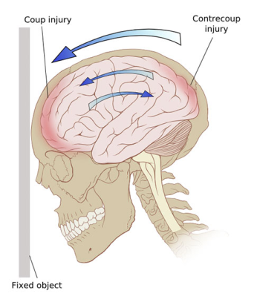
What is a Traumatic Brain Injury?

A Traumatic Brain injury is caused by an external force to the brain. A moderate to severe TBI involves a change in state of consciousness; TBI can lead to temporary and/ or permanent changes in thinking, movement, emotions and communication. This can cause extensive tearing of nerve tissue throughout the brain. The brain messages are slowed or lost.

Some examples, sport injuries, leisure activities, assault, motor vehicle accidents, whiplash, slips or fall, head knock etc.
TBI patients with moderate to severe injury have temporary loss of consciousness, loss of memory, feel disorientated, dazed or confused. The loss of memory is called post traumatic amnesia (PTA), this is the period that you may feel confused, act strangely, unable to remember what just happened, decreased attention span, fatigue easily, irritable, aggression and are easily over stimulated.

The Brain
Roro

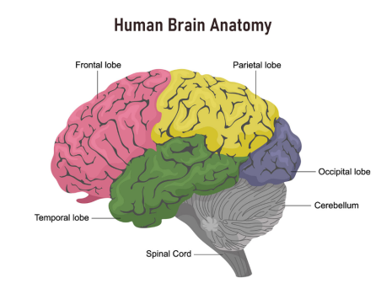
Each cerebral hemisphere has four parts called lobes / taupae. Each lobe controls different functions but they all work together.

- Frontal lobe: Think, plan and organise. Work out how to do things, controls emotions and impulses
- Parietal lobe: Tells left from right, read, recognises things by sight or touch, knows how your body feels and what position it is in e.g. lying down
- Temporal lobe: Forms new memories, order things in your mind, categories objects, understands sounds such as speech and music
- Occipital lobe: Receive visual information, interpret colour, shape and distance
- Brain stem: Controls vital life functions, breathing, heart rate, consciousness and ability to sleep

Common symptoms
tohumate

- Changes in balance, strength and co-ordination
- Problems affecting speech, communication and swallowing
- Sensory changes including hearing loss, numbness and visual problems
- Reduced control over bowels and bladder
- Changes in attention, memory and cognitive functions
- Behavioural changes with emotions and social interactions and difficulties
- Mood and psychological functioning
- Headaches, pain, dizziness, nausea and vertigo

Inpatient team, their role, possible assessments and treatments

Early rehabilitation / whakaora to start as soon as possible, to improve your outcome. Rehabilitation is the process of using training and therapy to bring people back to health after an injury.

Rehabilitation / whakaora aims to improve your function and quality of life. This may include providing compensatory strategies to reduce the negative impact of your symptoms.

Since no single tool can get the full picture of a person’s strengths, challenges, and needs, many assessments are used to measure the stages and severity of TBI. This may include multiple health care professionals to assist with your recovery. The team involved depends on your individual needs and the stage of recovery.

They may include:

- Doctor
- Nurse
- Occupational Therapist
- Physiotherapist
- Pharmacist
- Complex discharge planner
- Psychologist
- Social worker
- Speech language therapist
- ACC case manager

During your recovery several assessments will be complete

Glasgow coma scale | GCS is used to assess your neurological status; assessing consciousness, eye opening, and motor responses and giving a score out of 15. The initial test is done as soon as possible after the injury to set a baseline. After that the sets are done frequently to see any changes in consciousness and to establish a pattern. In early stages individuals my respond better to their families and loved ones than health care providers so families can pay an active role during this time
Initial interview | With you or your family  Previous baseline to have an understanding of previous function, cognition, school or work to assist with goal setting.
Cognitive assessment | Post traumatic amnesia (PTA) is assessed through the Westmead assessment. Which reviews orientation (person/place) and memory recall. This assist with guidance regarding severity of TBI.  Assessment also includes areas of insight awareness, attention, memory, information processing (speed/delay) perception, self-monitoring, social judgement and complex problem solving.
Physical assessment | This may include physiotherapist, occupational therapist and speech language therapist completing individual assessments to review:  - Motor deficits - muscle weakness, abnormal muscle tone, range of motions reduce co-ordination  - Sensory deficits – visual, hearing loss and sensation  - Physical symptoms – headache, fatigue, seizures and pain.  - Dysphagia (difficulty swallowing)  - Communication, language deficits, cognitive communication issues or word finding difficulties.  - Function – changes in position, carrying, moving, walking and activities of daily living
Behavioural and emotional assessment | Observing and reviewing for  - Emotional changes  - Mood change  - Ability to adjust to problems  - Personality changes – aggressive outburst, inappropriate behaviour, loss of motivation and engagement  - Mental health disorders should also be considered

Recovery
Whakaora

Most adults with TBI experience different stages of recovery. The length and outcome of each stage is unpredictable and does not follow a specific time frame.
A brain injury can affect you in many ways and you may need to see a number of different people who can help you recover. When you need to go to appointments it can be a good idea to take a support person. Remember to rest before and after appointments as necessary.

Te Whare Tapa Wha

Te Whare Tapa Wha describes health and wellbeing as wharenui (meeting house) with four walls and a foundation, that helps us identify where we need extra support. The four walls present:
- Taha Wairua – spiritual wellbeing
- Taha Hinengaro – mental and emotional wellbeing
- Taha Tinana – physical wellbeing
- Taha Whanau – family and social wellbeing
The foundation is our connection with the whenua / land. A useful link below has ideas that focus on each of the specific areas. https://www.raisementalhealth.co.nz/hinengaro.html

Management
Whakahaere

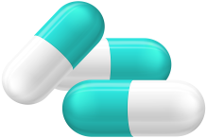
Pain relief – Use paracetamol or codeine for headaches, do not use aspirin or an anti-inflammatory pain reliever such as ibuprofen (NSAID). Please discuss concerns discuss with your doctor.
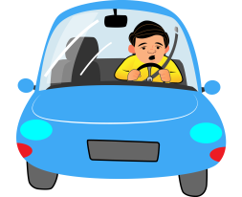

Driving - Do not drive or operate heavy machinery until you have medical clearance

Drinking / drugs – Do not drink alcohol, take sleeping pills or recreational drugs as they can delay your recovery or increase your complications following a head injury.
If you feel like you have a problem with drinking or drug taking, seek help from a counsellor or doctor. 0800787797 Alcohol and Drug Help line.

Fatigue Management

Fatigue (tiredness) is one of the most common symptoms following a TBI; it is a constant draining feeling of having no energy. Fatigue can affect many areas; it is an important part of your rehabilitation to recognise signs of fatigue and how to manage these areas. For example:

Decrease your concentration, memory and ability to cope in social situations  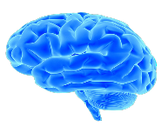  This Photo by Unknown Author is licensed under CC BY-NC | Experience increase irritability, distractibility, depression and anxiety  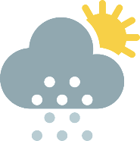 | Your brain is processing information slower and it takes more energy to complete tasks  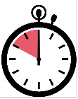
Task would require a lot of thinking and concentrating will drain your energy faster, leaving you tired  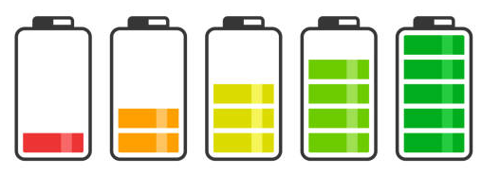 | Fatigue gets worse when sleep is not enough leaving you feeling unreferred in the morning.  Enough rest and sleep is important for the brain to recover  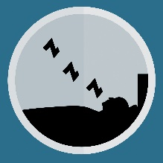 | Fatigue management is your starting point for your energy.  Accept and recognise your limits and manage you levels, this will assist with your recovery.

When managing fatigue, consider the 3 P’s
Prioritising - Planning - Pacing

Have a notebook or diary to plan meaningful goals or activities you like. Record achievements and identify patterns of fatigue
Prioritising kaupapa matua:
- Write out tasks you feel you must or need to do and what would happen if you don’t do them?
- Number them in order of urgency / importance to you
- The list should include your therapy, social interactions, hobbies, interests and daily tasks.
- If you need assistants with any tasks, ask family or friends to assist. You are still recovering asking for help is good that means you will have energy to complete other tasks.
Planning whakamahere:
- Plan your activities for your day and the week ahead
- Leave enough time to rest afterwards
- Identify the time of day you to do the activities
- Before starting a task think about how you’ll do it and for how long i.e – sit down to complete the tasks, book appointments during least traffic (school runs), groceries shopping when there is no rush (week days and during school hours)
Pacing tere haere:
- Take your time and stop before you are exhausted
- Spread the activities through the day or week
- Don’t try and do all heavy activities at once, increase time frame a little everyday
- Take regular breaks
- Use a timer to remind yourself to rest
Rest okiokinga /Sleep moe

It is important to get adequate amounts of sleep moe and mental rest to allow your brain to recover.
People tend to sleep more than usual after a head injury. Lack of sleep can worsen the symptoms you’re experiencing, such as concertation difficulties, headaches, frustration.
Getting enough sleep and having good sleep habits is essential to your recovery. This includes;

- Having a routine i.e. develop a ritual before bed to help wind down and relax for example taking a bath or listening to soothing music
Going to bed and getting up at the same time each day
- Taking power naps during the day, but avoiding this is in the later afternoon, use an alarm to make sure you don’t sleep to long i.e. 30 minutes
- Use your bed for sleeping only the recommendation is 8-10 hours of sleep
- Reduce screen time because light from electronic devices such as phones, television or tablets can affect your sleep cycle
- To decrease stress and worry before bedtime you can use a notebook and write everything down
- Do not have caffeine, nicotine or alcohol before bed
It is recommended that you get regular exposure to the outdoors and natural light because it is assists with your circadian rhythm (sleep cycle).

Stress and anxiety management

There are several different reasons regarding stress, some examples are below

- Frustration regarding your recovery
- Fiancial hardship
- Family problems
- Other people’s expectations
- Your own expectations
It is important to recognise when you are stress and why.

Once you have “why”, then consider some solutions on how to reduce your stress, otherwise the stress affects your sleep patterns and takes over your thought processing, which can make your recovery time longer.

If you are unable to come up with a solution to your stress, ask for assistance from family / friends or ask if you are able to get assistance from ACC or counselling.

A useful link that assists with stress
Stress (mate māharahara) | Health Navigator NZ

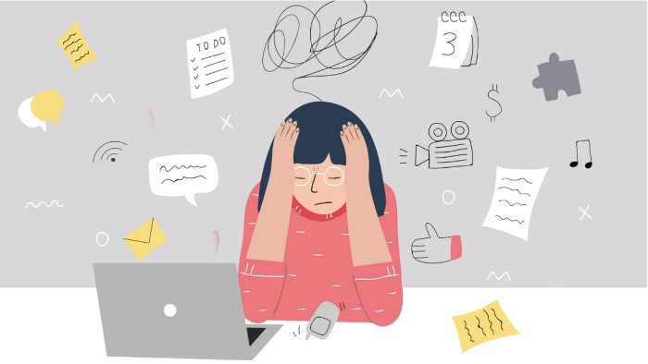

Behavioral and personality changes

Following a TBI damage to the brain often results in changes in behaviour, mood and personality. Some changes of behaviour include;
- Frustration
- Irritability
- Losing your temper
- Inflexibility
- Impulsive
- Depression / anxiety
- Changes in mood i.e. mood swings, emotional breakdown, lack of motivation
- Change in behaviour
Things that can help

- Learn to recognise your triggers so you can avoid or manage them i.e. certain time of day, certain activity, or loud or crowded environments
- Listen to your families feedback or concerns
- Try and stay in a regular routine as this will make you feel more in control of your life
- Ask for help if unsure
- Make sure you do activities you enjoy
- Find healthy outlets for anger for example exercise i.e. gym, outdoor walking
- Relaxation in a way you find most comfortable i.e. listening to music, reading, having a bath
- Fatigue management and behavioural changes go hand in hand refer above for fatigue management
Sports
Hakinakina

It is dangerous for the brain to be injured again if it has not recovered from the first injury. The most important goal after experiencing a head injury is to avoid another, especially while you are still recovering.

Regarding returning to sports it is recommended that you wait until you are no longer experiencing any symptoms and receive full medical clearance from your doctor / concussion services who will guide and support your return to sport and physical activity. Until then remember: if in doubt sit out.

It is important that you gradually return to your usual daily activity bit by bit, so you don’t place extra stress on your healing brain.

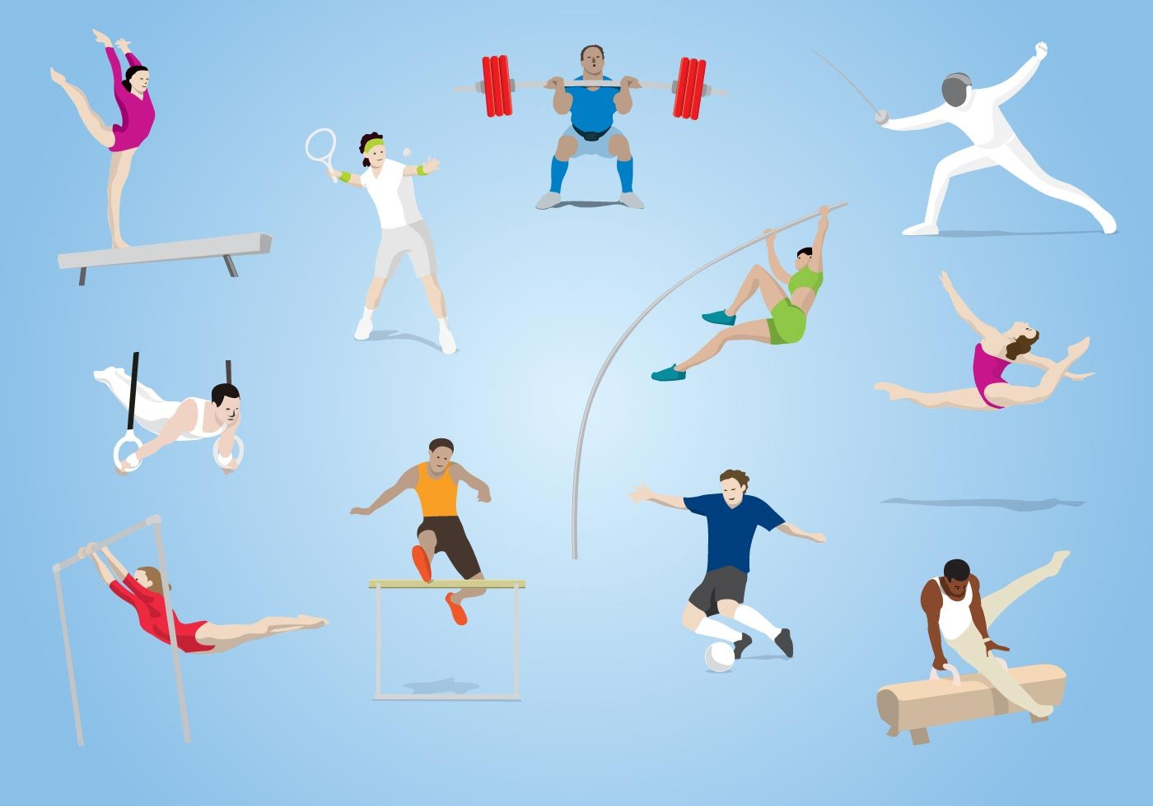

Gradual Return to Activity Mahi

Stage  Atamira | Objective  Whainga | Recommended Levels of Activity Mahi
No activity | Recovery | No or minimal activity physical and cognitive rest
Light  Marama | No Return of symptoms  Avoid stimulating environments and activities | Short periods of cognitive and physical activity  Frequent short rests between / during activities  i.e. walking
Moderate  Ahua | Gradually increase activity levels and intensity | Increase duration and intensity of activities  Return to light aerobic exercise  Commence gradual return to work/study
Heavy  Taumaha | Return to full activities, decreasing rest periods as tolerated | Increase work hours/demand as tolerable  Passing drills in ball games  Avoid full contact sports
Normal  Noa | Full return to daily activities and routine without symptoms | Normal length and intensity or work, study, and leisure  Full contact sports

Physical Recovery
tiana

Physiotherapists can help with
- Headaches
- Neck pain
- Vertigo or dizziness
- Balance issues
- Poor exercise / exertional tolerance
If you have dizziness or vertigo please discuss with Concussion services or your GP in regards to a physiotherapist review. Physiotherapists are trained to provide appropriate interventions for these conditions. Physiotherapists are able to assist with Personalised exercise programs and will encourage self management to build up your strength, improve coordination and control, static and dynamic balanced, exertional tolerance / fitness levels and dual or multitasking.

Occupational Therapy can help with:
- Return to activities of daily living e.g.
- Cognitive fatigue and retraining
- Rehabilitation approach that may include equipment to ensure safety at home, work or school.
Once you are discharge from hospital a referral will be completed to ACC concussion clinic for follow up in the community, they have a therapy team and best recommendation is to work with this team regarding you concerns and expectation.

Work / mahi and study / ako

You may need to take time off work mahi or study ako if you are having trouble concentrating or remembering things. Everybody is different, ACC have a return to work and school service they can guide you in regards to an appropriate plan.
Things to consider:

- Based on the significance of your injury it is important to not return to work / mahi or study / ako to early as this can delay your recovery
- Make a plan when you are going to return to work / mahi i.e. try and return with part time hours and light duties
- Remember you are still recovering and may struggle with fatigue, memory, concertation and emotions. Known your limits, take breaks as needed and change your return to work/study hours.
- Avoid making major decisions and becoming involved in stressful situations until you feel you are ready
- You will require medical clearance for readiness to return to work / mahi or study / ako.

Information for care givers / family / relationships

The impact of changes to mood and behaviour can affect friends and other family members. It can take everyone time to adjust to the changes so support each other through the process.

What can you do to help?

- Encourage independence; this will foster self confidence and self esteem while reducing the risk of resentment when unreasonable demands are not met
- discourage over-dependence;
- Family should encourage the person to do as much as reasonably possible, within the limits imposed by the TBI.
- Your family member may have a reduced attention span; keep instructions simple, short and to the point. When carrying out a new task give time to process the information or instruction and allow time to carry these out.
- Some tasks may need to be done in sections; intervals vs all at once while they are recovering at home e.g. cooking have breaks between prepping and cooking
- Set boundaries i.e. yes they have had a significant event however you can set boundaries regarding their behaviours, routines or requests
- Tell the person when they have behaved inappropriate but do so in a discreet and non confrontational way
- Make contact with ACC for further support as required or GP and be honest about your feelings, struggles, worries so you as a family can get the best support to care for your loved one
Warning Signs

In the early days of discharge it is common to feel symptoms such as dizziness, blurred vision, headaches and problems with your memory, among other symptoms. It is important that you, and your responsible adult who can monitor your condition, are aware of the symptoms listed below which could indicate a more serious injury:

- Loss of consciousness
- Inability to be woken
- Clear fluid coming out of your ears or nose
- Any weakness in one or both arms or legs
- Loss of balance or problems walking
- Increasing disorientation
- Slurred speech
- Unusual behaviour
- Seizures
If your experience any of these symptoms it is important to go to an emergency department or call emergency services immediately

My important contacts

My health professional (e.g. doctor, physiotherapist)
Name: ____________________________________
Phone Number:_____________________________

My employment contact person (e.g. manager)
Name:_____________________________________
Phone number:______________________________

My ACC contact person (case manager)
Name:______________________________________
Phone Number:______________________________

Other contacts
Name:________________________________________
Phone number: ________________________________
Useful resources:

Goal Setting

Setting goals may be part of your recovery journey this will help your therapists work with on activities that are meaning to you. This may be done with family involvement and support from staff.

Short term goals

Longer Term Goals

