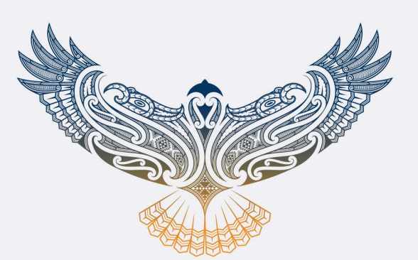
The path of making things right: Te ara whakatika

The Story Behind the Tohu
This tohu was created to reflect the pūrākau (story) of lived experience — a symbol that acknowledges what whānau (families) navigate in life after trauma. For many, the journey is filled with uncertainty, unknowns, and ongoing change. It is rarely short-term and often becomes a lifelong path of adjustment.
Yet with the right supports around them, whānau can flourish — finding their own rhythm and rising into mana motuhake (self-determination, autonomy, and independence) as they learn to navigate a new normal.
Every kaupapa (initiative) must be grounded in lived experience. While data helps us understand the issues, this tohu reminds us that every number represents a person receiving care (kiritaki) and their wider whānau. We may only walk alongside people for a small part of their journey, but it is ngā hau o te oranga (the winds of wellbeing) — systems, services, kaimahi (workers), community supports, and partners — that help lift the kāhu and enable it to fly.
These unseen winds are critical. Without the right supports in place, recovery becomes harder, and systems can become fragmented. This tohu reflects the importance of whakatika (strengthening and improving what is not working) and kotahitanga (unity and collective action) to ensure whānau receive the support they need.
The kāhu (Australasian harrier hawk) was chosen as a kaitiaki (guardian) because it represents resilience and adaptability. Even after devastation, it returns. It reminds whānau that they are not alone — and that there is life after trauma.

Te Ara o te Kāhu |The Journey of the Kāhu
The journey begins with te pīwakawaka (fantail) — an agile kaitiaki that meets whānau at the threshold of crisis. Moving quickly and closely, it guides whānau through the shock, urgency, and chaos of acute trauma.
When the immediate danger has passed, another manu (bird) takes flight — te kāhu.
The kāhu represents the longer journey that follows: rebuilding, finding stability, and reshaping life for tūroro (patients) and their whānau.
After trauma, the wings of te kāhu tremble. It carries grief, confusion, and the reality that life has changed. This is a moment many whānau know well — stepping into a new normal they did not choose.
Yet te kāhu does not rise through strength alone.
It leans into ngā hau o te oranga — the uplifting currents created by whānau, clinicians, kaimahi, navigators, community services, and system partners. These are the invisible winds that carry the manu when its own strength feels thin.

A Journey of Healing
The kāhu teaches us that healing is not linear.
Its path rises, circles, dips, and climbs again — reflecting the realities of recovery: setbacks, moments of clarity, grief, progress, and resilience. Each loop represents learning. Each rise reflects reclaiming.
As it climbs higher, te kāhu becomes both messenger and kaitiaki — carrying the voices of whānau, their strength, and their truth.
It reminds us that recovery is never undertaken alone.
When whānau are supported well, they can reach mana motuhake — not independence from others, but the confidence to navigate life with dignity, insight, and rangatiratanga (self-determination and leadership over one’s own journey).
A life reshaped, not diminished.
Together, te pīwakawaka and te kāhu represent the full trauma journey — the storm, and the healing that follows.

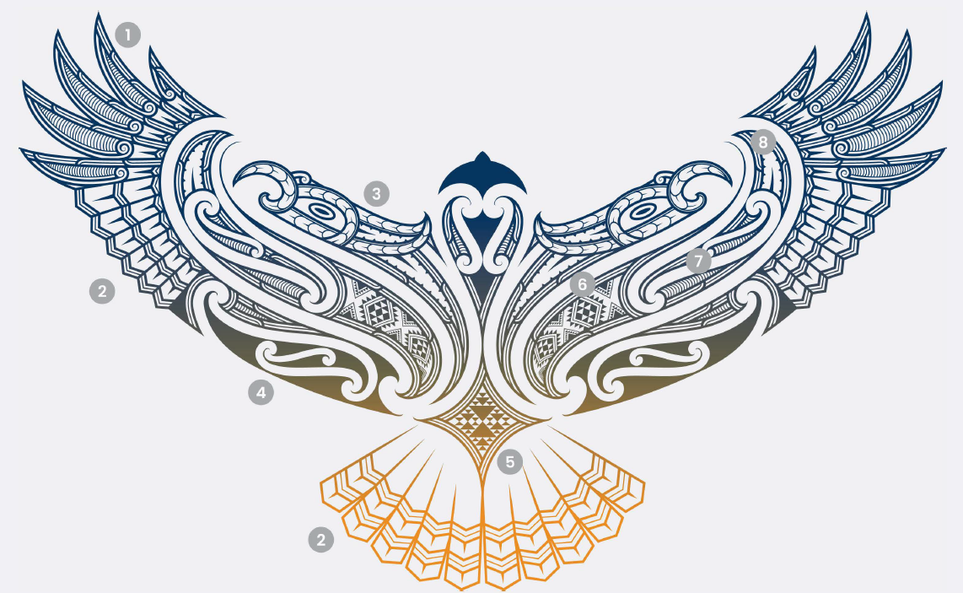
Design Rationale
The numbers below correspond to those on the tohu above.
- Pikopiko (Healing): The fresh frond of the pikopiko reflects new life, new beginnings and potential as it grows to its full form. It unfurls and regenerates signifying recovery, resilience, and the body's ability to restore itself.
- Pakati (courage): Pakati notches are representative of warriors, of battles won and of courage.
- Kaitiaki (Protection): As kiritaki focus on the path ahead of them, our kaitiaki help carry the weight so they may remain forthright and steadfast.
- Ngā hau o te oranga (support): The uplifting winds of support (whānau, kaimahi, clinicians, navigators, community services, system partners). This is what gives our kāhu flight.
- Niho Taniwha (Protection): Taniwha teeth embodies the strength of the community for our kiritaki, the weaving together of their support system and the guardianship of the taniwha on their team.
- Aramoana (Navigation): This is a taniko pattern design which acknowledges how every kiritaki and whānau are on their own path, that each route may look a little different and may require a different awa to get to their destination.
- Ahuahu mataroa (Achievement): Included to reflect the achievement of the journey thus far, of the past, to look forward and hold space.
- Taratara-ā-kae (Manaaki): Barbed notches signify the resources of the network so that the kāhu may be abundant, sustained and plentiful on its journey.

