

Harm (adverse) event submission portal user guide 2025

Contents
Introduction 3
Support 3
Accessing the Portal 3
Navigating the Portal 4
Key Sections: 4
Submitting a new harm event 5
Submitting a Part B for an existing harm event 13
Where to enter Part B details 13
Filling out the Part B 14
Harm Event List page 18
View details or edit event details 18
Download data 19
View more columns 20
Filter or sort the data 20

Published in March 2026 by Health Quality & Safety Commission Te Tāhū Hauora, PO Box 25496, Wellington 6146, New Zealand.
This document is available online at: www.hqsc.govt.nz
Contact for enquiries: harm.event@hqsc.govt.nz
Published under Creative Commons License CC BY-NC 4.0. This means you may share and adapt the material provided you give the appropriate credit, provide a link to the licence, and indicate if changes
were made. You may not use the material for commercial use. For more information about this licence, see: https://creativecommons.org/licenses/by-nc-sa/4.0/.



Introduction
This user guide provides instructions on navigating and using the portal for tasks relating to harm (adverse) events. It is designed for users who need to enter, update, and review event-related data within the portal.

Support
For assistance, please contact harm.event@hqsc.govt.nz
Guidance for applying the Healing, Learning and Improving from Harm Policy is available through the Harm (adverse) event submission portal landing page.

Accessing the Portal
If it is your first time accessing the portal, please follow the registration guide available through our harm (adverse) events submission portal landing page.
If you have already set up your account, then please proceed with the instructions below.
- Go to https://harmevent.hqsc.govt.nz/SignIn
- Log in by clicking on the Access the portal button.
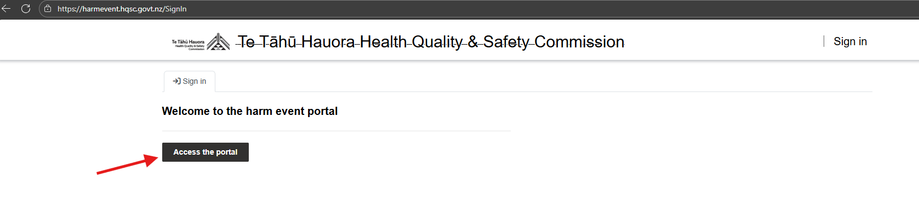

Navigating the Portal
After logging in, you will be directed to the main page.
Note: Fields marked with an asterisk (*) are mandatory fields and you will not be able to submit the form until they are completed.

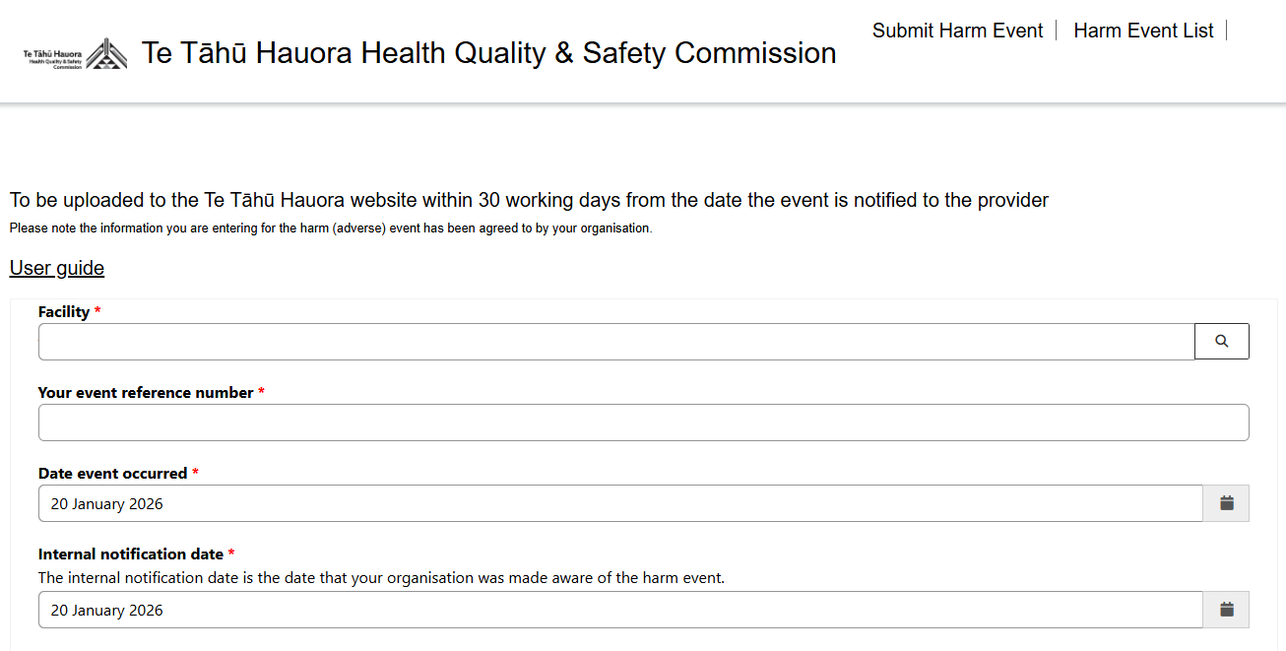

Key Sections:
In the top right corner of the screen, you will see the following two tabs alongside your username:
- Submit Harm Event
- Harm Event List
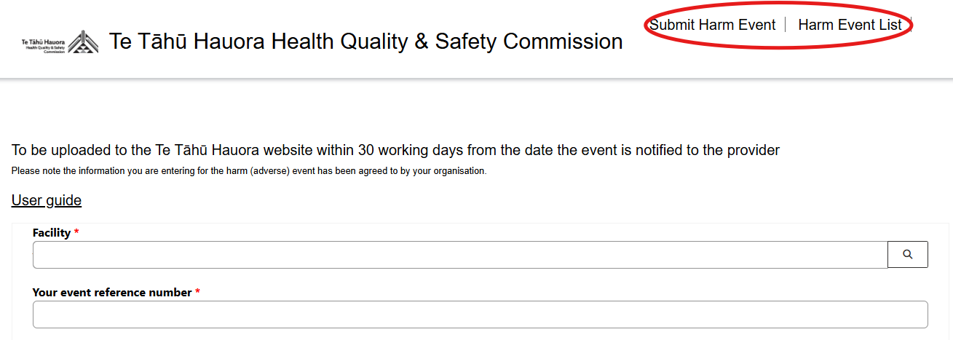

Submitting a new harm event
Click the Submit Harm Event tab to submit the events.
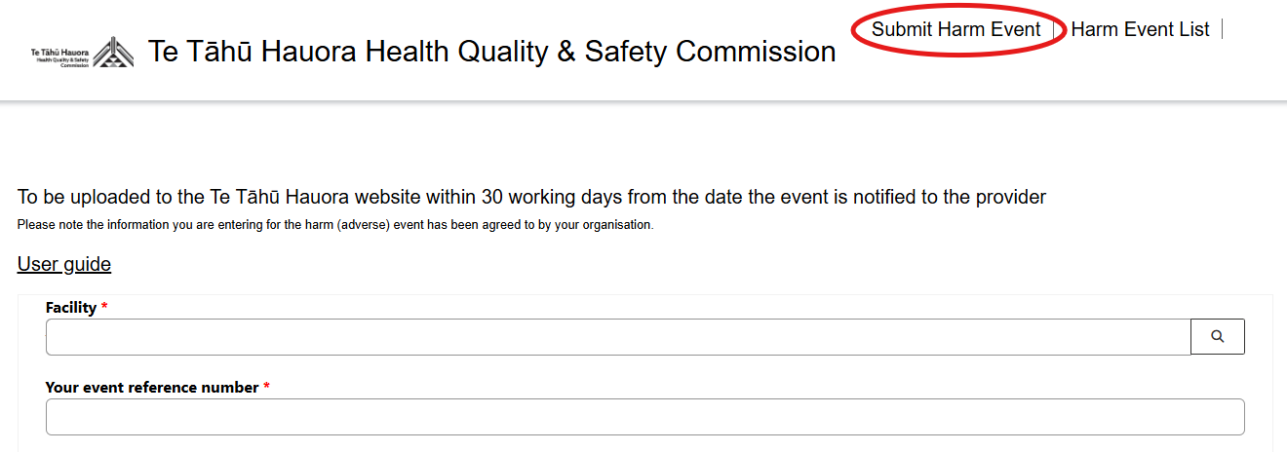

Facility: Click on the Facility search button to choose the Facility.
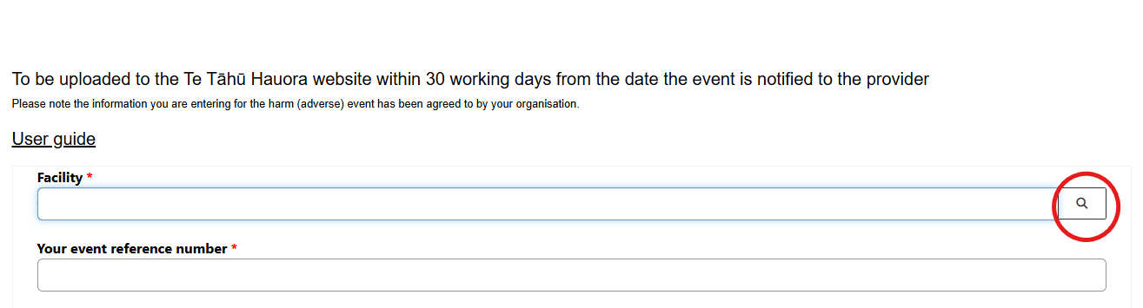

Choose one record by clicking in the box next to the relevant Facility (or) type the Facility into the Search bar and click on the magnifier. Then, check the relevant box and press the Select button. 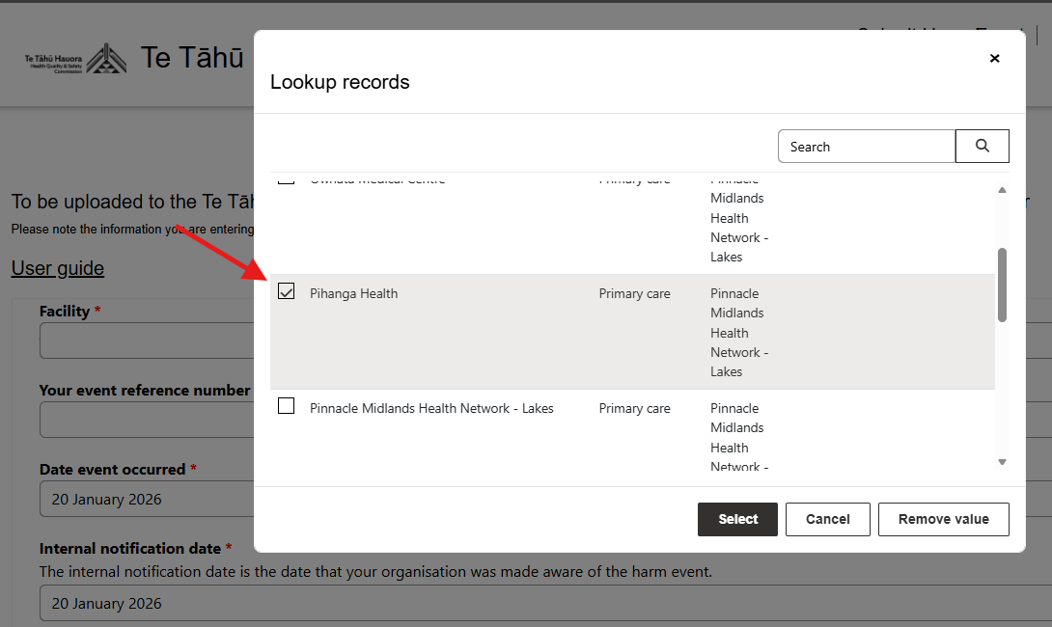
OR
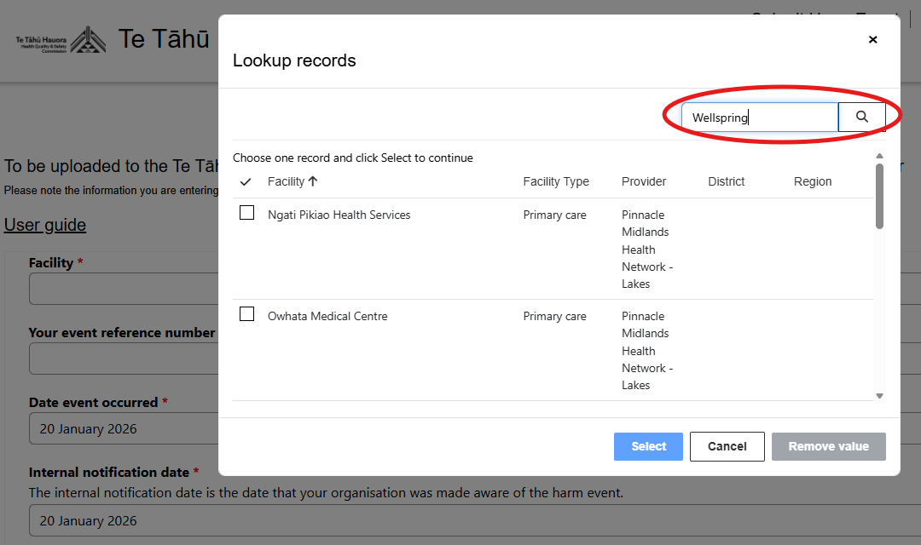

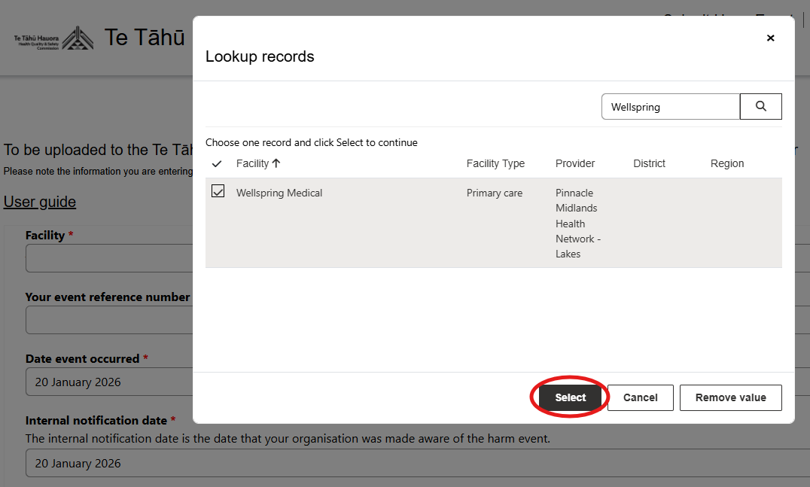
Your event reference number: Enter the unique event reference number for this event. This could be the reference number generated by your organisation’s incident management system (e.g. Safety First, Datix). If your organisation does not have an incident management system, please create a reference number for the submitted event.
Note: the event reference number needs to be unique from other events, or an error message will pop up.
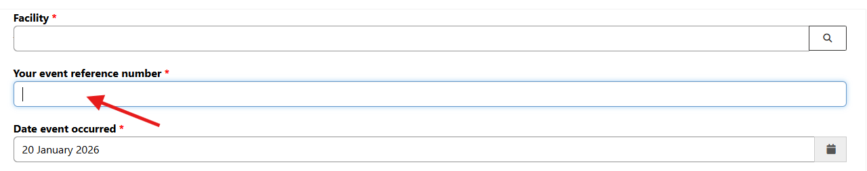
Date event occurred: Click on the calendar icon to open the calendar pop up and select the date the harm event occurred. If the harm occurred over a period of time, select the date at the beginning of this period.
Note: dates beyond the reporting period are not available for selection. First date selectable is 1 Jan 2020.
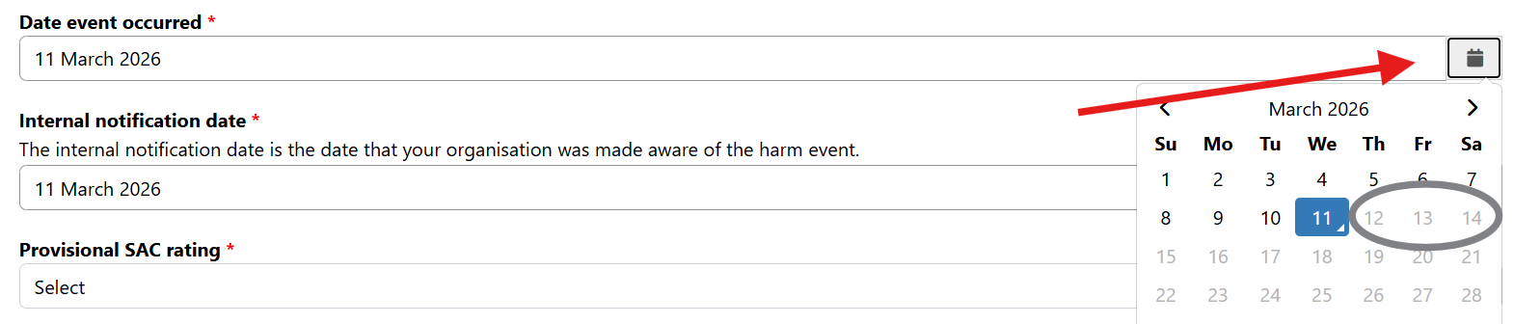

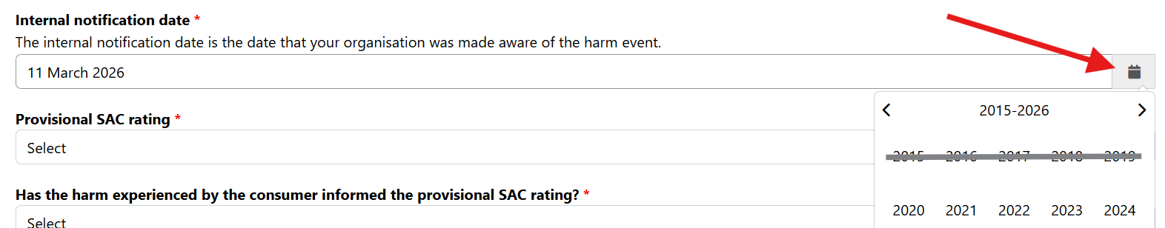
Internal notification date: Click on the calendar icon to open the calendar pop up and select the date the event was internally reported. This is the date when an incident form was completed, or the harm event was escalated for review.

Note: If people would like to submit or edit a date from before 1 Jan 2020, please let us know at harm.event@hqsc.govt.nz

Submitting an Always Report and Review (ARR)
Note: This question is only visible to private hospital and Health New Zealand (Health NZ) submitters. If you are NOT a private hospital or Health NZ submitter, please proceed to the instructions in Dark blue Provisional SAC rating.

- On ARR List: Indicate if the event is on the ARR list (Yes/No).
If yes, please follow instructions in teal:
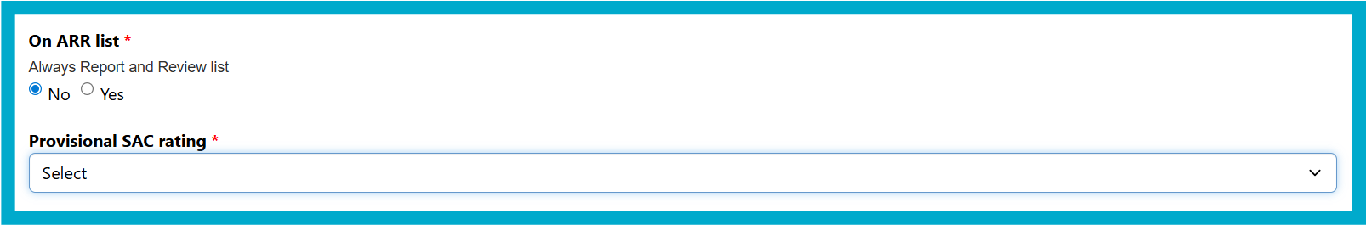
- Provisional Severity Assessment Code (SAC) rating allows a dropdown selection of 1–⁠4.

- Has the harm experienced by the consumer informed the provisional SAC rating? Select Yes or No.
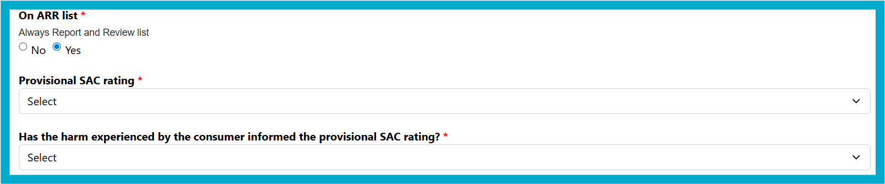
The ARR category field becomes mandatory. Click on the magnifier and check the box next to the relevant option.

If it is a seclusion event, you will be asked two further questions:
Was the secluded person under forensic mental health services? AND was the secluded person under the following legislation?
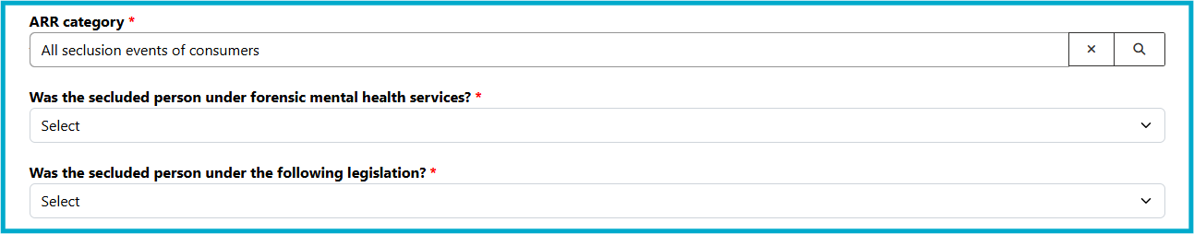
Select Yes or No from the dropdown.

If the event is not on the ARR list, or you are not submitting a harm event for Health NZ
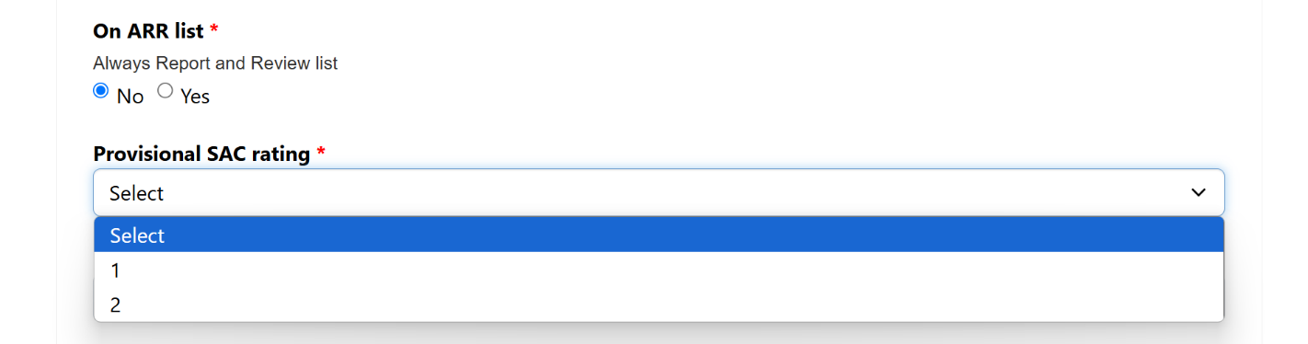
- Provisional Severity Assessment Code (SAC) rating allows a dropdown selection of 1 or 2.

- Has the harm experienced by the consumer informed the provisional SAC rating? Select Yes or No.
- Relevant SAC guide for the current harm event: Select the SAC guide that is relevant to the harm event you are currently submitting. SAC guides can be found on our website: Severity assessment code (SAC) examples.
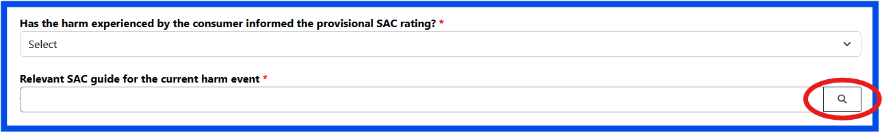
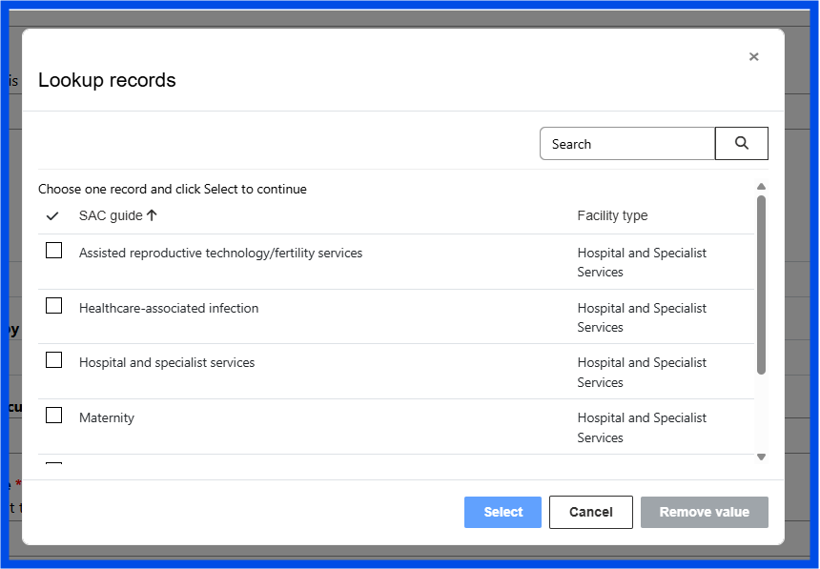

- Harm event from SAC guide: Select the specific event description that relates to the harm event you are submitting. If your harm event does not fit the SAC categories listed, please email harm.event@hqsc.govt.nz.
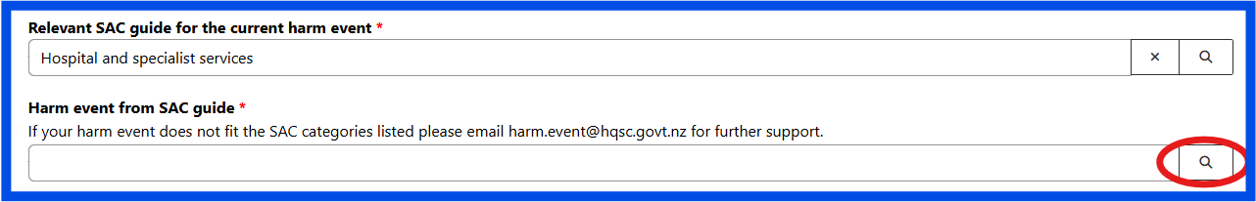

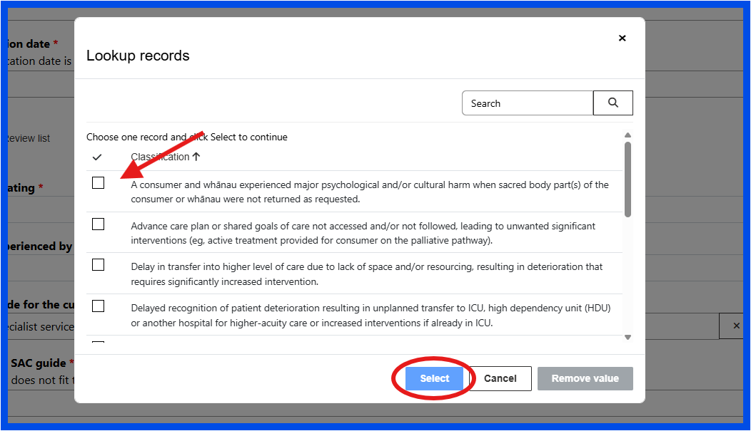
If you are submitting a pressure injury event you will see two extra questions:
- PI stage: select the stage of the pressure injury from the dropdown.
- Has a wound care specialist been involved in the care: Select yes or no.
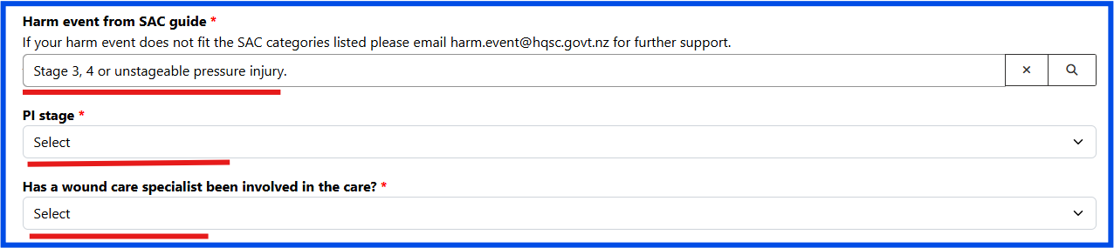
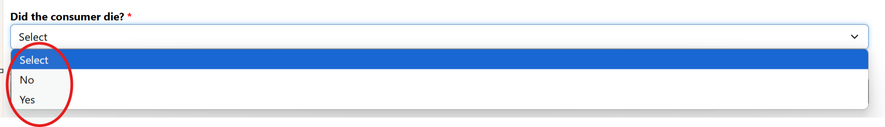
Did the consumer die? – select yes or no from the dropdown

- Age, Gender, and Ethnicity 1: Click the search and select the appropriate option from the lookup records
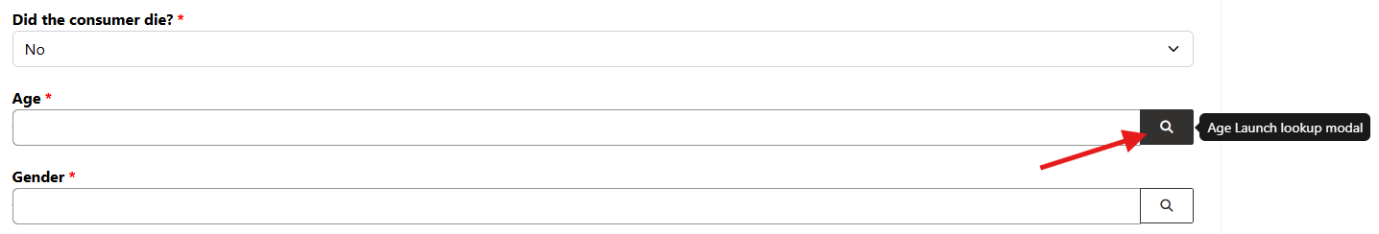
Ethnicity 2 and Ethnicity 3 – These are optional fields
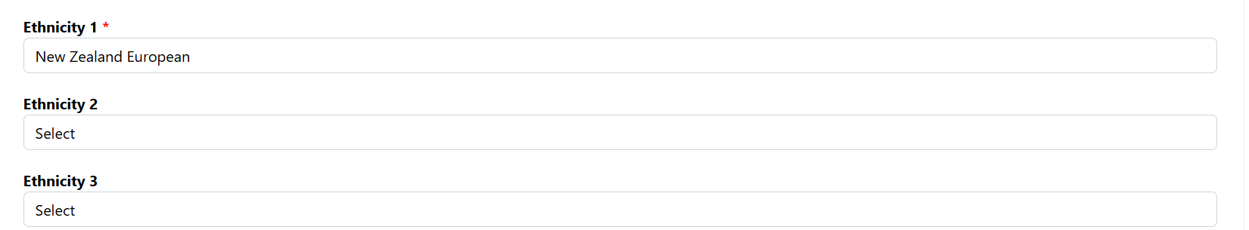
Click Submit when all the required fields are completed.
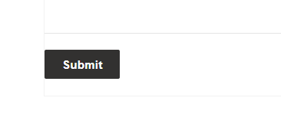

If your submission was successful, you will see the message ‘Successfully submitted Part A’.
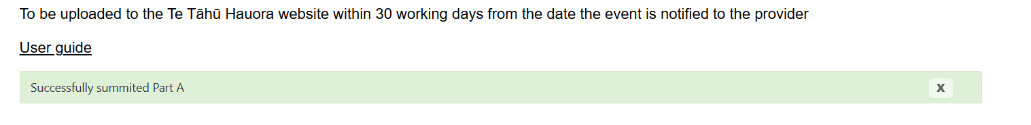
You will also receive email confirmation that your submission has been received saying: “Thank you! We have received your submission of a new harm (adverse) event.”

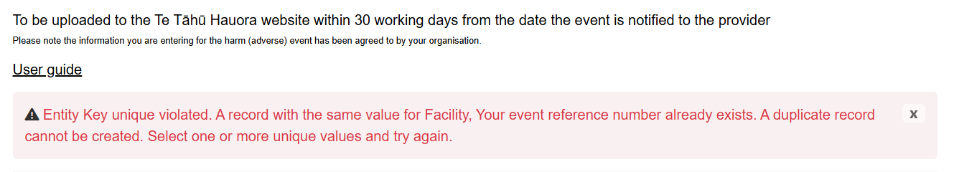
Note: If the event reference number already exists in the harm event list for your facility, the following message will appear: “Your event reference number already exists.” When this occurs, you must enter a unique event reference number, as the portal does not allow duplicate event reference numbers.

Submitting a Part B for an existing harm event

Where to enter Part B details
All part B details must be uploaded to the portal within 120 working days from the date the event was notified to the provider.
If you have previously submitted a Part A and you would like to complete the Part B for this event, go to the Harm Event List page.
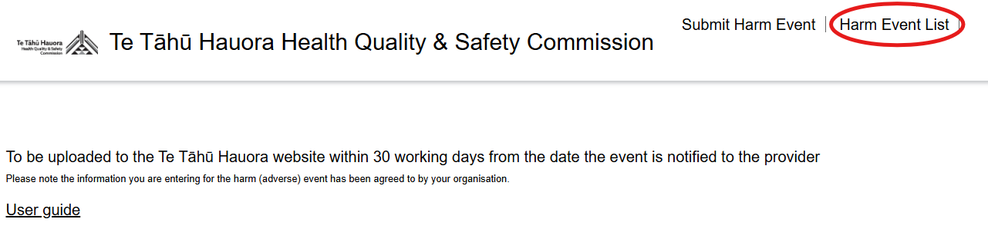

Look for the reference code of the relevant event. You may need to search or scroll (shown in blue below) to find the event. Then, click the three dots next to the Event Status column (circled in red below).
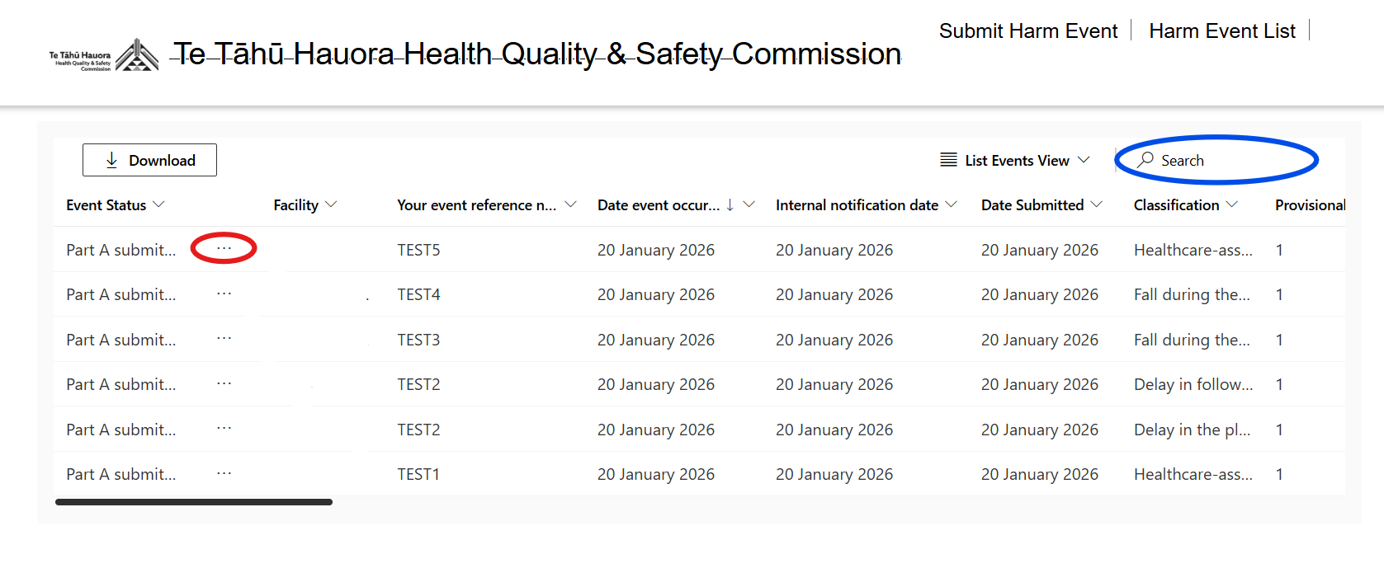
Then click ‘Edit Part B’ from the options that drop down.
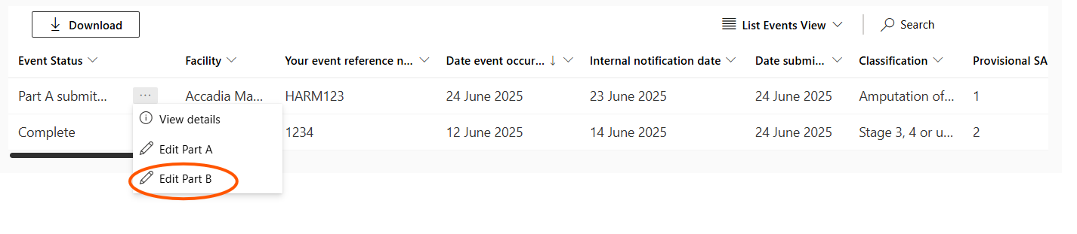

Now you can follow the instructions below to complete the Part B.

Filling out the Part B
Event Details
- Final SAC rating: Select the final SAC rating from the dropdown list. If, following the review, the harm event no longer meets the criteria for a SAC event select 'Non-SAC' event.
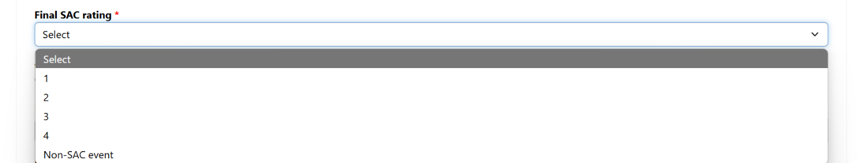
- Would you like to de-notify the event: Indicate whether the harm event should be de-notified (Yes/No).
Note: De-notification is applicable for Part As that have already been submitted, but on review, it has been confirmed that the event is no longer a SAC 1, 2 or ARR but is now a SAC 3, 4 or non-SAC event. Meaning, it no longer requires notification to Te Tāhū Hauora.
  - If Yes – Provide the reason for de-notification in the De-notification reason box below.
  - If No – go to the next question ‘Date review completed’

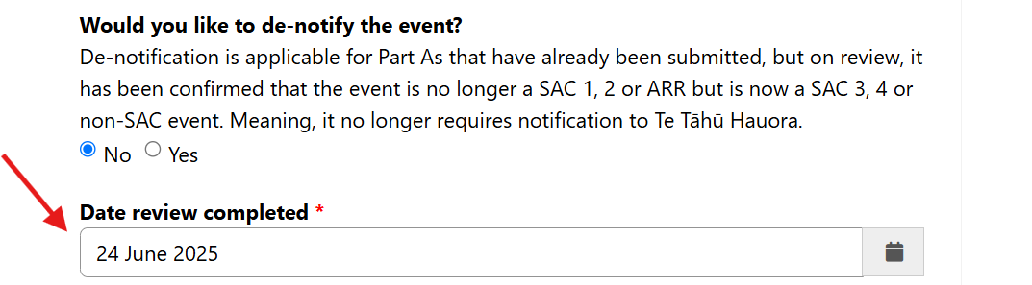
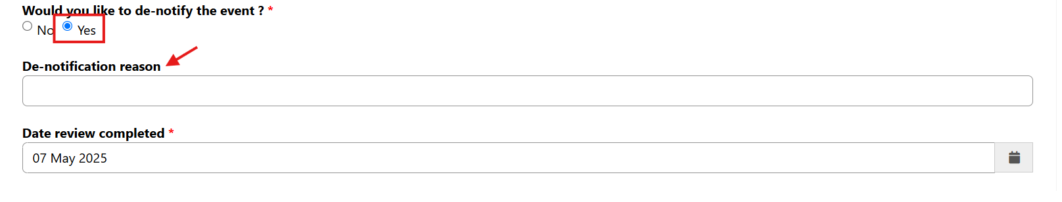
Date review completed: Click on the calendar icon and select the date the review was finalised within your organisation.
Note: dates beyond the reporting period are not available for selection. First date selectable is 1 Jan 2020. If people would like to submit or edit a date from before 1 Jan 2020, please let us know at harm.event@hqsc.govt.nz
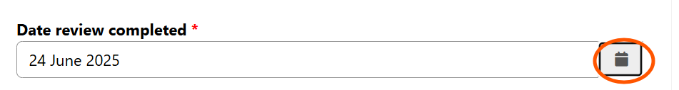
- Review Methodology Used: Click the magnifying glass to search and then select methodology used from the list. If the methodology used is not listed select ‘Other’.
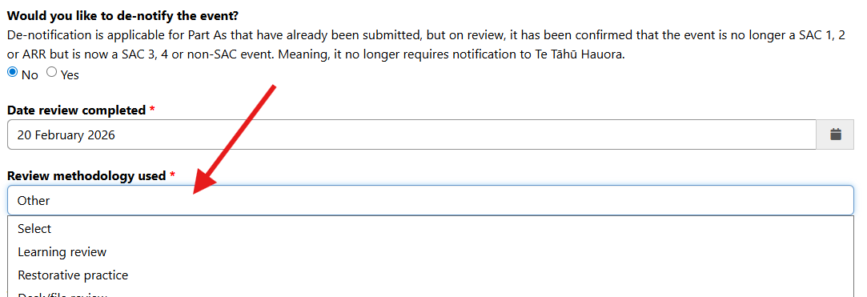
If you are reporting a seclusion event, you will need to indicate this is a seclusion event then answer four additional questions as seen below.
Note: This question is only visible to private hospital and Health New Zealand (Health NZ) submitters. If you are NOT a private hospital or Health NZ submitter, please proceed to the next instructions – Identifying learning opportunities.

- Is this a seclusion event?: Select the option (Yes/No).
- Was the seclusion event longer than 24 hours cumulative within 28 days?: Select the option from the list (Yes/No).
- Did the event comply with the Guidelines for reducing and eliminating seclusion and restraint under the Mental Health (Compulsory Assessment and Treatment) Act 1992?: Select the option from the list (Yes/No).
- Did the review include consumer and/or whānau participation?: Select the option from the list (Yes/No).
- What influencing factors contributed to the seclusion event?: Select the options from the list.
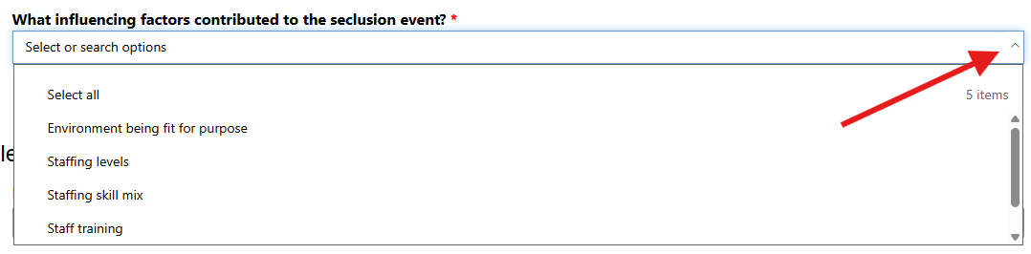
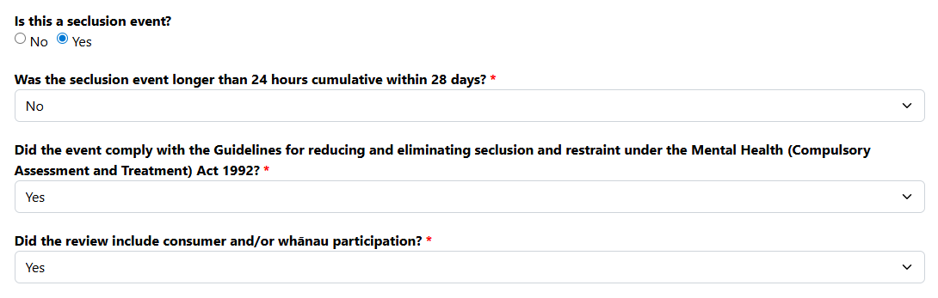

Identifying Learning Opportunities
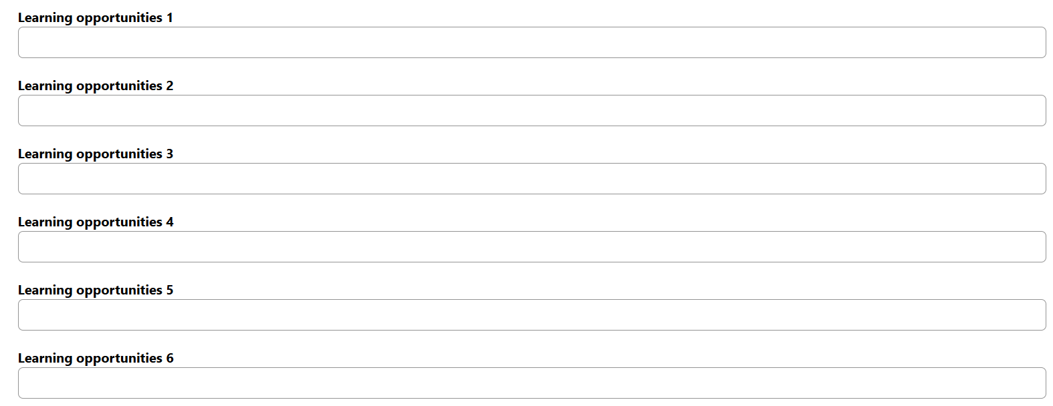
- Up to six learning opportunities can be entered into the six boxes.
- Anonymised Report Submission: Indicate whether the anonymised report has been submitted (Yes/No).
Uploading the Final Review Report
- Attach full anonymised report (PDF only).
- Maximum: 1 file, up to 5MB
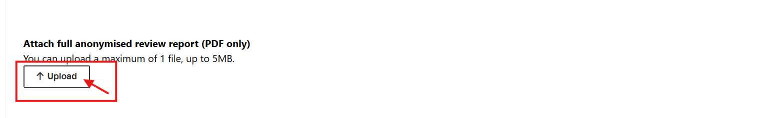
Like attaching a file to an email, click Upload. Navigate in your files to find your anonymised review report and click Open to upload the file.
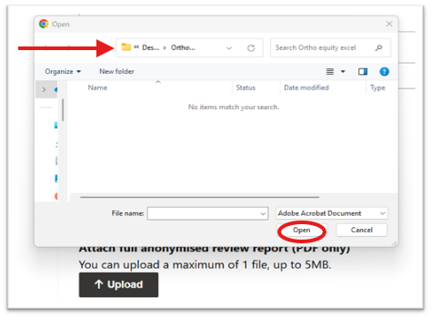
The following image shows a successful file upload:
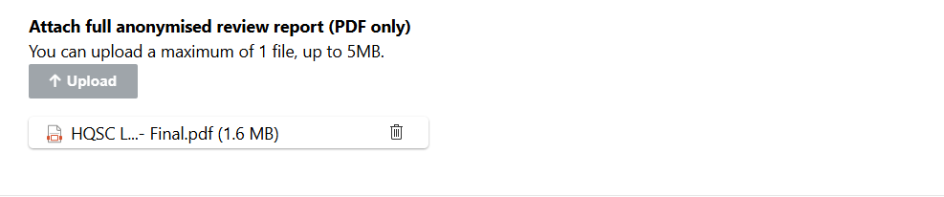
For the question This harm (adverse) event has been approved for transmission by the organisation’s chief executive (or equivalent) or senior delegate who endorses the accuracy and content of the document on their behalf, choose yes or no. If ‘yes’ is selected the event status will show as ‘Complete’ in the Harm Event list.

Harm Event List page

View details or edit event details
To view or edit a previously submitted part A or B, navigate to the Harm Event List page.
You can use the search bar to search the reference code of the event you would like to edit.
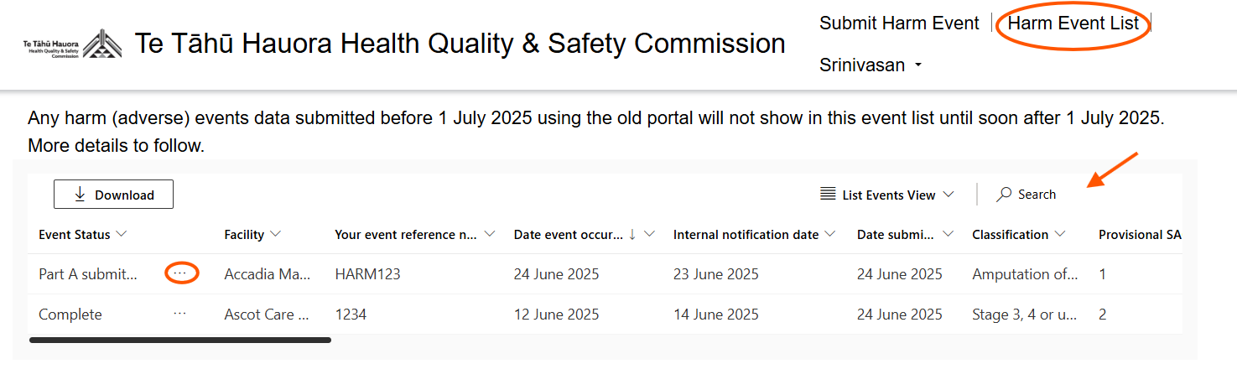
To edit an event, click on the three dots to the right of the ‘Event Status’ column.

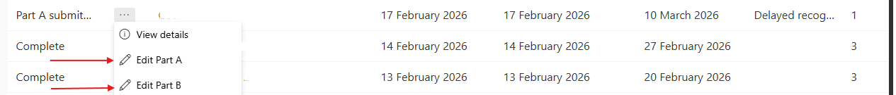
Click Edit Part A or Edit Part B.

A pop up will appear where you can make any changes.
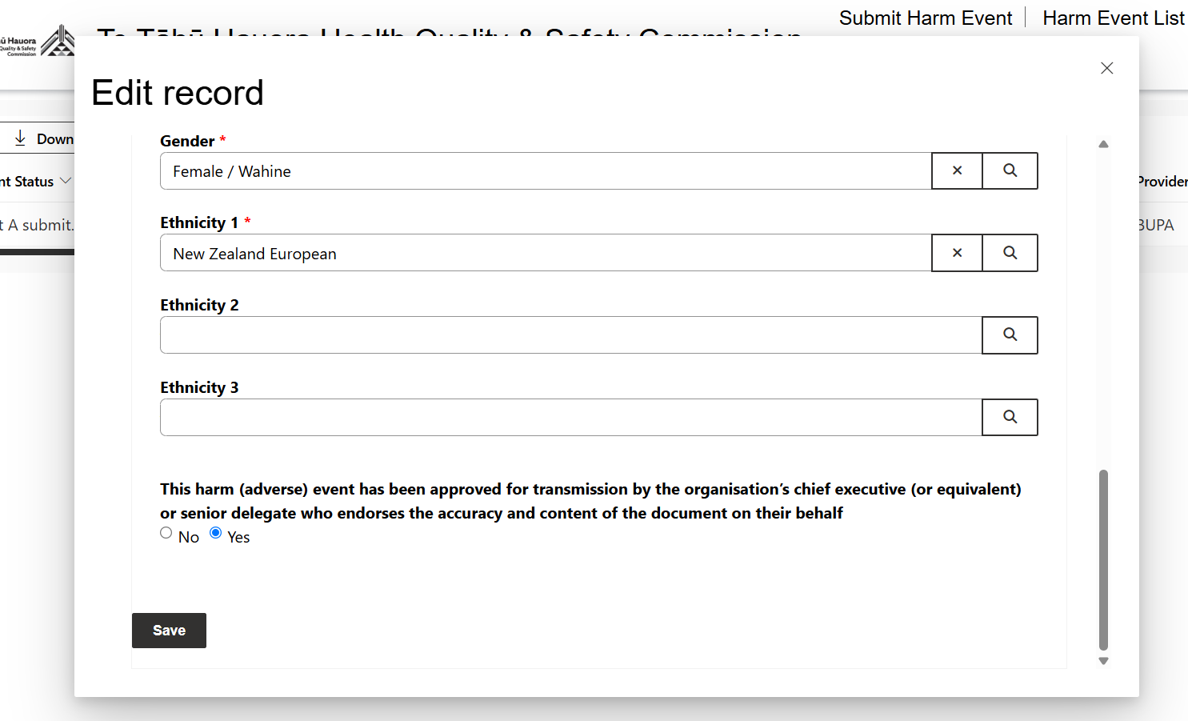
At the bottom of the page Click Save to save your changes.

Download data
To download submitted harm event data, click the Download button. This will save as an excel workbook to your computer.
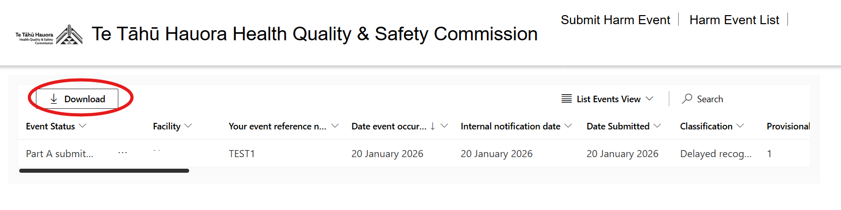

View more columns
Drag the black bar at the bottom of the Harm Event List table to scroll across and view more columns.
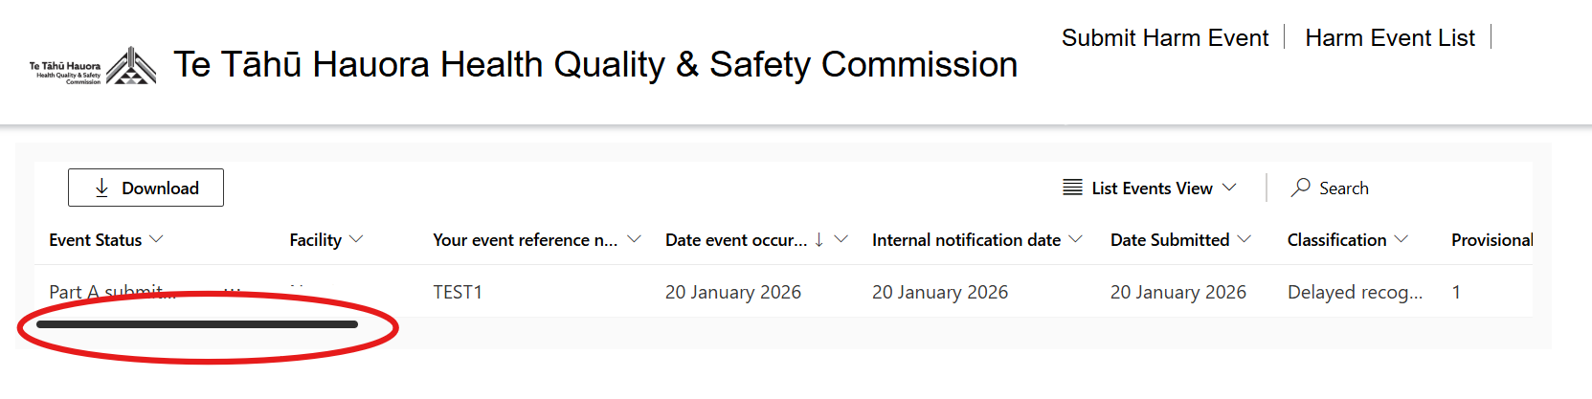

Filter or sort the data
To filter or sort the event list, click on the arrow next to the column you would like to sort or filter.
Click the down arrow as shown in the screenshot, sort the events to be ascending or descending, or filter the events. The Filter by function uses standard search criteria terms.
