

Learning from health care harm
System safety report, using data from multiple agencies
1 July 2022 to 30 June 2025



Published June 2026 by Health Quality & Safety Commission Te Tāhū Hauora,
PO Box 25496, Wellington, 6146.

ISBN 978-1-991122-49-0
Available online at hqsc.govt.nz
Enquiries to: info@hqsc.govt.nz

This work is licensed under the Creative Commons AttributionNonCommercial-ShareAlike 4.0 International (CC BY-NC-SA 4.0). To view a copy of this licence, visit creativecommons.org/licenses/by-nc-sa/4.0




Contents
Executive summary 5
Introduction 6
Background 7
Agency roles and contribution of data to the report 8
Health Quality & Safety Commission Te Tāhū Hauora 8
Health NZ 10
Accident Compensation Corporation 11
Health and Disability Commissioner complaints data 11
Method 13
Overview of the 10 themes 14
Rationale for selection of priority focus areas 18
System learning opportunity: procedure and clinical process reliability 18
System learning opportunity: hospital-acquired pressure injuries 18
System learning opportunity: transitions of care for older people 19
Next steps 20
Conclusion 21
Appendix 22
References 33

Table
Table 1: World Health Organization incident classification codes and categories and the themes of this report 13

Figures
Figure A1: Reported harm (adverse) events by provider type, July 2018–June 2025 22
Figure A2: Reported SAC 1 and 2 harm (adverse) events, Falls, July 2018–June 2025 23
Figure A3: Reported SAC 1 and 2 harm (adverse) events, pressure injuries, July 2018–June 2025 23
Figure A4: Rate of hospital-acquired pressure injuries per 100 episodes, Q1 2017– Q2 2025, with baseline of 2017–2019 (NMDS) 24
Figure A5: Hospital acquired pressure injuries identified in hospitalisation data to triangulate with SAC 1 and 2 harm events of pressure injuries, by age group, Jan 2017–June 2025 25
Figure A6: Reported SAC 1 and 2 harm (adverse) events, deterioration, July 2018–June 2025 25
Figure A7: Reported SAC 1 and 2 harm (adverse) events, clinical administration, July 2018–June 2025 26
Figure A8: Reported SAC 1 and 2 harm (adverse) events, complications, July 2018–June 2025 26
Figure A9: Reported SAC 1 and 2 harm (adverse) events, delays, July 2018–June 2025 27
Figure A10: Reported SAC 1 and 2 harm (adverse) events, wrong consumer, site or side, July 2018–June 2025 27
Figure A11: Number of reported events by SAC rating for wrong consumer and wrong site, 2022/23–2024/25 28
Figure A12: Average occupied bed days (OBDs) for acute admissions of patients aged 65 years and over, by selected diagnosis, 2012–2024 28
Figure A13: Decomposition analysis of the cause of increase in occupied bed days associated with lack of mobility diagnosis admissions, 2018–2024 29
Figure A14: Rate of accepted ACC Treatment Injury claims per 100,000 resident population Q3 2014 – Q3 2025 30
Figure A15: Number of ACC-accepted treatment injury claims of pressure injury, 2016/17–2024/25 31
Figure A16: Number of hospital-acquired pressure injuries and non-hospital-acquired pressure injuries recorded in the National Minimum Dataset, Q1 2017–Q3 2025 32
Figure A17: Reported ACC risk of harm events, 2022–2025 (ending June) 32

Executive summary
The Learning from health care harm system safety report aims to highlight the breadth of harm occurring across the health and disability system. Patients are at the heart of the health system, and this report highlights system learning opportunities that support health entities to improve care and safety.
The Pae Ora (Healthy Futures) Act 2022 objectives for the Health Quality & Safety Commission Te Tāhū Hauora are to lead and coordinate work across the health sector for the purposes of monitoring and improving the quality and safety of services, and helping providers to improve the quality and safety of services (subpart 3). The Commission’s functions are to advise the Minister of Health on how services quality and safety may be improved and measure the quality and safety of services.
Responding to an ongoing system expectation to collectively learn from harm, Health New Zealand | Te Whatu Ora, the Accident Compensation Corporation, the Health and Disability Commissioner and the Commission shared harm data to identify opportunities for system learning and focused improvement.
This report draws on the harm data and insights to better understand where harm is occurring across the health and disability system and where issues converge. The report does not seek to analyse individual harm events or assign causal responsibility. Instead, it focuses on learning more about common system-level themes and pressures that influence where harm occurs across the system.
Analysis of this multi-agency quantitative harm data and qualitative insights from 1 July 2022 to 30 June 2025 identified 10 recurring system-level themes. These included inconsistency in clinical processes and procedures; delays and breakdowns during transitions of care; harm associated with pressure injuries; workforce and governance pressures affecting system resilience; and inequities in access, experience and outcomes for specific population groups. These represent common themes of harm across multiple care settings, reflecting the complexity and interconnected nature of the health and disability system.
After considering the improvement work already undertaken, we prioritised the 10 system-level themes into three system learning opportunities for coordinated system-level improvement:
procedure and clinical process reliability
hospital-acquired pressure injuries
transitions of care for older people aged 65 years and over.
This report identifies learning opportunities for all health entities, and we will share this report with them through the National Quality Forum to agree on next steps. The system learning opportunities require further exploration to understand how current work is carried out and to identify where focused improvements can be implemented and appropriately resourced.

Introduction
The fundamental belief that the safety of the health and disability system is a shared responsibility informs this Learning from health care harm system safety report. The report uses data from multiple agencies: Health New Zealand | Te Whatu Ora (Health NZ), the Accident Compensation Corporation (ACC), the Health and Disability Commissioner (HDC) and the Health Quality & Safety Commission Te Tāhū Hauora (the Commission). Each agency holds a distinct role in identifying harm and in facilitating the opportunity for affected people to heal, for the system to learn and for the quality and safety of health care to improve. Combining data enables us to look beyond our historical approach of a single agency view to develop a collective understanding of harm across the system. In this way, we can identify system learning opportunities that address systemic issues affecting quality and safety of care.

Background
In New Zealand, multiple agencies (ACC, HDC, Health NZ and the Commission) have roles in monitoring and improving system safety. Each agency collects, analyses and responds to different signals of harm. Each dataset provides valuable insight, but no single source can fully describe where harm is occurring or the system influences that may have contributed to that harm.
Examining shared harm data at a national level makes it possible to identify recurring themes and potential system influences that are not visible through isolated reviews or single-agency analyses. This is important to support learning beyond individual organisational or agency perspectives toward a shared data system view.
System safety is an approach that recognises that harm events in the system arise from the relationships and the interactions between people and the context within which they work. Understanding the realities of everyday work in a complex health system helps us understand how people navigate risks in real time and find solutions that better support safe care.
Despite sustained improvement efforts, potentially avoidable harm remains a significant and persistent challenge, both within New Zealand and internationally (WHO 2021). Harm occurs across the health and disability system; in New Zealand, it has a disproportionate impact on older people, people with complex needs, Māori and rural communities (Moore et al 2024).
How system safety risks are identified, escalated and acted upon remains a challenge within complex health systems both nationally and internationally. Where multiple organisations have responsibility for monitoring, learning and improvement within their agency, visibility is often limited to discrete parts of the care system rather than the full care journey. This creates blind spots in recognising evolving risks and potential harm.
As a result, the ability to prioritise risk at a system level is reduced; translation of safety information into coordinated system responses is delayed and learning is less effectively embedded into sustained system-wide improvement.
The global significance of health care harm was formally recognised through the development and adoption of the World Health Organization (WHO) Global Patient Safety Action Plan in 2021 (WHO 2021). Central to the WHO action plan is the expectation that member states take coordinated, system‑level action to align existing strategies and data sources and use shared learning to identify potentially avoidable harm and prioritise improvement efforts.
This approach enables a wider view of the system factors that impact on health care, with the aim of making visible where these influence how harm occurs across the health and disability system. The national perspective informs system learning opportunities, with potential to strengthen safety through the application of system re-design, enabling provision of care that is person centred, informed by principles of system safety and resilience engineering.

Agency roles and contribution of data to the report
This section describes the role of each participating agency and the specific harm data that contributed to the report. These data sources collectively capture system safety signals across hospital and aged residential care settings and provided the evidence base for the thematic synthesis that follows.

Health Quality & Safety Commission Te Tāhū Hauora
The Commission is a Crown entity. Its role is to lead and coordinate work across the health sector for the purposes of monitoring and improving the quality and safety of services and helping providers improve the quality and safety of services, as defined in the Pae Ora (Healthy Futures) Act 2022.
Regarding harm, the Commission utilises quality and safety indicators (such as serious harm events or quality safety markers (QSMs)) and provides public reports measured against these and other information that the Commission considers relevant. The Commission promotes and disseminates information to support improved quality and safety of services.
The Ngā Paerewa health and disability services standard NZS 8134:2021 criterion 2.2.5 requires harm (adverse) events to be reported to the Commission. This standard covers a wide range of health and disability services and provides the foundation for describing best practice. The Commission’s role is to actively support the health and disability sector with its responsibilities to follow the national policy (HQSC 2023b), which supports healing, learning and improvement from harm.
The Commission shares national annual serious harm event data, informed by statistical analysis, publicly via infographics (HQSC nd(a)). This is based on the harm (adverse) events reported to the commission from providers using WHO conceptual framework for patient safety WHO Conceptual Framework for the International Classification for Patient Safety, and WHO codes and definitions.
Our summary of findings from 1 July 2022 to 30 June 2025 draws on this analysis to highlight key patterns of harm across the health and disability system. Outlined below are some of the Commissions key data and information that have contributed to this report.

Statistical analysis of harm event data
Analysis of reported harm events from July 2022 to June 2025 (Appendix Figures A2–A3, A6–A11) provides insight into where significant harm is occurring and where further analysis and action is required. ‘Special cause variation’ in the control charts refers to unexpected fluctuations in a process caused by specific, identifiable factors rather than natural, everyday operation (common cause variation). This formed the foundation from which triangulation of other datasets occurred to inform system-level themes.
A review of this data shows there has been a sustained decrease in hospital falls resulting in serious harm, including fractures, life-saving intervention or death (Appendix, Figure A2). This reflects the sustained impact of the Commission’s falls prevention quality improvement programme, alongside the continued use of current resources, supporting improved clinical practice. Similarly, early signs of a decrease in complications was observed, indicating improvement in some areas of clinical care (Appendix, Figure A8; see also our Harm (adverse) events quarterly dashboard: Background: Data definitions: WHO codes and definitions).
Harm events associated with delayed recognition of deterioration have shown a sustained decrease (Appendix, Figure A6). This aligns with the Commission’s Early Warning Score Quality Improvement Programme and indicates strengthened recognition and response to clinical deterioration.
In contrast, there has been a sustained increase in non-hospital-acquired pressure injuries (Appendix, Figure A3) and hospital-acquired pressure injuries (Stage 3, 4 and unstageable) (Appendix, Figure A4 & A5). This prompted a multi-agency review between the Commission, ACC and Health NZ in September 2024. (The outcome of this improvement work is outlined in Theme 4 – pressure injuries and falls.)
Clinical administration-related harm events have indicated an increase since 2023 (Appendix, Figure A7). This trend suggests the presence of underlying system or process-related issues that require further detailed examination. The persistence of this pattern indicates that these events are unlikely to be random variation and instead may reflect structural inefficiencies or workflow vulnerabilities in how care is delivered in the clinical setting.
We identified wrong consumer and wrong site events as an area requiring further review (Appendix, Figure A10). On further examination, these incidents were predominantly low-harm radiology events, classified as severity assessment code (SAC) 4 (Appendix, Figure A11). Many of these were near-miss events, which highlights both the effectiveness of existing safety barriers and a strong culture of reporting within radiology services. The visibility of these events likely reflects high reporting transparency rather than a deterioration in clinical practice.
Special cause variation was also observed in harm events related to delays in care (Appendix, Figure A9). These signals prompted further triangulation with additional system-level datasets to better understand the contributing factors. This broader analysis identified system flow pressures as a key concern, influencing delayed access to health care (Appendix, Figure A12).
Access to primary health care has deteriorated since the COVID-19 pandemic, contributing to increased demand on acute services. From 2023 onwards, there has been a marked rise in emergency department presentations, especially among higher-acuity triage categories (Appendix, Figure A12). This shift indicates both increased patient complexity and potential unmet need in the community setting.
There has also been a significant increase in acute hospital admissions among people aged 65 years and over (Appendix, Figure A12). In parallel, people aged 75 years and older have experienced longer average lengths of stay, often with repeated admissions (Appendix, Figure A13). These patterns could reflect increasing clinical complexity, frailty and challenges in achieving timely discharge for this patient group. A growth in occupied bed days among older patients with reduced mobility (Appendix, Figure A13), further reflects rising demand for inpatient care, placing further strain on hospital capacity and patient flow.
Taken together, these system-wide flow pressures are contributing to delays in care and affecting the delivery of timely health services (HQSC 2024d). The observed patterns highlight the influence of broader health system dynamics, rather than isolated service-level issues, underscoring the need for coordinated, whole-of-system responses.

Thematic analysis of maternity adverse events reported
1 July 2018–30 June 2023
The maternity thematic analysis (HQSC 2023a) report highlights how the underpinning safety model and tools used in the past have led to a focus on individual actions, with a relative absence of wider system influences. As a result, this has limited learning about the wider health and disability system and how best to improve the conditions in which maternity care is provided. By changing the underpinning safety model and tools, we can gain a better understanding of the context and influences that shape care, bringing together multiple perspectives to develop sustainable system-focused improvements.

Thematic analysis of aged residential care harm (adverse) events reported 1 July 2024–30 June 2025
As of 1 July 2024, clinical harm events for aged residential care (ARC) must be reported pursuant to the requirements of the Commission’s ‘healing learning and improving from harm: national adverse events policy. The Commission has completed an analysis of the first year (2024/25) of ARC harm events reported directly to the Commission. The report, which is available on the Commission’s website, identifies opportunity for improving learning from reviews that focus on system change rather than person-focused improvement (HQSC 2026).

Use of insight reports
The previously published insight reports (HQSC 2024a (September), 2024b (November), 2025a) contributed to the analytical evidence base for this report’s thematic analysis. This thematic foundation underpins the prioritisation process described later in this report, which consolidates the 10 themes into three priority focus areas.

Health NZ
Health NZ designs, commissions and delivers public health services for New Zealanders. For this report, Health NZ contributed context and supported understanding of harm associated with hospital-based care, drawing on its national system insights from quality alerts (informed by the QSM) and harm events.
Health NZ undertook a strategic assessment of the aged care sector in New Zealand in a review of aged care funding and service models that led to the Sapere report (Moore et al 2024). The report raised concerns about the supply and commissioning of aged care services. Equitable and timely service access has become compromised due to workforce pressures, rural shortages and funding inadequacies. As is seen in other jurisdictions, the ageing population will put significant pressure on health care services.

Accident Compensation Corporation
The ACC is a purchaser, steward and injury prevention partner within the health and disability system. We reviewed ACC risk-of-harm notification analysis (2022–June 2025) and grouped it by common patterns to identify the following recurring system‑level causes of serious harm (Appendix, Figure A15).
Surgical and procedural complications
Healthcare‑associated infection and sepsis
Equipment and medical device incidents
Diagnostic error and failure to follow up
Anticoagulation and antiplatelet‑related events
Medication errors and adverse drug events
Obstetric and maternity‑related incidents
Clinical deterioration and monitoring failures
Retained foreign objects and retained surgical items
Blood and transfusion‑related events.
ACC treatment injury data provides additional insight into harm patterns, including trends in infection-related harm and pressure injuries (Appendix, Figures A14–A17). The data shows increasing rates of accepted treatment injury claims over time, as well as growth in pressure injury claims, providing further evidence of system-level pressures and patterns of harm identified in this report.

Health and Disability Commissioner complaints data
The HDC is an independent Crown entity whose role is to promote and protect the rights of people using health and disability services, as set out in the Code of Health and Disability Services Consumers’ Rights. The HDC does this by resolving complaints from consumers and whānau about quality of care and making specific recommendations to improve the quality and safety of the health and disability system.
The HDC’s contributed complaints data highlights how system pressures are experienced in practice, including issues related to access, delays, communication, informed consent and quality of care across health and disability services.
During 2024/25, complaints about public hospital services commonly related to:
care and treatment, including delayed access to care across a number of service areas (emergency departments, cancer care, maternity care, ophthalmology follow-up, primary care and radiology)
communication issues
informed consent (including pressure on informed consent processes).
During 2024/2025, complaints about the aged care sector related to:
challenges in discharge planning and transitions from hospital to aged residential care and community services
gaps in access to psychogeriatric care
workforce sustainability and capability pressures
escalation of care and access to timely medical review
dementia care and management of behaviours of stress and distress
documentation and care planning
provision of end‑of‑life care
inadequate communication with family and welfare guardians
variability in complaints management capability.

Method
The focus of our analysis was not to quantify harm rates or attribute causality but to interpret statistical signals alongside other quantitative and qualitative insights to understand where harm is occurring within the health and disability system.
During the three-year period of this report, the Commission undertook annual statistical analysis of harm (adverse) data (see Appendix, Figures A2–A10) to identify common cause and special cause variation. These findings were then reviewed and triangulated with data from ACC, HDC and Health NZ to provide broader system context and identify 10 themes. We held internal discussions to validate emerging insights. This approach reduced reliance on any single dataset or organisational perspective and strengthened our confidence in the resulting findings.
The 10 system-level themes are:
- timeliness and transitions of care
- procedure and clinical process reliability
- infection and sepsis risk
- pressure injuries and falls
- escalation and early recognition of deterioration
- workforce capacity and sustainability
- clinical governance maturity and feedback loops
- data visibility and quality improvement capacity
- equity and cultural safety
- transitions of care for older people (65+ years).
To test the robustness of the thematic structure, we mapped the 10 themes to WHO incident classification categories (WHO 2010). The mapping spans clinical administration, clinical processes, infection, medication, staffing, organisational factors and patient accidents. This alignment provides assurance that the themes reflect recognised domains of system safety risk rather than localised or anecdotal issues.
Table 1: World Health Organization incident classification codes and categories and the themes of this report
WHO code | WHO category | Our themes
1 | Clinical administration | 9
2 | Clinical process / procedures | 1, 2, 5, 4, 10
4 | Healthcare-associated infection | 3
7 | Medication / IV fluids | 2
11 | Consumer accidents | 4, 10
14 | Resources/organisational/management | 6, 7, 8, 9, 10

Overview of the 10 themes
Our themes provided a structured understanding of where harm is occurring across the health and disability system, the system conditions associated with that harm and shared system‑level risk signals from multiple data sources across the system. We have also identified where work is underway or completed to address some of the issues identified within these areas.

Theme 1 – Timeliness and transitions of care
Care pathways between primary, community and hospital services are not universally reliable. Delays in diagnosis, specialist assessment, treatment initiation and follow‑up contribute to potentially avoidable deterioration and harm, particularly during transitions between services.
The New Zealand Health Plan (Te Pae Waenga) (Health NZ 2025b) was launched in August 2025. It aims to improve health care access, focused on faster cancer treatment, reduced emergency department wait times and strengthening primary health care to enable consistent and equitable care across New Zealand.

Theme 2 – Procedure and clinical process reliability
As a generic theme, clinical processes are embedded within the other themes identified below. More specifically, however, persistent safety issues are evident related to informed consent and handover documentation, diagnostic and procedural errors, retained surgical items, dental equipment and medical device incidents, transfusion‑related events, medication harm related to anticoagulation and antiplatelet-related events. There is variability in the reliability of core clinical processes and safeguards, particularly under systems pressure.
The Commission has worked with the health sector to improve procedure and clinical process reliability. Since 2012, the Commission has been encouraging hospitals to use the WHO’s Surgical Safety Checklist. More recently, the Commission has developed a national anticoagulation stewardship programme, with the intention of promoting safe, high-quality care by improving the use of anticoagulants within health care settings.

Theme 3 – Infection and sepsis risk
Ongoing infection prevention and control issues are evident, including missed or delayed laboratory results, IV line‑associated infection, post‑operative infections and sepsis. Sepsis events are associated with high severity harm and fatality for patients.
The Commission worked with Sepsis Trust NZ and a multidisciplinary sepsis technical advisory group, including representatives from clinical professional bodies, to develop a sepsis quality improvement package (HQSC nd(b)). These evidence-informed resources support a standard approach for health professionals working in hospitals or in pre-hospital community settings and include sepsis pathway tools, clinical and measurement guides and learning materials, which together improve early recognition and treatment of patients with sepsis. Health NZ has prioritised a sepsis work programme to commence in 2027.

Theme 4 – Pressure injuries and falls
In 2022/23, there was a sustained increase in non-hospital-acquired pressure injuries (NHAPIs), and in 2023/24, there was a sustained increase in reported harm events for hospital-acquired pressure injuries (HAPI) of stage 3 and 4 or unstageable.
Collaboration between ACC, Health NZ and the Commission resulted in further analysis using the national minimum dataset and ACC treatment injury claims. Data was grouped according to age and ethnicity. The NHAPI analysis was presented to the National Quality Forum in 2025,and it was agreed that the Commission would lead a community-based improvement project related to NHAPI harm. This is currently underway (HQSC 2025b), with the focus on NHAPIs for Pacific and Māori aged 75+ years in Counties Manukau District.
Following analysis of ACC-accepted treatment injury claims, HAPIs remain a persistent safety signal. There has been significant historical investment by ACC in reducing HAPIs, and the Commission has monitored clinical practice through the HAPI QSM. Health NZ districts collect the clinical practice data for the HAPI QSM, which measures completion rates for pressure injury assessments and individualised care plan for high-risk patients. Health NZ is actively monitoring its Health Roundtable data for stage 3 and 4 or unstageable HAPIs. There appears to be a system learning opportunity to understand what other system issues are contributing to HAPIs, for example, barriers to individualised care planning or easy access to appropriate equipment.
Historically, the Commission has focused on a falls prevention quality improvement programme and currently makes its ‘10 topics in reducing harm from falls’ resources available to the health sector to support the prevention of falls and reduce harm from falls in older people. Following this focused quality improvement programme, which ran from 2012–2018, there has been a sustained reduction in falls that resulted in life-saving interventions or death or fracture of a major bone.

Theme 5 – Escalation and early recognition of deterioration
Recognition and response to patient deterioration and delayed recognition and escalation contribute to serious harm. Evidence shows that early recognition is more reliable where vital signs monitoring and escalation pathways are visible, understood and consistently applied, whilst harm persists when recognition, escalation or response is delayed. Early warning systems support identification of patient deterioration and require sustained emphasis on reliability, timely clinical response and sufficient health workforce capacity. They are designed to support timely recognition and escalation of patient deterioration through structured observation and response pathways. The Commission has supported more consistent use of early warning systems across hospital settings.
The Commission developed and facilitated implementation of national standardised early warning systems to help clinicians identify when a patient's condition starts to get worse and support them in their escalation processes: the New Zealand Early Warning System, for adults in inpatient hospital settings; the Maternal Early Warning System, for pregnant or recently pregnant women in hospital settings; and the Paediatric Early Warning System, for children and young people in paediatric settings. All of these apply the same principles but use age and condition‑appropriate parameters where clinical presentation and normal physiological ranges differ. Escalation pathways were developed by each district to reflect local settings that recognise the different context and resourcing.
This focused quality improvement initiative has resulted in a sustained reduction in serious harm events reported to the Commission for delayed recognition of patient deterioration resulting in death, cardiopulmonary resuscitation or severe loss of function (Infographic 2023/24).
The Commission is currently supporting the implementation of the Deterioration Early Warning System, designed for use in aged residential care settings. Research shows that older people living in aged residential care often experience subtle or atypical signs of acute deterioration that are not well captured by hospital‑based early warning tools. The Deterioration Early Warning System supports health care assistants to notice day‑to‑day changes that may indicate acute deterioration, triggering a structured nursing assessment and a standardised escalation pathway.

Theme 6 – Workforce capacity and sustainability
Sustained workforce pressures include normalisation of inadequate staffing; reliance on discretionary effort; reduced continuity of care and challenges with supervision and skill mix, particularly in high-acuity, fast-paced clinical environments.
The New Zealand Health Plan (Te Pae Waenga) (Health NZ 2025b) is aimed at improving health care access, workforce support and clinical leadership.

Theme 7 – Clinical governance maturity and feedback loops
Feedback from alerts, learning from harm reviews, complaints and incident analysis do not always translate into timely or sustained system change. In some areas, known safety initiatives are not yet consistently embedded or reliably applied in everyday practice, contributing to the persistence of previously identified risks.
Clinical governance is a mechanism to provide accountability for quality of care and to improve consumer experience and outcomes. In November 2024, the Commission published the Collaborating for Quality: A framework for clinical governance | He mahi ngātahi kia kounga: He anga hei whakahaere whare haumanu (HQSC 2024c). It sets out a high-level framework for clinical governance in health and disability services across New Zealand and contains updated views on system safety, quality and equity to achieve a learning and responsive system for all populations. The Commission is working in partnership with Health NZ to support regional clinical governance; it held two regional workshops to this end (Central (Te Ikaroa) and the South Island (Te Waipounamu)). The Commission is also working with other health and disability providers to support their clinical governance arrangements, such as non-government organisations and public health organisations.

Theme 8 – Data visibility and quality improvement capacity
To drive quality improvement, front-line teams require timely, local visibility of issues, supported by accessible safety information and analytical capability. Digital enablement and quality improvement capacity vary across settings, reducing the system’s ability to detect, respond to and learn from harm consistently.
The Health NZ Centre for Digital Modernisation of Health was established to provide assurance on deliverability, scalability and reproducibility of digital health initiatives. It has a focus on integrating clinical input and leadership into digital projects and ensuring robust governance and accountability. Health NZ proposed 10-year road map, the Health Digital Investment Plan (Health NZ 2025a), details strategic direction, governance, clinical leadership integration and the phased approach to digital transformation.
In July 2024, the Commission transferred its Ako tahi hei whakapai ake i te kounga | Improving together: Building capability for quality and safety education programme to Health NZ. This programme had been in place since 2021. It is designed to build skills in system improvement and evidence-based change, enabling health professionals to lead quality improvement projects, focusing on system-wide changes that improve patient safety. Health NZ has continued to deliver the programme, which is accessible to the workforce across health and disability sector.

Theme 9 – Equity and cultural safety
Access barriers and advocacy gaps disproportionately affect Māori, rural communities, older people and people with complex or high needs. Stratified analysis by ethnicity, rurality and deprivation is required to understand differential exposure to risk and outcomes.
The Commission’s Equity Explorer provides information on how health and health care varies between groups of people and between districts within New Zealand.

Theme 10 – Transitions of care for older people (65+ years)
Older people experience higher health needs and more frequent interaction with the health and disability system. Issues associated with transitions of care are compounded by frailty, workforce pressure, governance limitations and system capability, particularly across hospital, community and aged residential care settings.

Rationale for selection of priority focus areas
The 10 system‑level themes provide a comprehensive description of where and how system safety risk has manifested across the system and highlight system-learning opportunities.
A deliberate prioritisation exercise identified which themes should be elevated for focused action, drawing on the shared evidence presented in this report and reflecting where focused quality improvement has already been undertaken. Through this process, we identified three priority system learning opportunities: procedure and clinical process reliability, hospital-acquired pressure injuries and transitions of care for older people.

System learning opportunity: procedure and clinical process reliability
Procedure and clinical process reliability reflects underlying system conditions rather than individual performance. Across the system, severe harm continues to occur when core processes designed to support safe care are undertaken in different ways under conditions of operational pressure, competing demands and workflow complexity. These conditions influence how care is delivered in practice, including when and how safeguards are applied. Understanding daily work practices (work-as-done) in the context of these system pressures will enable redesign of processes, tools and environments that better support the workforce and improve the reliability of safe care.
Where care involves complexity, time pressures, multiple handovers or transitions between teams, the importance of system safeguards increases. These safeguards include documentation, confirmation processes, escalation pathways, equipment checks and clarity of roles and responsibilities. Sometimes, system safeguards (tools, tasks and technologies) may have been implemented but not designed with the health worker in mind and may not reflect the everyday realities of a complex and constantly changing environment.
This focus area was prioritised because it represents one of the clearest opportunities to reduce high‑severity, potentially avoidable harm through system‑level improvement. Procedure and clinical process reliability underpins multiple other risks this report has identified, reflects system design and reliability weaknesses rather than isolated error and is amenable to coordinated action that strengthens safeguards across settings. Focusing improvement effort here shifts attention to strengthening core system processes that are designed with the end-user and enable health workers to provide safe care.

System learning opportunity: hospital-acquired pressure injuries
Pressure injuries represent a predictable system safety signal and may reflect how well hospitals support safe, person-centred care when there is reduced mobility, frailty or complex needs.
In hospital settings, pressure injuries are reflective of workforce capacity, care planning, access to appropriate equipment, continuity of care and surveillance. Most but not all pressure injuries are potentially avoidable. Early identification of the risk factors of developing a pressure injury should instigate care focused on prevention to reduce deterioration and the need for more specialised care with the potential of an extended length of stay.
Despite established prevention strategies, HAPIs continue to occur, suggesting variable implementation and inconsistency of clinical practice and internal reporting. This may also reflect the variety of pressures within hospitals, such as the churn of patients, workforce skill mix, delays in discharge to care facilities (external pressures), accessibility of equipment (tools) and assessment processes (technologies) that do not enable the workforce. A disproportionate impact is evident for Māori and European people aged 55 years and over, reinforcing the need for equity‑informed and person-centred responses.
This focus area provides us with an opportunity to better understand the conditions that enable assessment and person-centred care planning. How these can be enhanced, through working with the workforce within the clinical environment to understand their work-as-done and for them to identify system improvements that will ensure the system supports care at the bedside.

System learning opportunity: transitions of care for older people
Transitions of care for older people is one of the clearest areas in which system pressure and access constraints intersect. Older people often experience higher health needs, greater frailty and more frequent interaction with the health system, making them especially vulnerable to harm when care is delayed, fragmented or poorly coordinated. In contrast to more discrete harm types, risk in this focus area accumulates over time and across settings, particularly during transitions between primary health care, emergency departments, acute hospital services, community care and ARC.
Multiple data sources demonstrate sustained deterioration in system flow affecting older people, including reduced access to primary health care, leading to increased emergency department presentations with people more unwell and requiring acute admission. This often leads to increasing length of stay, especially for people aged 75+ years, and prolonged occupied bed days. Analysis shows that prolonged hospitalisation compounds risk, such as developing a HAPI and reduction in mobility. This complicates safe discharge and increasing the likelihood of further harm during transitions of care.
This focus area was prioritised because it brings together multiple system pressures that consistently increase older people’s exposure to harm. Transitions of care can increase the risk of harm, particularly for people with complex needs, and require coordination across multiple services and agencies.
This focus area is extremely complex. However, as our understanding of what influences transitions of care grows, so too will the significant potential to reduce harm through better integration of services that enable person-centred care, less fragmentation and improved wellbeing.

Next steps
We will share this report with the National Quality Forum and relevant health entities, to agree on next steps. The system learning opportunities require further exploration to understand how current work is carried out and to identify where focused improvements can be implemented and appropriately resourced. For the system learning opportunities, there will be a number of areas for improvement that will require targeted interventions to maximise sustainable outcomes.

Conclusion
The report provides a national view of where harm is occurring, following analysis of multiple agency harm data from 1 July 2022 to 30 June 2025 that identified 10 system‑level themes describing recurring patterns of risk. Through analysis and recognition of previous or current focused quality improvement, we identified three system learning opportunities where improvement has the potential to reduce potentially avoidable harm:
procedure and clinical process reliability
hospital acquired pressure injuries
transitions of care for older people.
Improving system safety requires shared accountability, aligned priorities and coordinated action. Ultimately, we seek to understand the conditions that influence safety, to strengthen safety in the system through informed system learning, that when acted upon enables the health workforce to provide safe, person-centred care.

Appendix
This appendix provides the quantitative data that contributed to the findings presented in the report.
It is important to note that the data presented here is based on a snapshot in time (control charts updated May 2026) of harm (adverse) events reported up to 30 June 2025. Once organisations complete their harm (adverse) event reviews, the SAC rating may change or the events may be withdrawn, which affects the total numbers of harm (adverse) events.
Figure A1: Reported harm (adverse) events by provider type, July 2018–June 2025
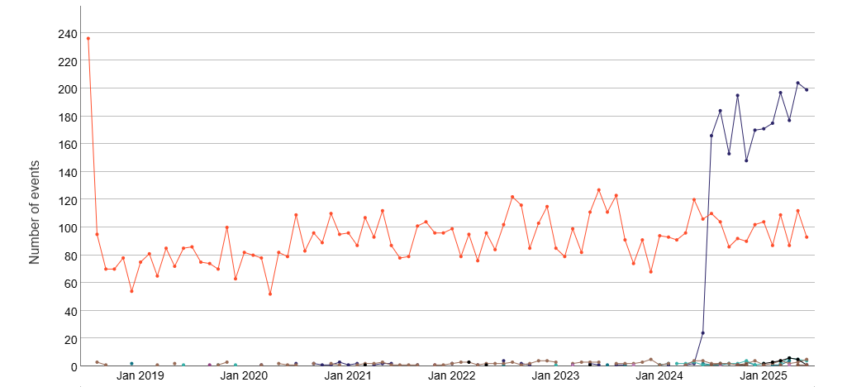
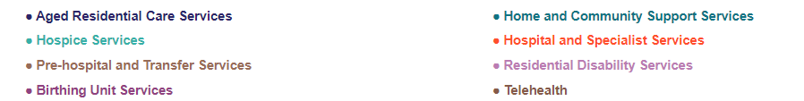
Note:
The chart shows the number of events by month and year of the date the event was notified internally.

Figure A2: Reported SAC 1 and 2 harm (adverse) events, Falls, July 2018–June 2025
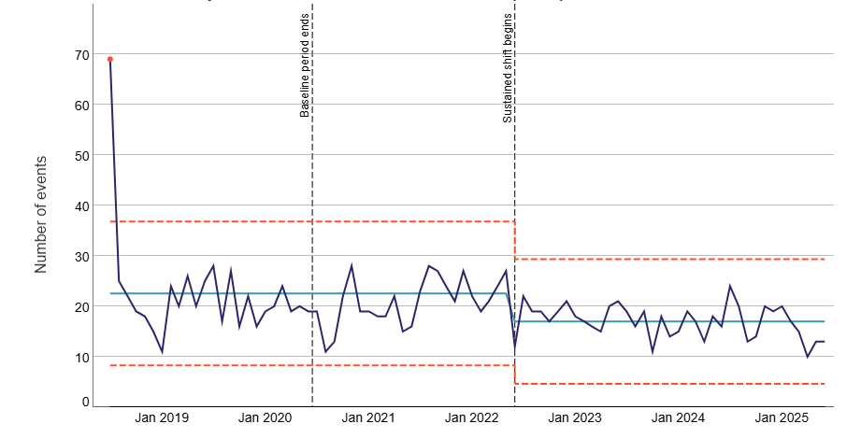
Note:
How to read control charts
The teal line shows the average for each period. The first average is based on July 2018 to June 2020. If eight or more points in a row are all above or below the average, this may indicate a shift (special cause variation). If the shift continues, a new average and control limits are calculated from that point (from July 2020 onwards). In some cases, limits may be adjusted manually if a clear shift can be seen.
The red dashed lines show the upper and lower control limits, where most data should fall. Points outside these limits may indicate special cause variation.
The chart shows the number of events by month and year of the date the event was notified internally.
Figure A3: Reported SAC 1 and 2 harm (adverse) events, pressure injuries, July 2018–June 2025
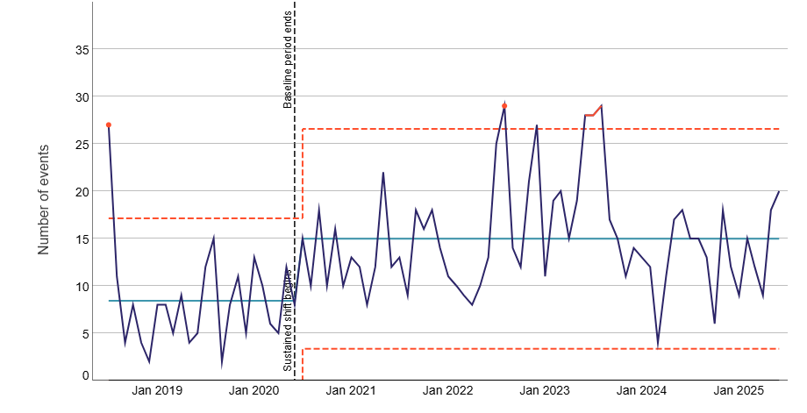
Note:
How to read control charts
The teal line shows the average for each period. The first average is based on July 2018 to June 2020. If eight or more points in a row are all above or below the average, this may indicate a shift (special cause variation). If the shift continues, a new average and control limits are calculated from that point (from July 2020 onwards). In some cases, limits may be adjusted manually if a clear shift can be seen.
The red dashed lines show the upper and lower control limits, where most data should fall. Points outside these limits may indicate special cause variation.
The chart shows the number of events by month and year of the date the event was notified internally.
Figure A4: Rate of hospital-acquired pressure injuries per 100 episodes, Q1 2017– Q2 2025, with baseline of 2017–2019 (NMDS)
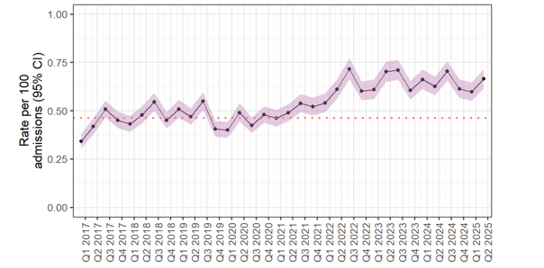
Figure A5: Hospital acquired pressure injuries identified in hospitalisation data to triangulate with SAC 1 and 2 harm events of pressure injuries, by age group, Jan 2017–June 2025
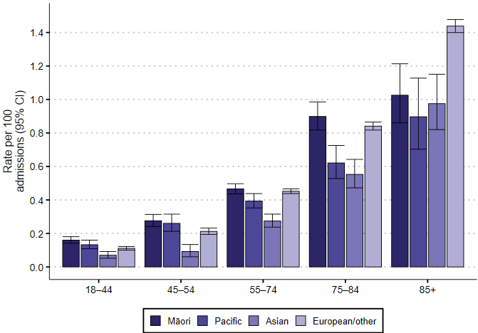
Figure A6: Reported SAC 1 and 2 harm (adverse) events, deterioration, July 2018–June 2025
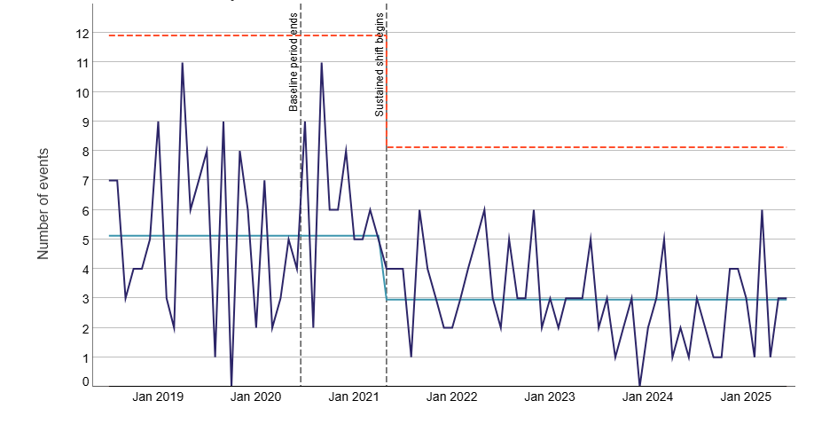
Note:
How to read control charts
The teal line shows the average for each period. The first average is based on July 2018 to June 2020. If eight or more points in a row are all above or below the average, this may indicate a shift (special cause variation). If the shift continues, a new average and control limits are calculated from that point (from July 2020 onwards). In some cases, limits may be adjusted manually if a clear shift can be seen.
The red dashed lines show the upper and lower control limits, where most data should fall. Points outside these limits may indicate special cause variation.
The chart shows the number of events by month and year of the date the event was notified internally.
Figure A7: Reported SAC 1 and 2 harm (adverse) events, clinical administration, July 2018–June 2025
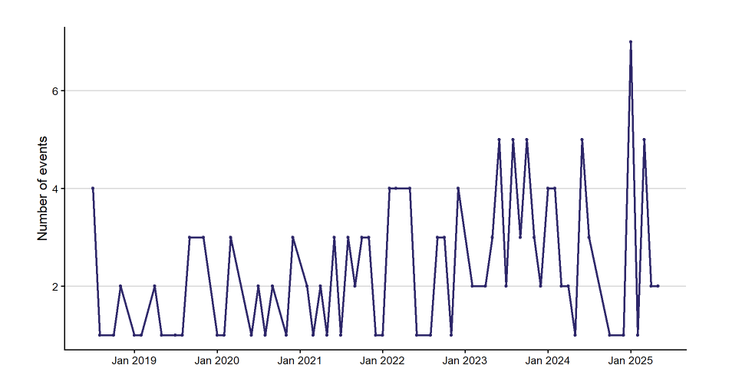
Note:
The chart shows the number of events by month and year of the date the event was notified internally.
Figure A8: Reported SAC 1 and 2 harm (adverse) events, complications, July 2018–June 2025
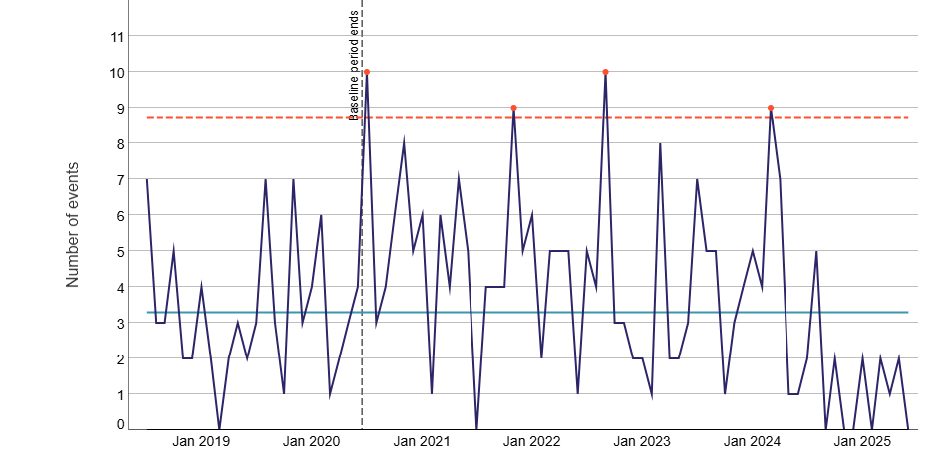
Note:
How to read control charts
The teal line shows the average for each period. The first average is based on July 2018 to June 2020. If eight or more points in a row are all above or below the average, this may indicate a shift (special cause variation). If the shift continues, a new average and control limits are calculated from that point (from July 2020 onwards). In some cases, limits may be adjusted manually if a clear shift can be seen.
The red dashed lines show the upper and lower control limits, where most data should fall. Points outside these limits may indicate special cause variation.
The chart shows the number of events by month and year of the date the event was notified internally.
Figure A9: Reported SAC 1 and 2 harm (adverse) events, delays, July 2018–June 2025
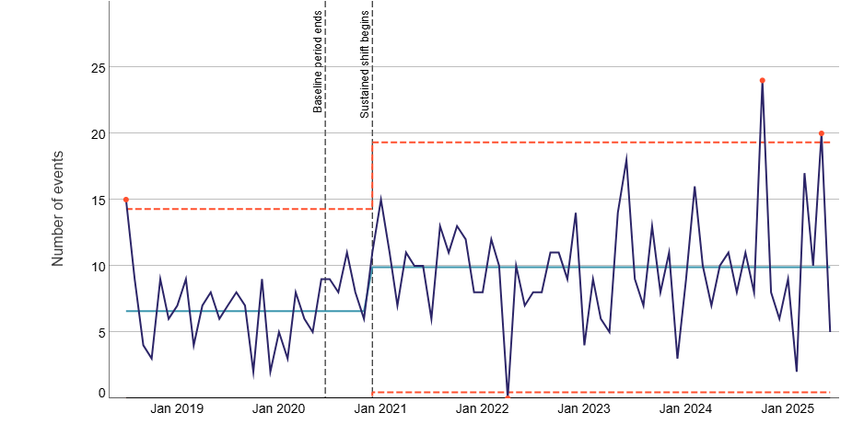
Note:
How to read control charts
The teal line shows the average for each period. The first average is based on July 2018 to June 2020. If eight or more points in a row are all above or below the average, this may indicate a shift (special cause variation). If the shift continues, a new average and control limits are calculated from that point (from July 2020 onwards). In some cases, limits may be adjusted manually if a clear shift can be seen.
The red dashed lines show the upper and lower control limits, where most data should fall. Points outside these limits may indicate special cause variation.
The chart shows the number of events by month and year of the date the event was notified internally.
Figure A10: Reported SAC 1 and 2 harm (adverse) events, wrong consumer, site or side, July 2018–June 2025
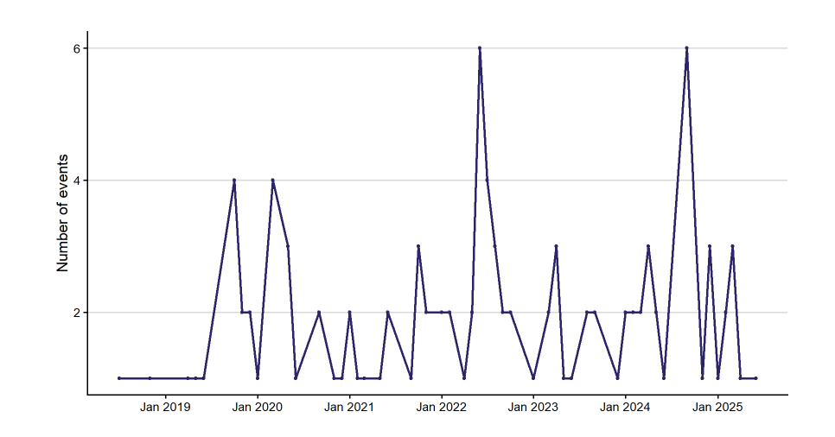
Note:
The chart shows the number of events by month and year of the date the event was notified internally.
Figure A11: Number of reported events by SAC rating for wrong consumer and wrong site, 2022/23–2024/25
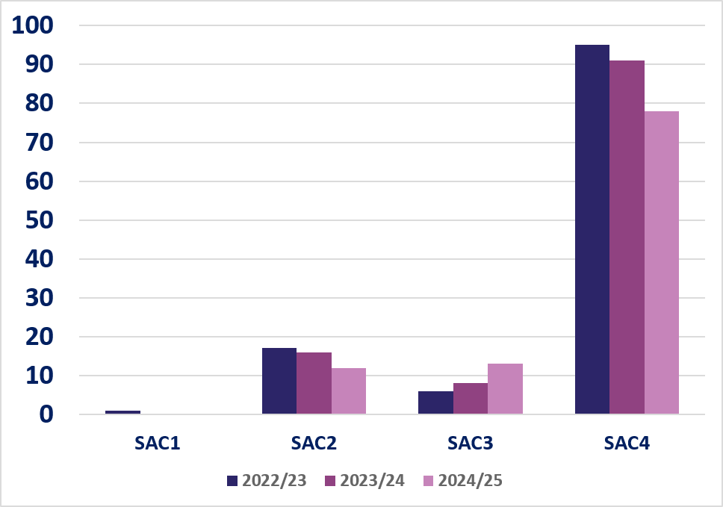
Note: There were no reported SAC 1 events in 2023/24 and 2024/25.
Figure A12: Average occupied bed days (OBDs) for acute admissions of patients aged 65 years and over, by selected diagnosis, 2012–2024
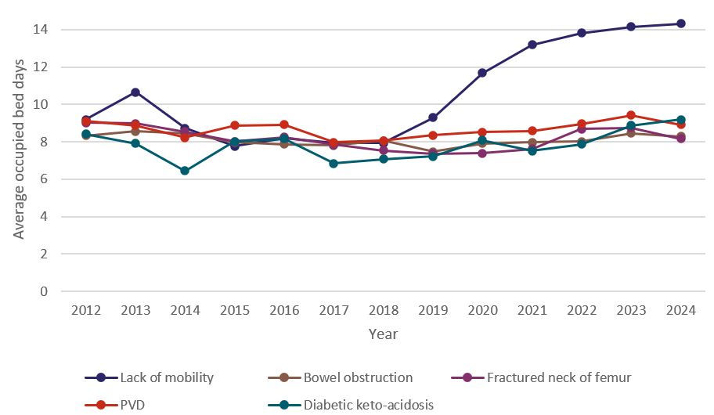
Note: This is a modified version of the original chart. It includes the five diagnoses with the highest average OBDs. In the original chart (which includes 13 diagnoses) (HQSC. 2024d). all diagnoses, apart from ‘Lack of mobility’, showed no significant changes over time.
Figure A13: Decomposition analysis of the cause of increase in occupied bed days associated with lack of mobility diagnosis admissions, 2018–2024
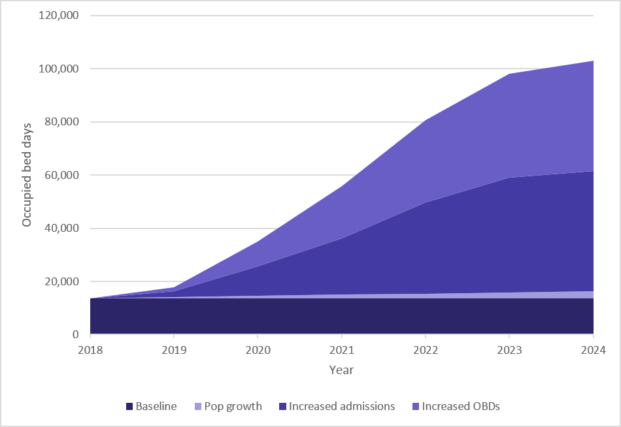
Note: Data in this graph is from Stats NZ and the NMDS. This chart shows the decomposition of increase in the total occupied bed days associated with lack of mobility diagnosis, primarily driven by the increase in admissions and average OBDs.
Figure A14: Rate of accepted ACC Treatment Injury claims per 100,000 resident population Q3 2014 – Q3 2025
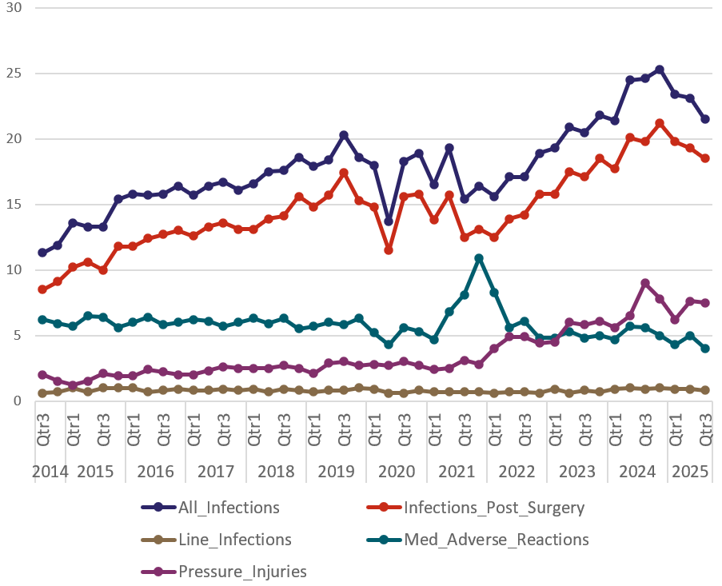
Note: ‘Post-op infections’ and ‘line infections’ are subsets of ‘All infection’. ‘Post-op infections’ and ‘line infections” are also mutually exclusive.
Figure A15: Number of ACC-accepted treatment injury claims of pressure injury, 2016/17–2024/25
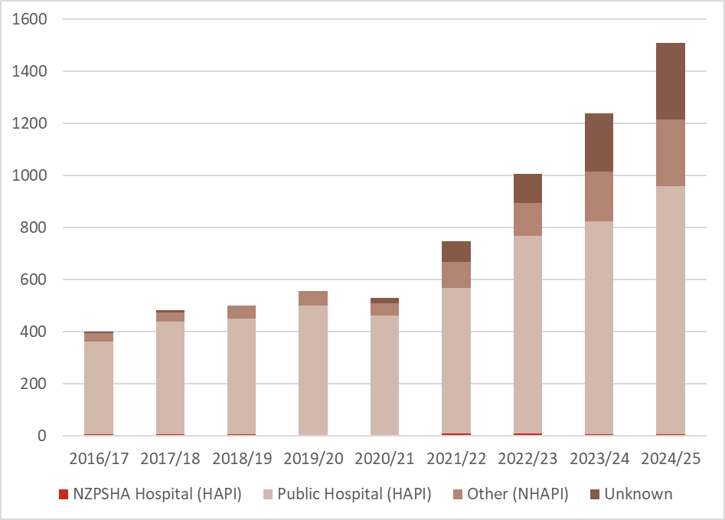
Note: This chart shows the number of ACC accepted treatment injury claims of pressure injuries by type of treating facilities.
Treating facility was used to determine where pressure injury was acquired.
NZPSHA: New Zealand Private Surgical Hospital Association.
Counts below 4 have been suppressed.
Figure A16: Number of hospital-acquired pressure injuries and non-hospital-acquired pressure injuries recorded in the National Minimum Dataset, Q1 2017–Q3 2025
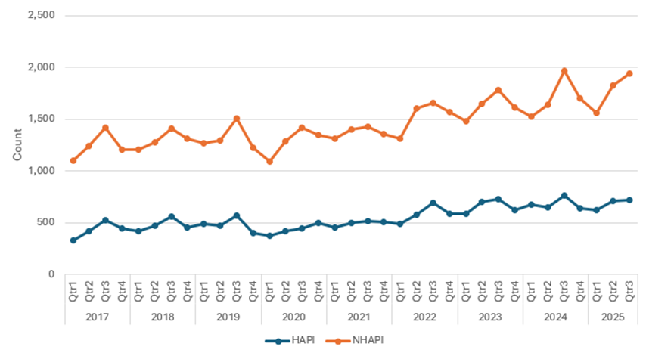
Note: The chart shows the time series of number of hospital and non-hospital-acquired pressure injuries recorded in hospitalisation.
Figure A17: Reported ACC risk of harm events, 2022–2025 (ending June)
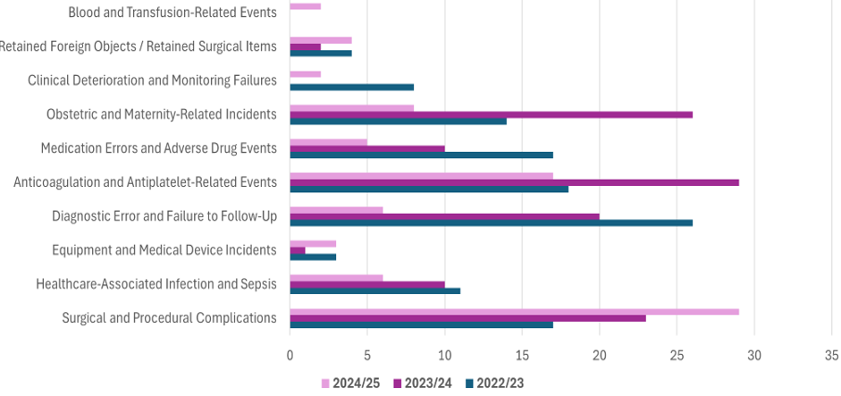Note: The chart shows the number of ACC risk-of-harm events by risk type for the years 2022–2025.

References
Health NZ. 2025a. Health Digital Investment Plan. Wellington: Health New Zealand (Health NZ).
Health NZ. 2025b. New Zealand Health Plan 2024 to 2027: Te Pae Waenga. Wellington: Health New Zealand (Health NZ).
HQSC. nd(a). Health and disability sector harm (adverse) events infographic. Health Quality & Safety Commission (HQSC). URL: hqsc.govt.nz/our-work/system-safety/healing-learning-and-improving-from-harm/infographic-health-and-disability-sector-adverse-events (accessed 14 May 2026).
HQSC. nd(b). Sepsis guides and tools for health professionals. Health Quality & Safety Commission (HQSC). URL: hqsc.govt.nz/our-work/improved-service-delivery/sepsis/sepsis-guides-and-tools-for-health-professionals (accessed 14 May 2026).
HQSC. 2023a. A qualitative thematic analysis of maternity adverse events reported 1 July 2018–30 June 2023. Wellington: Health Quality & Safety Commission (HQSC).
HQSC. 2023b. Healing, learning and improving from harm: National adverse events policy 2023. Wellington: Health Quality & Safety Commission (HQSC).
HQSC. 2024a (September). Assessing System Quality and Safety: Insights report. Wellington: Health Quality & Safety Commission (HQSC).
HQSC. 2024b (November). Assessing System Quality and Safety: Insights report. Wellington: Health Quality & Safety Commission (HQSC).
HQSC. 2024c. Collaborating for Quality: A framework for clinical governance | He mahi ngātahi kia kounga: He anga hei whakahaere whare haumanu. Wellington: Health Quality & Safety Commission (HQSC).
HQSC. 2024d. The Acuity of Acute Care: How increasing, changing or mismatched demand for services may be creating risks to available service supply. Wellington: Health Quality & Safety Commission (HQSC).
HQSC. 2025a. Community-acquired pressure injuries. Health Quality & Safety Commission (HQSC). URL: hqsc.govt.nz/our-work/improved-service-delivery/community-acquired-pressure-injuries (accessed 14 May 2026).
HQSC. 2026. Aged residential care analysis of harm (adverse) events, 1 July 2024 to 30 June 2025. Health Quality & Safety Commission (HQSC).
Moore D, Loan J, Rohani M, et al. 2024. A review of aged care funding and service models. Wellington: Health New Zealand | Te Whatu Ora.
WHO, WHO Patient Safety. 2010. Conceptual Framework for the International Classification for Patient Safety Version 1.1: Final technical report January 2009. Geneva: World Health Organization (WHO).
WHO. 2021. Global Patient Safety Action Plan 2021–2030: Towards eliminating avoidable harm in health care. Geneva: World Health Organization (WHO).

Pae Ora (Healthy Futures) Bill | New Zealand Legislation
hqsc.govt.nz/our-data/quality-and-safety-markers
hqsc.govt.nz/our-work/improved-service-delivery/safe-surgery-nz/projects/surgical-teamwork-and-communication/interventions/surgical-safety-checklist
The recent health and disability system reforms included a call for the Commission to establish a quality forum, to ‘share and assess quality risks across the health system’. The Commission has a government mandate to establish and lead this forum. The National Quality Forum is now the peak body for quality and safety for the public health and disability system in New Zealand.
The Health Roundtable is an independent, membership organisation of more than 200 hospitals from across Australia and New Zealand. The organisation was founded in 1995 to provide measures, dashboards and reports on comparative hospital performance across the two countries with the aim of improving clinical care, patient outcomes and hospital performance.

