Extravasation injury during surgery

This report alerts providers to the key findings of a recent review. It emphasises the changes implemented to prevent future similar events. Please consider this report, and whether the changes being made are relevant to your own systems.
This report is relevant to:
- operating theatre staff and team members
- quality improvement, clinical risk and patient safety managers.

Incident
A patient suffered an extravasation injury that required skin grafts to repair. The patient has been left with intermittent pain and loss of muscle strength, which has had long-term effects on their working life.

Chronology
- Mr B had two peripheral intravenous cannulas (PIVCs) inserted (one in each hand) before surgery.
- During surgery, both PIVCs were covered by wraps used to secure Mr B’s arms and surgical drapes, making it difficult to monitor the PIVC sites for extravasation.
- When the surgical drapes were removed post-surgery, it was discovered that Mr B’s left wrist and forearm were swollen and discoloured from an extravasation of intravenous fluid and anaesthetic drugs (Image 1).
- Mr B subsequently underwent a surgical debridement, a split thickness skin graft and prolonged rehabilitation (Image 2).
- Mr B has been left with intermittent forearm pain and reduced muscle strength, which has impacted on his working life.

Review findings
The mechanism that caused the injury was likely multifactorial, however three primary contributing factors were identified:
- The mode of wrapping and securing the arms resulted in venous constriction thereby limiting dilution of drugs administered.
- The peripheral administration of vesicant medicines such as calcium chloride.
- Direct inspection of an intravenous insertion site during surgery is deterred by requiring complicated disruption of sterile surgical drapes and the operating field, and can in turn increase risk of infection

Actions subsequently taken
- A standardised arm-tucking process was added to the organisation’s policy ‘Positioning the patient in the operating room’. Implementation of the policy by perioperative staff was supported by perioperative nurse educators/anaesthetists.
- PIVC checking times to be discussed at ‘time-out’ briefings for any lengthy surgery where PIVC sites are not easily accessible.
- Communication has been sent to anaesthetists and intensivists to highlight the danger of peripherally administered calcium chloride and other vesicant drugs, including to administer through a running intravenous fluid line for dilution if being given via a PIVC rather than a central line.
- A standard operating procedure was developed regarding how to administer necessary vesicant drugs when PIVC sites are not visible during surgery.
- Anaesthesiology and surgical services developed a process for perioperative management of extravasation injury, including review of the intravenous catheter guideline and introduction to perioperative extravasation injury first aid kits.
- The use of ivWatch™ continuous intravenous site monitoring for real-time infiltration detection to be trialled.

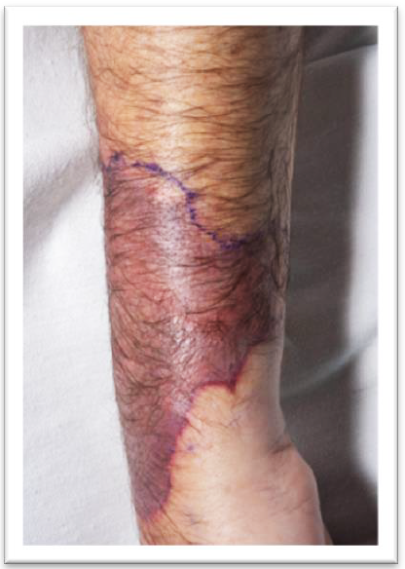
Commission comment
Image 1
- A meta-analysis¹ found that extravasation/infiltration was reported in
13.7 percent of PIVCs placed in the included studies.
- The PIVC sites most often implicated in extravasation injuries are those where there is little soft tissue protection for underlying structures, such as the hand.²
- The effects of unrecognised extravasation, as seen in this case, can be severe, resulting in long-term morbidity for patients.³
- Building regular observation into pre-operative checklists is recommended.

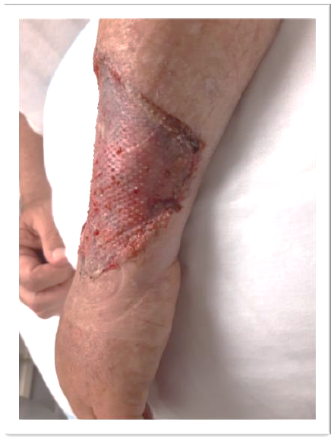
Image 2

2014/02
OB-26 Aug 21
- Marsh N, Webster J, Ullman AJ, et al. 2020. Peripheral intravenous catheter non‐infectious complications in adults: A systematic review and meta‐analysis. Journal of Advanced Nursing 76(12), 3346‒62.
- Al-Benna S, O’Boyle C, Holley J. 2013. Extravasation injuries in adults. International Scholarly Research Notices, 2013.
- Alexander L. 2020. Extravasation Injuries: A Trivial Injury Often Overlooked with Disastrous Consequences. World Journal of Plastic Surgery 9(3): 326.

