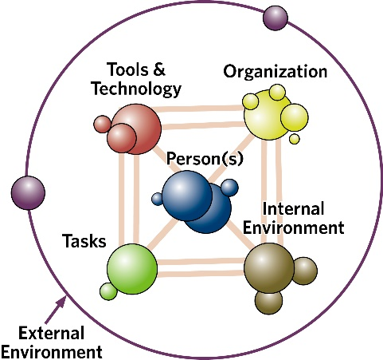**Systems Engineering Initiative for Patient Safety (SEIPS) worksheet: Categorisation and interaction tool**

This worksheet[1] can be used to record factors that enable or are barriers to desired overall system outcomes. First, enter a brief description of the factor, then use the boxes to record interactions, enablers or barriers to overall system performance and human wellbeing.

Record enablers with ‘+’ marks and barriers with ‘-’ signs. **More signs indicate a stronger impact**. Use a scale of 1-5 with 5 being the strongest or most negative impact. You can also enter text in the same box about a certain factor, such as who or what is related to it.

Importantly, you can highlight interactions between multiple factors. Interactions often work as magnifiers, improving enablers or increasing the negative ramifications of barriers.

See the examples below for ways to use the worksheet.

**Example of a completed worksheet**

**SEIPS worksheet: Categorisation and interaction tool**

Write a brief description of factors that enable or are barriers to desired outcomes. Factors and interactions can be recorded  
with ‘+’ or ‘-’ signs or text to indicate whether they facilitate or serve as a barrier to system performance and wellbeing.

| **Example descriptions of factor** | **Interactions** | **Person(s)** | **Task(s)** | **Tech & tools** | **Organisational** | **Environment** | |
| --- | --- | --- | --- | --- | --- | --- | --- |
| **Internal** | **External** |
| *New machine easier to roll (move) safely* |  |  |  | + |  |  |  |
| *Worker–feedback in procurement decision of surgical tools (lowering mistakes, increasing comfort, save time because easier to clean)* | +++  Worker opportunity to trial product | + |  | +++ | +++ |  |  |
| *Leaky faucet and dim bathroom making slips and falls more likely* | --- |  |  | - |  | --- |  |
| *Tighter scheduling windows for general practitioner (GP) visits with patients (pts) leading to burnout* | --- | GPs, pts | Visits |  |  |  |  |
| *Ambulance upgrade increasing visibility and driving safety* | ++ | + |  | +++ |  |  |  |

**SEIPS worksheet: Categorisation and interaction tool**

Write a brief description of factors that enable or are barriers to desired outcomes. Factors and interactions can be recorded  
with ‘+’ or ‘-’ signs or text to indicate whether they facilitate or serve as a barrier to system performance and wellbeing.

| **Description of factors** | **Interactions** | **Person(s)** | **Task(s)** | **Tech & tools** | **Organisational** | **Environment** | |
| --- | --- | --- | --- | --- | --- | --- | --- |
| **Internal** | **External** |
|  |  |  |  |  |  |  |  |
|  |  |  |  |  |  |  |  |
|  |  |  |  |  |  |  |  |
|  |  |  |  |  |  |  |  |
|  |  |  |  |  |  |  |  |
|  |  |  |  |  |  |  |  |
|  |  |  |  |  |  |  |  |
|  |  |  |  |  |  |  |  |
|  |  |  |  |  |  |  |  |
|  |  |  |  |  |  |  |  |
|  |  |  |  |  |  |  |  |
|  |  |  |  |  |  |  |  |
|  |  |  |  |  |  |  |  |

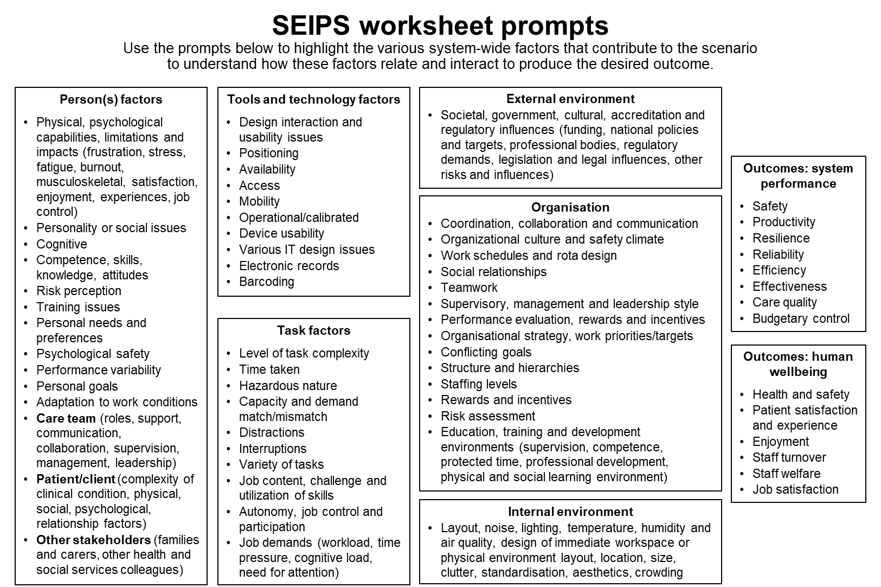

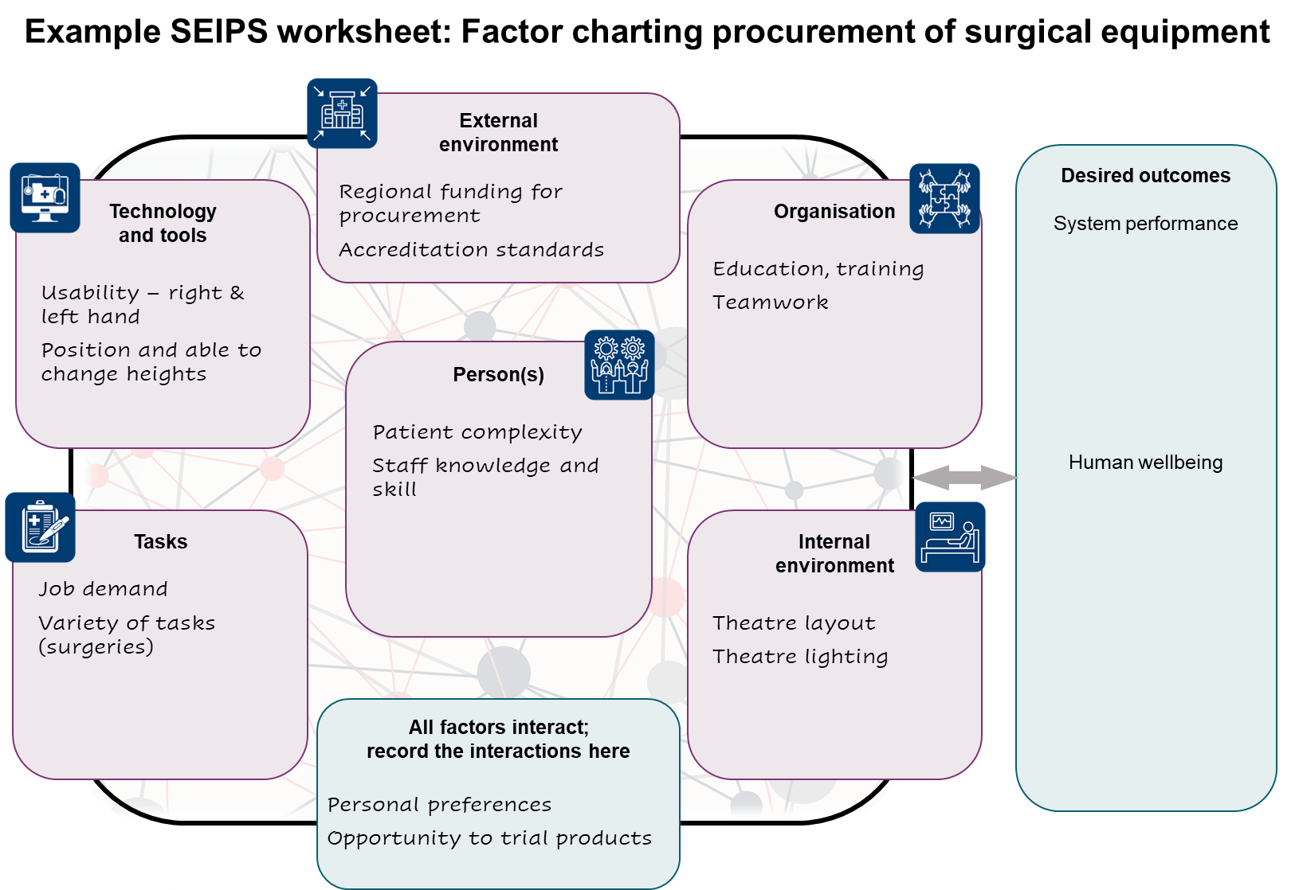

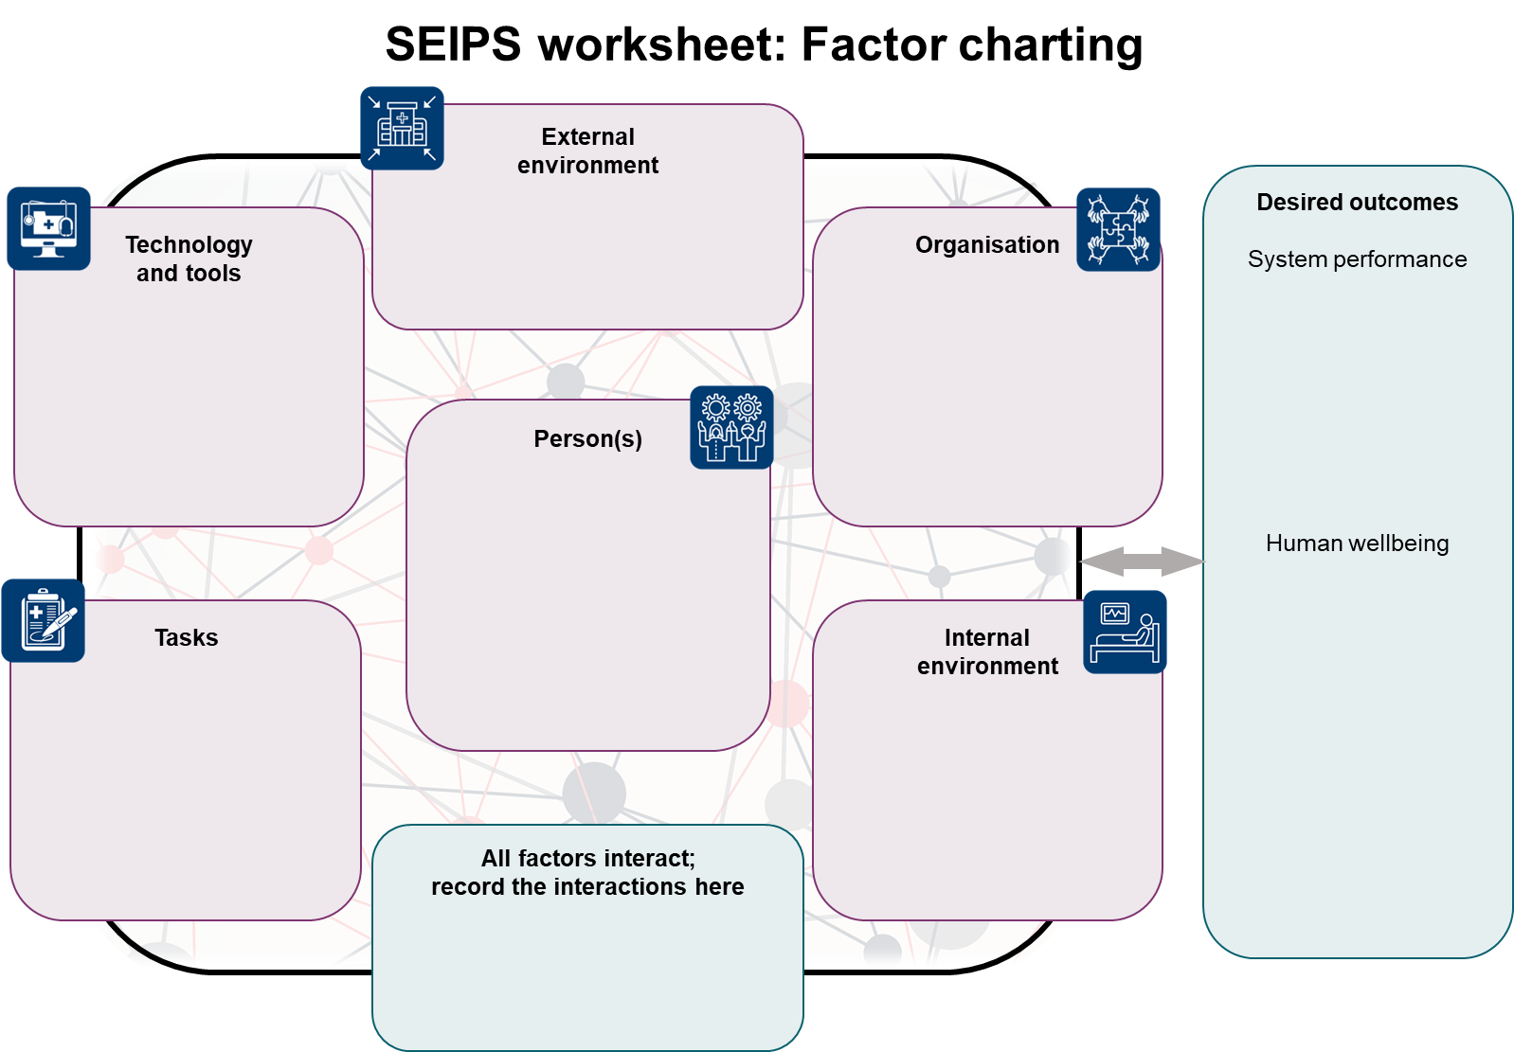

**Appendix 1: Accessible SEIPS worksheet prompts**

Note that the following prompts are the same as those in the boxes on pag 4, presented as lists.

Use these prompts to highlight the various factors across the system that contribute to the scenario to understand how these factors relate and interact to produce the desired outcome.

**Person(s) factors**

* Physical, psychological capabilities, limitations and impacts (ie, frustration, stress, fatigue, burnout, musculoskeletal, satisfaction, enjoyment, experiences, job control)
* interpersonal and social dynamics
* Cognitive
* Competence, skills, knowledge, attitudes
* Risk perception
* Training issues
* Personal needs and preferences
* Psychological safety
* Performance variability
* Personal goals
* Adaptation to work conditions
* **Care team** (roles, support, communication, collaboration, supervision, management, leadership)
* **Patient/client** (complexity of clinical condition, physical, social, psychological, relationship factors)
* **Other stakeholders** (families and carers, other health and social services colleagues)

**Tools and technology factors**

* Design interaction and usability issues
* Positioning
* Availability
* Access
* Mobility
* Operational/calibrated
* Device usability
* Various IT design issues
* Electronic records
* Barcoding

**Task factors**

* Level of task complexity
* Time taken
* Hazardous nature
* Capacity and demand match/mismatch
* Distractions
* Interruptions
* Variety of tasks
* Job content, challenge and utilisation of skills
* Autonomy, job control and participation
* Job demands (workload, time pressure, cognitive load, need for attention)

**Internal environment**

* Layout, noise, lighting, temperature, humidity and air quality, design of immediate workspace or physical environment layout, location, size, clutter, standardisation, aesthetics, crowding

**Organisation**

* Coordination, collaboration and communication
* Organizational culture and safety climate
* Work schedules and rota design
* Social relationships
* Teamwork
* Supervisory, management and leadership style
* Performance evaluation, rewards and incentives
* Organisational strategy, work priorities/targets
* Conflicting goals
* Structure and hierarchies
* Staffing levels
* Rewards and incentives
* Risk assessment
* Education, training and development environments (supervision, competence, protected time, professional development, physical and social learning environment)

**External environment**

* Societal, government, cultural, accreditation and regulatory influences (funding, national policies and targets, professional bodies, regulatory demands, legislation and legal influences, other risks and influences)

**Desirable outcomes: system performance**

* Safety
* Productivity
* Resilience
* Reliability
* Efficiency
* Effectiveness
* Care quality
* Budgetary control

**Outcomes: human wellbeing**

* Health and safety
* Patient satisfaction and experience
* Enjoyment
* Staff turnover
* Staff welfare
* Job satisfaction

1. The diagrams on pages 1–3 are adapted from the work by Richard Holden and from work by Dan Nathan-Roberts and Katie Buckley with permission. The worksheets on pages 4–6 are adapted from work by Professor Paul Bowie, NHS Education for Scotland, with permission.