**Harm (adverse) event submission portal user guide 2025**



Published in August 2025 by Te Tāhū Hauora Health Quality & Safety Commission,   
PO Box 25496, Wellington 6146, Aotearoa New Zealand.

ISBN: 978-1-991122-35-3 (online)

This document is available online at: [www.hqsc.govt.nz](https://hqsc.sharepoint.com/sites/dms-hqintel/Data%20Warehouse/2.%20ETL/2.%20Implementation%20for%20data%20sources/Adverse%20events/External%20user%20guides/User%20guide%20for%20the%20Harm%20(adverse)%20event%20management%20tool/www.hqsc.govt.nz)

Contact for enquiries: [harm.event@hqsc.govt.nz](mailto:harm.event@hqsc.govt.nz)

Published under Creative Commons License CC BY-NC 4.0. This means you may share and adapt the material provided you give the appropriate credit, provide a link to the licence, and indicate if changes were made. You may not use the material for commercial use. For more information about this licence, see: <https://creativecommons.org/licenses/by-nc-sa/4.0/>.





**Contents**

Introduction 4

Support 4

Accessing the portal 4

Navigating the portal 5

Key sections 5

Submitting a new harm event 6

Provider information 6

Facility 6

Your event reference number 8

Date event occurred 9

Internal notification date 9

Continue to page 11 if you are NOT a private hospital or Health New Zealand 10

Submitting an Always Report and Review (ARR) 10

If you are submitting a pressure injury event 12

Did the consumer die? 13

Age, gender and ethnicity 1 13

Ethnicity 2 and Ethnicity 3 13

Submit 13

Submitting a Part B for an existing harm event 15

Where to enter Part B details 15

Filling out Part B 16

Uploading the review report 18

Harm Event List page 20

View details or edit event details 20

Download data 21

View more columns 21

Filter or sort the data 21

How to save submitted Event details (Part A and Part B) as a PDF to attach in an email 22

Introduction

This user guide provides instructions on navigating and using the portal for tasks relating to harm (adverse) events. It is designed for users who need to enter, update and review event-related data within the portal.

Support

For assistance, please email [harm.event@hqsc.govt.nz](mailto:harm.event@hqsc.govt.nz)

**See the user guide for the Healing, learning and improving from harm policy.**

[User guide: Healing, learning and improving from harm: National adverse events policy 2023 – hqsc.govt.nz](https://www.hqsc.govt.nz/resources/resource-library/user-guide-healing-learning-and-improving-from-harm-national-adverse-events-policy-2023/)

Accessing the portal

If it is your first time accessing the portal, please follow the registration guide available through our [Harm (adverse) events submission portal](https://www.hqsc.govt.nz/our-work/system-safety/harm-adverse-event-submission-portal/) landing page.

If **you have already set up your account**, please follow the instructions below.

* Go to <https://harmevent.hqsc.govt.nz/SignIn>
* Log in by clicking on the **Microsoft Entra ID** button.

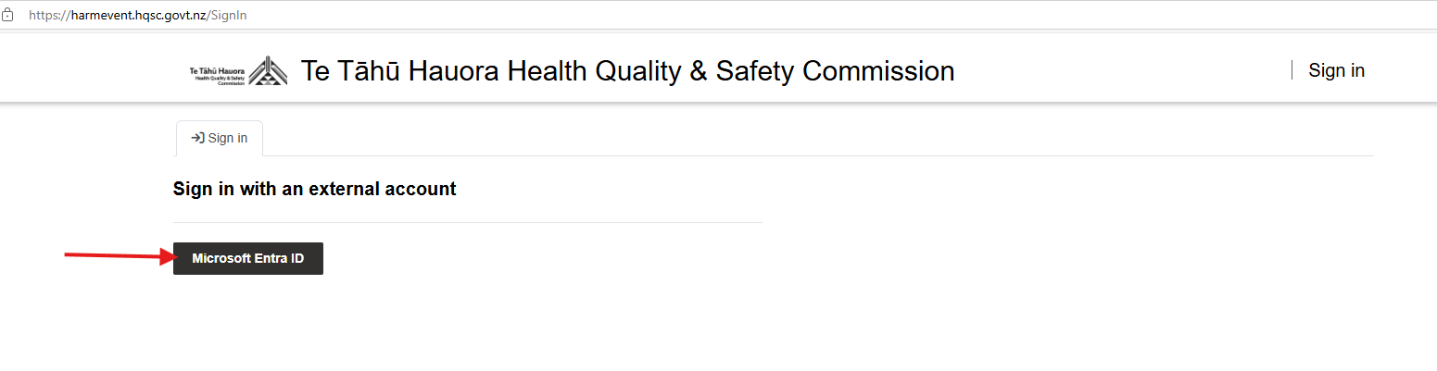

Navigating the portal

After logging in, you will be directed to the main page.

|  |
| --- |
| Note: Fields marked with an asterisk (*) are mandatory. You will not be able to submit the form until you have completed these fields. |

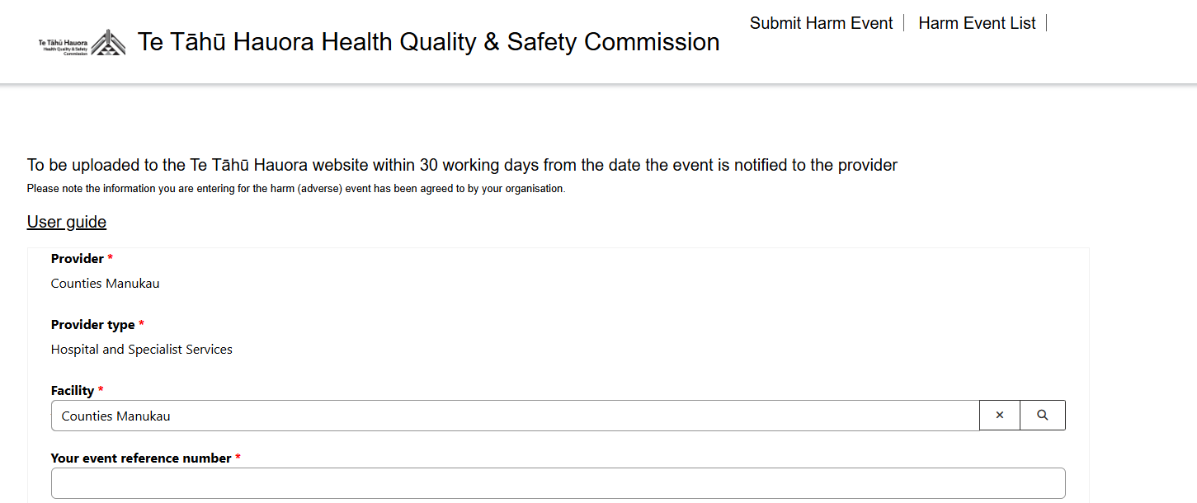

Key sections

In the **top right corner** of the screen, you will see two tabs alongside your username**:**

* **Submit Harm Event** – for entering a new event
* **Harm Event List** – for editing and reviewing an existing event and submitting a Part B.

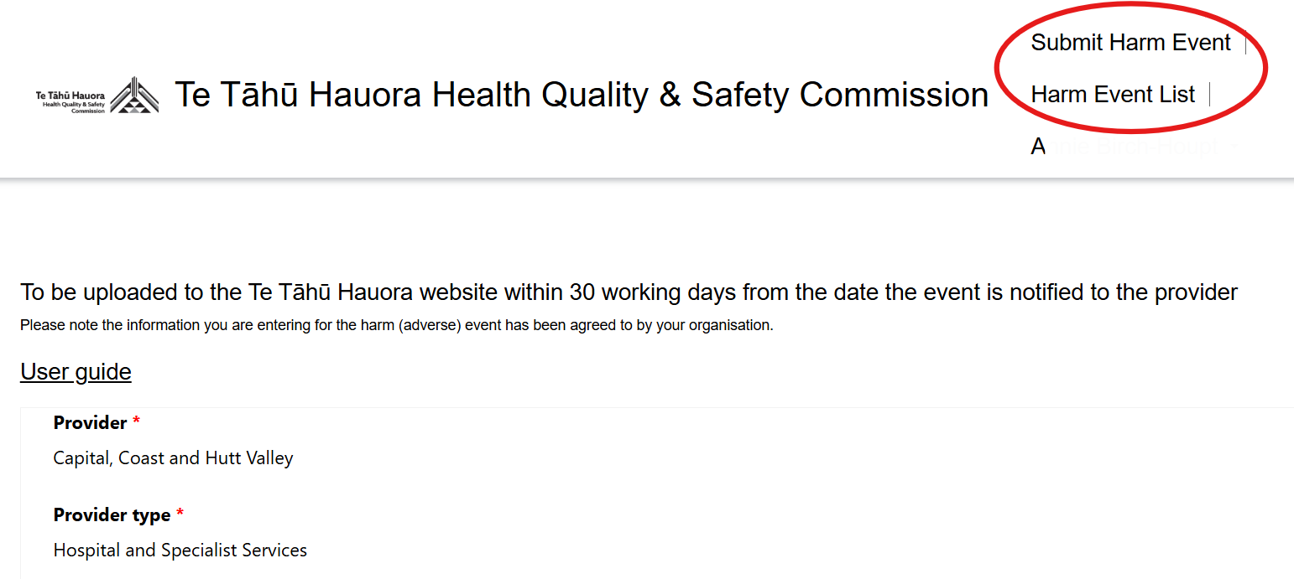

Submitting a new harm event

Click the **Submit Harm Event** tabto submit a new event.

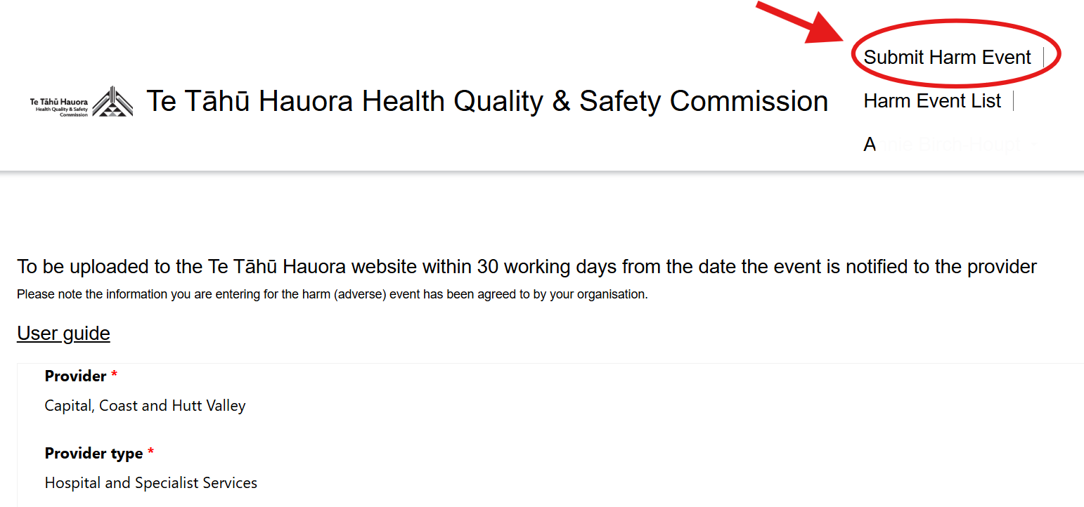

Provider information

* **Provider:** This field requires no manual entry and is automatically filled.
* **Provider type:** This field requires no manual entry and is automatically filled.

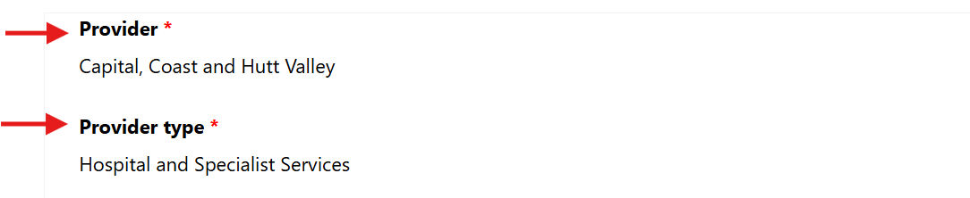

Facility

Click on the magnifier in the **Facility** Search bar to choose the facility.

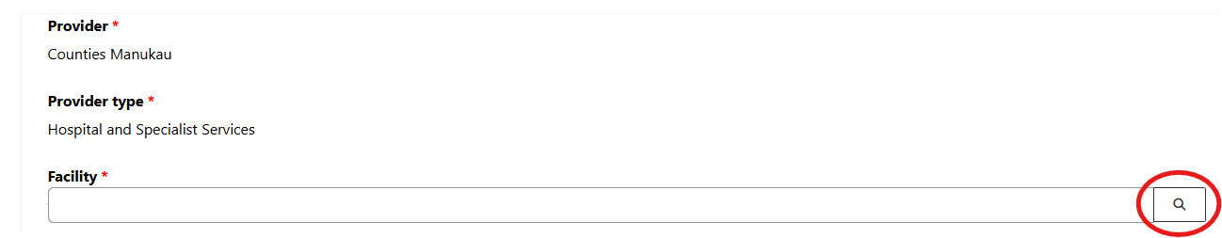

To choose one record, either:

* click in the box next to the relevant facility

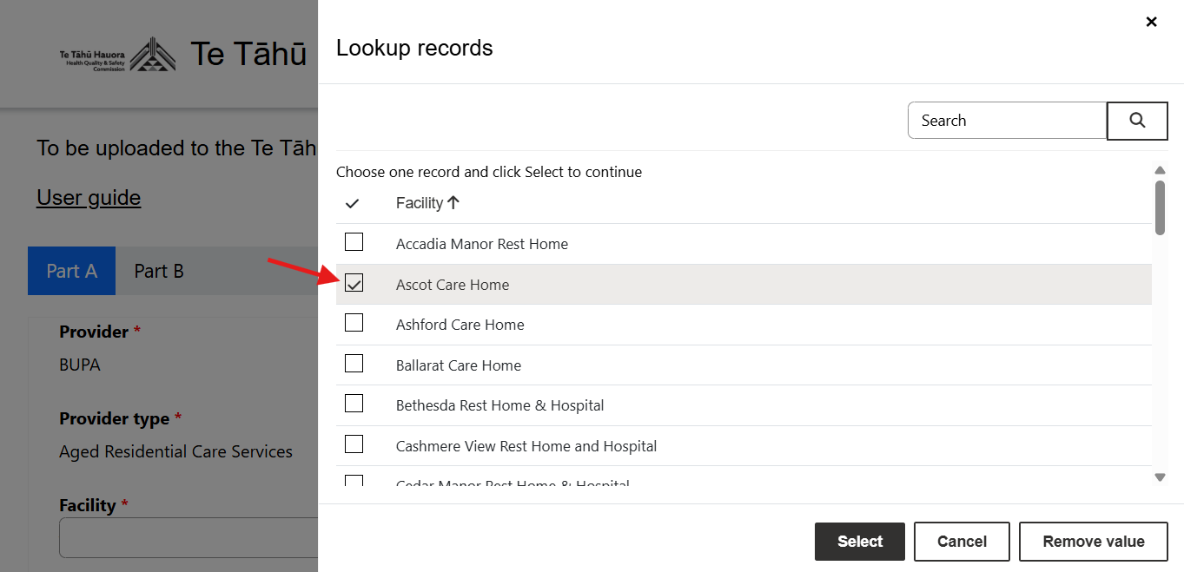

* or type the facility into the Search bar and click on the magnifier. Then check the relevant box and press the **Select** button.

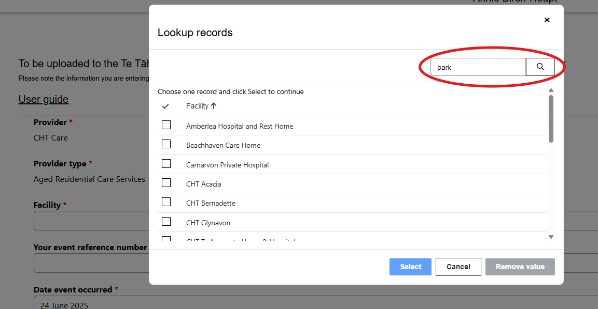

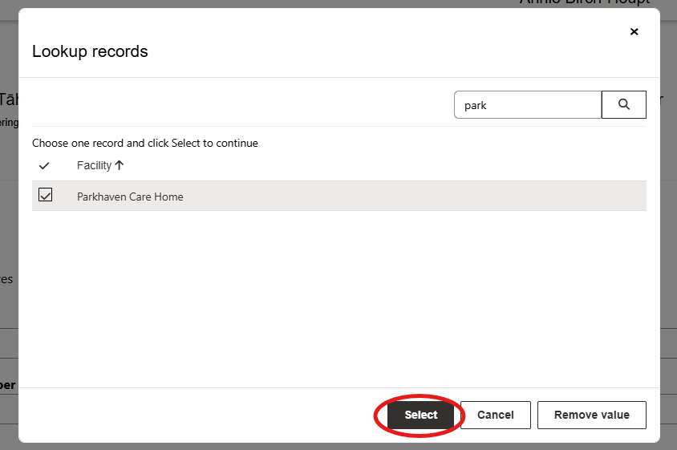

Your event reference number

Enter the unique event reference number for this event. This could be the reference number generated by your organisation’s incident management system (eg, Safety First, Datix). If your organisation does not have an incident management system, please create a reference number for the submitted event that makes sense to you.

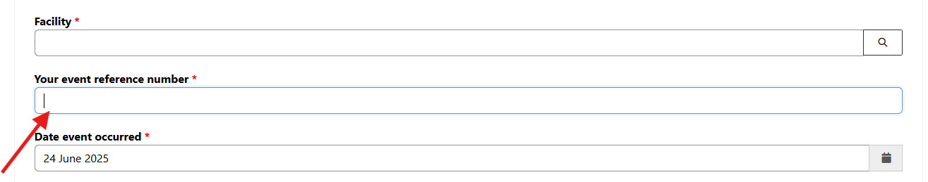

Date event occurred

Click on the calendar icon to open the calendar pop-up and select the date when the harm event occurred. If the harm occurred over a sustained period of time, select the date at the beginning of this period.

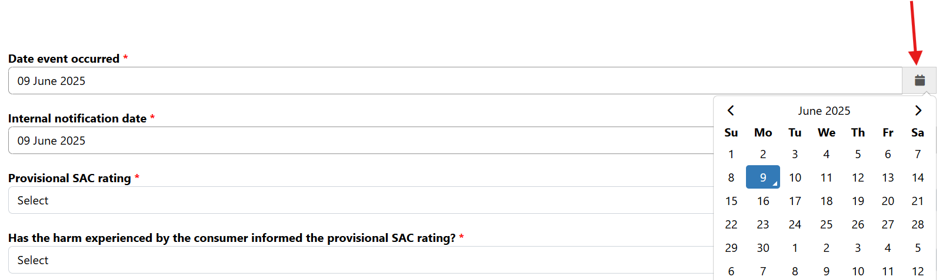

Internal notification date

Click on the calendar icon to open the calendar pop-up and select the date when the event was internally reported. This is the date when an incident form was completed or the harm event was escalated for review.

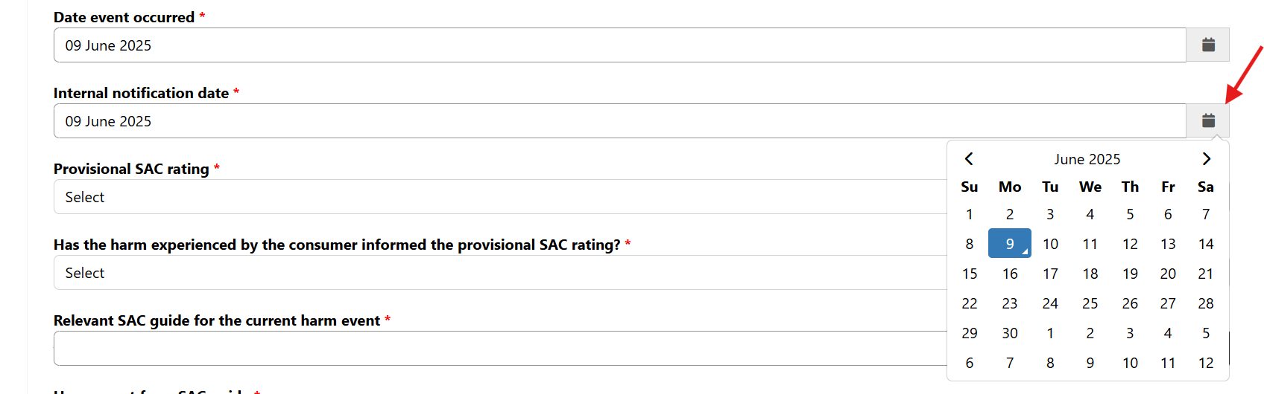

|  |
| --- |
| Continue to page 11 if you are NOT a private hospital or Health New Zealand |

Submitting an Always Report and Review (ARR)

|  |
| --- |
| Note: This question is only visible to private hospitals and Health New Zealand (Health NZ) submitters. If you are **not** a private hospital or Health NZ submitter, please go straight to the section in **dark blue**. |

* Select a **provisional severity assessment code (SAC) rating** of 1–⁠4 from the dropdown list.

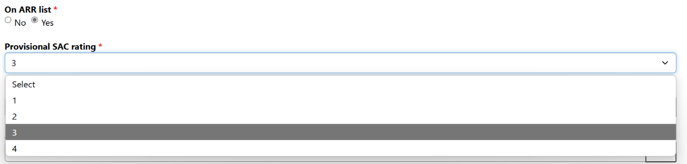

* **Has the harm experienced by the consumer informed the provisional SAC rating?** Select *Yes* or *No* from the dropdown list.
* Select the **ARR category**. Click on the magnifier in the search bar and check the box next to the relevant option.

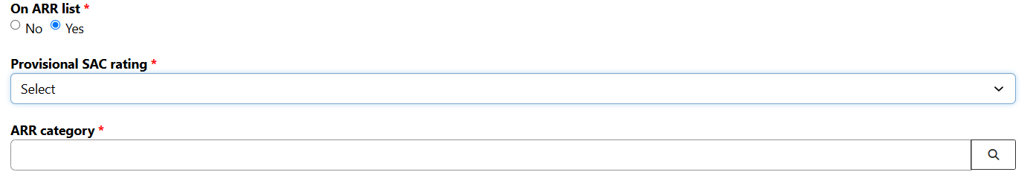

* If it is a seclusion event, you will be asked one further question:

**Was the secluded person under the Mental Health (Compulsory Assessment and Treatment) Act 1992?**

Select *Yes* or *No* from the dropdown list.

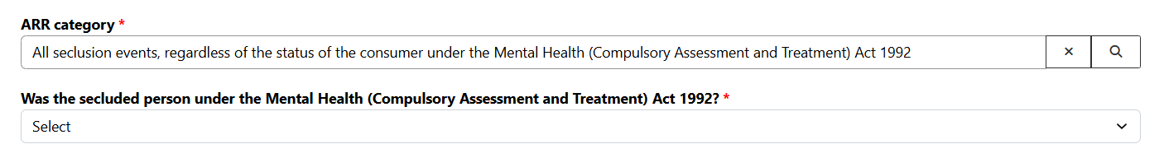

|  |
| --- |
| For all users continue here to submit your harm event |

* **Select a provisional severity assessment code (SAC) rating** of 1 or 2 from the dropdown list.
* **Has the harm experienced by the consumer informed the provisional SAC rating?** Select *Yes* or *No* from the dropdown list.

**Relevant SAC guide for the current harm event:** Select the SAC guide that is relevant to the harm event you are currently submitting. For more information on SAC guides: [Severity assessment code (SAC) examples – hqsc.gvot.nz](https://www.hqsc.govt.nz/resources/resource-library/severity-assessment-code-sac-examples/)

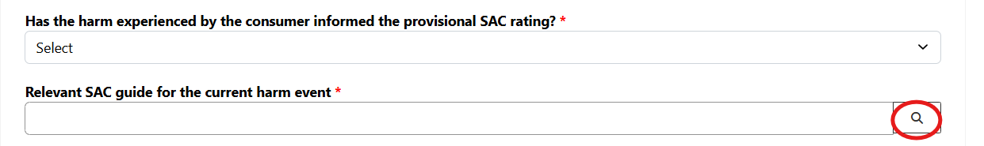

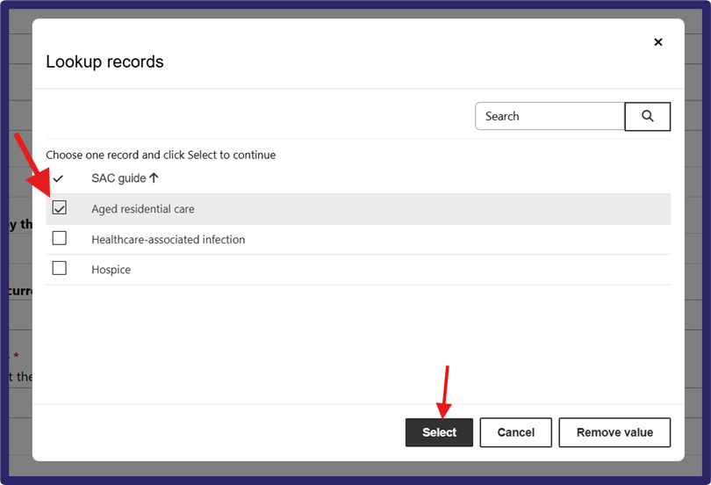

* **Harm event from SAC guide**: Select the specific event description that relates to the harm event you are submitting. If your harm event does not fit the SAC categories listed, please email [harm.event@hqsc.govt.nz](mailto:harm.event@hqsc.govt.nz).

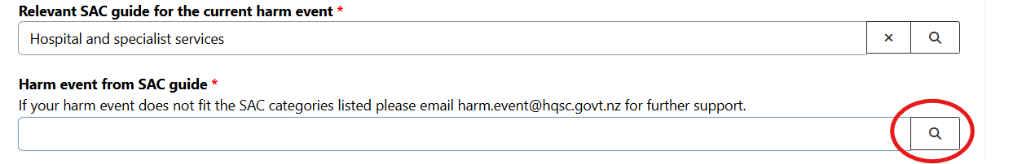

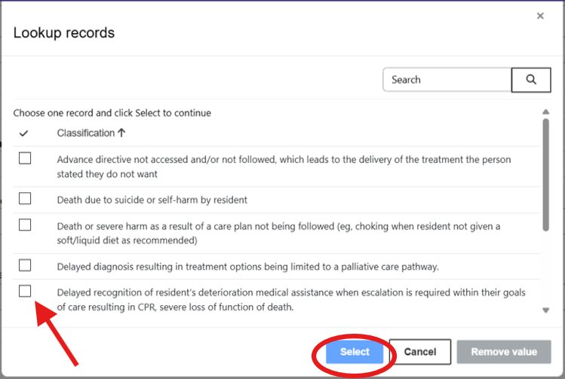

If you are submitting a pressure injury event

If you are submitting a **pressure injury** (PI) event, you will see two extra questions.

* **PI stage:** Select the stage of the pressure injury from the dropdown list.
* **Has a wound care specialist been involved in the care?** Select *Yes* or *No* from the dropdown list*.*

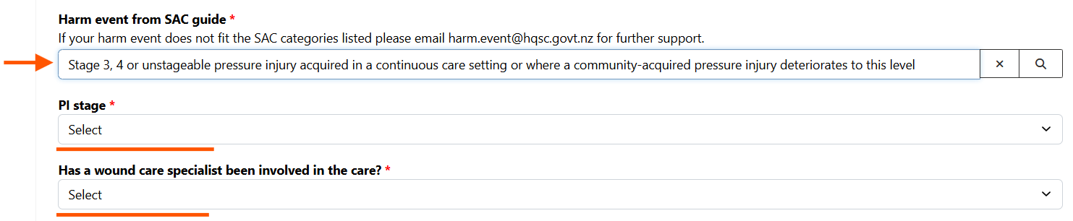

Did the consumer die?

Select *Yes* or *No* from the dropdown list.

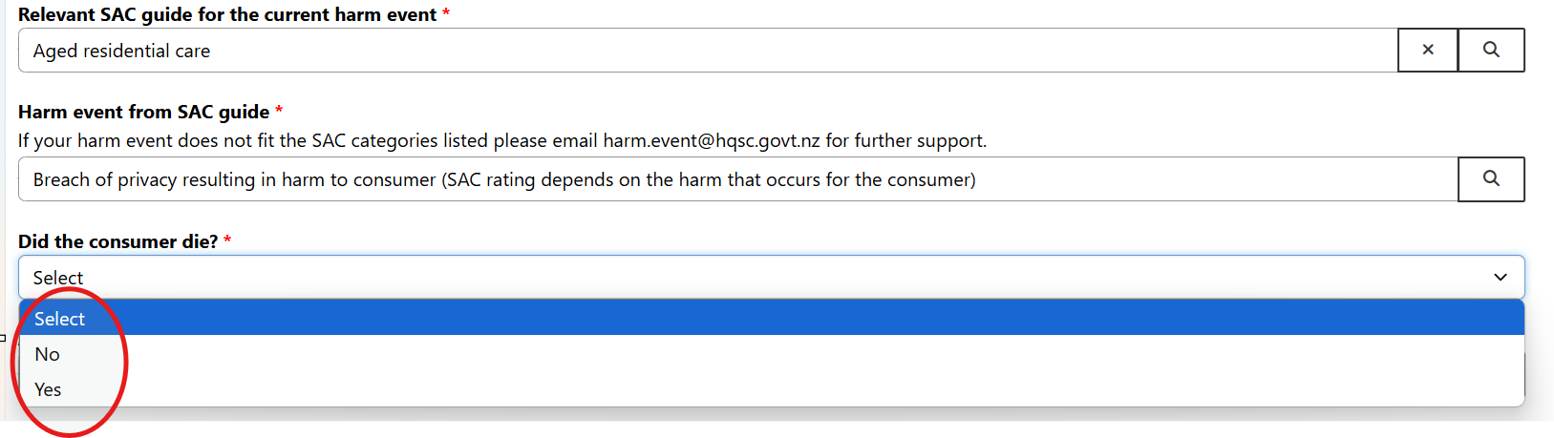

Age, gender and ethnicity 1

Click the magnifier in the search bar and select the relevant option from the lookup records.

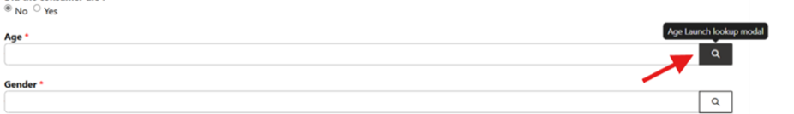

Ethnicity 2 and Ethnicity 3

These are optional fields.

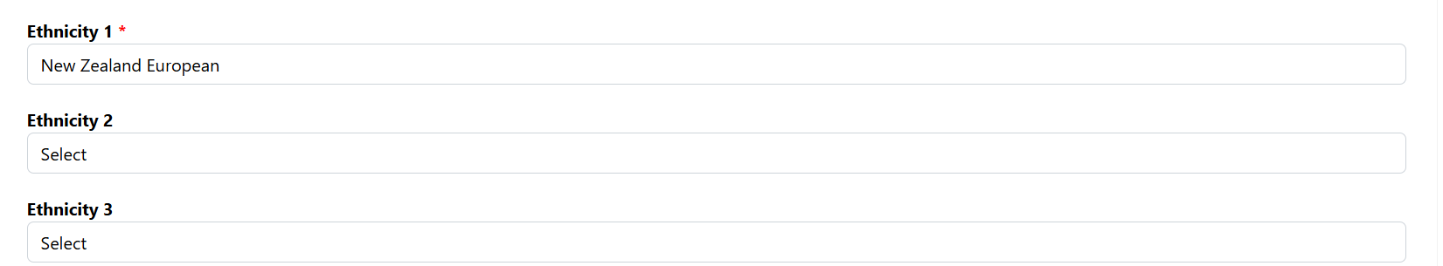

Submit

Click **Submit** when all the required fields are completed.

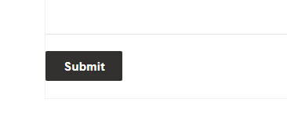

If your submission was successful, you will see the message ‘Successfully submitted Part A’.

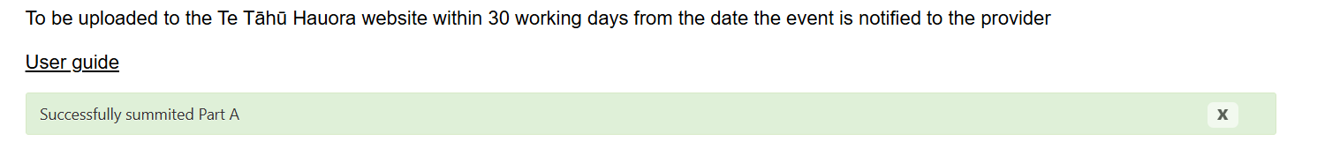

You will also receive email confirmation that your submission has been received, stating: ‘Thank you! We have received your submission of a new harm (adverse) event for event reference number #_______.’

Submitting a Part B for an existing harm event

Where to enter Part B details

All part B details must be uploaded to the portal within **120 working days** from the date the event was notified to the provider.

If you have previously submitted a Part A and you would like to complete the Part B for this event, go to the **Harm Event List** page.

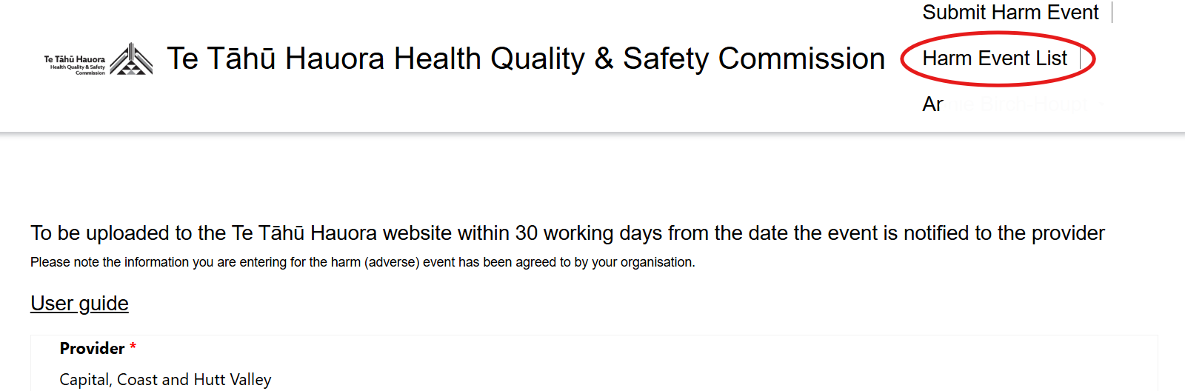

Look for the reference code of the relevant event. You may need to search or scroll (shown in blue below) to find the event. Then click the three dots next to the Event Status column (circled in red below).

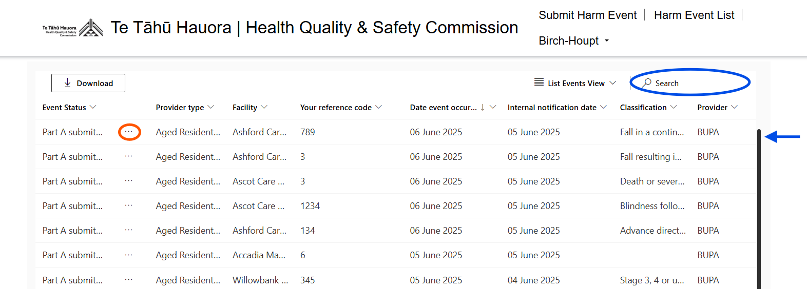

Then click **Edit Part B** from the options in the dropdown list.

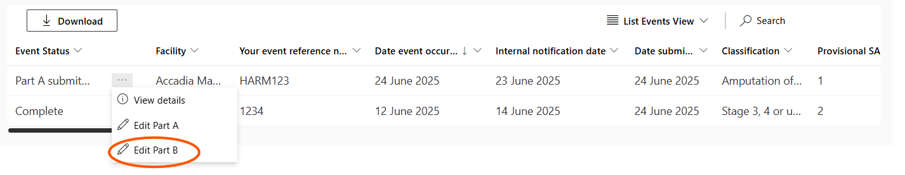

Now you can follow the instructions below to complete Part B.

Filling out Part B

Event details

* **Final SAC rating:** Select the final SAC rating from the dropdown list. If, following the review, the harm event no longer meets the criteria for a SAC event, select **Non-SAC event**.

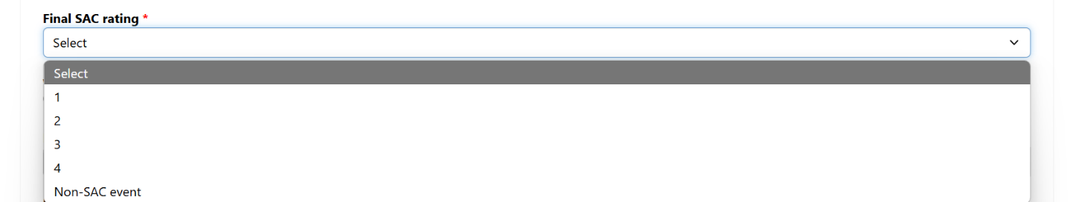

* **Would you like to de-notify the event?** Indicate whether the harm event should be de‑notified (*Yes/No*).

Note: De-notification is applicable for a Part A submission that has already been submitted but, on review, it has been confirmed that the event is no longer a SAC 1 or 2 or an ARR and instead is now a SAC 3 or 4 or a non-SAC event. That is, it no longer requires notification to Te Tāhū Hauora.

* If *Yes*– provide the reason for de-notification in the **De-notification reason** box below.
* If *No* – Go to the next question, **Date review completed**.

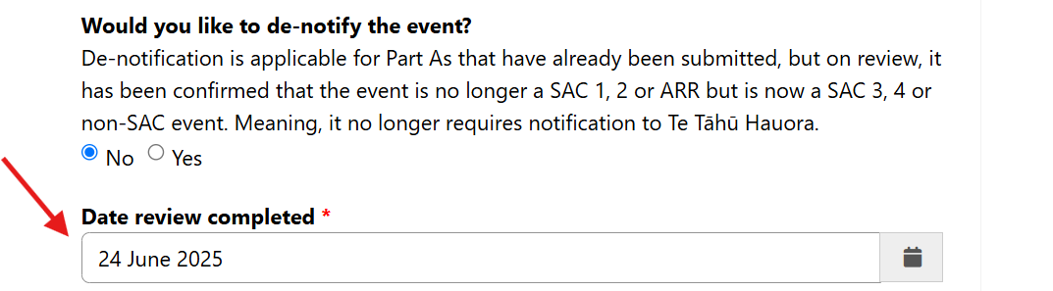

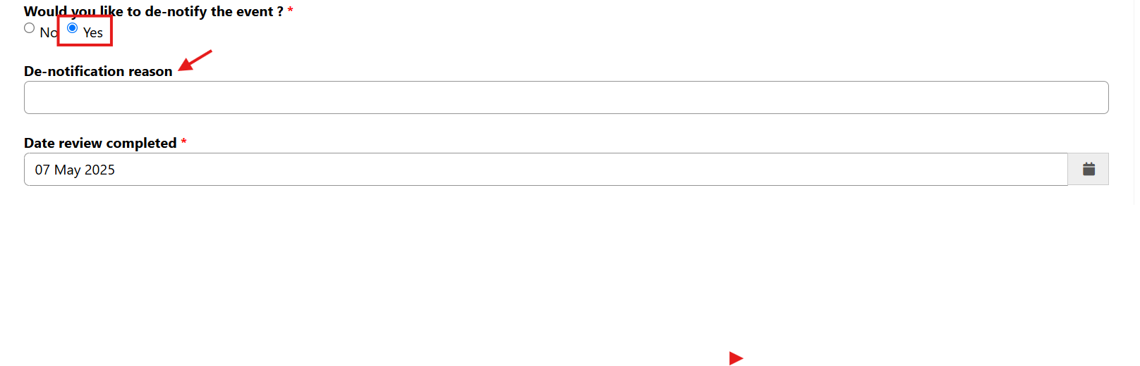

* **Date review completed:** Click on the calendar icon and select the date the review was finalised within your organisation. Future dates cannot be entered.

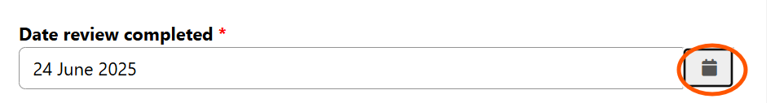

* **Review methodology used:** Click on the magnifier to search and then select methodology used from the lookup list. If the methodology you used is not listed, select **Other**.

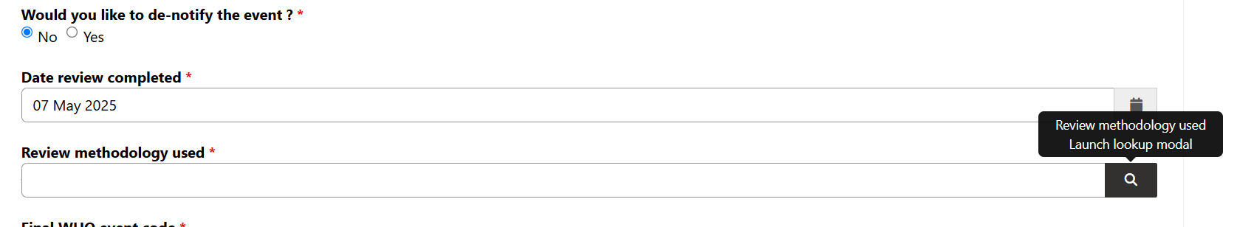

* **Seclusion event:** If you are reporting a seclusion event, you will need to indicate this is a seclusion event and then answer the four additional questions below.

|  |
| --- |
| Note: This question is only visible to private hospital and Health New Zealand (Health NZ) submitters. If you are **not** a private hospital or Health NZ submitter, please go straight to the next section – Identifying learning opportunities. |

* Is this a seclusion event? Select Yes/No.
* Was the seclusion event longer than 24 hours cumulative within 28 days? Select *Yes/No* from the dropdown list.
* Did the event comply with the Guidelines for reducing and eliminating seclusion and restraint under the Mental Health (Compulsory Assessment and Treatment) Act 1992? Select *Yes/No* from the dropdown list.
* Did the review include consumer and/or whānau participation? Select *Yes/No* from the dropdown list.
* What influencing factors contributed to the seclusion event? Select the relevant option from the dropdown list.

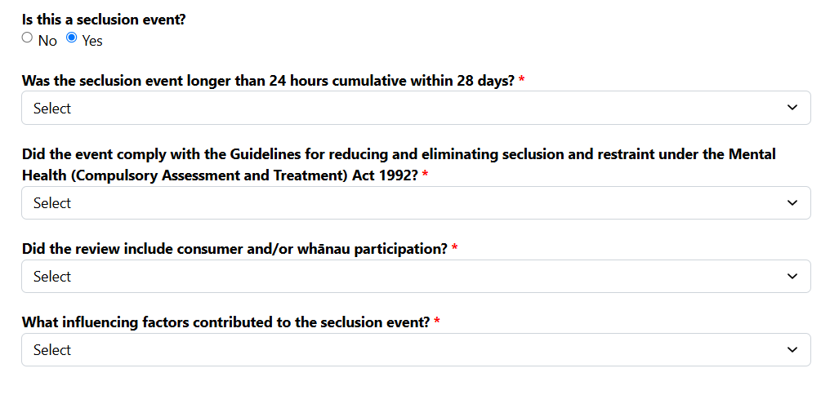

Identifying learning opportunities

You can enter up to six **learning opportunities**.

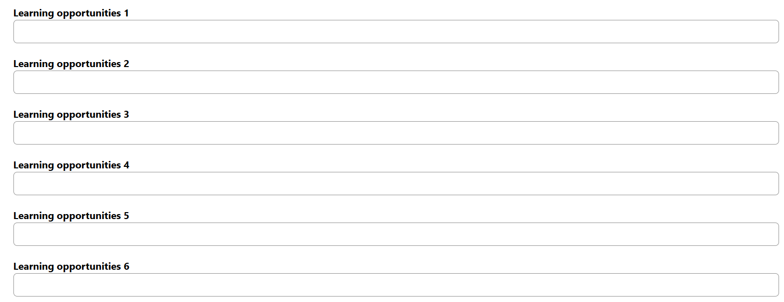

Anonymised report submission

Indicate whether the anonymised report has been submitted (*Yes/No*).



Uploading the review report

* Similar to attaching a file to an email, click **Upload** to begin attaching the report.
* Navigate in your files to find your anonymised review report and click **Open** to upload the file. The report must be in a single file in PDF format, up to 5 MB.

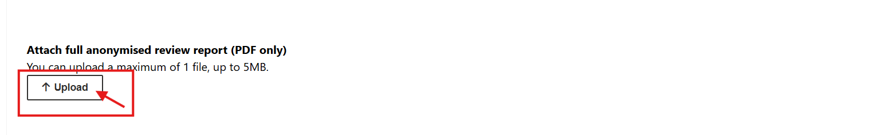

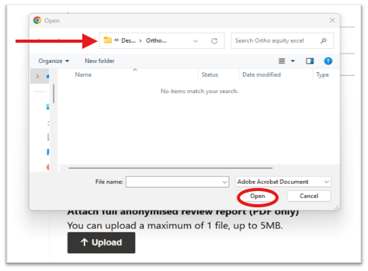

The following image shows a successful file upload.

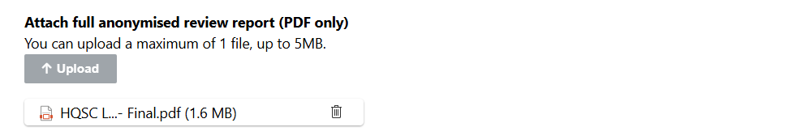

* For the question **This harm (adverse) event has been approved for transmission by the organisation’s chief executive (or equivalent) or senior delegate who endorses the accuracy and content of the document on their behalf**, select *Yes* or *No*. If you select *Yes*, the event status will show as **Complete** in the Harm Event List.

Harm Event List page

View details or edit event details

* To view or edit a previously submitted part A or B, navigate to the **Harm Event List** page.
* You can use the search bar to search the reference code of the event you would like to edit.
* To edit an event, click on the three dots to the right of the **Event Status** column.

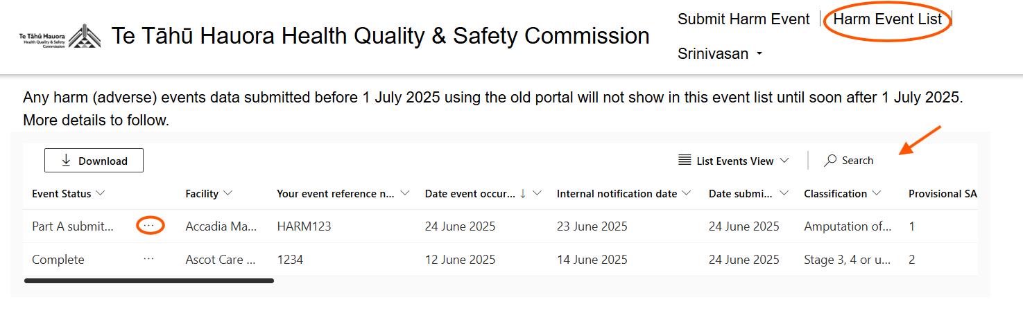

* Click **Edit Part A** or **Edit Part B**.

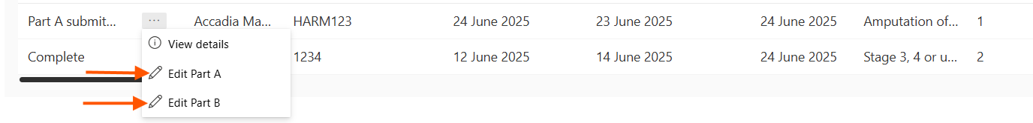

* Make any changes in the pop-up that appears.

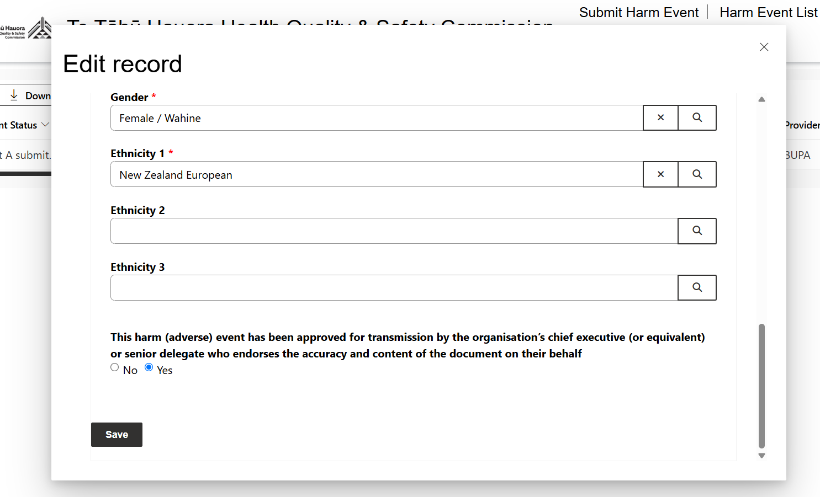

* At the bottom of the page, click **Save** to save your changes.

Download data

To download submitted harm event data, click the **Download** button. This will save the data as an Excel workbook to your computer.

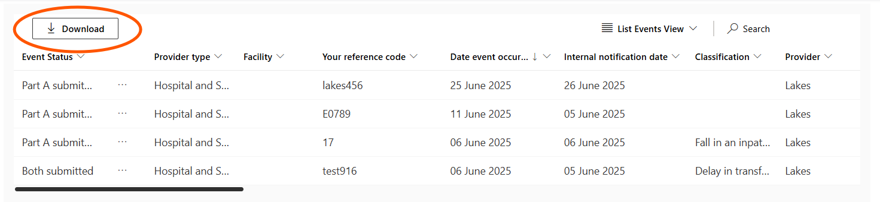

View more columns

Drag the black bar at the bottom of the Harm Event List table to scroll across and view more columns.

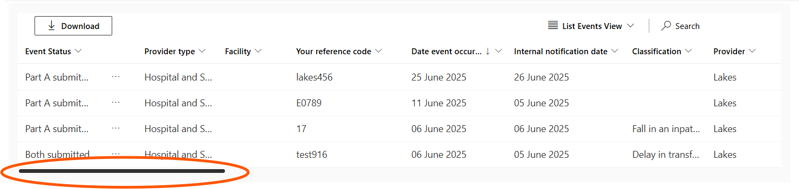

Filter or sort the data

* To filter or sort the event list, click on the arrow next to the column you would like to sort or filter.
* Click the down arrow, as shown in the screenshot, to sort the events to be ascending or descending, or filter the events. The **Filter by** function uses standard search criteria terms.

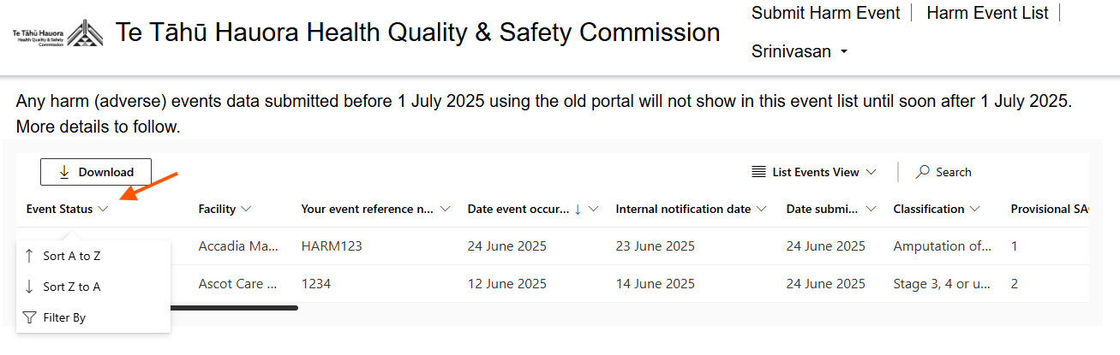

How to save submitted Event details (Part A and Part B)   
as a PDF to attach in an email

This section explains how submitted harm events in the portal can be saved as PDFs. This will be helpful if you need notify services that you have made a submission to Te Tāhū Hauora as it will enable you to send the record as an attachment in an email.



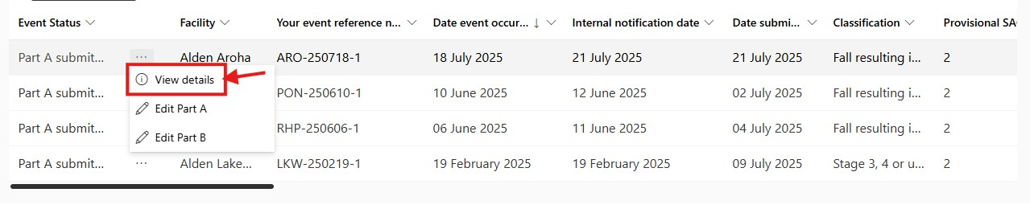

A new window will pop up displaying the ‘Record details’.

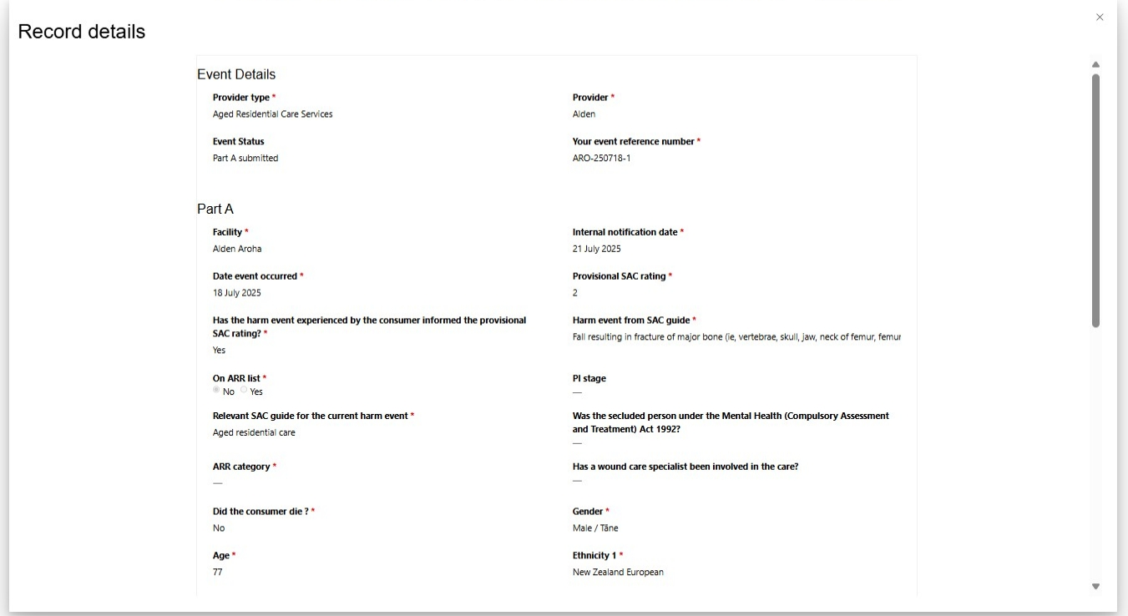

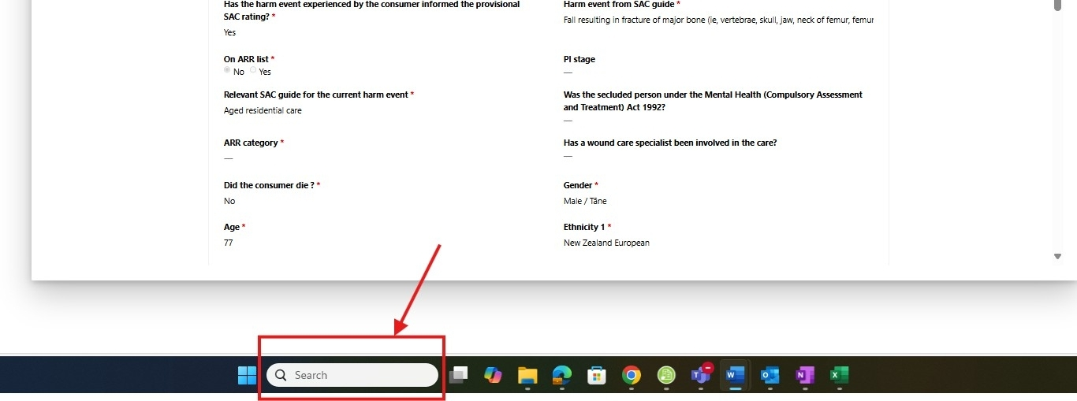

In the search box, type ‘**Snipping Tool**’.

Note: This tool is not available on Windows versions earlier than 10 or on Mac. Please use your preferred method to take screenshots.

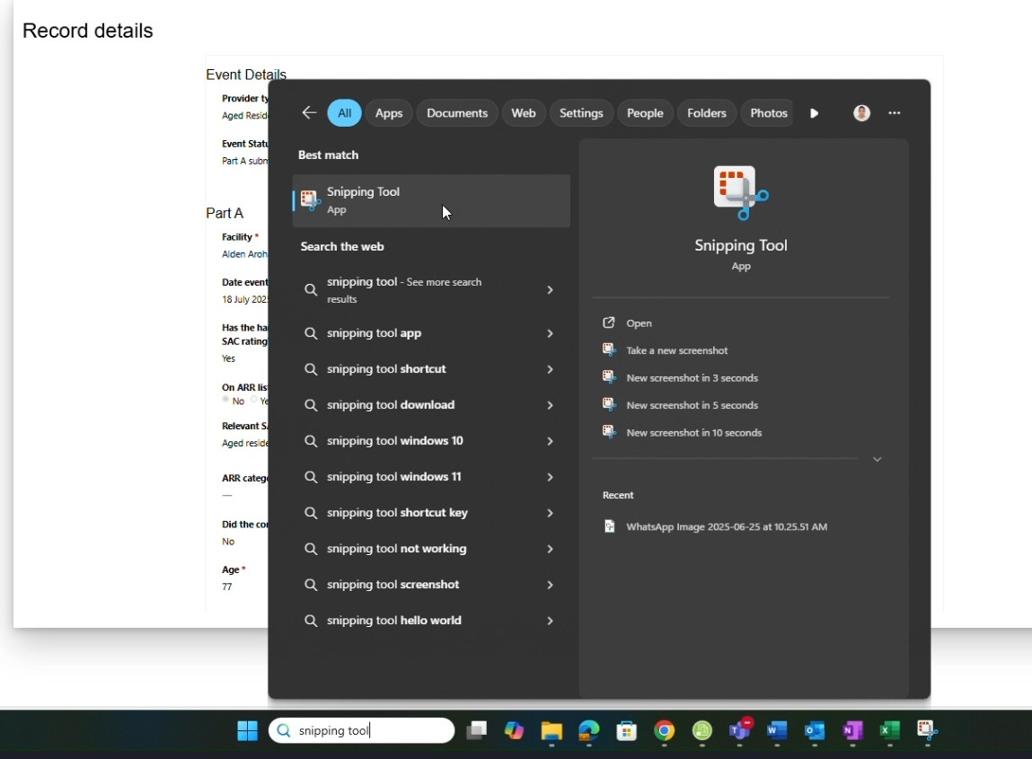

Select as shown.

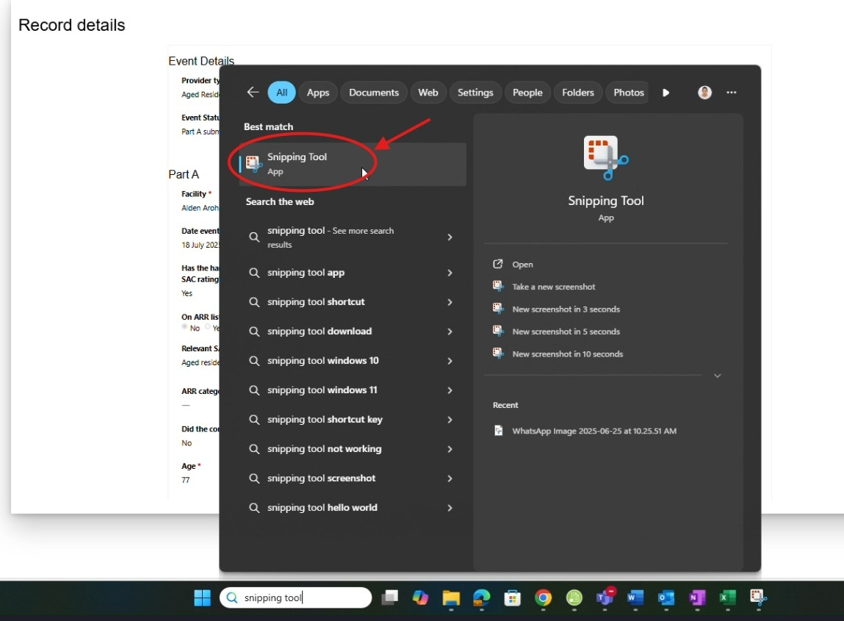

The Snipping Tool will open.

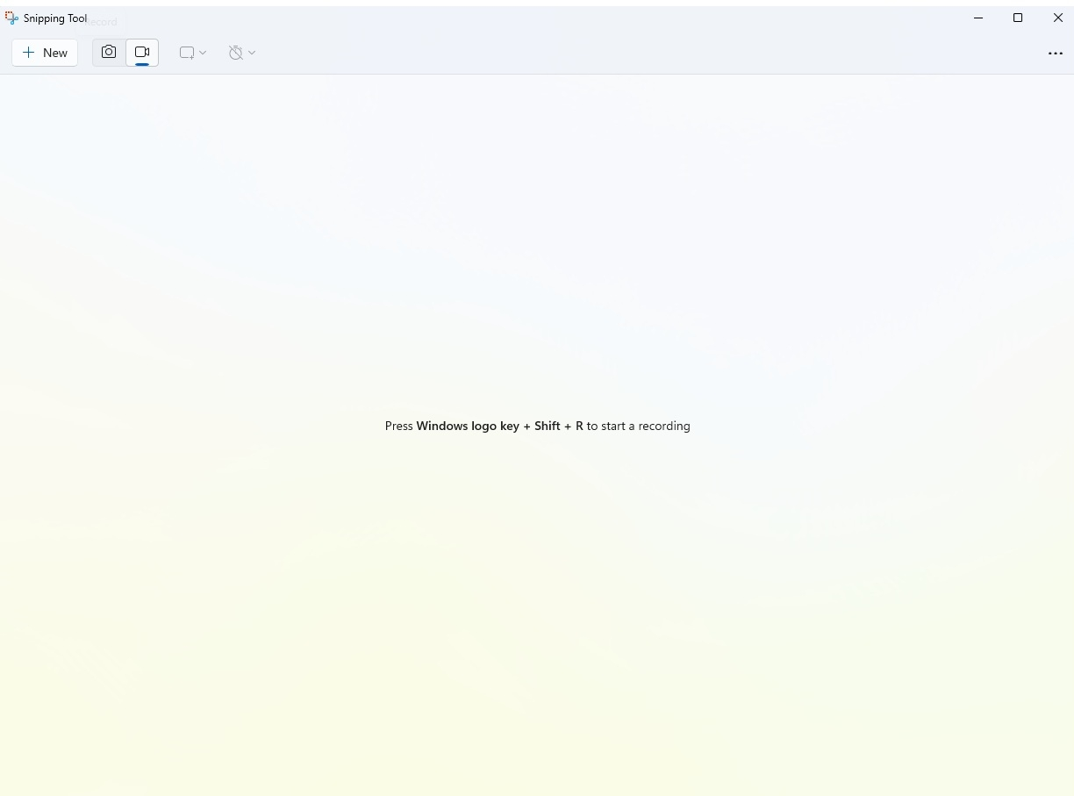

Click ‘New’

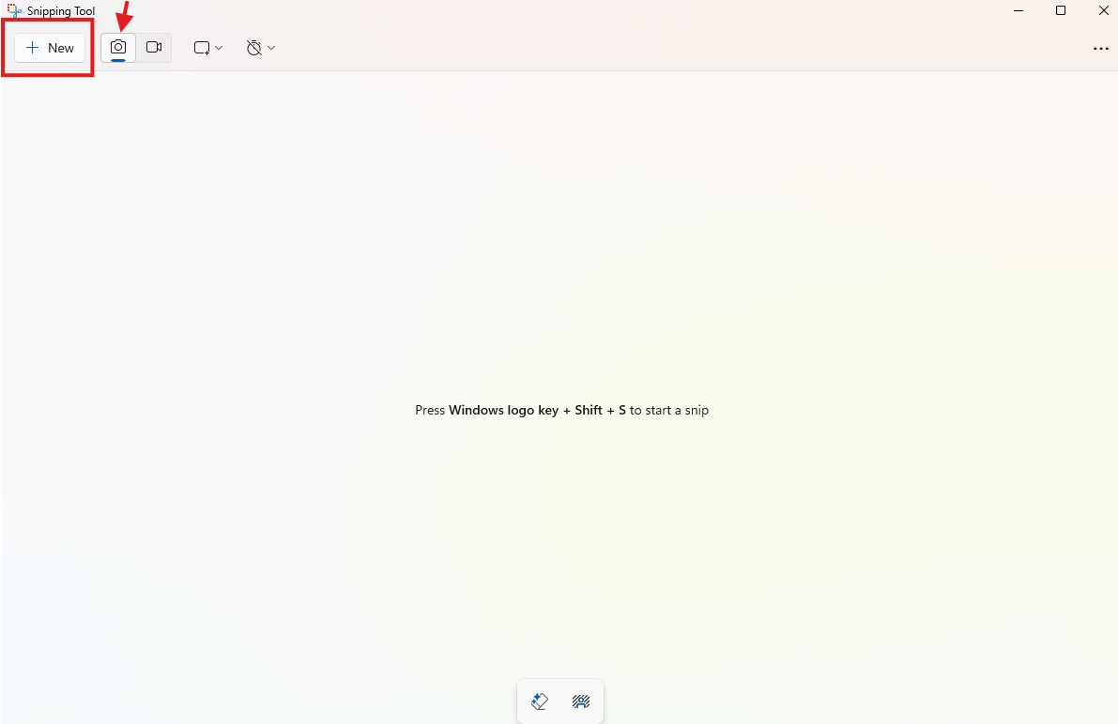

To capture the screen, use your mouse to drag and select the area you want to capture, such as ‘Record details’.

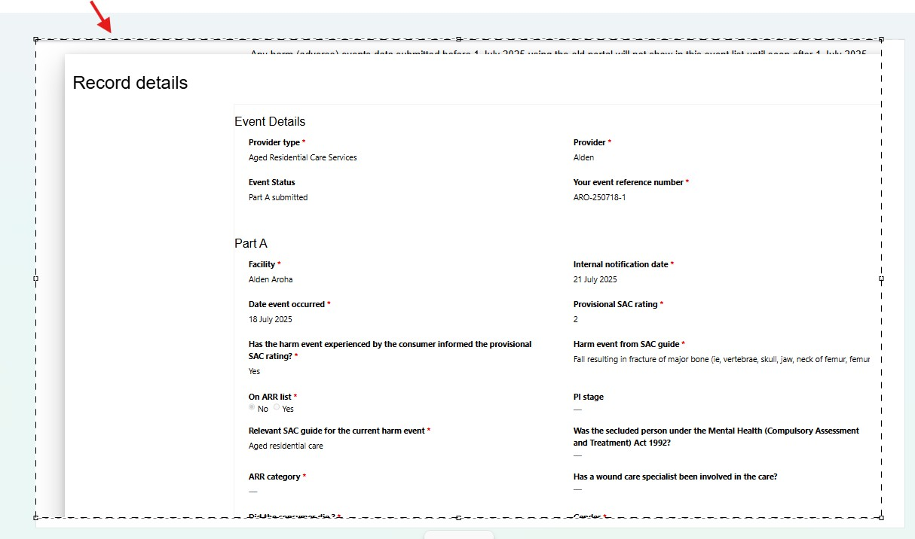

Click ‘Save As’ icon to save the screenshot.

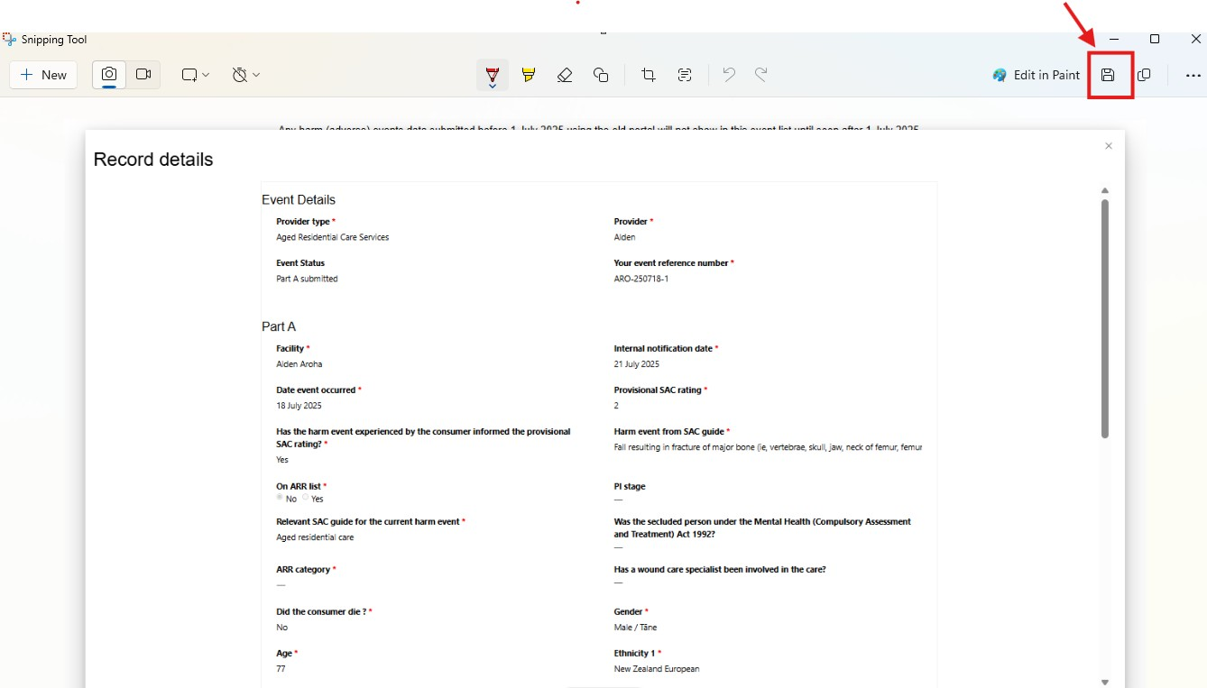

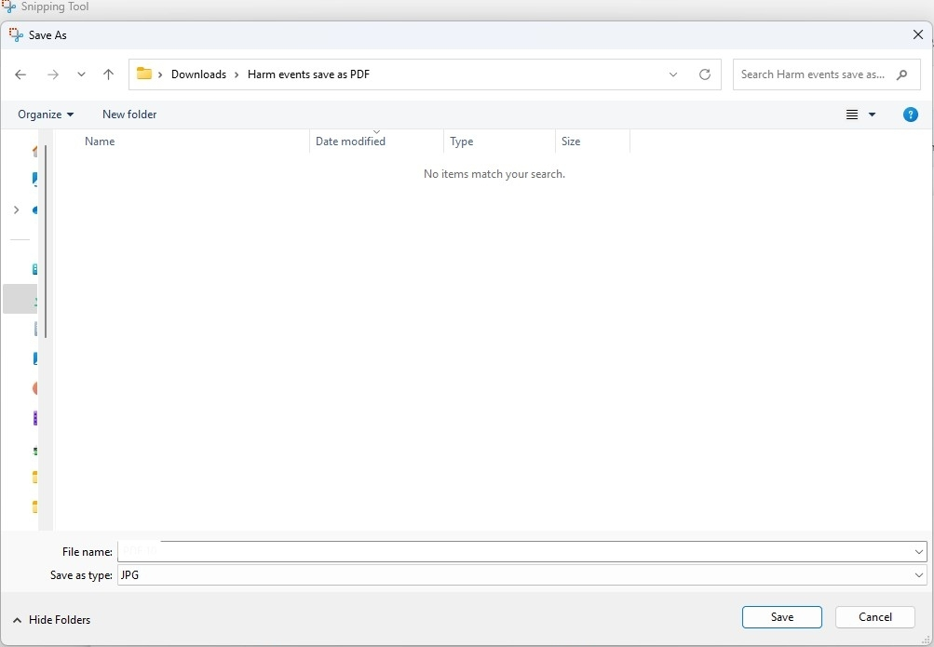

Save the ‘File name’ as shown below

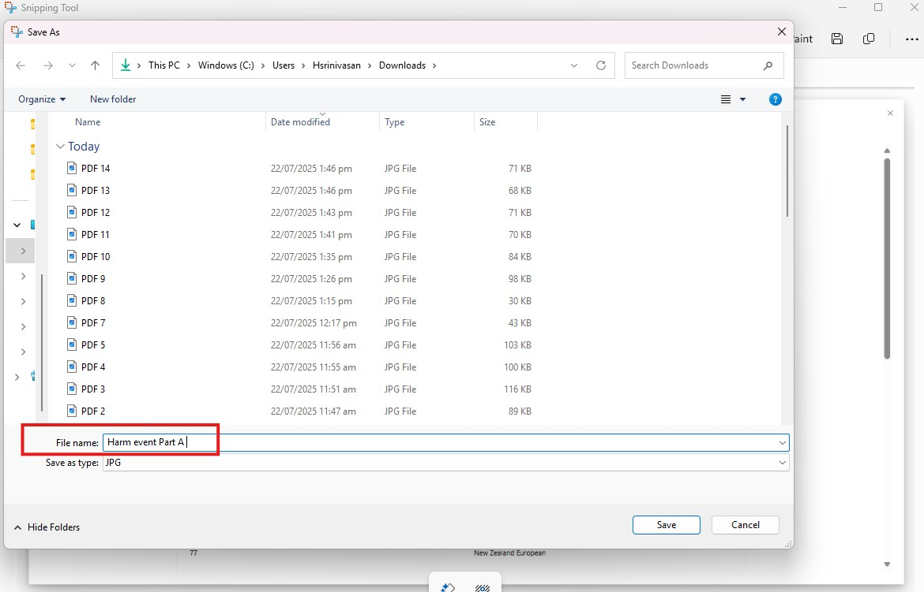

Now to save for Part B, scroll down

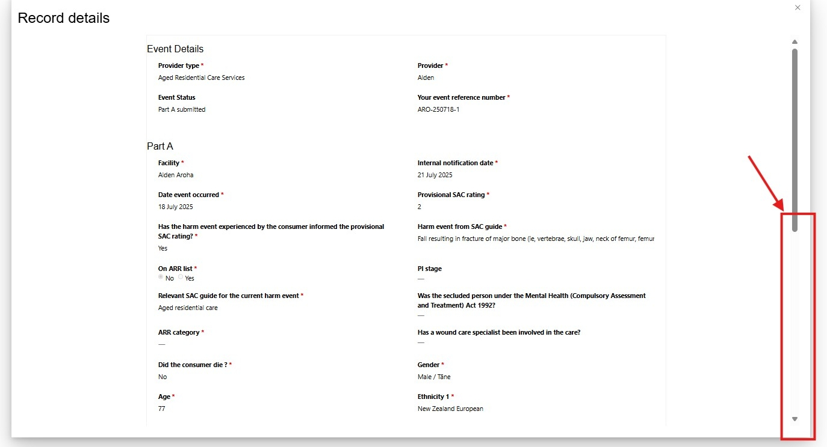

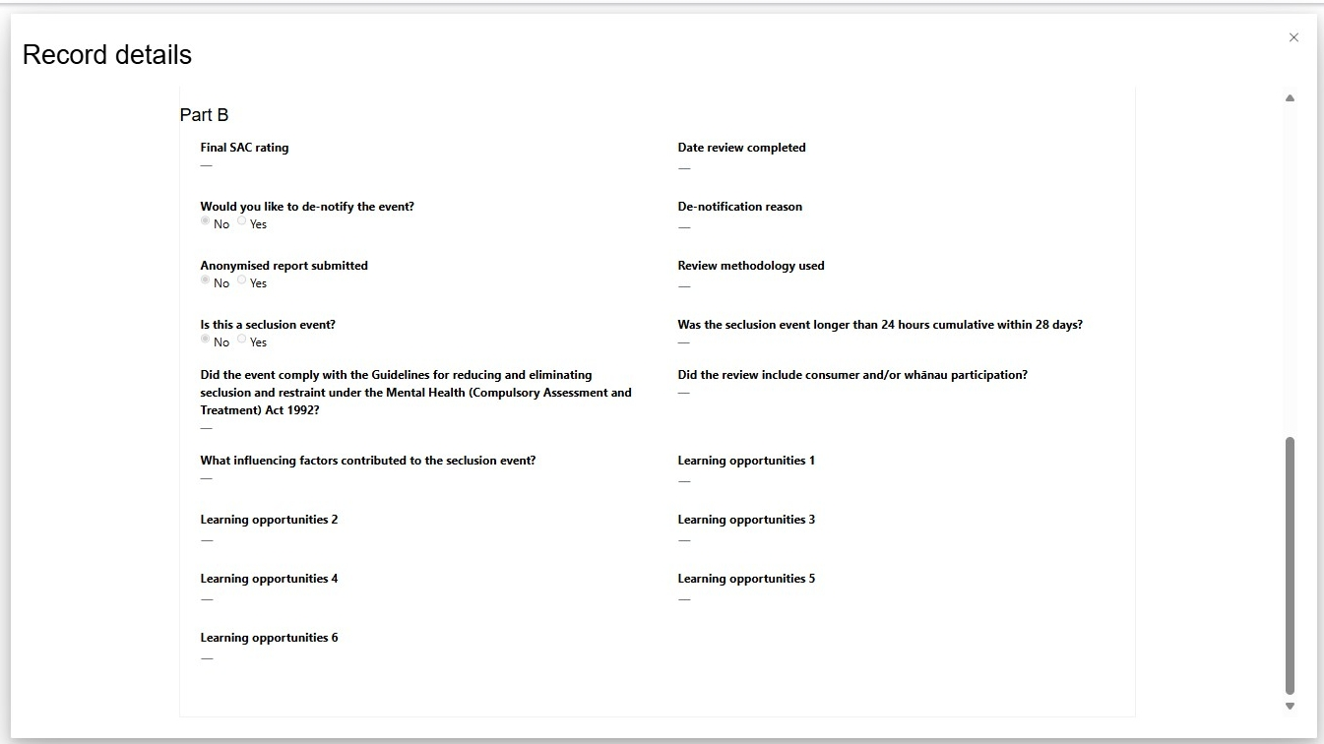

To take the screenshots, follow the same steps you used for Part A, except save the file with the new name shown below.

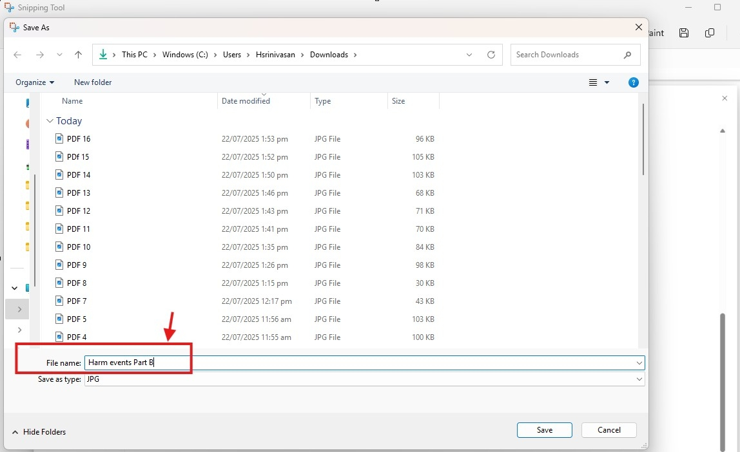

Now, the files will be saved in the folder where you chose to save them.

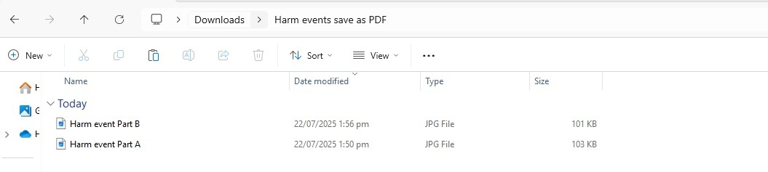

If you prefer to have the files as a PDF instead of JPG, open a Word document. Click ‘Insert’ as shown.

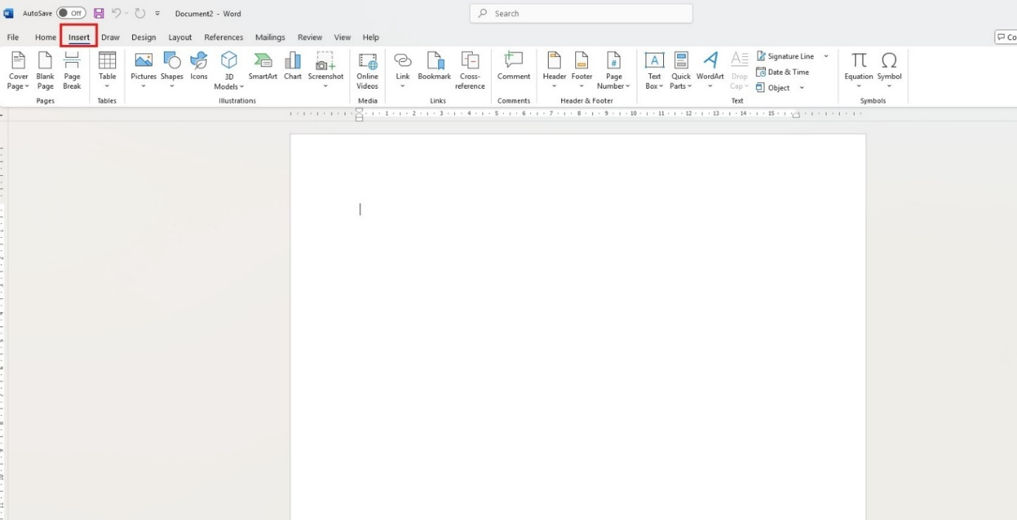

Select and click ‘Pictures’

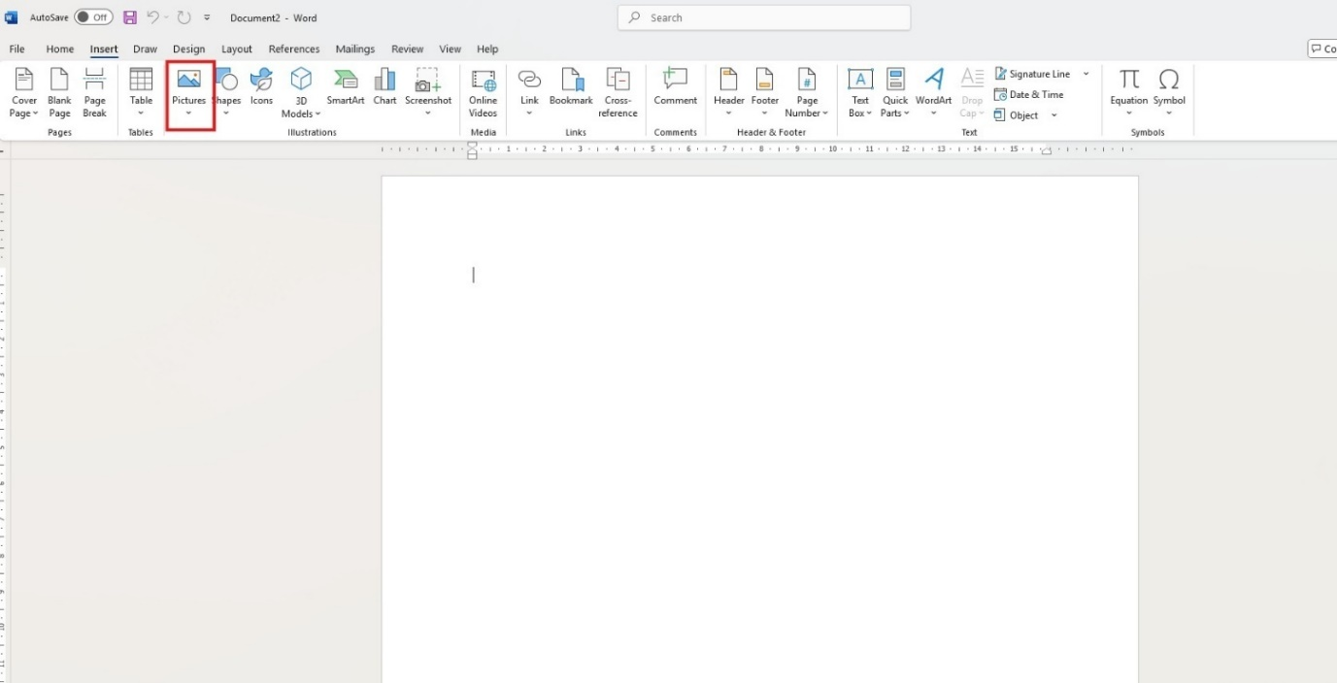

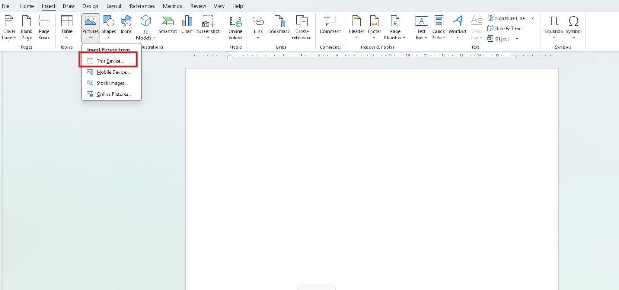

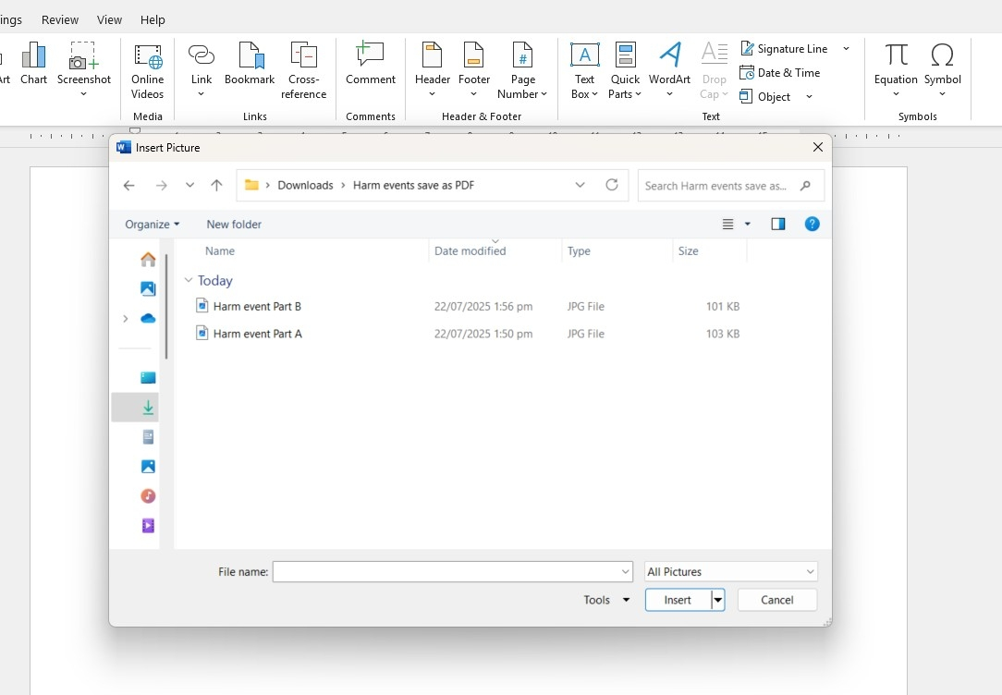

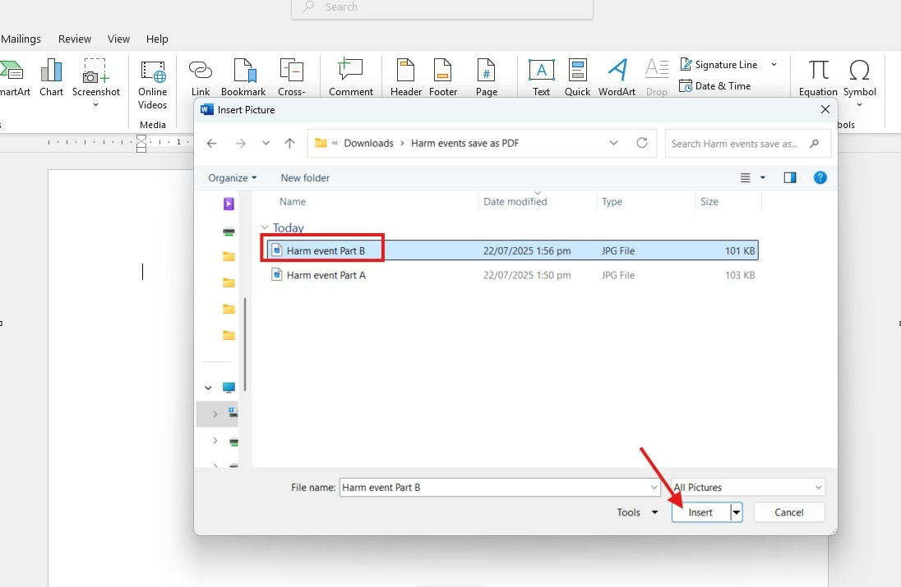

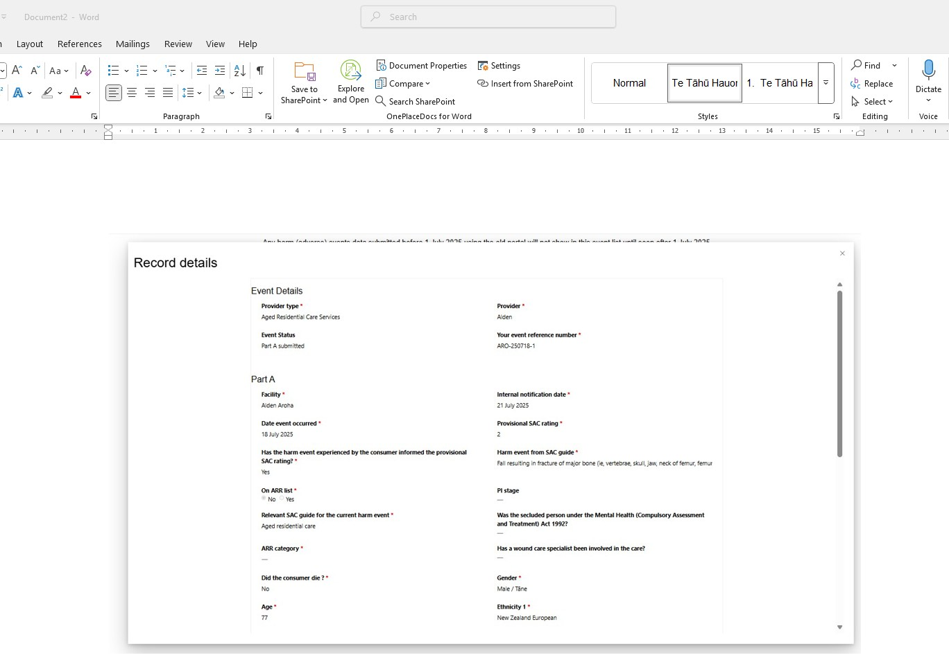

Next, go to ‘Insert’ and click on ‘Picture’

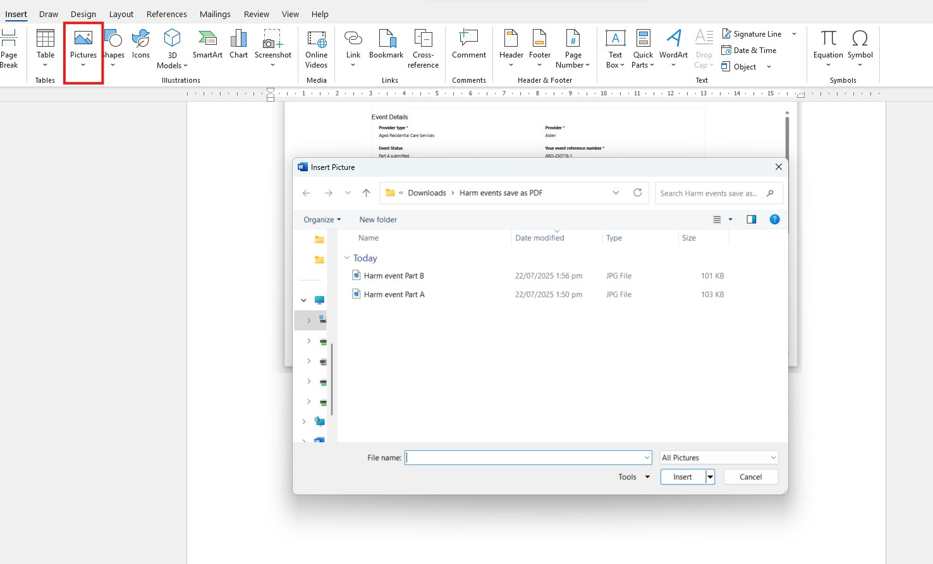

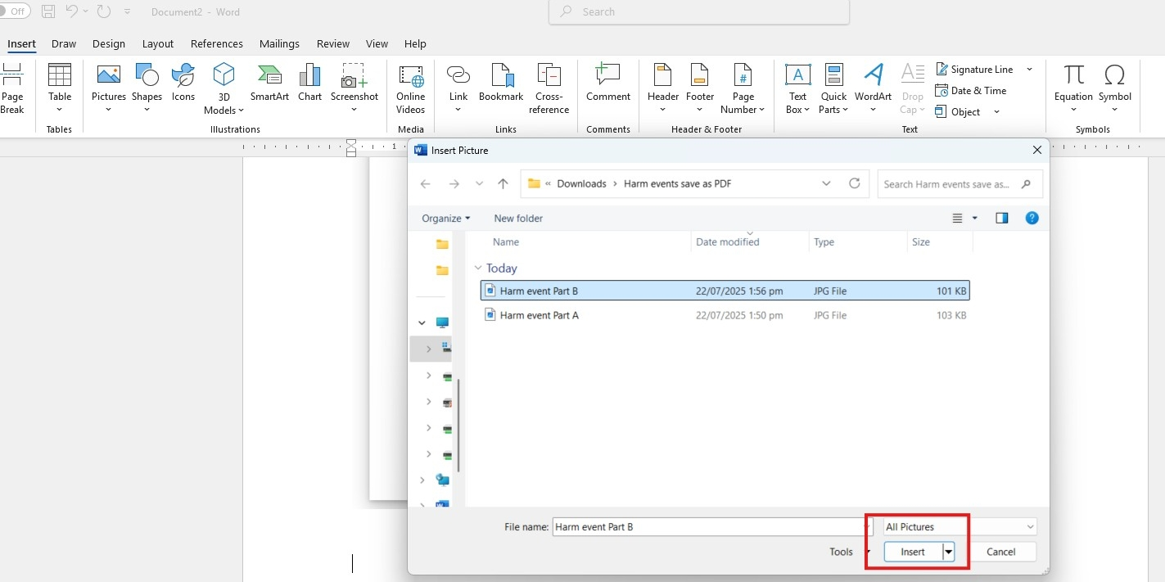

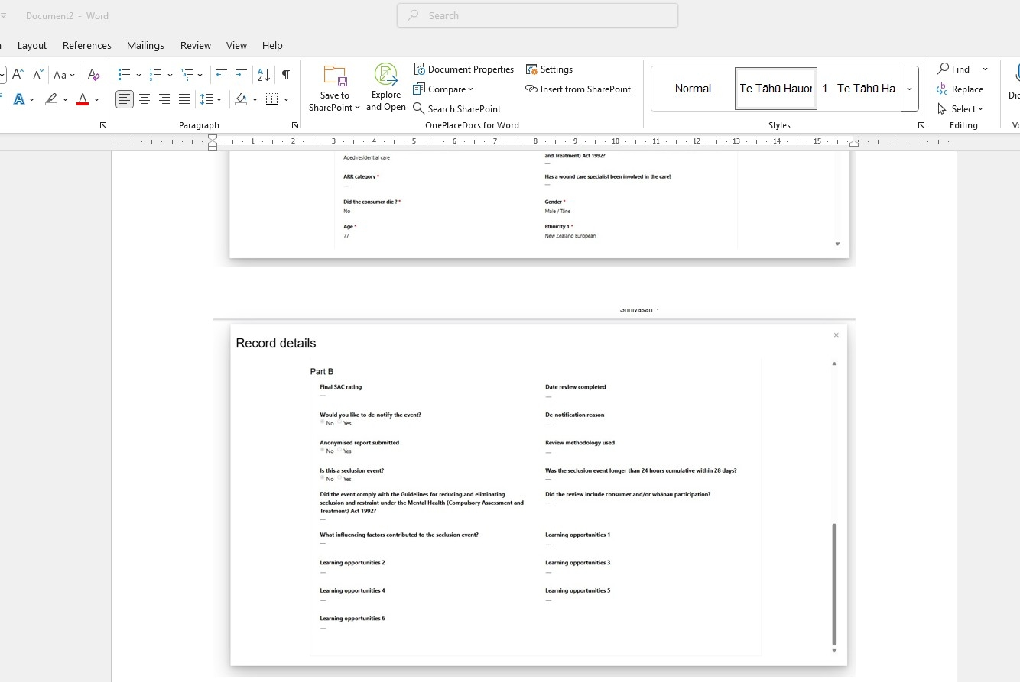

Click ‘File’

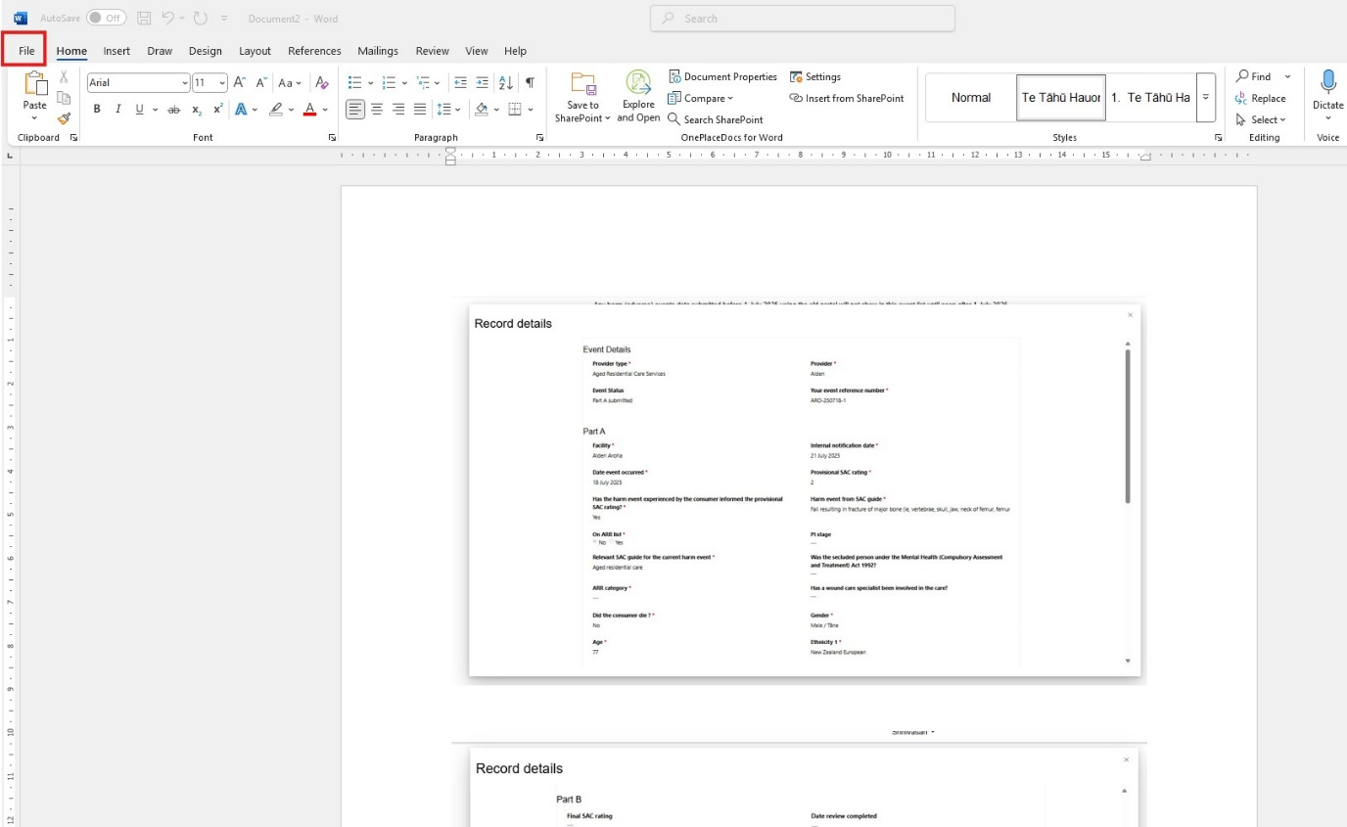

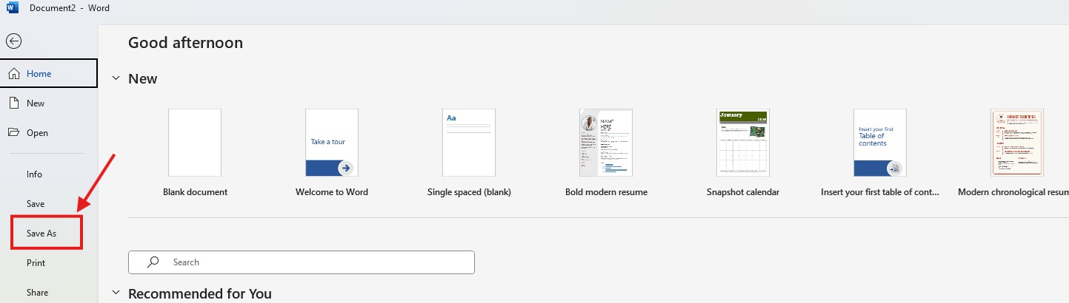

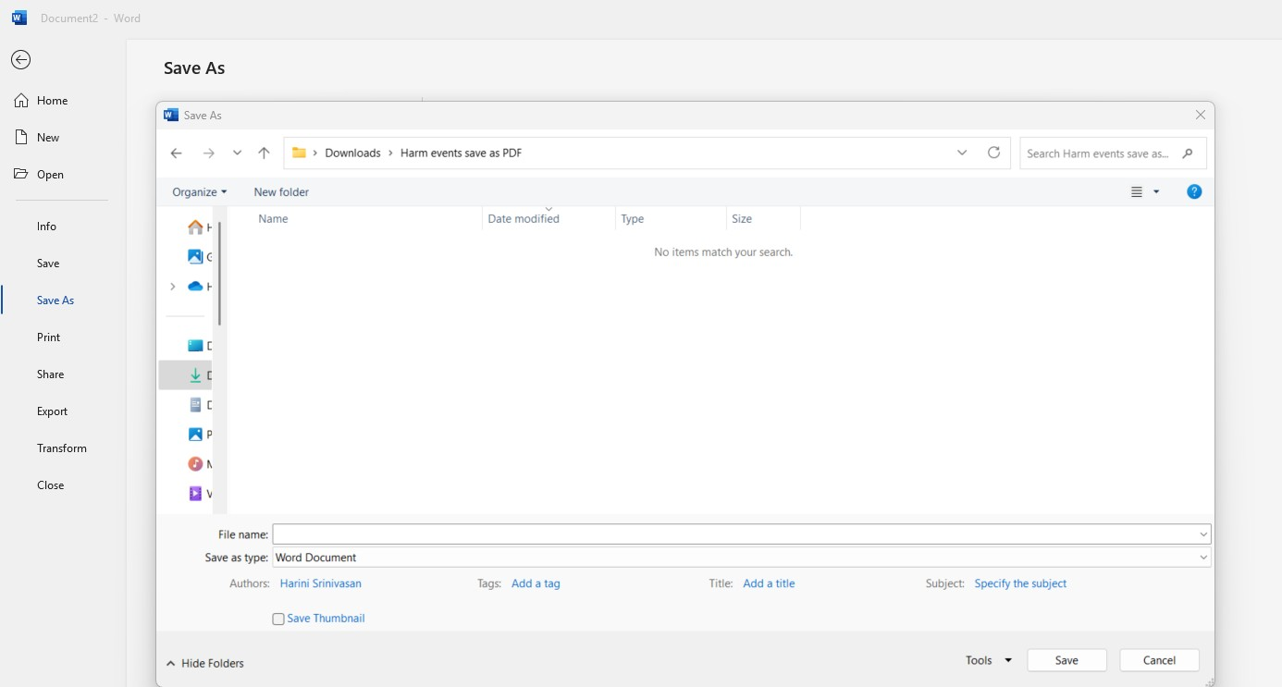

Enter the file name and select ‘PDF’ from the 'Save as type' dropdown

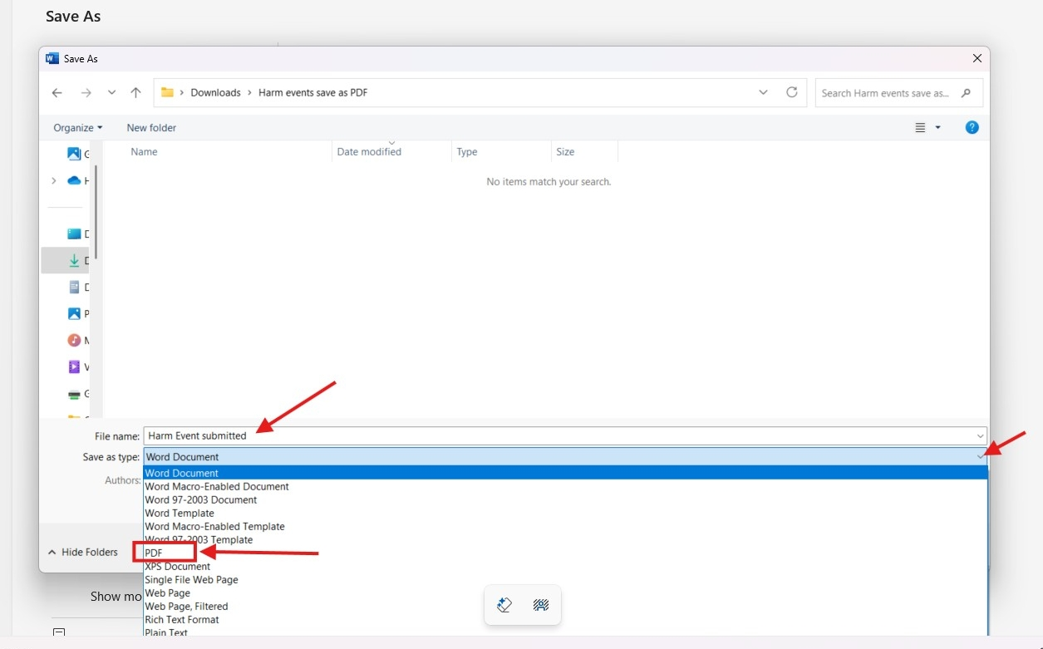

Click ‘Save’

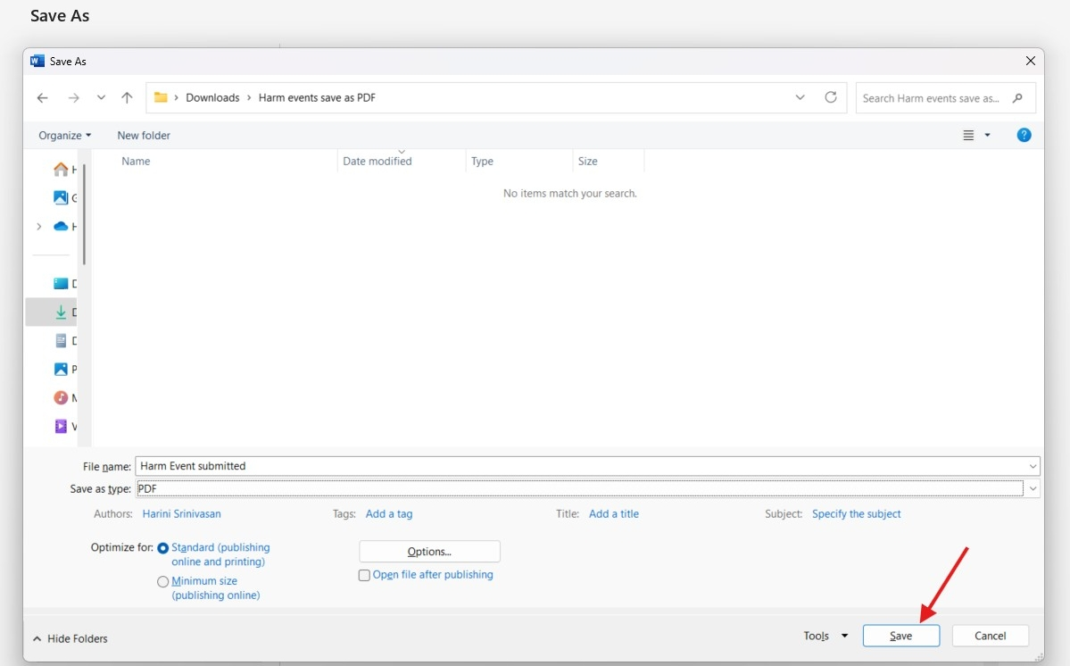

The PDF file will be created and saved in the location as shown

