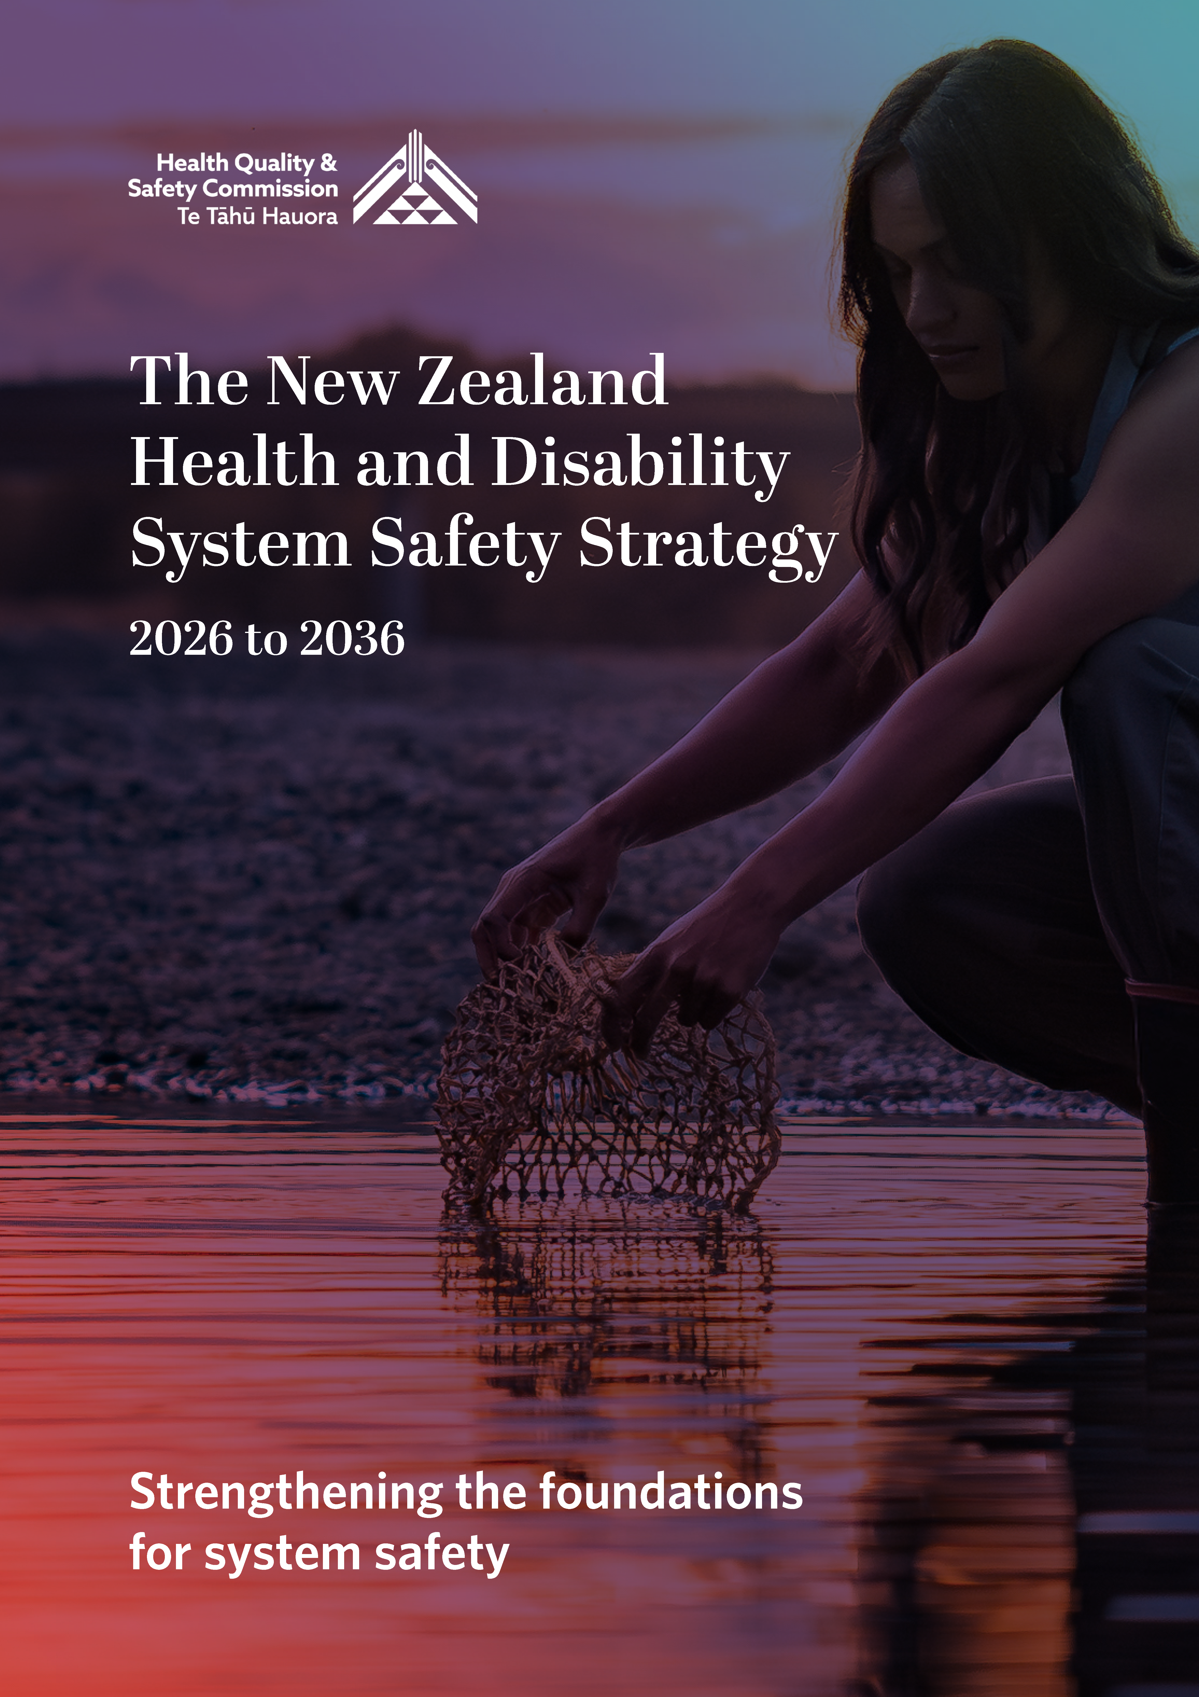

The New Zealand Health and Disability System Safety Strategy 2026 to 2036
Strengthening the foundations for system safety

Published June 2026 by Health Quality & Safety Commission Te Tāhū Hauora,
PO Box 25496, Wellington, 6146.

ISBN 978-1-991122-29-2
Available online at www.hqsc.govt.nz
Enquiries to: info@hqsc.govt.nz

This work is licensed under the Creative Commons AttributionNonCommercial-ShareAlike 4.0 International (CC BY-NC-SA 4.0). To view a copy of this licence, visit https://creativecommons.org/licenses/by-nc-sa/4.0


Minister’s foreword
A safe, high-quality health and disability system is essential to the wellbeing of all New Zealanders. Every interaction people have with the system should be safe, respectful and centred on their needs, regardless of where they live or how they access care. Maintaining this in an increasingly complex and pressured system requires clear direction, strong leadership and a shared commitment to improvement.
The New Zealand Health and Disability System Safety Strategy (the Strategy) sets out a system-wide approach to strengthening quality and safety across New Zealand’s health and disability sector. It recognises that care is provided within a complex, interconnected system. Safety is shaped by how services are designed, how organisations work together, and the conditions in which people deliver care. The Strategy defines what we expect of the system and how we will act collectively to reduce potentially avoidable harm, support learning and provide safe, people-centred care that supports equal health outcomes for everyone.
People are at the heart of the Strategy. Their experiences and insights are critical to understanding where the system is working well and where it needs to change. The Strategy also recognises the essential role of the workforce and the need to support the people who deliver care, so they can do so safely, sustainably and with confidence.
The Strategy has been through engagement across the health and disability sector. It provides a framework to inform actions that align with the Government’s health priorities and with international best practice in safety science. It also complements other national health strategies, including the New Zealand Health Strategy, by strengthening the foundations that enable safe and effective care.
By working together across agencies, organisations and communities, we can build a health and disability system that is safer, more resilient and better able to respond to the needs of all New Zealanders, now and into the future.
I acknowledge the leadership and contributions of those across the system who have shaped this Strategy. This leadership will be essential as we take responsibility for delivering real, measurable improvements in safety and quality.

Hon Simeon Brown
Minister of Health

Contents
Minister’s foreword 3
Whakataukī 5
Executive summary 6
Introduction 8
Purpose 8
Mandate 9
Strategy development 10
Acknowledgements 10
Background 11
Defining quality and safety 11
A system approach to quality and safety 14
Quality and safety in New Zealand 14
A changing context and emerging risks 15
Vision and guiding principles 16
Patients and their whānau are at the heart of the system 17
Collaborative relationships across the system 18
Building the capacity for learning and improvement 18
Enabling and supporting the workforce 19
Focus areas and expected outcomes 20
The System Safety Strategy’s five focus areas 21
Action plan 28
Bibliography 29

Whakataukī
Mā mua ka kite a muri, mā muri ka ora a mua
Those who lead give sight to those who follow,
those who follow give life to those who lead
This whakataukī speaks to the importance of working together. It acknowledges and values the importance of both leaders and followers because both are essential and they are co-dependent.
We are trying to understand and conceptualise safety; we are weaving a hīnaki, a net designed to catch tuna [freshwater eels]. In its natural environment of the waterways, the hīnaki is alive, moving, interconnected, with openings for tuna to swim in. Outside of that context, it may look insubstantial, unimportant or full of holes – but when the whānau need kai, it’s the net I reach for. The weaving has strength and purpose.
‘Living in te ao Māori, we’re trying to take something living and dynamic and translate it into a strategy. Every time we intersect with the health system, it’s one of those matua kupenga [knots] in the net. It’s at a matua kupenga that matters, however, when you are inside the system, it’s hard to see the whole net. Where do you sit in the hīnaki? Where do you intersect with the system, in different times and spaces?
(Co-chair, strategy rōpū)

Executive summary
The New Zealand Health and Disability System Safety Strategy (the Strategy) (Figure 1) sets a clear, system-wide direction for strengthening quality and safety as a foundation for people-centred care for the next 10 years. It reflects contemporary safety science, recognising that quality and safety is shaped by how the system is designed, led and supported, rather than by the actions of individuals alone.
The Strategy is grounded in four guiding principles that, together, shape how system safety is understood and strengthened. It places patients and whānau at the heart of the system and recognises that to deliver safe care, effective and collaborative relationships across the health and disability system are required.
It emphasises the need for learning and improvement to be continuous and shared, and for the workforce to be supported and culturally safe in order to deliver care reliably. Taken together, these principles aim to reduce potentially avoidable harm, build trust, and ensure that different levels of need are met with appropriately different responses so that outcomes are fair and consistent across the population.
Five interconnected focus areas translate these principles into action. They identify where early, deliberate action is required to strengthen the foundations of system safety and where collective effort will deliver the greatest impact. The immediate priority is collective action and accountability, which establishes the leadership, structures and shared expectations needed to coordinate system safety activity. The remaining focus areas describe how the system will build capability over time to support continuous improvement, enable and support the workforce, strengthen patient and whānau partnership, and improve the use of information and learning.
The focus areas are the platform for delivery. They are where the detailed system safety action plan will be developed, agreed and implemented. Taken together, they are intended to produce a more connected and resilient health and disability system; one that enables system-wide leadership with a strong focus on quality and safety, enhanced patient and workforce engagement and greater system-wide learning and improvement. Over time, this will collectively support safe, quality, people-centred care.

Figure 1: The New Zealand Health and Disability System Safety Strategy
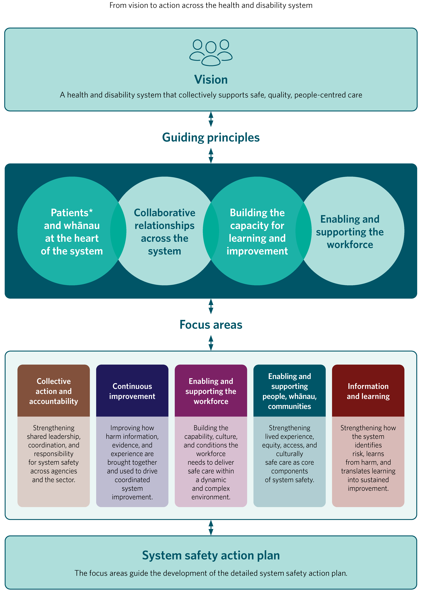
* In this document, we use the word ‘patient’ to refer to any person who engages with the health and disability system in New Zealand at any stage of their life.

Introduction

Purpose
The New Zealand Health and Disability System Safety Strategy (the Strategy) sets out system-wide direction for improving the quality and safety of care in New Zealand. It establishes the foundational principles and priority focus areas required to strengthen system safety across the health and disability sector. The system includes the wider public health and prevention functions that contribute to the health of the population and shape the environments in which safe care is delivered. The strategy is for everyone in the health and disability system, including those health entities referred to in the New Zealand Health Strategy and defined in the Pae Ora (Healthy Futures) Act 2022 (that is, Health New Zealand | Te Whatu Ora, Health Quality & Safety Commission, Pharmac and New Zealand Blood and Organ Service), regulators, national agencies, service providers, the health workforce and users of health services.
The analogy of the health system as a hīnaki (a net for catching tuna (eel)) reflects its complex, interconnected nature and the importance of working together to deliver people-centred care.
Approaches to quality and safety have evolved in recent years from a narrow focus on individual clinical error to a systems-based perspective informed by contemporary safety science. Health is a complex adaptive system that comprises multiple interconnected parts, that through their interaction, create both quality care and inevitable risk. Improving safety depends not only on individual actions, but also on how systems are designed, led and supported to enable safe, people-centred care.
Grounded in this understanding, the Strategy shifts the focus from individual error to the systems in which people work and the conditions that shape everyday practice. It applies across the whole sector.
The Strategy provides the foundation that will strengthen quality and safety. It recognises that people have experienced harm as a result of the care they have received, and that reducing potentially avoidable harm and improving the experience of care is central to the Strategy’s purpose. Guided by its first principle, ‘Patients and whānau are at the heart of the system’, the Strategy ensures that patients and whānau are central to defining what people-centred care looks like. It also recognises that their experiences, insights and aspirations are essential to understanding where quality and safety are strong in the system, and where the system must improve to reduce potentially avoidable harm. The Strategy’s initial emphasis is on building shared understanding, alignment, and collective capability across the sector so that patient and whānau voices are consistently heard and acted on.
The Strategy provides the overarching framework and direction within which more detailed work will occur. Initial activity will focus on developing a system safety action plan guided by the focus areas set out in this document. This plan will describe the specific actions, responsibilities and sequencing required to embed system safety and establish a strong and collective foundation for long-term improvement. Its development and delivery will require sustained commitment from across the system, particularly in the context of the pressures facing all health systems and will depend on shared ownership and collaboration.

Mandate
This 10-year Strategy has been created in response to the Government’s 2024 Health Policy Statement, which sets out priorities for the health and disability sector to 30 June 2027. One of those priorities was to develop a strategy that:
defines quality and safety for the New Zealand health and disability sector
provides a framework that guides actions for improving the quality and safety of the health system
aligns with international best practice and complements the WHO Global Patient Safety Action Plan 2021–2030.
The Strategy complements the New Zealand Health Strategy (2023) and other strategies prepared by peak bodies within health. It is aligned with the Pae Ora (Healthy Futures) Act 2022 and a commitment to honouring the relationship between Māori and the Crown under Te Tiriti o Waitangi, setting out specific commitments to improving Māori health and wellbeing. In practice, this includes ensuring Māori have a strong and meaningful voice in shaping services, defining what quality and safety mean, and identifying areas where improvement is required. Strengthening Māori participation in decision making supports services to be better targeted to the needs of communities, enables Māori to exercise greater influence over their health and wellbeing, and contributes to improved outcomes for those with the greatest need.
As a Member State of the World Health Organization (WHO), New Zealand is obliged under World Health Assembly resolutions WHA 72.6 (2019) and WHA 74.13 (2021) to prioritise patient safety within health policy and programmes. These resolutions recognise patient safety as a global health priority. New Zealand has endorsed and aligned this strategy with the WHO’s Global Patient Safety Action Plan 2021–2030, which provides a framework to develop a national action plan for eliminating potentially avoidable harm and improving system safety.
New Zealand has further affirmed its commitment through formal acknowledgement of the Mandaluyong Declaration on Patient Safety, which calls for renewed urgency and establishes patient safety as a foundational pillar of resilient, people-centred and equitable health systems.
Development of the strategy action plan will require engagement and collective ownership across the whole of the sector including hospital, community, primary care and allied health services. While the Strategy is grounded in contemporary safety science and provides a clear system-level framework, implementation must be informed by system capacity and capability, including workforce pressures.

Strategy development
This Strategy is the first step in a staged and iterative process. It recognises that the system is emerging from significant reform, and that further detailed planning must reflect evolving system capacity, capability and readiness for change.
The first stage lays the foundations for system safety by clarifying scope, roles and expectations, and sets the system-level focus areas that will guide subsequent planning and implementation.
The second stage will require structured engagement with the sector to inform the development of a detailed, time-bound system safety action plan during the first year of the Strategy’s implementation. This action plan will translate the Strategy’s focus areas into agreed priorities, responsibilities and deliverables. It will propose actions that are practical, appropriately sequenced, and aligned with sector capability and accountability arrangements, as well as identifying areas requiring further development, coordination or investment.
Progress will be reported through established national mechanisms, and updates will be shared with the Minister of Health and the public as the work programme evolves. Given this is a 10-year strategy, we recommend it be reviewed and updated where appropriate after five years.

Acknowledgements
The Health Quality & Safety Commission | Te Tāhū Hauora (the Commission) acknowledges patients, whānau and the health and disability sector, whose commitment has led to the development of this strategy.
In particular, we highlight the contributions of:
members of the New Zealand System Safety Strategy Rōpū, who strive daily to improve the quality and safety of the health and disability sector for the people of New Zealand
the Commission consumer advisory group Te kāhui mahi ngātahi
the Commission consumer network Kōtuinga kiritaki
the Commission Māori advisory group Te Kāhui Piringa
all participants who contributed through sector engagement.

Background
This section provides a context for the Strategy by outlining what quality and safety mean in a health and disability systems setting. Collaborating for Quality: A clinical governance framework recognises quality as multidimensional, comprising a set of core quality domains that together underpin high quality, people-centred care. These domains are:
patients and whānau are active partners of the health team
engaged, effective and culturally safe health workforce
clinically effective health care
system safety and learning.
Care cannot be effective and people centred, or deliver equal outcomes, if it exposes patients, whānau or the workforce to potentially avoidable harm. International frameworks consistently recognise safety as a core component of quality and a prerequisite for achieving better health outcomes.
Collaborating for Quality: A clinical governance framework also describes a set of interrelated system drivers that underpin quality and safety, including leadership and governance, culture, patient partnership, system design, workforce capability, and the effective use of information for learning and improvement. A whole of system approach to quality and safety recognises the influence of these drivers, alongside wider factors such as resource availability, demand, policy settings and the differing needs of communities. Improvement depends on an understanding of how care is designed, organised, resourced and supported, and on the leadership, culture and learning processes that shape everyday practice. This broader understanding of safety provides the basis for a system-level approach to improving quality of care and reducing potentially avoidable harm.

Defining quality and safety
Quality and safety are central to the design and performance of the system. High-quality care is underpinned by the consistent use of the best available evidence and by a clear understanding of what matters to patients and their whānau.
Quality reflects both what care is provided and how it is delivered. This relies on systems and processes that enable safe, timely and coordinated care, support shared decision making, and ensure that resources are used wisely and equitably. As expectations, evidence and population needs evolve, a commitment to continuous improvement is essential to maintaining and strengthening quality.
A high-quality system also provides care that is consistent and fair. It minimises unnecessary variation while accounting for personal characteristics such as ethnicity, gender, geographic location and socioeconomic status. Reducing unjustified variation is a core aspect of delivering fair care. Ensuring equal outcomes for all is a central aspect of quality and safety and, to achieve this, the system needs to recognise that different people with different levels of advantage require different approaches and resources.
Internationally, the Institute of Medicine (2000) identified six core domains of quality, adopted widely, including by the World Health Organization – which provide a foundation for understanding and measuring quality in health care.
Building on this understanding, the following definition of quality sets out how high-quality, safe care is defined in the New Zealand context:
The endeavour of continuously, equitably and sustainably meeting
consumer, whānau and community health needs.
Based on Sampath et al 2021
Building on this broader understanding of quality, the Strategy focuses on system safety as the lens through which we understand how safety is experienced by people across the health and disability system. The term system safety is preferable to ‘patient safety’ as it better reflects the breadth and complexity of the sector, and the different roles that people play within it.
System safety recognises that care is delivered within an interconnected system as represented in Figure 2. It asks us to consider how the system can be made safer not only for patients and their whānau, but also for the workforce and everyone who participates in or supports care. While ‘patient safety’ often implies a focus on clinical settings, ‘system safety’ captures the wider environment of publicly and privately funded and regulated health and disability services and the diverse experiences of those who use them.
For the purposes of this Strategy, system safety is defined as:
a people-centred approach where understanding how the system shapes
experiences and outcomes is used to learn and improve quality and safety.
This definition underscores that system safety is grounded in the realities of everyday care and in how the health workforce navigates risk within a complex environment. A system focused approach looks beyond individual actions to the interactions and conditions that shape experiences and outcomes, strengthening the sector’s ability to respond to harm and building the capacity for shared learning.

Figure 2: System safety at a glance
System safety depends on how well different parts of the health and disability system work together.
Responsibility for safety is shared across system stewardship, national safety levers, service delivery, workforce capability, and the lived experience of people and whanau.
The Strategy focuses on strengthening how these parts of the system work together, and on using the right levers in the right places to improve system safety.

A system approach to quality and safety
The possibility of harm in the provision of care has long been recognised, yet despite sustained efforts, rates of harm and unintended outcomes have not improved as hoped. Earlier approaches focused on identifying errors in or deviations from expected practice and preventing their recurrence through compliance, standardising practice and corrective action. While these methods aimed to reduce the number of things that go wrong, they frequently placed attention on individual behaviour and left wider system influences unseen. This narrow focus created blind spots to evolving risks and limited the system’s ability to adapt to increasing complexity.
Over time, both nationally and internationally, the concept of safety has shifted as safety science increasingly recognises the challenges of complexity and that safety is shaped primarily by the conditions in which people work. This reframed the central question from ‘Who made the mistake?’ to ‘How did the system allow this to happen?’. That in turn prompted a move toward strengthening system design and organisational resilience and learning from harm. New Zealand’s adoption of systems based approaches, including the use of systems learning reviews, reinforced this shift by examining potentially avoidable harm and near misses without blame and by focusing on culture, tools, environments and processes.
System safety thinking has continued to evolve from this traditional retrospective focus referred to as Safety I, to an approach that also seeks to understand how safe care is delivered successfully under everyday conditions, known as Safety II. These approaches are not mutually exclusive. Together, they enable a more balanced understanding of safety by recognising both vulnerabilities and the adaptations that support safe care, especially in times of pressure or uncertainty.
This understanding challenges us to recognise that quality and safety are created through the system’s ability to navigate constantly changing demands and risks. It reinforces that improvement relies on creating the conditions that support high quality, safe, people-centred care, and on embracing a whole-of-system approach that acknowledges the influence of resources, demand, policy settings and the differing needs of communities.

Quality and safety in New Zealand
New Zealand was an early adopter of a whole-of-sector quality and safety approach and over the past three decades, has progressively strengthened this approach through legislative and structural reforms. Despite these developments it is important to recognise that people have experienced harm because of the care they have received, and that reducing potentially avoidable harm requires continued attention and adaptation. As the system has evolved, it has become clear that quality and safety require an ongoing, system-wide commitment to learning and improvement.
The Health and Disability Commissioner Act 1994 and the Code of Health and Disability Services Consumers’ Rights clearly articulated consumers’ rights to be treated with respect, receive safe and appropriate care, and be fully informed. This shifted the system toward transparency, accountability and partnership with consumers.
In 2005, the ‘medical misadventure’ model of the Accident Compensation Corporation (ACC) was replaced with the concept of treatment injury. This reform removed the need to prove fault, enabling a no-fault approach that supports learning from harm rather than litigation.
The Commission, established in 2010 as a Crown entity under the New Zealand Public Health and Disability Act 2000, is the national organisation responsible for monitoring and helping providers to improve the quality and safety of their services (Pae Ora (Healthy Futures) Act 2022).

A changing context and emerging risks
Over the past decade, New Zealand has had sustained reductions in the occurrence of potentially avoidable harm in several areas, such as some surgical site infections, inpatient falls and deterioration related harm. However, the environment in which care is delivered has changed significantly. Notably it is more complex, interconnected and unpredictable, with the result that it has exposed the limitations of previous approaches to quality and safety and highlighted emerging safety risks.
Health and disability providers are now caring for larger numbers of people with more complex health needs, shaped by an ageing population, rapid technological and therapeutic change, and shifting socioeconomic and epidemiological patterns. These pressures are unevenly distributed as some groups experience greater risk and more complex needs. These groups include Māori, Pacific peoples, Asian communities, people living with disabilities, migrants, former refugees, rainbow and rural communities.
Cultural safety is therefore essential to system safety. Cultural safety goes beyond cultural competence or individual capability; it requires the system to recognise and address how power, privilege, bias and racism operate within policies, structures and everyday practice. These can contribute directly to delayed care, miscommunication, loss of trust and potentially avoidable harm.
Reduced access to primary and secondary care has emerged as another clear safety concern. Delays in assessment and treatment mean conditions are often identified later when they are more serious and the delays also reduce the opportunities to intervene safely, increasing the pressure on urgent and emergency services. With hospitals also carrying a substantial burden of potentially avoidable harm, this adds further pressure to an already stretched system. National data shows that one in every 15 adult inpatients has a healthcare associated infection (HAI), and that pressure injuries have also increased. Both issues are preventable and together they represent opportunities to reduce potentially avoidable harm, improve patient experience and relieve pressure on services.
In this context, nationally agreed health targets provide important signals of where system pressures and safety risks are most evident. Targets related to access to cancer treatment, planned care, childhood immunisation and emergency department flow highlight areas where delays and unreliable processes increase the risk of harm. Improving quality and safety in these areas supports more timely and consistent care, reduces avoidable rework and complications, and improves use of system capacity. Strengthening system safety therefore supports progress against health targets while easing pressure across services.
There are a rising number of complaints to the Health and Disability Commissioner with many relating to access, communication, coordination and responsiveness. This reflects concerns about the system’s ability to provide consistent, connected care.
Persistent workforce shortages, rising workloads and increased complexity have reduced the ability of frontline teams to participate consistently in safety activities. Variations in processes and local work arounds now occur in a context that is less resilient and has fewer buffers.
These patterns demonstrate the limits of relying primarily on a retrospective approach in a system now operating in a volatile, uncertain, complex and ambiguous environment. Standardising practice alone cannot address these challenges. A more adaptive, system level approach is needed – one that understands how care is shaped by real world conditions, supports culturally safe practice and strengthens people’s ability to navigate the system safely.
To respond, the system needs to strengthen structures, relationships, processes and safety capabilities around creating conditions that support the workforce to deliver safe care. Establishing these foundations will help the system perform more reliably under pressure, reduce failure and support continuous improvement as a routine feature of care.
A renewed and whole-of-system approach is needed. It must be grounded in modern safety science and informed by the discipline of human factors, which helps us understand how people interact with systems, environments and processes. It also requires a commitment to restorative learning so that the system can understand and respond to the needs of those affected by harm. In parallel, effective collaboration across agencies is necessary to ensure that insights are shared, recognise risks early and align improvement efforts.

Vision and guiding principles
The case for a system-level approach to safety has been set out in the preceding sections. Building on this, our vision is for a New Zealand health and disability system that:
‘collectively supports safe, quality people-centred care.’
So far, we have described the shared challenges facing the system and the collective effort required to strengthen system safety. The following section sets out the focus areas where coordinated action across the system is needed. To support this collaborative approach, the Strategy is anchored in a set of guiding principles that shape how the system works, learns and makes decisions. These principles, outlined in this section, provide the foundation for the focus areas and underpin a consistent, people-centred approach to improving system safety.

Patients and their whānau are at the heart of the system
If safe care is to be achieved, patients and their whānau need to be informed, involved and treated as partners in their care. Care is more likely to be trusted, culturally safe and effective when it reflects people’s needs, values and aspirations. This principle is supported internationally through the WHO Global Patient Safety Action Plan and, in New Zealand, by the Wai 2575 principles and the Code of Health and Disability Services Consumers’ Rights.
A trauma informed approach informs this principle by recognising that people experience trauma, including through previous interactions with the system. Without due attention, service responses can inadvertently compound harm and undermine trust.
Placing patients and whānau at the centre strengthens system safety because their experiences reveal risks, gaps and opportunities that may not be visible through formal reporting alone. Responses grounded in transparency, listening and restorative approaches help avoid compounding harm, rebuild trust and support learning that improves safety for others. Participating meaningfully in decisions about care and in the design and evaluation of services, ensures the system can be responsive to what matters most for patients and their whānau, helping to reduce potentially avoidable harm and improve quality.
A patient-centred approach recognises that people have diverse needs shaped by culture, identity, lived experience and access to care. When systems rely on the same solutions for everyone, trust can erode and inequities can deepen. Engagement processes therefore need to be practical, accessible and well supported, including for groups that have been historically under-served. The Code of expectations for health entities’ engagement with patients and whānau provides a framework for making this engagement consistent and meaningful.
Looking ahead, whānau and people-centred care will be defined by the needs, experiences and outcomes of patients and communities. Their feedback – both qualitative and quantitative – will contribute to a learning system that continually adapts and improves. Supporting patients and whānau to participate at every level, from the clinical encounter to system governance, strengthens the system’s ability to recognise emerging risks, anticipate change and deliver care that is safe, equitable and aligned with what matters most to the people receiving it.

Collaborative relationships across the system
This principle is grounded in collective responsibility and accountability for system safety. Safe, people-centred care depends on strong working relationships between teams, organisations and agencies across the health and disability system. Collective leadership for system safety extends beyond recognising and responding to harm and includes shared responsibility for designing services, pathways and systems that minimise risk from the outset.
Many safety risks arise at the boundaries between parts of the system. Common examples are when care must be coordinated across multiple hospital teams, between primary and secondary care, or at national level where planning, funding and service delivery functions sit in different organisations. When collaboration breaks down, care can become fragmented, leading to inefficiencies, inconsistent decisions and, at worst, a loss of trust between the system and the people it serves.
Strengthening collaboration involves breaking down silos that exist between organisations and between professions so that an integrated team around patients and their whānau delivers care. This approach includes:
having shared health records, care plans and information flows that reduce duplication and improveunderstanding of each contributor’s role
having a culture of mutual respect across professional and organisational boundaries
actively involving patients and whānau as part of the care team.
Effective collaboration also requires clear pathways for escalating and resolving issues before they affect other parts of the system. It must involve careful management of transitions between services so that people experience continuity rather than gaps or delays.
By fostering these collaborative relationships, the system creates the conditions needed for safe, coordinated and people-centred care. In addition, it strengthens its ability to respond to complexity, manage shared risks and maintain trust across all levels of the health and disability system.

Building the capacity for learning and improvement
The system needs to learn from how care is delivered, how risks and opportunities evolve, and what this means for safe, effective and people-centred care – and then enable improvement. This principle supports system safety by encouraging a shift from seeking reassurance to a more inquisitive, problem sensing approach. This alternative approach involves actively looking for information that challenges assumptions and that reveals where it is becoming easier or harder to provide good care.
Building capacity in this way requires the people and infrastructure to interpret patterns across services, drawing on patient, whānau and workforce perspectives, as well as reliable qualitative and quantitative information. This helps to reduce the focus on individual events and instead to appreciate the wider conditions that influence performance and safety across the system.
Effective system safety relies on strong connections across organisations so that information about harm (adverse) events, near misses and everyday practice is gathered and shared in a way that reveals where issues sit in the system. When learning flows reliably across the sector, it becomes easier to target the right level of response – local, regional or national – and to support safer, more consistent care.
By strengthening the system’s ability to generate, interpret and act on insights, this principle supports the system to develop the adaptability and resilience it needs to maintain safety in a complex and changing environment, and to promote ongoing improvement in how care is delivered.

Enabling and supporting the workforce
A supported and engaged workforce is fundamental to system safety. The people who deliver care play a central role in shaping safe, high quality, people centred services. Further, the relationships they build with patients and whānau influence whether care is compassionate, culturally safe and effective. As the system becomes more dynamic and complex, the workforce must continuously navigate emerging risks, shifting priorities and competing demands, which means their adaptability and decisions are essential to maintaining safety.
To meet these demands, the workforce needs the education, tools, technology, resources and leadership that enable them to work safely and confidently. They should have opportunities to influence the systems, processes and environments that shape their practice. It is critical the workforce is culturally safe, so that teams respond appropriately to the diverse needs of the people for whom they care and support equitable outcomes.
Workforce insights are a critical source of system intelligence, with detailed knowledge of how organisational pressures, resources, task design, technology and culture shape the workforces’ ability to deliver safe care. When work demands exceed system capability, frustration, moral injury and burnout can occur, affecting both workforce wellbeing and the safety of care. For system safety to improve, the workforce must be able to speak openly about the realities of care without fear of blame. Enabling them to ‘give an account’ of their experience helps reveal system weaknesses, strengthens system learning, and supports more effective responses when harm occurs.
By enabling and supporting the workforce – through a focus on capability, resources, cultural safety and psychological safety – the system is strengthened and has an improved ability to anticipate and respond to risk.
Compassionate and kind care cannot be delivered without
ensuring the wellbeing of staff.
(Phase 1 engagement)

Focus areas and expected outcomes
Building on the guiding principles outlined above, this Strategy identifies five interconnected focus areas that translate the principles into practical areas of work. These areas will form the foundation for developing a detailed action plan. This action plan must consider the roles of current national quality and safety infrastructure, such as the National Quality Forum, in its development and implementation.
The first focus area – collective action and accountability – is the immediate priority for implementation. It establishes the structures, relationships, shared expectations and governance mechanisms required to coordinate system safety activity. This focus area will therefore shape the initial strategy action plan developed in the first year, including setting a clear direction for how key agencies will work together to translate the priority areas into a phased and measurable work programme. The action plan will be co-designed with relevant agencies to support implementation, clarify roles and responsibilities, and enable robust monitoring of progress. Development of the plan within the first year will also include defining timeframes and sequencing actions. As the entity responsible for policy leadership, system monitoring and regulation, the Ministry of Health – Manatū Hauora will play a central role alongside the Commission in convening agencies, providing stewardship and ensuring alignment and accountability across the health and disability system.
The remaining focus areas describe the broader shifts required to embed safety across the system. They will guide the development of capability and confidence over time, progressively supporting the system to become better equipped to learn, adapt and respond to emerging risks, and opportunities in a complex environment.

The System Safety Strategy’s five focus areas
The Strategy responds to the aspects of the system that shape safety outcomes through five interconnected focus areas.
Alongside the principles, these focus areas articulate and reinforce the priority areas that underpin other key strategic health documents, such as the Government Policy Statement on Health 2024–2027 and the New Zealand Health Strategy. Together, they strengthen how the health and disability system works collectively to reduce harm and improve safety over time.
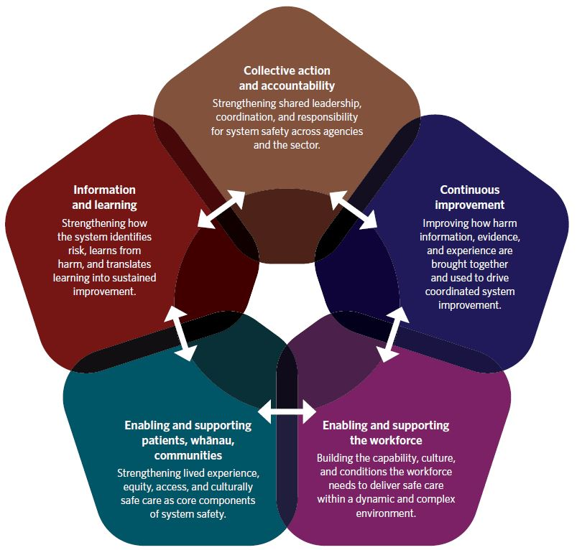

Focus area 1: Collective action and accountability
Strengthening system safety requires the system to act collectively. That is, patients and whānau, agencies, organisations and leaders need to work in a coordinated way to share responsibility for quality and safety. This focus area is about putting in place the necessary structures, building trusting relationships and setting expectations to create a more connected system – one that can identify emerging risks, set clear priorities and sustain improvement over time.
A key early priority is to establish an appropriate cross agency body with the mandate and authority to lead the development and implementation of the strategy action plan. This group must be able to agree direction, commit resources and drive change across organisational boundaries. Its stewardship role will include aligning expectations across agencies and overseeing the development and implementation of the action plan, which will include actions to:
embed Collaborating for Quality: A framework for clinical governance at all levels of the system and with an emphasis on governance across system boundaries
improve processes that support collaborative cross sector reviews of harm events
develop national cross sector health information management systems that inform and support quality and safety
strengthen oversight of systematic safety issues
enhance collaboration with international partners on care, quality and safety initiatives.
Collective action and accountability for system safety extend beyond responding to harm and recognising emerging risks. They include shared accountability for how services are planned, commissioned and purchased. This means commissioning for quality, purchasing for outcomes, and ensuring that safety is embedded at the point of service design and procurement. By designing and funding services that are safe, effective and people centred from the outset, the system can reduce the likelihood of potentially avoidable harm. This moves efforts to support system learning resulting in sustaining reliable, high quality care.
Early work in this focus area will need to further strengthen existing structures that will embed the Strategy across all levels of the system. This includes clarifying expectations for clinical governance, developing clear escalation pathways, and improving how information is shared and used so that reviews, reporting and learning are coordinated and consistent.
By establishing these foundations, this focus area creates the conditions for the rest of the Strategy to succeed. It supports active patient and whānau engagement, clearer national leadership, stronger alignment across agencies, and a shift from isolated local efforts to a coherent, system-wide programme of work. This collective platform will guide the detailed action plan developed in the first year and will underpin sustained improvement across the sector.

Focus area 2: Continuous improvement
Continuous improvement relies on a clear, shared understanding of emerging risks across the system and how best to respond. The first step is to improve how information is brought together and used across agencies. Early actions include building on existing memoranda of understanding between data holding agencies and creating regular forums for shared review of information relating to system safety. These steps will help ensure that insights are connected rather than leaving them in silos, supporting a more coherent picture of system risk and enabling more timely action.
A key emphasis within this focus area is to get that information to the people best placed to interpret and act on it. Much of the insight needed to understand risk sits with patients and whānau and those close to the front line, where local context, workflow knowledge and day to day operational realities are most visible. Enabling those closest to care to use information confidently supports a safety culture in which continuous learning becomes part of everyday practice. Achieving this culture will require connected clinical governance at local, regional and national levels with the ability to interpret data correctly, understand patterns, escalate concerns and identify opportunities for improvement. With stronger improvement, capability at all levels of the system ensures more people will be able to engage with information as part of their role and contribute to system learning.
Targeted improvement efforts will be guided by shared system intelligence and will build on work already under way – such as the development of a National Action Plan for the optimal use of medicines. Additional opportunities include expanding capacity and capability for quality improvement in home-based and disability support settings and strengthening cross agency collaboration in areas associated with high cost harm.
Continuous improvement will also require looking beyond clinical settings. Insights from patient experience data, inequity indicators and access measures will help develop tools that better identify the safety impacts of delayed or inequitable access. These insights will support earlier intervention and more proactive responses to emerging risks.
Capability building is really important. If you want people
to continuously learn that needs to be something that is built
into the system to enable them to do that.
(Phase 1 engagement)

Focus area 3: Enable and support the health workforce
A safe system relies on a workforce that feels supported, valued and able to participate meaningfully in activity to improve quality and safety. The system pressures of high demand, increasing complexity and stretched resources can limit the time available for reporting harm, contributing to reviews or engaging in improvement work. A fear of blame can also discourage open participation and reduces the visibility of risk. When harm occurs because of working within the system, its impact on the workforce and individuals needs to be recognised and appropriate supported provided.
Actions in this focus area will need to strengthen the conditions that enable workforce engagement and support wellbeing, recognising that this is essential to the quality and safety of people centred care. This will include further embedding the Healing, learning and improving from harm policy, developing a national plan for workforce wellbeing, and expanding the use of human centred design so systems, tools and processes better support the realities of the workforce. Strengthening these conditions requires understanding how resourcing, priorities, tools, technology, task design and the working environment affect workforce wellbeing and performance. It also means ensuring the workforce has the skills and knowledge to co-create people centred care with patients, whānau and communities, including through culturally safe communication, mutual respect and being responsive to the spiritual, emotional, cultural, social and physical dimensions of health.
Safety will also need to be recognised and further embedded as a core competency across the sector. The action plan will set out how system safety principles and human factors knowledge will be better incorporated into education, accreditation and professional development in partnership with undergraduate and postgraduate educational providers, colleges and professional bodies. Making safety expectations more visible within competency frameworks and performance processes will reinforce this.
Finally, the detailed action plan will need to ensure support for workforce participation in safety activity, that over time will help to strengthen a culture of learning. A core part of this work will be to further embed cultural safety across the workforce. That includes supporting the workforce to understand and respect the diverse worldviews, values and practices of the people and communities they serve, address implicit biases, and create care environments where everyone feels safe, respected and understood.
Ensure that health care professionals are educated in cultural
safety, with an emphasis on understanding and respecting
Māori worldviews, values, and practices. This includes
addressing implicit biases and creating an environment
where Māori patients feel safe, respected and understood.
(Phase 1 engagement)

Focus area 4: Enable and support patients and whānau
To be safe and effective, a system must listen to and involve patients and whānau and enable them to influence system re-design to improve the way it delivers care. This focus area strengthens how the sector partners with people, ensuring care is people- and whānau centred, mana enhancing and culturally safe.
Early work will need actions to create the conditions for more consistent and meaningful engagement. This includes fully embedding the Code of expectations for health entities’ engagement with consumers and whānau and supporting the application of the Code of Health and Disability Services Consumers’ Rights. Together these support people to participate fully in their care, receive clear and accessible information to enable informed consent, raise concerns through clear processes about current care and receive timely, independent review when needed. It also means using the data and insights already gathered through surveys, feedback, complaints and lived experience accounts can inform governance, improvement activity and service design.
A critical part of this work is to strengthen patient involvement across the whole care pathway. While data demonstrates patients and whānau feel they are active partners in determining their individual care, it is also important to improve how their input shapes the system that delivers that care, this is not always the case and less consistently utilised to guide priorities and inform system level decisions about what needs to change. These voices must come from a diverse range of people and communities, including those who have been poorly served or unable to access adequate care, so that their perspectives help shape people-centred care that better meets wide-ranging needs and expectations.
Capturing and responding to diverse voices require a whole of sector approach. Agencies will work together to develop actions that strengthen patient partnership and support the voices of those with lived experience to be embedded more consistently across services and programmes. These actions include building capacity, knowledge and skills of patients and whānau and providing them with the resources they need to participate meaningfully. Through this approach, the system can build trust, strengthen partnerships and include people as active participants in shaping safer, more responsive care. Embedding actions that help the system to understand the needs of those who have experienced harm – and to apply restorative approaches – will be essential to supporting healing, learning and ongoing improvement.

Focus area 5: Information and learning
Strengthening system safety requires a learning environment where information is consistently brought together, shared and used to guide action. This final focus area builds the foundations for a more connected and insightful approach to monitoring potentially avoidable harm, understanding system risk and using evidence to drive improvement across the sector.
Early work will need to focus on strengthening how information on safety is collected, analysed and shared. This includes improving the systematic sharing of reports, insights and intelligence generated through monitoring, review, complaints and other assurance processes. Activity to improve the consistency of reporting and expand coverage across different parts of the sector will be important to help build a clearer picture of system-level risks. Establishing a community of practice to support system learning and improvement will also need to be part of the action plan.
Developing the capability of the system safety workforce is another priority. This includes establishing educational pathways to equip those involved in system safety work with the skills, knowledge and experience they need to identify risks, interpret system signals and contribute to improvement. This will help embed learning as a core component of system safety practice.
Further actions are needed to increase the system’s use of international knowledge. Maintaining and building on collaboration with global partners and participating in international alliances will support the spread of evidence-based approaches and provide opportunities for benchmarking and shared learning on complex safety challenges.
Finally, this focus area must include actions to strengthen New Zealand’s research base in system safety. Examples include developing a research agenda to identify priority areas, build understanding of the New Zealand context and guide longer-term investment in system safety research.

Action plan
The focus areas outlined in this Strategy provide a comprehensive approach and suggest some specific actions that will strengthen system safety across New Zealand. Together, they set out the capabilities, relationships and system conditions needed to build and sustain a safer and more responsive health and disability system, leveraging off existing frameworks, relationships and areas of good practice.
Early actions need to concentrate on strengthening the foundational elements of system safety, particularly those in Focus area 1: Collective action and accountability. While elements already exist, there is a need to consolidate, extend and better connect current structures and arrangements. Establishing clearer expectations and improving ways of working across organisational boundaries will enable subsequent initiatives to be delivered more effectively.
As outlined in the Strategy development and review section, this approach recognises that the system is emerging from significant reform and organisational change. Building a comprehensive action and implementation plan allows agencies time to prepare for implementation, build capability and sequence work appropriately.
This phase will clarify responsibilities and agree deliverables and milestones. It will require active collaboration across agencies and meaningful engagement with patients, whānau, providers, professional bodies and other system partners to ensure that the resulting actions are practical, coherent and aligned with system-wide capability and accountability arrangements.

Bibliography
Bates D et al. 2023. The Safety of Inpatient Health Care. New England Journal of Medicine 388(2): 142–153.
Bodenheimer T, Sinsky C. 2014. From triple to quadruple aim: care of the patient requires care of the provider. Annals of Family Medicine 12(6): 573–576.
Carayon P, Xie A, Kianfar S. 2014. Human factors and ergonomics as a patient safety practice. BMJ Quality & Safety 23(3): 196–205.
Carayon P, Hundt SA, Karsh BT et al. 2006. Work system design for patient safety: The SEIPS model. Quality & Safety in Health Care 15(Suppl 1): i50–58.
Cook R. 2002. How complex systems fail. URL: how.complexsystems.fail (accessed 15 May 2026).
Darzi I. 2024. Independent Investigation of the National Health Service in England. London: UK Government.
Edmondson A, Bevan H. 2021. A practical guide to the art of psychological safety in the real world of health and care. Coventry: NHS Horizons.
Hignett S, Lang A. 2018. Human Factors for Health and Social Care. CIEHF White Paper.
Hollnagel E, Wears R, Braithwaite J. 2015. From Safety-I to Safety-II: A White Paper. University of Southern Denmark; University of Florida; Macquarie University.
HQSC. 2023. Healing, learning and improving from harm: National adverse events policy. Wellington: Health Quality & Safety Commission Te Tāhū Hauora (HQSC).
Kirkup b. 2015. The Report of the Morecambe Bay Investigation. London: The Stationery Office.
Leape L et al. 1991. The nature of adverse events in hospitalized patients: results of the Harvard Medical Practice Study II. New England Journal of Medicine 324(6): 377–384.
Lim R et al. Development of a Competency Framework for Healthcare Safety Investigators: An E-Delphi Study. DOI: http://dx.doi.org/10.2139/ssrn.5377316 (accessed 15 May 2026).
Macrae C, Vincent C. 2014. Learning from failure: the need for independent safety investigation in healthcare. Journal of the Royal Society of Medicine 107: 439–443.
Mesinioti P, Macrae C, Sheard L et al. 2025. Closing investigations: The role of national policy in shaping structural, organisational and relational constraints on learning from patient safety incidents. Safety Science 192.
Mid Staffordshire NHS Foundation Trust Public Inquiry. Report of the Mid Staffordshire NHS Foundation Trust Public Inquiry. 2013. URL: gov.uk/government/organisations/mid-staffordshire-nhs-foundation-trust-public-inquiry (accessed 15 May 2026).
Ministry of Health. 2023. Health Workforce Strategic Framework. Wellington: Ministry of Health.
Ministry of Health. 2023. Rural Health Strategy. Wellington: Ministry of Health.
Moore J, Mello M. 2017. Improving reconciliation following medical injury: a qualitative study of responses to patient safety incidents in New Zealand. BMJ Quality & Safety 26(10): 788–798.
National Collaborative for Restorative Initiatives in Health. 2023. He Maungarongo ki Ngā Iwi: Envisioning a Restorative Health System in Aotearoa New Zealand. Wellington: National Collaborative for Restorative Initiatives in Health.
Nicolini D, Waring J, Mengis J. 2011. Policy and practice in the use of root cause analysis to investigate clinical adverse events: mind the gap. Social Science & Medicine 73(2): 217–225.
Perlo J, Balik B, Swensen S, et al. 2017. Framework for Improving Joy in Work. Cambridge, United States: Institute for Healthcare Improvement.
Pupulidy I, Vesel C. 2017. The Learning Review: Adding to the Accident Investigation Toolbox. Ispra, Italy: ESReDA Seminar, European Commission Joint Research Centre.
Pupulidy, I Vesel C. 2023. Human & Organization Potential. United States: Dynamic Inquiry LLC.
Royal Commission of Inquiry into Abuse in Care. URL: abuseincare.org.nz (accessed 15 May 2026).
Shanafelt T, Trockel M, Stolz S, et al. 2025. Ten Principles to Advance Occupational Well-being in Health Care Organizations. Mayo Clinic Proceedings, 100, 995–1004.
Wailling J, Kooijman A, Hughes J, et al. 2022. Humanizing harm: Using a restorative approach to heal and learn from adverse events. Health Expectations 25(4): 1192–1199.
Walker J. 2017. Solving the World’s Biggest Problems: Better Philanthropy Through Systems Change. Stanford Social Innovation Review. URL: https://doi.org/10.48558/743S-NV97 (accessed 15 May 2026).
Wears R, Sutcliffe K. 2020. Still Not Safe: Patient Safety and the Middle-Managing of American Medicine. New York: Oxford University Press.
Wilkinson J, Marshall C. 2021. Health practitioner experience of Health and Disability Commissioner investigations. Journal of Primary Health Care 13(3): 213–221.
Woods D, Branlat M. 2010. Hollnagel’s test: being ‘in control’ of highly interdependent multi-layered networked systems. Cognition, Technology & Work 12(2): 95–101.
Woods D, Branlat M. 2011. Basic patterns in how adaptive systems fail. In Resilience Engineering in Practice. E. Hollnagel (Ed.). Ashgate.
WHO. WHO Charter on Health Worker Safety: A Priority for Patient Safety. World Health Organization.

Legislation
Accident Compensation Act 2001.
Health and Disability Services (Safety) Act 2001.
Health and Safety at Work Act 2015.
Health Practitioners Competence Assurance Act 2003.

Websites
Health Services Safety Investigation Body (hssib.org.uk)
Health and Disability Commissioner – Te Toihau Hauora, Hauātanga (hdc.org.nz)
Patient Safety Commissioner (patientsafetycommissioner.org.uk)
Health and disability services standard (standards.govt.nz/shop/nzs-81342021)
Te Pou. Trauma informed approaches (tepou.co.nz/initiatives/keeping-it-real/trauma-informed-approaches)
UKOM (Norway). (ukom.no)

In this document, we use the word ‘patient’ to refer to any person who engages with the health and disability system in New Zealand at any stage of their life.
It is acknowledged the word ‘care’ can be triggering for some communities due to its connection to ‘Abuse in care’, as a consequence the term ‘people-centred health care’ is used in preference where feasible.
Pae Ora (Healthy Futures) Act 2022, see URL: health.govt.nz/about-us/new-zealands-health-system/overview-and-statutory-framework/pae-ora-healthy-futures-act (accessed 31 March 2026).
In this document, we use the word ‘patient’ to refer to any person who engages with the health and disability system in New Zealand at any stage of their life.
Minister of Health. 2024. Government Policy Statement on Health 2024–2027. Wellington: Ministry of Health.
World Health Organization. 2021. Global Patient Safety Action Plan 2021–30. URL: who.int/teams/integrated-health-services/patient-safety/policy/global-patient-safety-action-plan (accessed 30 March 2026).
Minister of Health. 2023. New Zealand Health Strategy 2023. URL: health.govt.nz/system/files/2023-07/new-zealand-health-strategy-oct23.pdf
https://gpssmanila.doh.gov.ph/manila-mandaluyong-declaration-2/ (accessed 31 March 2026).
Health Quality & Safety Commission Te Tāhū Hauora. 2024. Collaborating for Quality: A clinical governance framework. URL: hqsc.govt.nz/resources/resource-library/collaborating-for-quality-a-framework-for-clinical-governance (accessed 31 March 2026).
Sampath B, Rakover J, Baldoza K, et al. 2021. Whole System Quality: A unified approach to building responsive, resilient health care systems. IHI White Paper. Boston, MA: Institute for Healthcare Improvement.
hqsc.govt.nz/assets/Core-pages/About-us/Insights-reports/Te-Tahu-Hauora-Assessing-system-quality-and-safety-insights-report-November-2024.pdf?hash=54a4e1bb5ad4c00b3d02ba34e04c1df5b8f0bf08
Health Quality & Safety Commission Te Tāhū Hauora. 2022. Aotearoa New Zealand national point prevalence survey of healthcare-associated infections. URL: hqsc.govt.nz/resources/resource-library/pps-report-2022/ (accessed 31 March 2026).
Ministry of Health. 2024. Wai 2575 Health Services and Outcomes Inquiry. URL: health.govt.nz/maori-health/wai-2575-health-services-and-outcomes-inquiry (accessed 31 March 2026).
Health and Disability Commissioner. 1996. Health and Disability Commissioner (Code of Health and Disability Services Consumers’ Rights) Regulations 1996. URL: hdc.org.nz/your-rights/about-the-code/code-of-health-and-disability-services-consumers-rights/ (accessed 31 March 2026).
Health Quality & Safety Commission Te Tāhū Hauora. 2023. Code of expectations for health entities’ engagement with consumers and whanau. URL: hqsc.govt.nz/resources/resource-library/code-of-expectations-for-health-entities-engagement-with-consumers-and-whanau/ (accessed 31 March 2026).
Health Quality & Safety Commission Te Tāhū Hauora. 2023. Healing, learning and improving from harm. URL: hqsc.govt.nz/our-work/system-safety/healing-learning-and-improving-from-harm/ (accessed 31 March 2026).
Based on Te Whare Tapa Whā model of Māori health. See: Ministry of Health. 2023. URL: health.govt.nz/maori-health/maori-health-models/te-whare-tapa-wha (accessed 2 November 2025).

