Organisational self-assessment:10 priorities in an integrated approach to falls in older people – what's your plan?

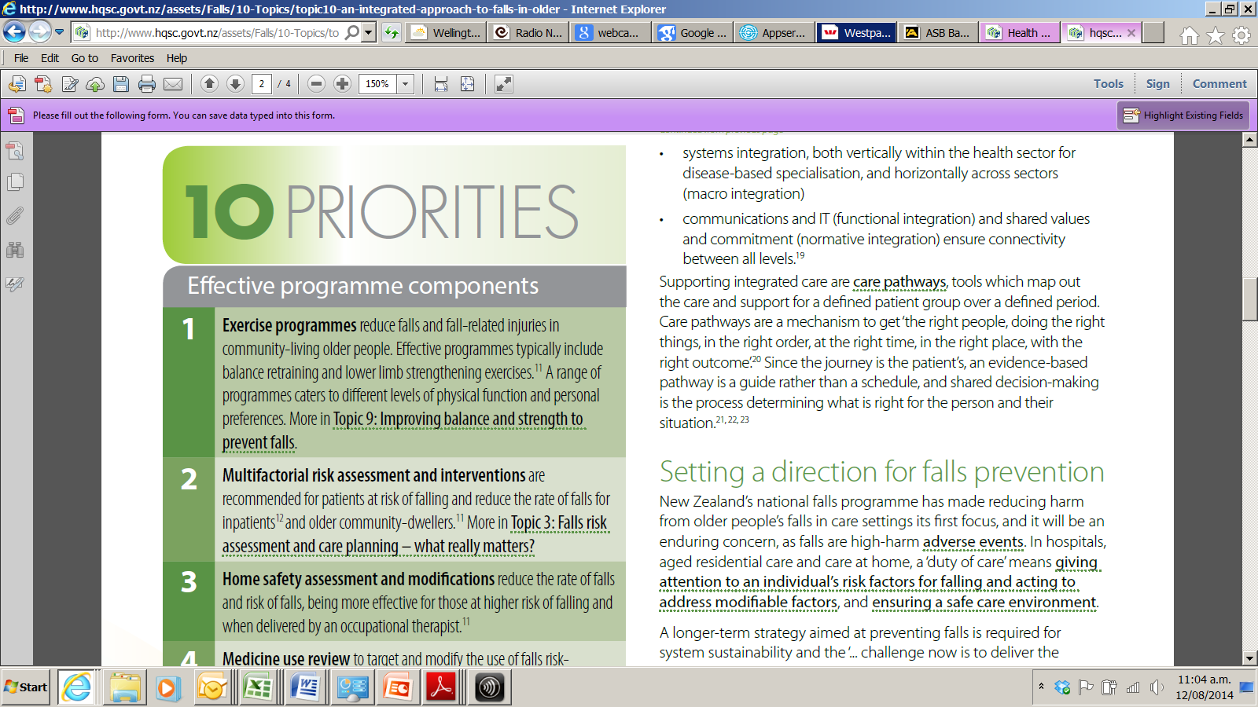 | YOUR PERSPECTIVE AS A STAKEHOLDER Describe your role and/or service, and the key issues in falls prevention for older people whose care falls within your sphere of influence:
 | Work through this part of the self-assessment initially |  |  | Complete this part every 6 months after your baseline self-assessment
Effective programme components | Does your approach to preventing falls in older people have these components? YES/NO How are they implemented? Describe... | Gaps identified | Action plan | Progress
1. Exercise programmes reduce falls and fall-related injuries in community-living older people. Effective programmes typically include balance retraining and lower limb strengthening exercises. A range of programmes caters to different levels of physical function and personal preferences. More in Topic 9: Improving balance and strength to prevent falls.
2. Multifactorial risk assessment and interventions are recommended for patients at risk of falling and reduce the rate of falls for inpatients and by older people living in the community.¹ More in Topic 3: Falls risk assessment: a multifactorial approach and Topic 4: Addressing risk factors in an individualised care plan.
3. Home safety assessment and modifications reduce the rate of falls and risk of falls, being more effective for those at higher risk of falling and when delivered by an occupational therapist.¹ More about environmental interventions in Topic 5: Safe environment and safe care are essential to prevent falls.
4. Medicine use review to target and modify the use medicines that increase the risk of falling helps to reduce the rate of falls.^{1,} Prescribed vitamin D supplementation for older person who is at risk of vitamin D deficiency/insufficiency may reduce the likelihood, and number, of falls. More in Topic 8: Medicines: balancing benefits and falls risks


Service delivery | Do services for older people include these elements? YES/NO  How are they implemented? Describe... | Gaps identified | Action plan | Progress
5. Locally developed integrated falls pathway and referral processes, in which ‘any door is the right door’ for assessment of falls risk and referring the person for appropriate interventions.
6. Systematic approaches to assessment of bone health and fracture risk and appropriate interventions for primary and secondary prevention of fragility fractures; and improvement of fracture care and recovery. More in Topic 7: Why hip fracture prevention and care matter explains the importance of fracture liaison services and the Australian and New Zealand Hip Fracture Registry’s guidelines and clinical care standards.
7. For older people identified as frail, comprehensive geriatric assessment as a key to safe, compassionate integrated care in primary, long-term care and acute settings, especially for those with problems which contribute to the risk of falling, such as impaired mobility and dementia.,

Leadership actions | Are these actions being taken? YES/NO  What processes and systems are you using? Describe... | Gaps identified | Action plan | Progress
8. Keep falls on the agenda as everyone’s business. The causes of falls in older people are complex. We should not be surprised that improving service is complex and will take sustained effort and attention. Using patient stories at all levels is a powerful reminder and motivator.
9. Ensure systems and processes are in place to collect, monitor and analyse data related to fall prevention measures and falls incidents. Provide meaningful feedback to everyone involved so as to promote learning and show where practice can be improved.
10. Ensure system capacity and capability for quality improvement and innovative practice for preventing falls. Both evidence-based and experience-based falls prevention practices require behaviour change and new competencies for staff, as well as change management to support organisational and system change. Networks can be energising, build resilience and spread knowledge and learning. Investment is needed as well as a whole-of-system integrated approach.

Gillespie LD, Robertson MC, Gillespie WJ et al. Interventions for preventing falls in older people living in the community. Cochrane Database of Systematic Reviews (9): CD007146.
Cameron ID, Gillespie LD, Robertson MC et al. 2012. Interventions for preventing falls in older people in care facilities and hospitals. Cochrane Database of Systematic Reviews (12): CD005465.
Blalock SJ, Casteel C, Roth MT et al. 2010. Impact of enhanced pharmacologic care on the prevention of falls: A randomized controlled trial. American Journal of Geriatric Pharmacotherapy 8(5): 428–40.
Ganz DA, Alkema GE, Wu S. 2008. It takes a village to prevent falls: reconceptualizing fall prevention and management for older adults. Injury Prevention 14(4): 266–71.
Clegg A, Young J, Iliffe S et al. 2013. Frailty in elderly people. The Lancet 381(9868): 752–62.
Taylor ME, Delbaere K, Close JC et al. 2012. Managing falls in older patients with cognitive impairment. Aging Health 8(6): 573–88.
Oliver D, Healey F, Haines TP. 2010. Preventing falls and fall-related injuries in hospitals. Clinics in Geriatric Medicine 26(4): 645–92.
Fixsen D, Scott V, Blase K et al. 2011. When evidence is not enough: the challenge of implementing fall prevention strategies. Journal of Safety Research 42(6): 419–22.
Mountford J, Marshall M. 2014. More dialogue, more learning, more action. BMJ Quality & Safety (23): 89–91

