Tool F: Run charts

How to construct a run chart
There are seven steps involved in constructing a run chart:
- The horizontal axis for the run chart will usually be a timescale. Appropriate time increments to develop the axis will typically be days, weeks or months. A useful practice is to label several future time increments even though no data yet exists for that timeframe. The scale should cover the time period of interest for the graph, not just the time when data is currently available.
- Develop the vertical axis for the run chart. Choose a good scale that is easy to plot and read, and leaves ample room for future data that might be larger or smaller than the values used to create the initial run chart. Criteria for a good scale include:
- most of the data lies in about the middle half of the graph
- labelled values on the axis are round numbers and equally spaced.
Plot the data point. Make a dot (or another symbol). Connecting the dots with a line is optional but the dots should always be distinguishable from the line. Data is communicated through the dots, not the line.
Label the graph with a descriptive title. Label the horizontal axis with the sequence of the data. Label the vertical axis with name of the intervention or characteristic you are studying.
Calculate and draw a median of the data on the run chart. The median is the number in the middle of the data set when the data is reordered from the highest to the lowest value. If the number of observations is even, the median is the average of the two middle values. The median is necessary in order to interpret a run chart. To analyse a run chart you need at least 10 data points.
Add additional information to the chart. Add a goal or target line if appropriate. Annotate unusual events, changes tested or other pertinent information on the run chart at an appropriate time location.

Interpreting run charts
There are four rules to identify non-random patterns in the data displayed on a run chart:
- A shift in the process or too many data points in a run (six or more consecutive points above or below the median).
- A trend (five or more consecutive points all increasing or decreasing).
- Too many or too few runs (use a table to determine this one).
- An ‘astronomical’ data point (explained below).
If one or more of the above rules apply to the run chart, this indicates the intervention tested has influenced the collected data. These results can be negative (not what you expected; it didn’t improve things or even made things worse) or positive (improvement seen; what you predicted). The team needs to study the run chart and decide whether they are on track and then expand the test, then adapt or change the intervention.
Provost and Murray describe a more in-depth analysis on the use of run charts in The Healthcare Data Guide.
An ‘astronomical data point’ is used in detecting unusually large or small numbers. An astronomical data point is one that is obviously, even blatantly, different from the rest of the points; all studying the chart would agree the point is unusual. Astronomical points should not be confused with the highest or lowest data points, which every run chart will have. While rules 1, 2 and 3 are probability based and objective, rule 4 is subjective and recognises the importance of the visual display of the data in a run chart.

Run chart analysis
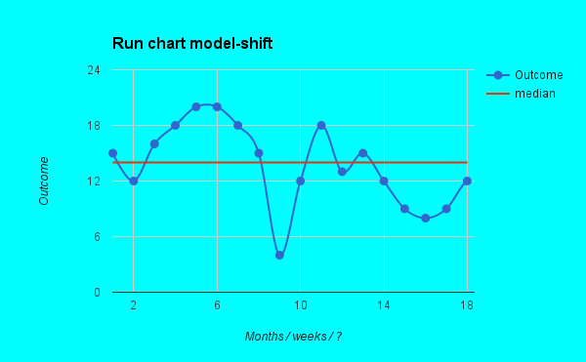
A shift is when six or more outcomes are positioned on one side of the median. In this example the outcomes between time moment three and eight are positioned above the median.
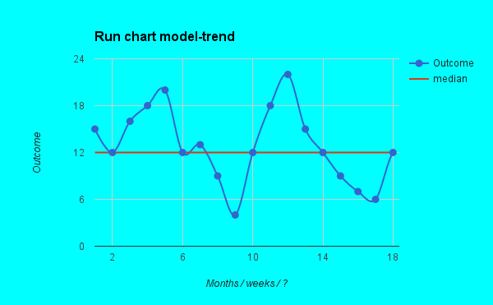
A trend is when five or more consecutive outcomes are going up or down. From time moment 12, five consecutive outcomes are going down.

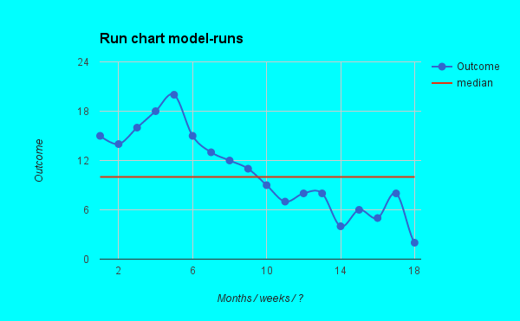
A non-random pattern is signalled by too many or too few runs or crossings of the median. A run is a series of point in a row on one side of the median. An easy way to determine the number of runs is to count the number of times the line connecting the data points crosses the median and add one. In the example above, the data line crosses the median once we add one, which means there are two runs. The table below tells you if the number of runs counted is too many or too few for the number of data points.
Table for checking too many or too few runs on a run chart:
Total number of data point on run chart not falling on the median | Lower limit for number of runs (<than this is ‘too few’) | Upper limit for number of runs (>than this is ‘too many’)
10 | 3 | 9
11 | 3 | 10
12 | 3 | 11
13 | 4 | 11
14 | 4 | 12
15 | 5 | 12
16 | 5 | 13
17 | 5 | 13
18 | 6 | 14
Source: Adapted from Swed FS, Eisenhart C. 1943. Tables for Testing Randomness of Grouping in a Sequence of Alternatives. Annals of Mathematical Statistics XIV(66): 87, tables II and III.
In this example there are too few runs for the 18 data points. You need at least six and there are only two. This is a clear sign of non-randomness.
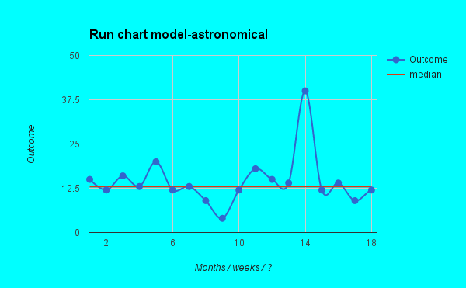
The result on week 14 shows an astronomical point. This indicates that something changed at that time. We should seek to understand what caused that change and either replicate if it was a good thing, or prevent it occurring again if it was a bad thing.

Provost LP, Murray SK. 2011. The Healthcare Data Guide: learning from data for improvement. San Francisco, CA: Jossey-Bass.
Ibid.

