Tool H: Pareto chart

What it is
A Pareto chart helps to visualise the most frequently occurring causes of a problem. It is based on the Pareto 80/20 principle, which asserts that a minority of the causes of a problem usually have the most or major impact on it.

When to use it
TOOL G
page 35
Use a Pareto chart once the cause and effect diagram (see Tool G) is completed as it can help to identify the Pareto areas to work on first.
- Direct your efforts to the biggest improvement opportunity. Do this by highlighting the key causes of a problem in contrast to the multitude of insignificant causes.

How to use it
Determine the categories and the units for comparison of the data, such as frequency, cost or time.
Total the raw data in each category then determine the grand total by adding the totals of each category.
Re-order the categories from largest to smallest.
Determine the cumulative percent of each category (ie, the sum of each category plus all categories before it in the rank order, divided by the grand total and multiplied by 100).
Draw and label the left-hand vertical axis with the unit of comparison.
Draw and label the horizontal axis with the categories. List the categories from left to right in rank order.
Draw and label the right-hand vertical axis from 0 to 100 percent. The 100 percent should line up with the grand total on the left-hand vertical axis.
Beginning with the largest category, draw bars for each category representing the total for that category.
Draw a line graph beginning at the right-hand corner of the first bar to represent the cumulative percent for each category as measured on the right-hand axis.
- Analyse the chart. Usually the top 20 percent of the categories will comprise roughly 80 percent of the cumulative total.

Tips
Pareto charts are useful displays of data for presentations. They show you are focused on the most significant factors.
Use the objective data collected to perform Pareto analysis as this can provide a more accurate picture of causes rather than basing decisions on the opinions of team members.
If there is no clear distinction between the categories (ie, if all bars are roughly the same height or half of the categories are required to account for 60 percent of the effect), consider organising the data in a different manner and repeating the Pareto analysis.
- Pareto analysis is most effective when the problem is well defined.

Example
A health care facility wanted to identify at what location in the facility the most falls occurred. To do so, they analysed the fall incident reports over a period of two years. They added up the number of falls for each location. The Pareto chart below was the result.

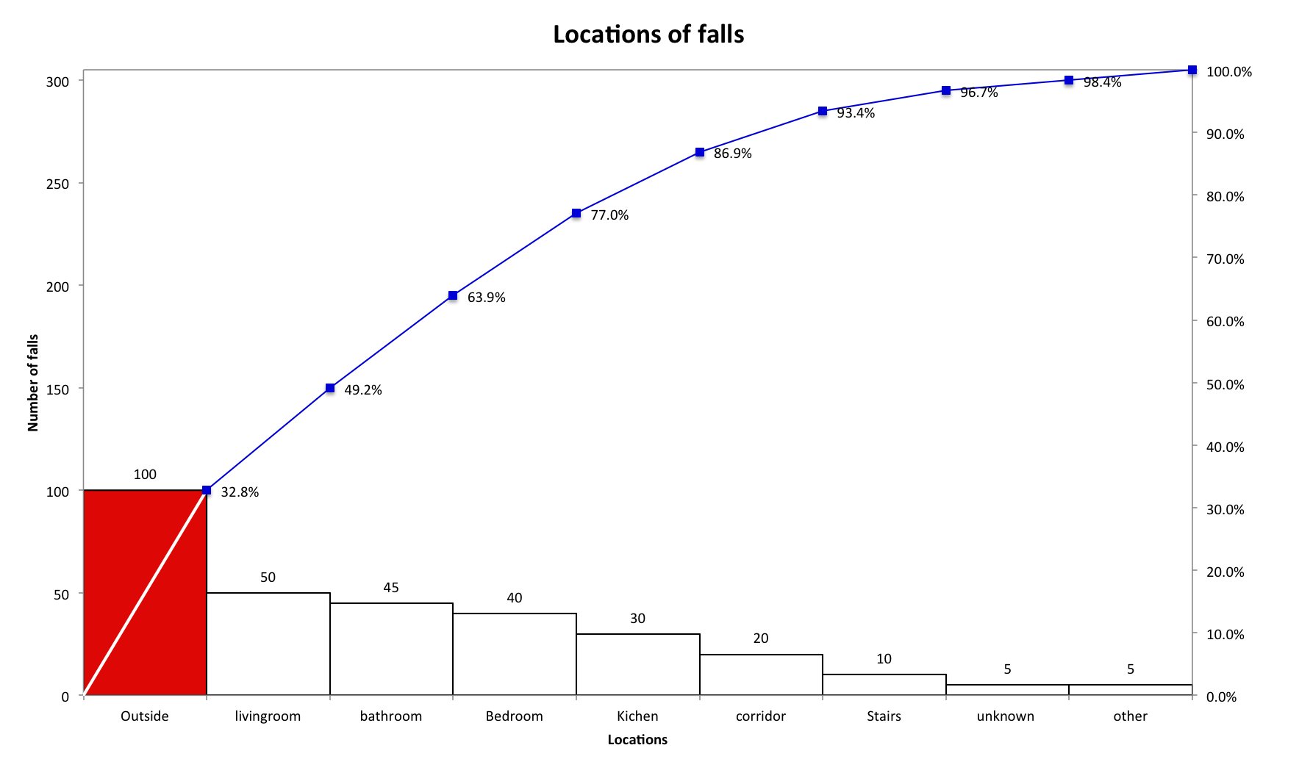
Pareto chart displaying the number of falls that occurred on the various locations in and around the facility. From this chart it is evident most falls occurred outside the facility (32 percent).

The bars on the chart display the actual number of falls that have occurred in each location. The line rising from left to right shows the percentage of the total that each category or bar represents of the total. This is to help you focus on the most important categories. So here you can see that if you reduce outside falls and living room falls, you may potentially prevent 50 percent of all falls. This could prevent a focus on falls on the stairs which would not have the greatest benefit for the residents.

