Tool I: Process mapping
A process is a series of steps or actions performed to achieve a specific purpose. All work is made up of processes. A process map is a pictorial representation of the series of actions that comprise a process.
Process mapping is undertaken to describe and understand the work being done. When used as an improvement tool, process mapping can help you identify:
gaps and critical steps
areas of complexity and double-ups
- inefficiencies and waste.
Process mapping can also help you reach consensus on what an improved process should look like.
There are many types of process maps. We have focused on developing a basic flowchart. The example below describes a simple process for turning on an alarm.
Figure 4: Alarm flowchart
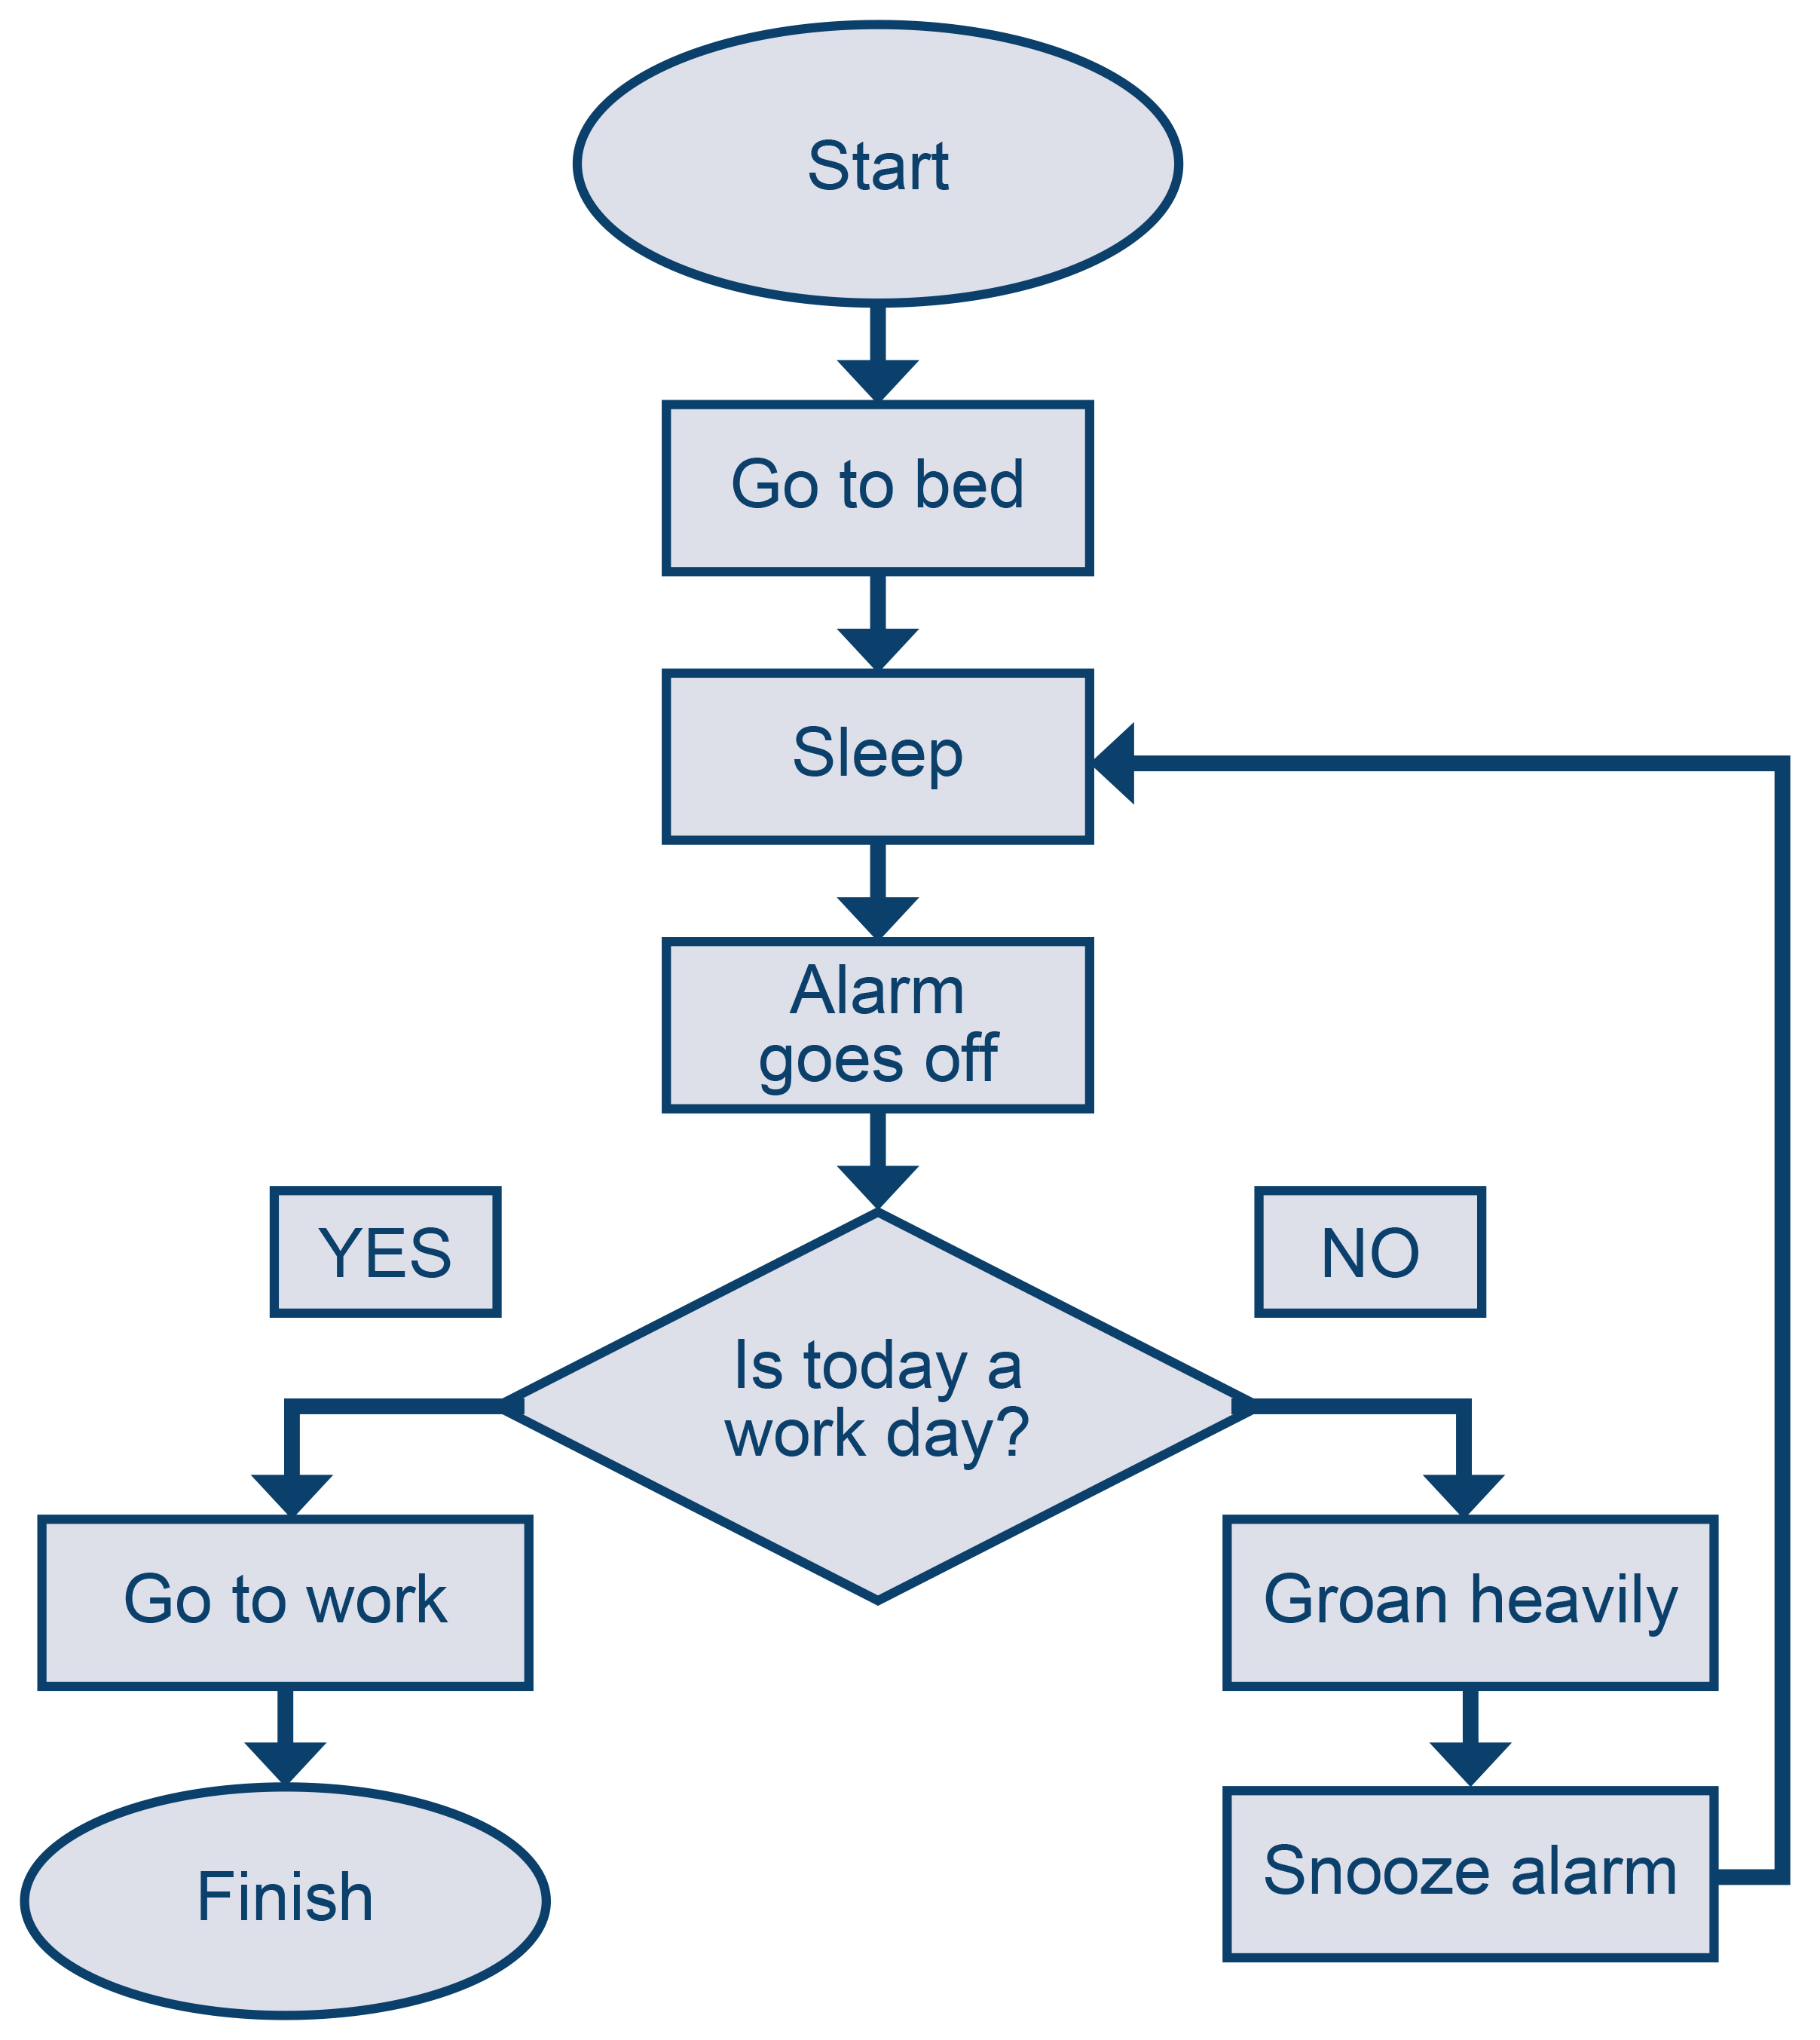

Figure 5: The meaning of symbols used in process maps or flowcharts
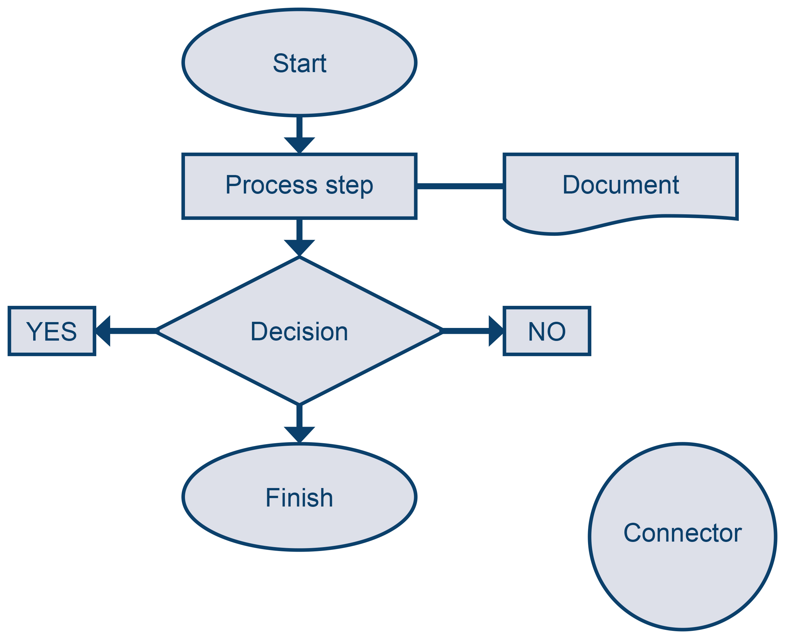
A process must always have a start and finish. The process steps are described in the square boxes and any documents attached to the process are described in the shape shown above. A decision diamond is used to show when the process may go in different directions depending on the answer to a question. There must always be at least two directional arrows out of the decision diamond. The round shape is used to show the diagram is carried onto another page or part of another process, eg, in our television process you might describe the process for contacting the television repair man in another flowchart and use a connector to say: see television repair man process.

Process mapping procedure
- Gather a team of the people who are involved with working in the process. Between six and eight people is best.
- Decide on the start and finish of the process you are going to map.
- Use sticky notes to document the process steps as described by the team members as they actually happen.
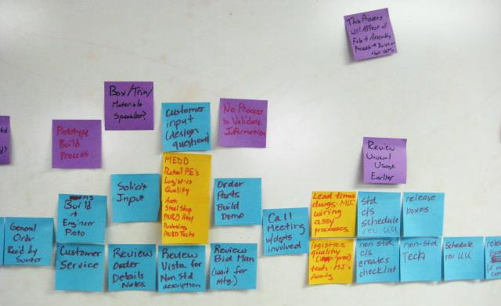
Check the completed process map against how it happens in reality. Go and look. Share the process map with other team members and get their input.
Identify the waste and duplication in the process map.
Remap the process to be the ideal process.
Plan how you are going to make the changes needed to make the ideal a reality. Use the Model for Improvement:
- Answer the three questions at the top of the Model for Improvement.
- Ensure you have a plan to measure the effect of your changes and review the results.
- Plan–do–study–act.

