Tool K: PDSA cycle checklist
Cycle #  Meeting # – date | Start date:  End date:
Objective of cycle | ____Collect data to develop a change ____Test a change* ____Implement a change**  Short objective of the cycle:
Plan  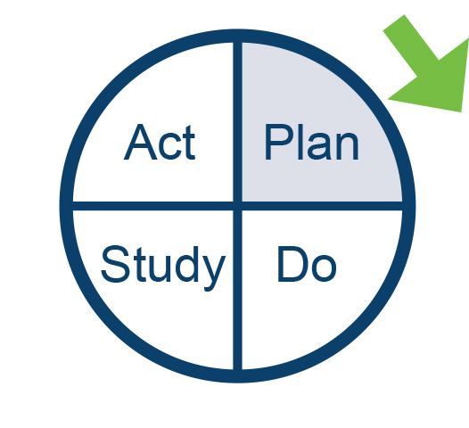 | Questions:  - ?  Prediction:  ?  Prediction:  ?  Prediction:  ?  Prediction:
Note:  *For test cycles reference p96 of Improvement Guide for testing checklist  **For Implementation cycle reference p136 of Improvement Guide for implementation checklist | Test/Implementation plan:  What change will be tested or implemented?  How will the change to be tested or implementation be conducted (consider small scale early)?  Who will run the test or implementation?  Where?  When will the test or implementation take place?
Collect data plan (usually required for all PDSA cycles):
What information is important to collect?
Why is it important?
Who will collect the data?
Who will analyse the data prior to study?
Where will data be collected?
When will the collection of data take place?
How will the data (measures or observations) be collected?

Do  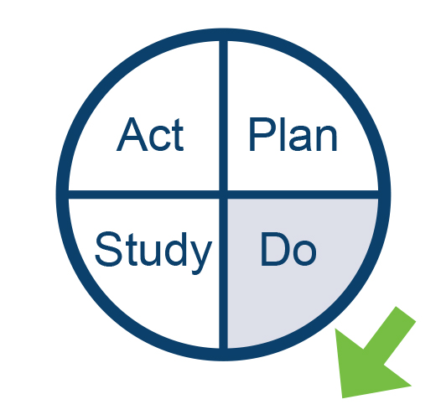 | Observations:  Record observations not part of the plan.  Did you need to modify the original plan?  If so, how?  Begin analysis of data (graph of the data, picture).
Study  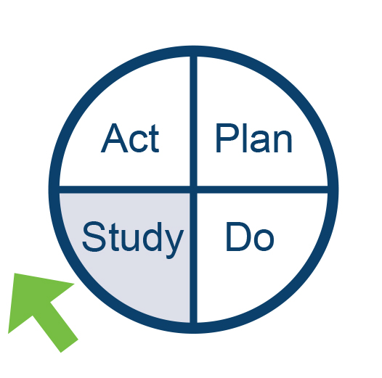 | Questions: (copy and paste questions and predictions from plan above and add results. Complete analysis of the data. Insert graphic analysis whenever possible.)  - ?  Prediction:  Learning (comparison of questions, predictions and analysis of data):  ?  Prediction:  Learning:  New Issues:  Summary:
Act  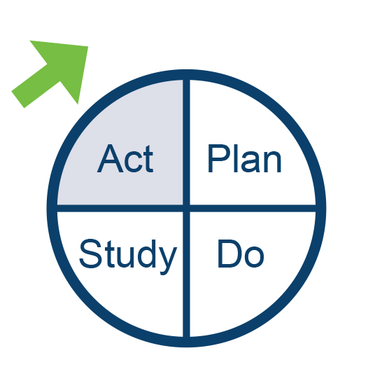 | Describe next PDSA cycle; new questions to answer/decisions made/action to be taken.
Ad hoc contributors | Recognise subject matter experts and others who have contributed to the learning.

The form is part of IHI QI 106 course: Mastering PDSA cycles and run charts (www.ihi.org/education/ihiopenschool/courses).
Langley GJ, Moen RD, Nolan KM, et al. 2009. The Improvement Guide: A Practical Approach to Enhancing Organizational Performance. (Second Edition) San Francisco: Jossey-Bass.

